

**SRS**

**WEB DESIGNING PROJECT**

**Project Title : Abbiocco**

**Guide: Prof. Chandra J**

**By:**

**FEMI FRANCIS (1741118)**

**MEHAK GUPTA (1741134)**

**RAHUL VINISH (1741138)**

**RAHUL PRADEEP(1741139)**

**Table of Contents**

**ABSTRACT** **2**

**INTRODUCTION** **3**

**SYSTEM ANALYSIS** **4**

Existing Platforms 4

Limitations of Existing platforms 4

Proposed Systems 5

Benefits of Proposed Systems 6

Hardware Requirements 7

Software Requirements 7

Modules 9

**Conclusion** **10**

# 

# 

# 

# **ABSTRACT**

There are many websites and mobile apps which recommend food recipes on the basis of entry date, access frequency, or the user’s rating. However, these apps do not take into consideration the user’s preferences and user’s budgets. Our project proposes to optimize the search which meets the user’s personal interests. It utilizes the user’s recipe browsing and cooking history.

Users can also make their own profiles that demonstrate recipes cooked by them to get opinions from other users and build a community. The project caters to the current day requirement of people wanting to cook their own meals in the quest of maintaining a healthy lifestyle.

Filtration of all recipes will be based on nutritional value, cooking time, ingredients, budgets, etc based on the current day requirements as opposed to the conventional filtration techniques employed in the past. Mass user data will be interpreted based on age, nationality, etc to optimize the recommendations and improve the overall experience.

# 

# 

# 

# 

# 

# **INTRODUCTION**

Due to the sudden upsurge of the society being health conscious and following a dietary life, it is essential to know the right way to consume our daily staples in the best way possible without making the process heavy on the pocket. Normally to gain knowledge on the nutritional values of the food we intake we’d require the assistance of a dietician. However, their assistance is restricted up until suggestions of meals and not the entire process of making them. Our project meets this very need, wherein the user will be able to learn how to cook recipes based on the ingredients available to them at that instant of time and the prep time they can dedicate. On the other hand, cooking videos/recipes will also be the user’s contribution who can gain recognition in the process.

Our method breaks down the search of recipes into ingredients, preparation time and ratings. This makes it efficient as it estimates the user’s preference for food. We also intend to suggest recipes based on the budget of the user, thereby making it pocket-friendly.

# 

# **SYSTEM ANALYSIS**

## **Existing Platforms**

Ever since the beginning of blogging on the internet food blogging and searching for recipes online have developed to be a very popular practice in several households. With the increase in demand for repositories of recipes where the user can efficiently surf through several recipes, several websites have been developed to fulfill this use case.

The most popular out of these websites are:

1. Tasty: This website lays more emphasis on their android application than the website and thus the website is unidirectional and doesn't allow the user to develop a presence on the platform by uploading his own recipes. Moreover, the search and filter on this website is difficult to navigate through and is more suitable for people from urban society who wish to explore different cuisines.
2. Yumm.ly: This works in similar grounds as Tasty. Yummly is an extended food blog which helps you develop your profile based on your usage of the website and the preferences you set. The website however has a static set of filters that you can choose from and are not extensive to narrow down the perfect recipe for our requirement.
3. Cookpad: Cookpad is a website that surfs through the most visited recipes in our area and develops a trending page according to the same. Cookpad like tasty allows for unidirectional communication and no profile system is in order for the users and there is not a user review system in order.

### **Limitations of Existing platforms**

For content consumption from every website the main thing the user aspires for is relevant data based on a simple search and a community to help and support him while on the platform. Recipes and food applications have a massive database for consumption by the user and their effectiveness lies in their ability to allow the user to be exposed relevant data while keeping the platform community base as is the trend of the current day.

Based on the same limitations of existing platforms that our project looks to improve are as follows:

1. Static search filters limiting the flexibility of the search of the user:

The existing platforms have limited search options that the user can use in order to filer his/her search results to narrow down onto his/her required recipes

1. Lack of a community development on the platforms.

The presence of a community in a food based website is almost mandatory in todays’ day and age and will allow the upcoming cooks or users who lack the ability for the same to be aided and helped by other members of the community. The community also helps to grow and expand the database and supports itself.

1. Unidirectional communication on the platforms

The absence of user profiles on several of these platforms results in a unidirectional communication

## **Proposed Systems**

The system that we propose with the help of this project lays emphasis and focus on the convenience and preferences of the user based on his habits on the application rather than hard-coded general elements.

The proposed website will be a social media for users to showcase new recipes that will add to the database of existing recipes, these will be used by the other users who require these recipes based on personal preferences of ingredients, quantity, calories, etc. On preparing these dishes the users will be prompted to give their feedback on the validity of these dishes that later decides the priority of these dishes on time of preparation.

There will be a page available to the user to track all the dishes that he has viewed or prepared to allow ease of access.

### **Benefits of Proposed Systems**

**1. User profiles:**

every user maintains a profile which indicates their culinary tastes and interests, which in

turn helps them to find kindred spirits based on their culinary culture.

**2.Uploading Recipes:**

users can upload their own recipes and can create their own recipe book. The regional

difference for the same food recipe could be easily distinguished as people from different

cultures would upload their recipes for the same food.

**3. Beginners Cup Of Tea:**

Abbiocco is primarily focused on people who are absolutely new to kitchen and cooking,

especially bachelors.It would be difficult for them to cook for a long time as they prefer a

shorter preparation time. Abbiocco filters the food recipes based on such personal

preferences and constraints.

**4. Cook As Well As Dietician :**

Since some users would follow a diet, Abbiocco provides the facility to follow regular

diet plans and thereby maintains a health planner by keeping track of the fitness of the

user.Special diet plans and the food to be consumed (along with the quantity and

contained nutrients ) will be available in the app.

**5.Feedback For The Feeds:**

Abbiocco's social media platform constitutes provisions for improving the culinary skills.

## 

## **Hardware Requirements**

* Processor: Intel dual core or above
* Processor Speed:1.0 GHZ or above
* RAM: 1 GB RAM or above
* Hard Disk: 20 GB hard disk or above

## **Software Requirements**

* **Sublime:**

Sublime will be the choice of code editor due to its flexible nature and the package control system that it provides to help in web development. The provision for creating and editing projects efficiently is also a pro of using sublime text editor.The primary languages that we will be using to make our web-app are: HTML5, CSS, JavaScript.

* **Git:**

The project will be hosted on Git and all updates will be committed there as and when team members add any code to the same.

* **MongoDB:**

Our data will primarily be stored in MongoDB, being a NoSql based database, and due to its improved compatibility with JS it will be efficient and apt for this project. MongoDB atlas will be used to visualize the data from the databases.

* **Web Browsers:**

Common web browsers include Microsoft Internet Explorer, Google Chrome, Mozilla Firefox, and Apple Safari. The primary function of a web browser is to render HTML, the code used to design or “mark-up” web pages. Each time a browser loads a web page, it processes the HTML, which may include text, links, and references to images and other items, such as cascading style sheets and JavaScript functions. The browser processes these items, then renders them in

the browser window

**Operating System: Windows:** 7 or newer, MAC: OS X v10.7 or higher, Linux: Ubuntu

**SYSTEM DESIGN**

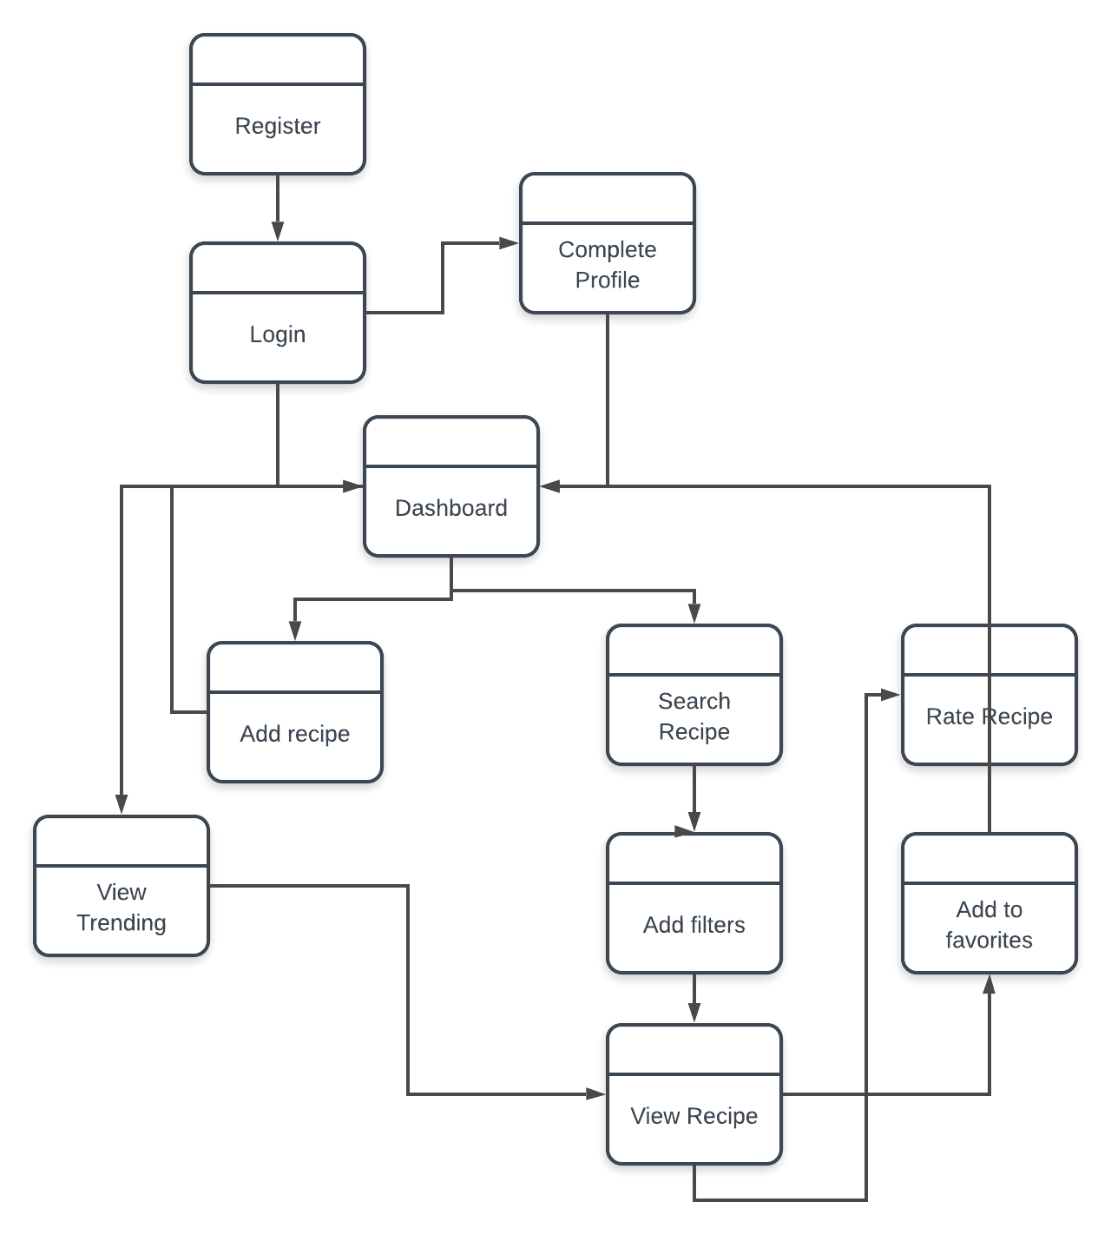

### 

### 

## **Modules**

1. Sign up:

This will be the view where a user signs up for a new account on the website

2. Login:

This module allows the registered and verified users to login.

3. View Saved Recipes:

This module views recipes saved by the user for later reference

4. Search Recipe:

This module helps the user search for required recipes by adding filters

5. Trending:

This module showcases all recipes based on user searches in the past and his filter setting patterns.

6. Profile:

Displays user progress on the website including views on recipes, customer reviews, etc.

7. User Reviews:

After the upload of each recipe, the user can give his/her review based on the dish for reference of the other users.

# 

# 

# 

# **Conclusion**

From the above data, the effectiveness and the working capacity of this project can be seen and approached. The project can be seen as one of the helping tools for society. The implementation of this project in society can be a helping tool, especially for the bachelors. Also, it will teach them how to make their own meals by consuming less time. Hence an effective way to get recipes in the easiest of ways.