VISUAL AND IMPLEMENTATION HANDOFF
Deep Research Streamlit
UI Design Handoff
A four-state editorial research workspace designed in UX Pilot

Document | Authoritative implementation source of truth
Product | Deep Research
Frontend target | Streamlit
Design tool | UX Pilot
Selected direction | Editorial Research Canvas
Document purpose | Visual and implementation handoff
Prepared | September 8, 2026

Contains embedded final UX Pilot screens, exact tokens, state behavior, Streamlit mapping, and review criteria.

1. Executive Design Summary
CHOSEN DIRECTION Editorial Research Canvas: a narrow session sidebar, an editorial main canvas, and a quiet details rail. The question and completed report remain visually dominant; observability is available one level deeper.
The product is organized as Question -> Investigation -> Answer. The shell remains stable while the central canvas changes from a focused form, to calm research progress, to a readable long-form report. This continuity reduces context switching and makes the final report feel like the natural result of the running workflow.
- Progressive disclosure keeps current activity, real progress, the active subject, and problems visible while hiding technical detail by default.
- Session history is split between fast recent access in the sidebar and a complete searchable history view in the main canvas.
- The running state communicates agent, subtopic, current action, and macro iteration through typography and a restrained progress treatment rather than KPI cards.
- The completed state gives the report a comfortable reading width; credibility, fact checking, traces, tokens, paths, limitations, and errors remain secondary.
- The design maps directly to Streamlit containers, columns, forms, status elements, progress indicators, metrics, expanders, Markdown, links, fragments, and session state.
STREAMLIT FIT No screen requires custom JavaScript, draggable surfaces, hover-only controls, animated graphs, bespoke routing, or dense custom data-grid behavior.

2. Global Visual System

Visual character
Calm, precise, scholarly, and operational without appearing administrative. The interface uses typography, spacing, alignment, and dividers before surface boxes. The palette is intentionally narrow and semantic.
Area | Specification | Implementation guidance
UI type | Source Sans 3 or Inter; 15-16px body | Use Streamlit's sans default when external fonts are unavailable.
Editorial type | Source Serif 4; 36-42px page/report titles | Fallback to Georgia for the research question and report headings.
Heading ladder | H1 36-42px; H2 24-28px; H3 19-22px | Maintain semantic Markdown heading order.
Labels | 12-13px, semibold, restrained uppercase | Use for section labels only; never for paragraphs.
Reading width | Approximately 720-820px | Target 65-75 characters per report line.
Main padding | 32-48px desktop | Reduce modestly on narrow screens; never crowd the report.
Spacing | 8px base; 16px groups; 24-32px sections; 40-48px majors | Use one consistent scale across states.
Radius | 6-8px | Reserve rounded borders for inputs, buttons, active rows, and status containers.
Borders | 1px #DCE2DF | Prefer dividers; avoid outlining every section.
Shadows | None by default | A faint native elevation is acceptable only for transient Streamlit elements.
Background | #FCFCFA / #FAFAF7 | Keep the report on the base surface, not inside a card.

Color semantics
- Deep teal is reserved for the primary action and active research state.
- Sage green communicates completion or verified success.
- Amber communicates limitations and iteration limits, never generic information.
- Red is reserved for execution failure or contradicted evidence.
- Every semantic color is paired with an explicit text label and a shape or icon.

3. Global Layout and Navigation
Region | Desktop behavior | Responsive behavior
Sidebar | Persistent 240-270px region with identity, New research, five recent sessions, and Session history. | May collapse using Streamlit's native sidebar control; never becomes a floating drawer.
Main canvas | Fluid editorial surface with a practical maximum around 1120px. | Uses available width; preserves readable inner content widths.
Document column | Approximately 720-820px for form, progress, and report content. | Becomes the full main width with 20-24px side padding.
Details rail | Approximately 220-260px on running and completed screens. | Stacks below primary content when two columns become cramped.
Header | Question or state title remains at the top of the main canvas. | Wraps naturally; no sticky custom header required.

Navigation model
- New research and Session history are sidebar actions that update the active view in session state.
- Recent sessions are direct shortcuts; completed sessions open in the report-reading state.
- The current session remains first in the sidebar and carries an explicit status word.
- Primary navigation does not use tabs. Tabs may be introduced only inside a future evidence appendix if user testing demonstrates a need.
- Historical sessions render from stored state and must never appear live merely because a prior event said running.
PERSISTENT RELATIONSHIP The sidebar answers where the user is; the main canvas answers what the research is doing or what it concluded.

4. Screen 1 - New Research
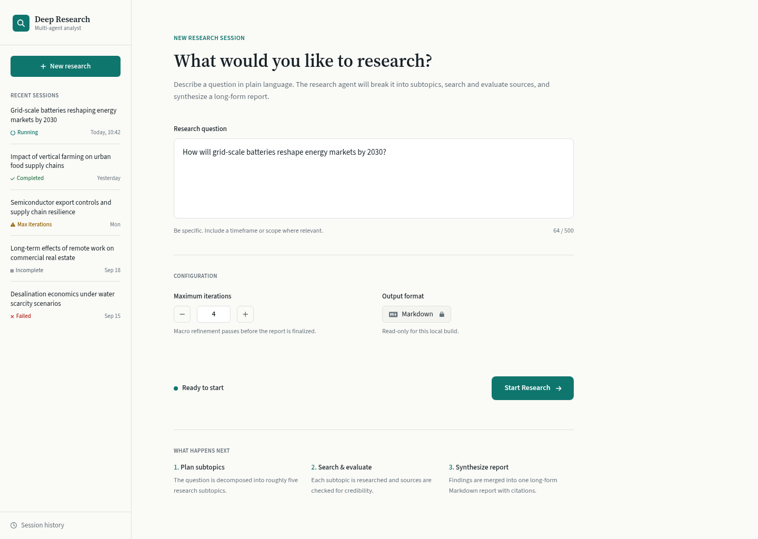
Figure 1. New Research - final UX Pilot design.

Numbered screenshot callouts
# | Region | Implementation intent
1 | Left sidebar | Persistent product identity, New research action, recent session status, and history entry point.
2 | Research question | Dominant large textarea; the screen's primary focus and first keyboard destination.
3 | Configuration | Maximum iterations and read-only Markdown format remain compact and subordinate.
4 | Ready status | Neutral state communicates that the form is valid without competing with the action.
5 | Start Research | Single prominent teal primary action aligned to the form's conclusion.

Purpose
Enable a user to define one meaningful research question and launch a session with the minimum necessary configuration.

Layout
- Begin with a small New research session label, then the serif question-oriented heading.
- Place the explanatory sentence directly beneath the heading, followed by the large textarea.
- Separate configuration with a divider; place maximum iterations and output format in two columns.
- Place Ready to start and Start Research on one final action row.
- Use the three-step What happens next explanation only as quiet reassurance; it must remain below the primary form.

Components
- ResearchQuestionInput: large multi-line input with helper text and a character count when enforced.
- MaxIterationsControl: compact numeric input with a bounded, documented range.
- OutputFormatIndicator: read-only Markdown indicator; do not present a disabled-looking selector if there is no choice.
- SessionStatus: neutral Ready to start message or field-level validation summary.
- StartResearchButton: the only primary action.
- RecentSessionItem: wrapped question, status text/icon, and relative date.

Interaction
- Disable Start Research only while the question is blank, invalid, or being submitted.
- Submit the question and iteration limit as one form transaction.
- On success, create the local session immediately and transition to Research Running.
- On failure, preserve the question and show the error adjacent to the action area.
- Selecting a recent completed session opens the completed report; selecting a nonterminal session opens its retained state.

Visual Details
- Question field occupies roughly the full 720-820px content column and approximately 140-170px height.
- Configuration labels are smaller and muted; the Start action carries the strongest color.
- Use dividers rather than cards to separate form phases.
- The inactive state uses text plus a small teal dot; validation errors use red text and an error icon.

Streamlit Mapping
- Use st.form with st.text_area, st.number_input, and st.form_submit_button.
- Render Markdown as plain read-only text or a disabled input only if the disabled style remains legible.
- Use st.sidebar for navigation and recent sessions.
- Use st.session_state to preserve the draft and selected session.
- Use minimal CSS only for maximum content width, heading typography, and compact status labels.

5. Screen 2 - Research Running
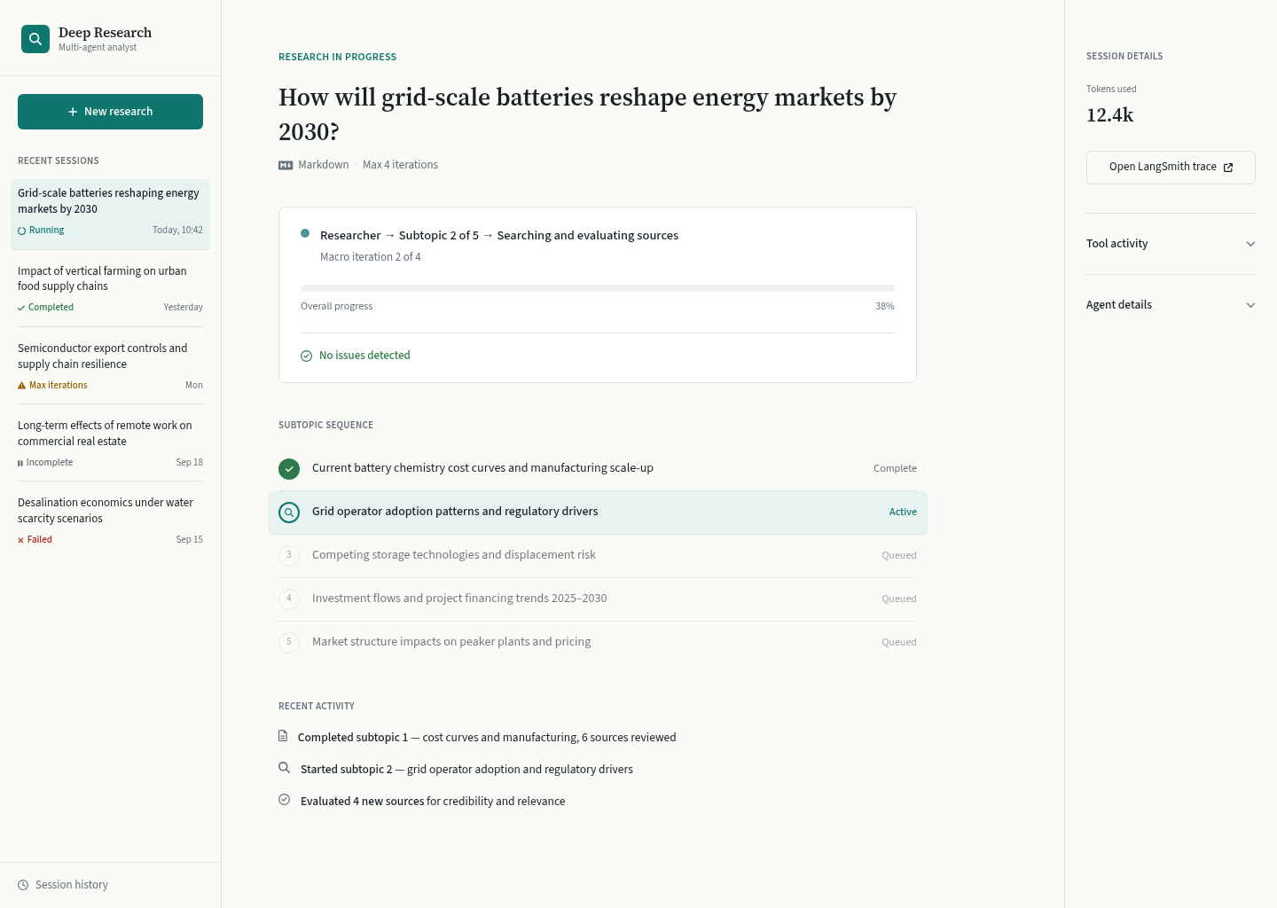
Figure 2. Research Running - final UX Pilot design.

Numbered screenshot callouts
# | Region | Implementation intent
1 | Selected session | Pale teal sidebar row identifies the current live session without a separate navigation system.
2 | Question header | The research question remains identifiable and anchors the run.
3 | Current activity | Primary sentence: Researcher -> Subtopic 2 of 5 -> Searching and evaluating sources.
4 | Progress and health | Macro iteration, truthful progress, and No issues detected answer the essential status questions.
5 | Subtopic sequence | One complete, one active, and remaining queued items make the research scope tangible.
6 | Recent activity | Exactly three plain-language summaries avoid console-like noise.
7 | Details rail | Tokens, trace, tool activity, and agent details remain secondary and progressively disclosed.

Purpose
Explain meaningful progress during a potentially long-running workflow while keeping the page visually stable and free of raw orchestration noise.

Current Agent Treatment
The current agent is the first bold phrase in the main activity sentence. It is not an avatar, character, or metric card. The active state is reinforced by a teal dot and the Research in progress label.

Macro Iteration Treatment
Macro iteration appears as smaller contextual text directly under the current activity sentence: Macro iteration 2 of 4. It communicates the outer loop without competing with the active subtopic.

Subtopic Progress
Show Subtopic 2 of 5 in the primary activity sentence and show the descriptive active topic in the sequence below. Completed, active, and queued states use distinct text labels, shapes, and restrained color.

Progress Visualization
- Use a single horizontal progress bar only when a truthful overall or current-phase value exists.
- Label heuristic progress as Estimated. If no defensible percentage exists, omit the percentage and retain iteration/subtopic counts.
- Do not show an ETA unless the backend supplies one with acceptable reliability.
- Keep the progress region in a fixed location so periodic updates do not move the rest of the page.

Recent Research Activity
Show the three newest meaningful summaries. Prefer verbs and research objects: completed a subtopic, began a subtopic, evaluated sources. Relative time may appear only when useful.

Tool-Call Summaries
The collapsed Tool activity expander may show additional summaries such as Searched IEA outlook, Reviewed four reports, or Extracted cost ranges. Never surface tool function names, raw arguments, unabridged outputs, or JSON by default.

Token Usage
Show one compact total such as 12.4k tokens. Hide the metric entirely when unavailable; never display zero as a substitute for missing telemetry.

LangSmith Trace
Use a clearly labeled Open LangSmith trace link button. Render it only when a valid trace URL exists.

Progressive Disclosure
Keep the primary run narrative in the main canvas. Place tool and agent details in collapsed expanders in the right rail. Nonfatal issues may appear as a compact warning line with a count and details expander.

Information Hidden by Default
- Raw LangGraph events, event payloads, node IDs, run IDs, span IDs, and serialized state.
- Tool arguments, full tool responses, raw prompts, full model messages, and provider configuration.
- Stack traces, retry internals, per-agent token tables, and every event timestamp.
- Full source lists before a report exists and any unsupported progress or ETA estimate.

Transition Behavior
- Update only the live fragment as events arrive; retain question, sidebar selection, and expanded-detail state.
- When work completes, update the sidebar status, replace the run status with a restrained completion banner, and render the report in the same main canvas.
- On failure, retain the last agent, iteration, subtopic, and activity so the user understands where execution stopped.
- On max iterations, use amber and state whether a report or partial report was produced; do not style it as a crash.

Streamlit Mapping
- st.status for the active narrative and st.progress for a defensible numeric value.
- st.container for the subtopic sequence and recent activity rows.
- st.columns([3, 1]) for main content and details rail.
- st.metric for the single compact token total.
- st.expander for Tool activity and Agent details; st.link_button for LangSmith.
- @st.fragment(run_every="2s") for the changing region; avoid full-page polling reruns.

6. Screen 3 - Research Completed
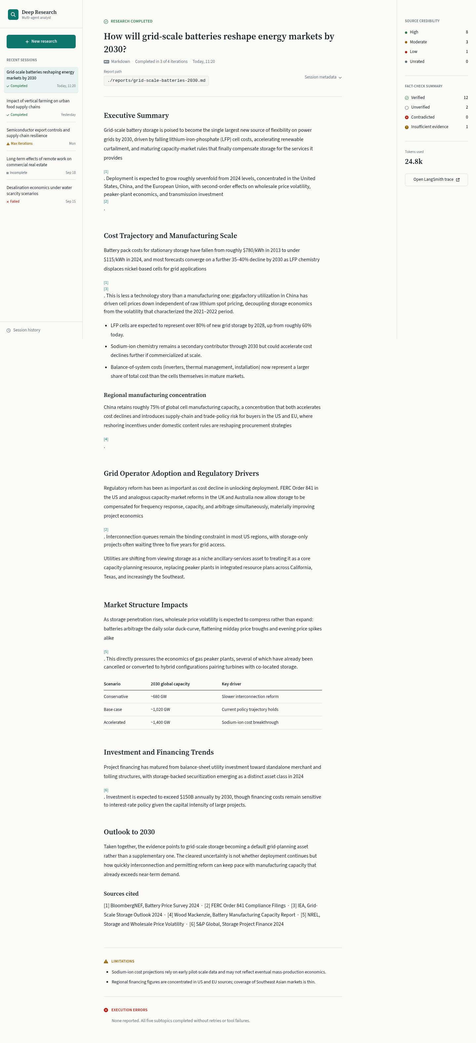
Figure 3A. Research Completed - header, metadata, quality summary, and report opening.


Figure 3B. Research Completed - long-form report reading area and scenario table.


Figure 3C. Research Completed - report conclusion, sources, limitations, and execution errors.

Numbered screenshot callouts
# | Region | Implementation intent
1 | Completed header (3A) | Preserves the question, terminal state, completion metadata, and report path.
2 | Report canvas (3A-3C) | Dominant editorial reading column with serif headings and comfortable line length.
3 | Credibility summary (3A) | Compact High, Moderate, Low, and Unrated counts; no unexplained score.
4 | Fact-check summary (3A) | Verified, Unverified, Contradicted, and Insufficient evidence use text and icon/color.
5 | Observability (3A) | Tokens and LangSmith link remain in the secondary rail.
6 | Scenario table (3B) | A compact evidence table stays within the report flow rather than becoming a dashboard.
7 | Sources cited (3C) | Readable source list follows the report body.
8 | Limitations (3C) | Amber editorial caveats describe evidence boundaries.
9 | Execution errors (3C) | Red operational treatment is separate even when the result is No errors reported.

Report Reading Experience
The report is the completed state's primary object. It begins immediately below restrained completion metadata and remains on the base surface. No tab, card, or dashboard tile encloses it.

Report Width
Target approximately 720-820px on desktop, producing 65-75 characters per line. The supporting rail must not reduce the report below a comfortable width; stack the rail below when necessary.

Typography
- Research question and report headings use Source Serif 4 or Georgia fallback.
- Body text uses Source Sans 3, Inter, or Streamlit's default sans at 15-16px with 1.55-1.7 line height.
- Markdown headings retain a clear semantic ladder; citations are teal links with visible focus states.
- Tables use compact but readable 13-14px text and lightweight rules.

Completion Status
Use a small green completion label and explicit text. If the report completed before the configured maximum, show Completed in 3 of 4 iterations as neutral metadata rather than as a progress warning.

Source Credibility
Summarize High, Moderate, Low, and Unrated counts, followed by one sentence explaining the distribution. The expanded source detail should include source, credibility tier, rationale, report section, and corroboration state.

Fact-Check Summary
Use Verified, Unverified, Contradicted, and Insufficient evidence. The expanded claim list contains the claim, verdict, concise rationale, and supporting sources. Do not reduce credibility or fact checking to an opaque overall score.

Limitations
Limitations are epistemic caveats such as regional coverage gaps, conflicting evidence, or immature projections. Use neutral or amber treatment and place them after the report and sources.

Execution Errors
Execution errors are tool, provider, parsing, or output failures. Use red only for actual errors, state their effect, and make diagnostics available in an expander. When none occurred, use a quiet plain-language confirmation.

Trace Link, Report Path, Tokens, and Metadata
- Place the selectable report path below the header or inside Session metadata; use code formatting.
- Keep total token usage and the trace link in the right rail.
- Keep session ID, start/completion times, configured limit, actual iteration count, and terminal status in a collapsed Session metadata expander.
- Hide unavailable token and trace elements rather than showing empty interface shells.

Progressive Disclosure and Navigation
The report and compact quality summaries are immediately visible. Detailed sources, claims, metadata, and diagnostics are one level deeper. New research and historical-session navigation remain in the sidebar.

Streamlit Mapping
- st.markdown for the report and heading hierarchy.
- st.columns([3, 1]) for report and quality rail, with a stacked fallback.
- Small st.metric values for quality counts and tokens; avoid metric grids.
- st.expander for source details, fact-check claims, errors, and session metadata.
- st.warning for limitations, st.error for real execution failures, and st.link_button for the trace.
- st.code(report_path, language=None) for the selectable file path.

7. Screen 4 - Session History
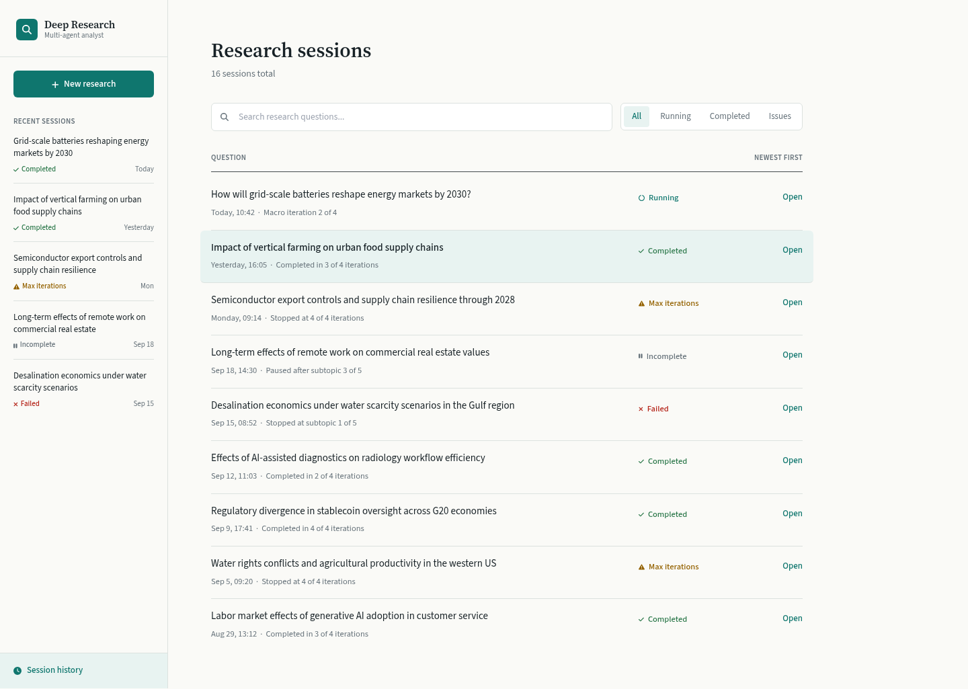
Figure 4. Session History - final UX Pilot design.

Numbered screenshot callouts
# | Region | Implementation intent
1 | Sidebar | Recent sessions remain available while the full archive occupies the main canvas.
2 | Search | Filters wrapped question text without converting the archive into a dense table.
3 | Status filter | Compact All, Running, Completed, and Issues views; Issues groups exceptional terminal states.
4 | Session row | Question leads; date, iteration context, explicit status, and Open action follow.
5 | Selected row | One pale teal row identifies the current selection without card styling.
6 | Terminal statuses | Running, Completed, Max iterations, Incomplete, and Failed remain textually distinct.

Purpose
Allow fast scanning and reopening of local research sessions while preserving the editorial character of the product.

Layout
- Use the main heading Research sessions and a small total count.
- Place search and compact status filtering on one row where width permits.
- Show newest-first ordering as a quiet label or select control.
- Render sessions as grouped rows separated by rules; do not use a dashboard card grid or database-like data table.

Session Item Structure
Each row contains a wrapping research question, date/time, useful iteration or interruption context, explicit status, and one Open action. The question is visually strongest.

Status Presentation
- Running: teal ring/dot plus Running.
- Completed: green check plus Completed.
- Max iterations reached: amber warning shape plus Max iterations.
- Incomplete: neutral pause shape plus Incomplete.
- Failed: red cross/error shape plus Failed.

Ordering and Selection
Default to newest first. Preserve search and filter values in session state. Use a single pale teal selected-row tint and do not rely on it as the only selected-state cue.

Completed and Failed Sessions
A completed session opens directly into the report-reading experience. A failed or incomplete session opens a retained progress summary with the stopping point and actionable error; a partial report is clearly labeled when available.

Navigation to Report
The Open action changes the selected session and renders its terminal state in the same application shell. Do not open a second browser route unless the application later adopts Streamlit's native multipage navigation.

Streamlit Mapping
- st.text_input for search and st.selectbox or st.segmented_control for status filtering.
- st.container and st.columns for each row; st.divider for lightweight separation.
- st.button with stable session-specific keys for Open actions.
- st.session_state for selected session, search query, filter, and ordering.
- Avoid st.dataframe as the primary archive because long questions need wrapping and row-level actions.

8. Detailed Screenshot Annotations
The numbered callout tables immediately below Figures 1-4 are the authoritative annotations. The consolidated map below identifies which implementation concerns are visually demonstrated by each screen.
Region | Screen evidence | Implementation significance
Primary action | Figure 1, callout 5 | Only Start Research receives primary filled-button emphasis.
Session navigation | Figures 1-4, sidebar callouts | One persistent sidebar supplies recent and full-history access.
Research status | Figure 2, callout 3 | Plain-language activity sentence outranks internal workflow terminology.
Current agent | Figure 2, callout 3 | Agent is integrated into status text, not represented as a persona.
Progress | Figure 2, callouts 4-5 | Macro iteration, progress bar, health, and subtopic sequence have distinct roles.
Activity summary | Figure 2, callout 6 | Three rows by default maintain calm density.
Observability | Figures 2-3, right rail | Tokens, trace, and technical expanders are visually secondary.
Report area | Figures 3A-3C, callout 2 | The central reading column dominates the completed state.
Credibility | Figure 3A, callout 3 | Counts and labels provide a compact trustworthiness overview.
Fact checking | Figure 3A, callout 4 | Verdicts use explicit language plus shape/color.

9. Component Inventory
Component | Used On | Purpose | Visual Treatment | Interaction | Streamlit Mapping
AppShell | All | Stable sidebar/main/rail frame | Warm base, hairline dividers | Changes active session view | st.sidebar, st.columns, st.container
ResearchQuestionInput | New | Capture the research question | Large textarea, dominant width | Validates and preserves draft | st.form, st.text_area
RunConfiguration | New; Running metadata | Set iteration limit and show format | Compact two-column group | Iterations editable only before run | st.number_input, st.caption/disabled input
StartResearchButton | New | Launch one session | Single filled teal action | Creates session and enters starting state | st.form_submit_button
SessionStatus | All | Communicate lifecycle state | Text + icon/shape + semantic color | Updates as state changes | st.status or styled container
AgentStatus | Running | Explain who is working and what they are doing | Bold leading phrase in activity sentence | Live fragment update | st.status, st.markdown
IterationProgress | Running | Show outer-loop position | Secondary metadata | Updates when macro iteration changes | st.caption, st.progress when truthful
SubtopicSequence | Running | Show research scope and current subtopic | Lightweight rows; one active tint | Active row changes; detail optional | st.container, st.expander
RecentActivity | Running | Summarize meaningful events | Three icon/text rows | Newest meaningful events replace older rows | st.container, st.markdown
ToolActivity | Running | Expose deeper tool summaries | Collapsed secondary disclosure | Expands on demand | st.expander
TokenUsage | Running; Completed | Show optional cost/volume signal | One compact value in rail | Hidden when unavailable | st.metric
TraceLink | Running; Completed | Open LangSmith detail | Secondary outlined link | External navigation | st.link_button
ReportViewer | Completed | Render final answer | Dominant editorial column | Native link and selection behavior | st.markdown
CredibilitySummary | Completed | Summarize source quality | Four labeled counts | Details expand below | st.metric/columns, st.expander
FactCheckSummary | Completed | Summarize claim verdicts | Four explicit verdict rows | Claim details expand | st.container, st.expander
LimitationsCallout | Completed; Partial | Explain evidence boundaries | Amber/neutral section | Always open when present | st.warning or styled container
ErrorCallout | Failed; Completed | Explain operational failures | Red only for actual errors | Diagnostics expand | st.error, st.expander
SessionHistoryItem | Sidebar; History | Identify and reopen a session | Wrapped question, metadata, explicit status | Selects session | st.container, st.button

10. UI State Matrix
State | Primary UI Change | Status Treatment | Available Actions | Secondary Details
Idle | New Research form is ready | Neutral Ready to start | Enter question; set iterations; start | Recent sessions remain available
Invalid form | Field-level validation appears; start disabled | Red text/icon at affected field | Correct input | Preserve all valid values
Starting | Form becomes read-only; status replaces action emphasis | Teal Preparing research plan | No duplicate submit | Create local session immediately
Running | Running canvas replaces form | Teal Research in progress | Inspect summary or secondary details | Sidebar session moves to top
Waiting for progress | Stable status region with no false percentage | Working; waiting for next update | Open trace if available | Keep last meaningful activity
Active progress | Agent/action, iteration, subtopic, sequence update | Teal active state + explicit labels | Expand active subtopic or tools | Refresh only live fragment
Completed | Rendered report replaces progress content | Green Research completed | Read report; inspect evidence; start new | Quality and metadata remain secondary
Max iterations reached | Report or partial report stays readable | Amber Max iterations | Read result; inspect limitation; start new | State that limit ended the run
Incomplete | Retained progress summary opens | Neutral Incomplete | Review stopping point; reopen history | Never imply live execution
Failed | Last progress plus actionable error | Red Failed | Inspect error; start new | Partial report shown only when available
Configuration error | Form remains with configuration message | Red Configuration error | Correct local configuration | Do not expose secrets or raw provider config
Token usage unavailable | Token element is omitted | Element omitted entirely | None | Other observability unaffected
LangSmith trace unavailable | Trace action is omitted | Element omitted entirely | None | Do not render disabled dead links
Partial report available | Clearly labeled partial report becomes readable | Amber Partial report | Read partial result; inspect cause | Errors and limitations remain separate

11. Progressive Disclosure Specification

Always Visible
- Research question or completed report title.
- Explicit session state.
- Meaningful current activity while running.
- Real iteration/subtopic progress that the backend can support.
- Whether a material problem exists.
- Final report when available.

Contextually Visible
- Subtopic sequence and three recent activities while running.
- Source credibility and fact-check summaries after completion.
- Limitations when the research has evidence boundaries.
- A partial-report label when execution ends before full synthesis.
- Actionable nonfatal issue count when an issue affects the result.

Hidden Behind Expander / Secondary Details
- Summarized tool activity beyond the three visible events.
- Agent details and internal stage descriptions.
- Token usage, LangSmith trace, report path, and session metadata.
- Per-source credibility rationale and corroboration.
- Per-claim fact-check rationale and supporting sources.
- Actionable diagnostic details for execution errors.

Never Show in Primary UI
- Raw events, serialized graph state, node IDs, span IDs, run IDs, raw prompts, or model messages.
- Tool function names, arguments, unabridged outputs, provider details, retry internals, or stack traces.
- Per-agent token tables, unsupported completion percentages, speculative ETAs, or empty telemetry shells.
- Secret values, API keys, environment variables, or local configuration contents.

12. Streamlit Implementation Mapping
Design Element | Streamlit Primitive | Role | Custom CSS Requirement
Application shell | st.sidebar; st.container; st.columns | Sidebar + main + optional details rail | Max-width and subtle divider colors only
View navigation | st.button or native navigation + session state | New, active session, completed session, history | Compact selected status label
Research form | st.form; st.text_area; st.number_input | Atomic validation and submit | Textarea height and editorial heading font
Output format | st.caption or read-only st.text_input | Display Markdown only | Optional compact read-only styling
Run status | st.status; st.progress; st.markdown | Agent -> subtopic -> action hierarchy | Typography inside status container
Live updates | @st.fragment(run_every="2s") | Refresh progress without page churn | None; preserve focus and expansion state
Subtopic sequence | st.container; st.columns; st.expander | Complete/active/queued rows | Small status label and active-row tint
Recent activity | st.container; st.markdown | Three understandable rows | Tighter row spacing if defaults are too loose
Observability rail | st.columns; st.metric; st.expander | Tokens and technical detail | Rail divider and compact metadata labels
Trace action | st.link_button | Open valid LangSmith URL | No custom behavior
Report | st.markdown | Render long-form Markdown | Serif headings, line length, paragraph rhythm, table rules
Quality summaries | st.columns; st.metric; st.container | Credibility and fact-check counts | Semantic label colors; no charts
Limitations | st.warning or styled container | Evidence caveats | Muted amber treatment if native warning is too strong
Errors | st.error; st.expander | Operational failure + diagnostics | Use native red semantics
Report path | st.code(language=None) | Selectable local path | Width/wrapping only if necessary
History | st.text_input; st.selectbox/segmented_control; rows | Search, filter, select sessions | Selected-row tint and compact status words
Session persistence | st.session_state | Selected view, draft, filters, expanded items | None

CSS BOUNDARY Custom CSS is limited to typography, content width, spacing rhythm, hairline borders, active-row tint, and compact semantic labels. No custom JavaScript is recommended or permitted by this specification.

13. Exact Visual Tokens
Token | Value | Usage
color.background | #FCFCFA | Base app and report surface
color.surface | #F5F7F6 | Secondary grouped areas
color.text | #172126 | Primary text
color.textMuted | #66727A | Metadata and supporting labels
color.border | #DCE2DF | Dividers and input borders
color.active | #0F6F68 | Primary action and active research
color.activeTint | #E8F3F1 | Selected and active row background
color.success | #2F7A4D | Completed and verified
color.successTint | #EAF4ED | Quiet success background
color.warning | #946200 | Limitations and max iterations
color.warningTint | #FFF4D6 | Limitations background
color.error | #B42318 | Failures and contradicted evidence
color.errorTint | #FDECEA | Error background
space.1 / 2 / 3 | 4px / 8px / 12px | Micro spacing and compact control gaps
space.4 / 6 / 8 | 16px / 24px / 32px | Groups and sections
space.10 / 12 | 40px / 48px | Major content transitions
radius.control | 6px | Inputs and compact controls
radius.container | 8px | Active status and selected row
border.default | 1px solid #DCE2DF | Rules, inputs, understated containers
shadow.default | none | No routine elevation
width.sidebar | 240-270px | Persistent desktop sidebar
width.detailsRail | 220-260px | Secondary running/completed details
width.report | 720-820px | Long-form reading column
type.body | 15-16px / 1.55 | UI and report body
type.label | 12-13px / 600 | Section labels and compact metadata
type.h3 | 19-22px / 600 | Report subheading
type.h2 | 24-28px / 600 | Major report section
type.h1 | 36-42px / 600 | Question and report title
weight.regular | 400 | Body copy
weight.medium | 500 | Controls and secondary emphasis
weight.semibold | 600 | Headings, labels, current activity

14. Accessibility Requirements
- Meet WCAG 2.2 AA contrast for body text, links, controls, focus indicators, and semantic statuses.
- Pair every status color with an explicit word and an icon or distinct shape.
- Use visible labels for all inputs; hint text may illustrate content but must not replace labels.
- Keep primary buttons at least 44px high and preserve native keyboard activation.
- Preserve Streamlit's visible focus treatment or replace it only with an equally visible focus ring.
- Do not move focus or collapse expanders during fragment refresh.
- Announce material lifecycle changes, not every incoming event; avoid a constantly chattering live region.
- Use semantic Markdown heading order and descriptive link text such as Open LangSmith trace.
- Allow long questions, source names, and report paths to wrap without horizontal scrolling.
- Pair all icons with visible text where meaning is not otherwise obvious.
- Keep report typography at 15-16px minimum with generous line height and restrained line length.
- Ensure detailed source and claim tables retain real headers and keyboard-readable structure.
- Respect reduced-motion preferences by avoiding continuous animation and unnecessary transitions.
- When progress is indeterminate, state the current activity in text instead of presenting a false numeric value.

15. Visual Acceptance Criteria
The GPT-5.6 Luna Max reviewer should compare the implementation directly against Figures 1-4 and apply every check below.

Overall layout fidelity
- Sidebar is narrow and persistent; main canvas remains dominant.
- Running/completed details rail is visibly secondary and stacks when width is constrained.
- No screen has been converted into a centered app card, dashboard grid, or custom routed shell.

Typography and spacing
- Question/report title uses the editorial type treatment and matches the 36-42px hierarchy.
- Body type remains 15-16px with readable line height; report lines stay within 65-75 characters.
- Spacing follows the 8px system and major sections use visibly larger gaps than related controls.
- Borders are hairlines, radii remain 6-8px, and routine shadows are absent.

Color and status
- Teal is used for active research and primary action, green for completion, amber for limitations/iteration limit, and red for actual errors.
- Every status includes text and shape/icon; no meaning depends on color alone.
- Selected session and active subtopic use the pale teal tint consistently.

New Research
- Research question is the dominant control; configuration remains compact.
- Start Research is the only filled primary action and validation is adjacent to the form.
- Markdown reads as a fixed output format rather than an unavailable choice.

Research Running
- The default view immediately communicates current agent, current subtopic, current action, macro iteration, and health.
- No more than three meaningful activities are visible by default.
- Tool details, agent details, tokens, and trace do not compete with the run narrative.
- No false progress percentage or speculative ETA appears.

Research Completed
- Rendered report dominates the state and is not hidden behind a tab or card.
- Credibility and fact-check summaries are compact, explicit, and non-chart-based.
- Limitations use amber/neutral treatment and execution errors use red, in separate sections.
- Trace, tokens, path, and metadata remain secondary but discoverable.

Session History
- Rows prioritize wrapped research questions and explicit status labels.
- Running, Completed, Max iterations, Incomplete, and Failed remain visually and textually distinct.
- History is not implemented as a dense data grid; each row retains a clear Open action.

Streamlit feasibility and consistency
- All interactions use native Streamlit primitives and session-state-driven views.
- Periodic updates are confined to a fragment and do not reset focus or expansion state.
- Custom CSS is limited to the approved boundary; no custom JavaScript is present.
- Typography, spacing, color, sidebar, status, and density remain coherent across all four states.

16. Fixed vs Flexible Design Decisions

Fixed
- Editorial Research Canvas is the primary visual direction.
- Persistent left sidebar for product identity, New research, recent sessions, and history.
- Question -> Investigation -> Answer hierarchy and stable shell across state transitions.
- Research question is dominant on New and Running; report is dominant on Completed.
- Agent -> subtopic -> current action is the primary running-state narrative; macro iteration is secondary.
- Only three recent activity summaries are visible by default.
- Tokens, traces, report paths, tool activity, and agent internals are secondary.
- Report is never hidden behind a tab.
- Credibility and fact-check summaries use explicit labeled counts, not opaque scores.
- Limitations and execution errors are visually and semantically separate.
- Core palette semantics, reading width, spacing hierarchy, and restrained card usage.
- No custom JavaScript, complex animation, draggable interfaces, or React-only patterns.

Flexible
- Pixel-level spacing may shift by approximately 2-4px to align with Streamlit's rendered DOM.
- Source Sans 3/Source Serif 4 may fall back to Streamlit's sans and Georgia when loading custom fonts is undesirable.
- Exact icon glyphs may change if their semantic label and visual weight remain consistent.
- Border radii may vary between 6px and 8px to match native controls.
- The details rail may stack beneath the main content earlier than shown when the report would otherwise become narrow.
- Question wrapping and report pagination naturally vary with viewport and user content.
- A progress bar may be omitted when no defensible numeric progress exists.
- The three-step What happens next explanation on New Research may be shortened if vertical space is limited.

17. Design Assets
ASSET REQUIREMENT No external visual assets are required.
- Preferred UI font: Source Sans 3 or Inter; Streamlit's default sans is an acceptable fallback.
- Preferred editorial font: Source Serif 4; Georgia is an acceptable system fallback.
- Use Streamlit-native or Material-style line icons for search, success, warning, error, trace, document, and history.
- No logo artwork, illustrations, photography, custom SVG set, or animation asset is required.
- The four embedded UX Pilot screenshots are reference images and should not be shipped as application assets.

18. UX Pilot References
These references are supplemental. The embedded screenshots and written specification remain sufficient if the URLs later change or become unavailable.
UX Pilot Project | Screen Name | Screen Identifier | UX Pilot URL | Embedded Source
Deep Research Streamlit UI Design | New Research | c9eFACpl7ceos6JLqFYa | Open UX Pilot page | 01-new-research.png
Deep Research Streamlit UI Design | Research Running | CwwYubFeLj1y4jUu03Ms | Open UX Pilot page | 02-research-running.png
Deep Research Streamlit UI Design | Research Completed | nhLzBmgusdeMgDqXpswm | Open UX Pilot page | 03-research-completed.png
Deep Research Streamlit UI Design | Session History | yvUEXXHhOJ2Psckmy0OZ | Open UX Pilot page | 04-session-history.png

UX Pilot page identifier: tSEwSmTJeFc0zWAa1eqy. All four screen records are marked completed.

19. Implementation Handoff Summary

For GPT-5.6 Luna High Implementer
- Treat Figures 1-4, Sections 4-7, the component inventory, state matrix, Streamlit mapping, and exact visual tokens as authoritative.
- Reproduce the information hierarchy and state behavior before applying polish.
- Use native Streamlit primitives and session-state-driven views; restrict CSS to the boundary defined in Section 12.
- Implement offline/fake-driven UI states first so all states can be reviewed without live providers.
- Do not invent additional navigation, dashboards, controls, metrics, or observability surfaces.
- Where a screenshot conflicts with a written feasibility rule, preserve the written Streamlit rule and the screenshot's hierarchy rather than recreating an impractical interaction.

For GPT-5.6 Luna Max Reviewer
- Judge visual and UX fidelity against Figures 1-4 and the checklist in Section 15.
- Verify the report is dominant after completion and the running state answers what, how far, subject, and problems at a glance.
- Verify tokens, traces, paths, tool details, and agent internals remain secondary.
- Verify limitations and execution errors remain distinct in language, position, and color.
- Verify all state variations in Section 10, including unavailable telemetry and partial results.
- Reject custom JavaScript, dense dashboard substitutions, false progress estimates, raw event logs, and unexplained departures from fixed decisions.
AUTHORITY ORDER 1) Embedded final screen visuals; 2) screen-specific specifications; 3) exact tokens and component/state tables; 4) flexible decisions. Fixed decisions require explicit user approval to change.
This handoff is self-contained. Implementation and review do not require access to the originating conversation, the Product Design workflow, or the UX Pilot project.

