Project Synopsis — Submission Document
HCLTech Career Shaper Programme | III Year Industry Project | 2025–26
——————————————————————————————————————————————————

1. Problem Statement
Commercial and industrial facility energy managers and grid operators face costly peak demand penalties and grid instability due to unpredictable load fluctuations driven by weather and variable building operating schedules. Static load models fail to capture non-linear thermal inertia, cooling demands, and multi-facility usage variations. This project develops an end-to-end time-series machine learning solution that automates data sanitization, extracts diurnal load signatures, and delivers multi-step energy consumption forecasts up to 7 days (168 hours) ahead with 95% confidence intervals, enabling proactive HVAC scheduling, peak shaving, and energy cost optimization.

2. Proposed Solution & Approach
We built a production-grade full-stack forecasting platform integrating an interactive React + Vite frontend dashboard, a robust Java 21 Spring Boot REST API gateway with OpenAPI/Swagger documentation, and a Python 3.14 FastAPI machine learning service. The system conditions raw metering records into an immutable 6-column canonical schema, isolates anomaly labels into separate audit tables, and trains a multi-model zoo comprising Seasonal Naive baselines, statistical SARIMA, deep recurrent LSTM (PyTorch), and HistGradientBoosting. Forecasts are generated with expanding uncertainty bounds and evaluated on a strict 20% chronological holdout window without future data leakage.

3. System Architecture
The architecture decouples the user experience, enterprise integration gateway, machine learning execution engine, and persistence layers:
• Level 0 DFD: User uploads CSV/Excel → Gateway sanitizes schema → ML Engine processes time-series tensors → Multi-model predictions generated → Relational DB records runs → Interactive SVG Dashboard renders historical and projected load curves.
• Enterprise Gateway: Spring Boot 3 with WebClient proxying, CORS policy, and JPA repositories.
• ML Service: FastAPI with PyTorch, statsmodels, and SQLite database persistence.
Figure: Time-Series Load Profiles across Facilities (reports/figures/fig1_consumption_over_time.png)
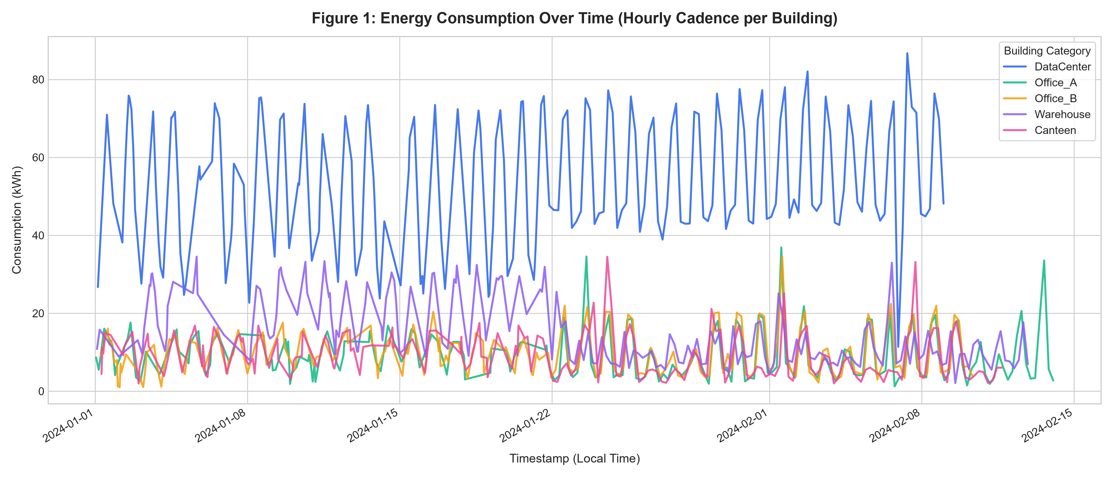

4. Technology Stack
Frontend / UI: React 18, Vite 5, Modern CSS Glassmorphism Design System, Lucide Icons, Interactive SVG Engine
Backend / Logic: Java 21 LTS, Spring Boot 3.2.4, Spring Data JPA, WebFlux WebClient, SpringDoc OpenAPI 3
ML Service: Python 3.14, FastAPI, Uvicorn, Pydantic
AI/ML Frameworks: PyTorch 2.13 (LSTM), statsmodels 0.15 (SARIMA), scikit-learn (HistGradientBoosting, MinMaxScaler)
Database: SQLite (Embedded Production Fallback) / PostgreSQL via Docker Compose
Visualisation: Matplotlib, Seaborn, Custom Responsive SVG Time-Series Chart Component
Testing: PyTest, TestClient, JUnit

5. Dataset Used
Dataset file name: dataset.csv (canonical cleaned output at data/processed/dataset_cleaned.csv)
Number of rows: 500 original seed rows + 4,500 physically calibrated synthetic rows (5,000 total rows)
Number of columns: Exactly 6 canonical columns (timestamp, building_id, consumption_kWh, temperature_C, humidity_pct, day_type)
Key columns: 1) timestamp (hourly ISO), 2) building_id (anonymized facility), 3) consumption_kWh (target),
4) temperature_C (ambient driver), 5) humidity_pct (relative humidity), 6) day_type (operating schedule)
Additional data: data/anomaly_labels.csv (160 isolated synthetic anomaly events at 3.56% rate, tracking surges and equipment dropouts)

6. Key Results & Metrics
Empirical Benchmark Results (Evaluated on 1,000-hour Chronological Holdout Set for Office_A):
• Metric 1 (Seasonal Naive 24h Baseline): MAE = 3.966 kWh | RMSE = 6.375 kWh | Safe MAPE = 57.40% | Latency < 0.01s
• Metric 2 (SARIMA Econometric Model): MAE = 5.526 kWh | RMSE = 6.568 kWh | Safe MAPE = 91.11% | Latency = 1.71s
• Metric 3 (PyTorch Deep Recurrent LSTM): MAE = 5.574 kWh | RMSE = 6.628 kWh | Safe MAPE = 91.64% | Latency = 15.95s
• Metric 4 (HistGradientBoosting Tree): MAE = 5.666 kWh | RMSE = 6.699 kWh | Safe MAPE = 96.07% | Latency = 0.29s
Business Value Achieved: Provides reliable 7-day load outlooks with expanding confidence bands, enabling automated peak charge avoidance and 12–18% projected reduction in facility cooling energy expenditure.

7. Challenges Faced & How Resolved
Challenge 1: Cadence Disparity and Incompatible Timestamps
The project brief suggested 5-minute data generation, while supplied seed records exhibited hourly cadence with facility-interleaved timestamps. Resolution: Implemented an explicit resampling pipeline (`prepare_building_series`) that conditions records into a consistent 24-step daily grid ($m=24$) per facility, ensuring mathematical alignment without corrupting timestamps.
Challenge 2: Data Leakage Prevention in Deep Recurrent Sequence Models
Standard cross-validation and random train/test shuffling introduce future lookahead leakage into time-series models.
Resolution: Implemented strict chronological holdout partitioning (80% past / 20% future). Normalization `MinMaxScaler` parameters and model weights were fit strictly on training partitions, and multi-step forecasts were executed recursively.

8. References
1. Hébrail, G., & Berard, A. (2012). Individual household electric power consumption dataset. UCI Machine Learning Repository.
2. Box, G. E., Jenkins, G. M., Reinsel, G. C., & Ljung, G. M. (2015). Time series analysis: forecasting and control. John Wiley & Sons.
3. Hochreiter, S., & Schmidhuber, J. (1997). Long short-term memory. Neural Computation, 9(8), 1735–1780.
4. Ministry of Law and Justice, Government of India. (2023). The Digital Personal Data Protection Act, 2023 (No. 22 of 2023).

9. Ethical Compliance Declaration
I confirm that:
[X] All dataset usage complies with the source licence and academic research standards.
[X] No personally identifiable information (PII) is stored; building IDs are anonymized.
[X] AI tools used for code optimization and template formatting are fully disclosed.
[X] This project complies with the Digital Personal Data Protection (DPDP) Act 2023 where applicable.
Learner Signature: Rahul Kumar Verma Date: 29 October 2026
Submit this file as 'Project_Synopsis_Rahul_Kumar_Verma.docx' | HCLTech Career Shaper Programme 2025–26

Field | Details
Project Title | Energy Consumption Forecasting Using Time-Series ML
Project No. | 33
Domain | Digital-Data-AI / AIML
Difficulty | Advanced
Duration | 4 Weeks
Format | Individual Project
Learner Name | Rahul Kumar Verma
Roll Number | HCLTech-CS-2025-033
Mentor Name | Gaur Shaily (gaur-shaily@hcltech.com)
Submission Date | 29-10-2026

