LandSplit
Offline Land Measurement and Division Web Application
Complete documentation · version of 31 October 2026

1. Overview
LandSplit is a single, standalone HTML file (landsplit.html, about 120 KB). It lets a user draw a plot of land, measure its sides and corner angles, divide it into parcels with straight lines, and read the area of every parcel in many units, including Bihar bigha, katha and dhur. It is written in plain HTML, CSS and JavaScript, needs no server, database, account, API key, external library or installation, and works fully offline in a modern browser on desktop or mobile.
The screen has a vertical toolbar on the left, the drawing canvas in the centre, and a settings and results panel on the right. On phones the layout stacks, with the toolbar scrolling sideways above the canvas. A permanent disclaimer at the bottom says that results are estimates only.

1.1 Feature summary
- Drawing: boundary polygon, rectangle, square and parallelogram tools; or type exact sizes.
- Parallel-line indicators: matching arrow marks and a ∥ badge between parallel lines, shown while you draw and on the finished plot.
- Measurements: every side length, every interior and exterior angle, perimeter and area, updating live while you drag.
- Live angles while drawing: the angle at each corner appears as you place points, with a live angle at the cursor.
- Sides & angles editor: build a polygon by typing side lengths and angles, with live preview; load the current plot back into the editor, change values and update it.
- Locks: lock any side length or corner angle so it stays fixed while the rest of the shape stretches to fit.
- Names: corners are named A, B, C… and sides AB, BC… (or numbers), each with its own show/hide checkbox.
- Division: any number of straight dividing lines, parcels with their own areas, perimeters, sides and angles, and a check that the parcels add up to the whole.
- Units: lengths in m, cm, mm, km, ft, in, yd; areas in m², cm², in², ft², yd², acre, hectare, bigha, katha, dhur and bigha-katha-dhur, with configurable Bihar values.
- Files: save and open JSON project files, automatic browser copy, CSV export, and a print report that can be saved as PDF.

1.2 Screen layout
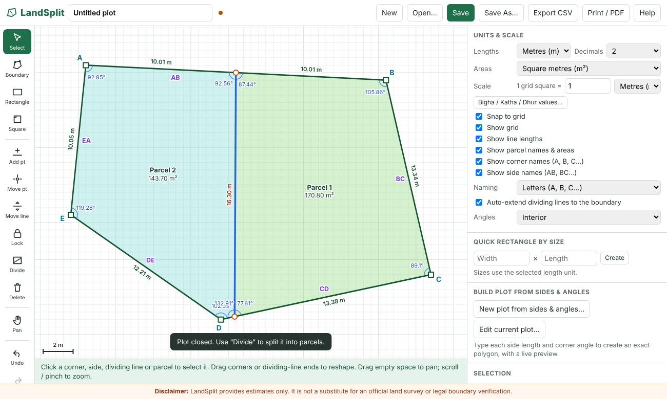
Figure 1 – A plot divided into two parcels, with corner names, side names, lengths and angles

2. Requirements and how each was met
Requirement area | What LandSplit provides
Main requirements | One HTML file; works offline; no dependencies; responsive layout; clean modern interface.
Draw land boundaries | Click-to-draw polygon, rectangle and square tools; automatic closing; select, add, move and delete points; edit corner coordinates, side lengths and corner angles; typed sides & angles editor; on-screen instructions for every tool.
Line length measurements | Length along every side, updated live; total perimeter; scale from "1 grid square = X unit" or from an actual side length; m, cm, mm, km, ft, in and yd.
Angle measurements | Interior angle at every corner with an arc and label; optional exterior angles; correct for irregular and concave plots; angles also shown while drawing.
Divide into parcels | Any number of straight dividing lines; draw, select, move (drag or by exact distance) and delete; parcels labelled Parcel 1, 2, 3 and renamable; per-parcel area, perimeter, side lengths and angles; check that parcel areas add up.
Editing tools | Select, Boundary, Rectangle, Square, Parallelogram, Add point, Move point, Move line, Lock, Divide, Delete, Pan, Undo, Redo, Clear (with confirmation), Zoom in, Zoom out, Reset view.
Parallel lines (added) | Parallel sides and dividing lines are detected automatically and marked with matching arrows and a ∥ badge, live while drawing and afterwards; optional distance between the lines.
Areas and units | m², cm², in², ft², yd², acre, hectare, bigha, katha, dhur and combined bigha-katha-dhur; change at any time; Bihar values configurable.
Save, open, continue | Save and Save As download a JSON project file; Open restores everything (including locks and name settings); warnings before losing unsaved work; automatic browser copy explained as separate from the file.
Export and print | CSV export; print report with drawing and tables; "Save as PDF" through the browser print dialog; summary of original and parcel areas.
Accuracy and validation | Shoelace polygon area; distance formula; vector angles; one consistent scale; self-intersection checks; warnings for divisions that miss the plot; zero-area parcels ignored; rounding that keeps displayed areas consistent.

3. Using the application

3.1 Draw the plot
- Boundary: click each corner. Click the first point again, press Enter or double-click to close the plot. Backspace removes the last point and Esc cancels.
- Rectangle / Square: press and drag on the canvas. Right-angle markers and "90°" show on each corner while you drag, together with the parallel markers.
- Parallelogram: see section 3.3.
- Quick rectangle by size: type a width and length (in the selected length unit) and press Create. A matching row creates a parallelogram from a base, a side and an angle.
- Drawing a new plot over an existing one asks for confirmation and can be undone.

3.2 Live angles while drawing
While the Boundary tool is active, the angle at every placed corner is shown in orange with a small arc. A further live angle follows your cursor at the last placed point, next to the live length of the line you are drawing, so you can aim for an exact angle before clicking. When the cursor reaches the first point, the angle at the closing corner is also shown. The Angles setting (Interior, Exterior, Both, Hidden) controls this display; choose Hidden to switch it off.
While drawing, the angle is the angle between the two lines at a corner (0° to 180°). If a corner later turns out to point inward, its true interior angle (over 180°) appears when the plot is closed.

3.3 Parallelogram tool
The Parallelogram tool (toolbar, shortcut P) builds a parallelogram from three points, so opposite sides are always parallel and equal:
- Press and drag from the first corner to the second (or click the first point, then click the second). This sets the first side.
- Click a third point. It sets the slanted second side and the angle. The fourth corner is calculated for you.
While you move the cursor for the third point, a live preview shows both side lengths, the angles at the first two corners and the parallel markers. Esc cancels. If the three points lie on one straight line, the tool refuses with a message and waits for another point. If a plot already exists, you are asked before it is replaced, and Undo brings it back.
To type exact values instead, use the second row of "Quick rectangle / parallelogram by size": enter the base, the slanted side and the angle between them (0° to 180°, not 0 or 180) and press Create. For example, base 10 m, side 6 m and angle 60° gives angles of 60° and 120° and an area of 51.96 m².
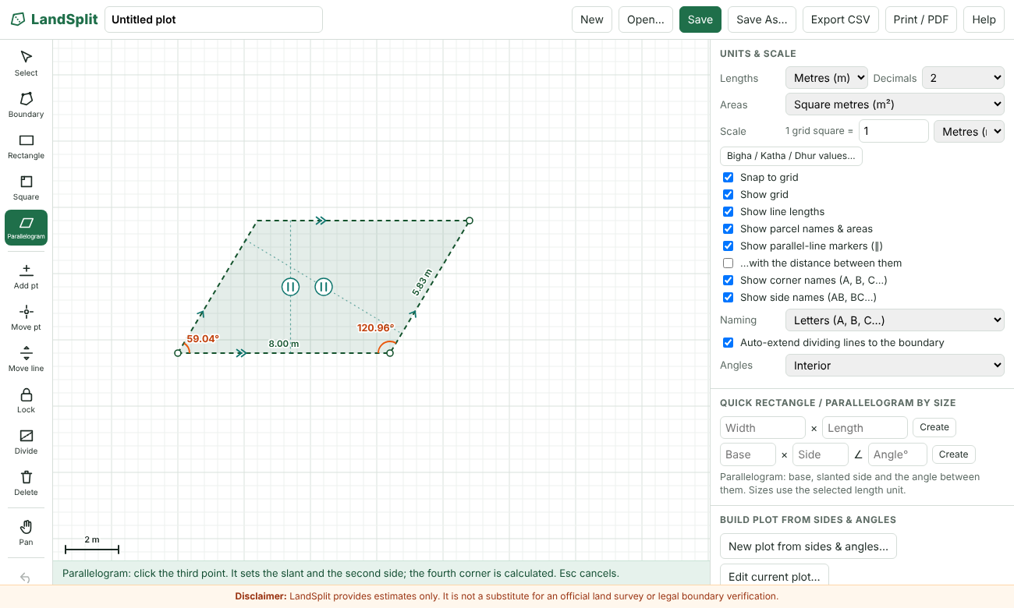
Figure 2 – Drawing a parallelogram: live preview with side lengths, angles and parallel markers

3.4 Parallel-line indicators
LandSplit marks lines that are parallel, in the textbook way:
- Arrow marks: lines with the same direction get matching arrow marks (›). The first group of parallel lines gets one arrow, the second group two (››), the third group three. All lines in a group carry their arrows at the same position and pointing the same way.
- ∥ badge: a small circle with the ∥ symbol, joined by a dotted line, sits between two neighbouring parallel lines that face each other. If a third parallel line lies between two others (for example a dividing line parallel to two sides), only neighbouring pairs get a badge. The badge moves along the dotted line to stay clear of parcel names and areas.
- Distance: tick "…with the distance between them" to show the perpendicular distance between each marked pair (for example 5.20 m between the long sides of a 10 m × 6 m parallelogram at 60°).
- While drawing: the markers appear live as soon as the line you are drawing is parallel to an earlier line. With the Boundary tool a label beside the cursor names the matching side, for example "∥ AB". The Parallelogram, Rectangle and Square tools show the markers on their previews.
- Not counted as parallel: lines that are on the same straight line (for example continuing straight along a side), and lines that differ by more than 0.05° in direction. A line that is only slightly off is therefore never reported as parallel.
- Setting: "Show parallel-line markers (∥)" and "…with the distance between them" are in the settings panel and are saved in the project file.
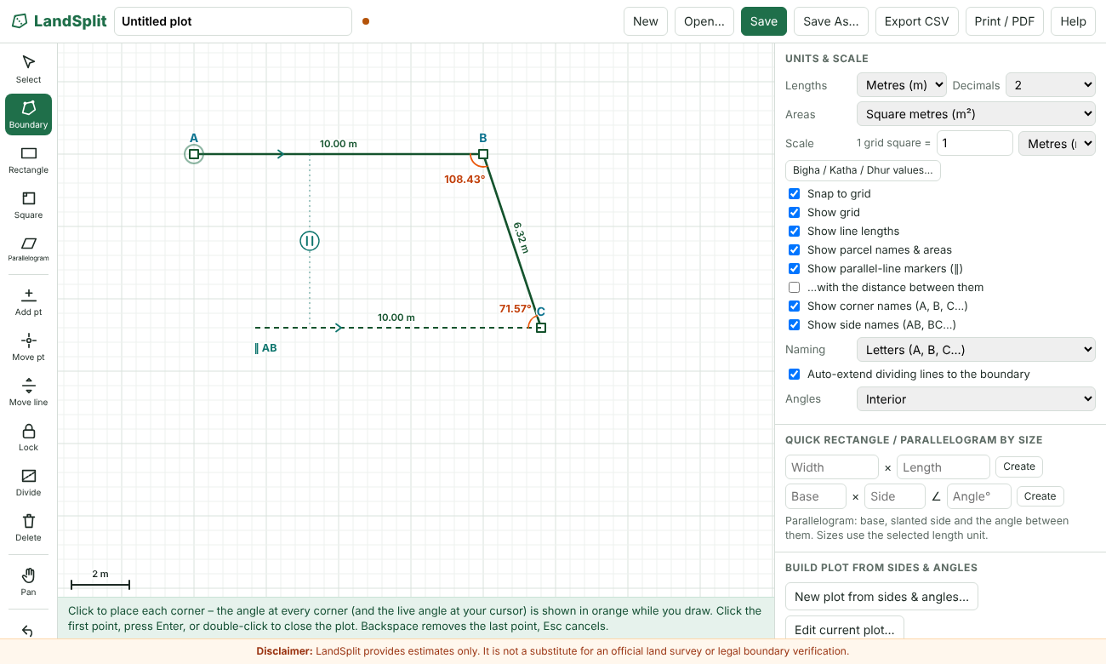
Figure 3 – Drawing a boundary: live angles in orange, and the parallel indicator (∥ AB) as soon as the new side is parallel to AB
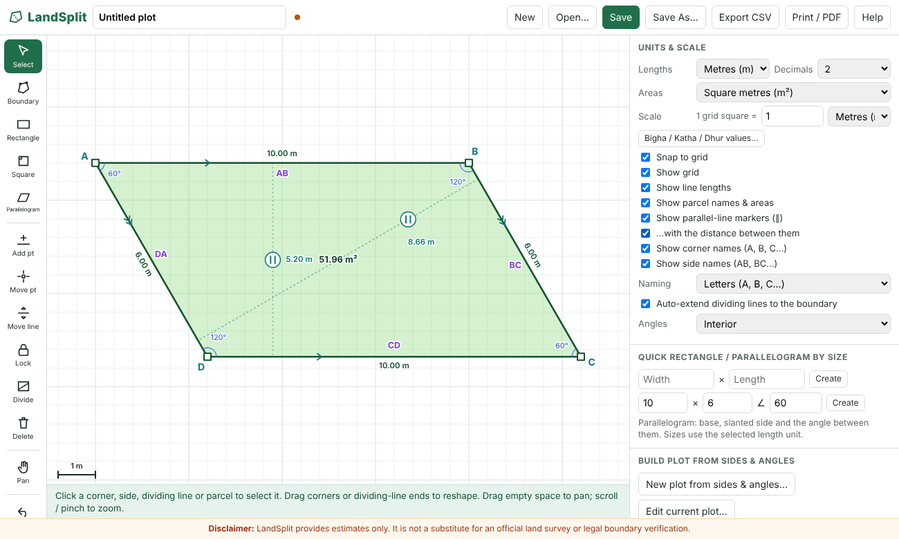
Figure 4 – A finished parallelogram: arrow marks, ∥ badges and the distances between the parallel sides

3.5 Select and edit
- Select: click a corner, side, dividing line or parcel. Drag corners to reshape. Drag empty space to pan; scroll or pinch to zoom.
- Add point: click on a side to insert a corner. Move point: drag a corner. Move line: drag a side, or drag a dividing line sideways.
- Delete: click a corner to remove it, a side to collapse it, or a dividing line to delete it.
- Selected side: type its actual length. "Set – move end corner" or "move start corner" reshapes the plot; "Use as scale reference" keeps the shape and rescales the drawing instead.
- Selected corner: type its X and Y position, or type its interior angle and press Set. Setting an angle rotates the next side around the corner and keeps side lengths.
- Any edit that would make the boundary cross itself is rejected with a message.

3.6 Build a plot from sides and angles
The "New plot from sides & angles…" button opens an editor in which you walk around the plot: enter the length of each side and the interior angle at each corner (the angle inside the plot between the two sides). An n-sided plot needs 2n − 3 measurements, so the last side and the last two angles are calculated for you and shown together with the perimeter and area. A live preview redraws as you type.
- Choose the number of sides (3 to 40). "Make regular" fills in equal sides and equal angles using the length of side 1.
- If the values cannot form a closed plot, for example because the shape crosses itself or the angles point outward, a red message explains why and "Create new plot" is disabled.
- Create new plot places the plot on the canvas at your chosen scale and length unit (after asking before replacing an existing plot).

3.7 Edit the current plot in the sides & angles editor
Press "Edit current plot…" (or "Load current plot" inside the editor) to fill the editor with the real side lengths and interior angles of the plot on the canvas. Change any value, watch the preview, then choose:
- Update current plot: reshapes the plot you have, keeping its first corner where it is and keeping the direction of side 1. When the number of sides is unchanged, dividing lines stay attached to their sides and locks are kept (re-measured on the new shape). If you change the number of sides, dividing lines and locks are removed after a confirmation.
- Create new plot: makes a separate plot from the values instead.
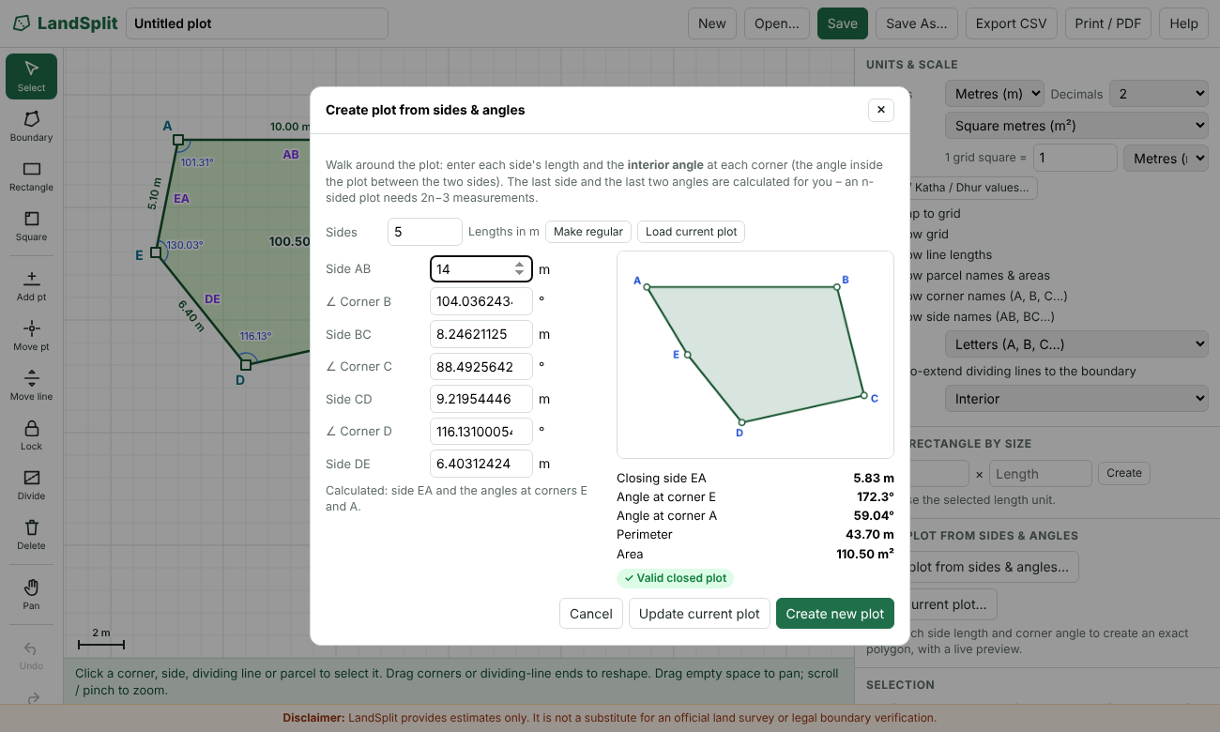
Figure 5 – The sides & angles editor with the current plot loaded and side AB changed to 14 m

3.8 Lock lengths and angles
A locked side length or corner angle stays fixed while you change other things. The unlocked sides and angles stretch to fit. This is useful, for example, when a boundary length and a corner angle are known from a deed and you want to adjust the rest of the shape.
- Lock tool (toolbar, shortcut K): click a side to lock or unlock its length. Click a corner, or its angle label, to lock or unlock that angle. A message confirms what was locked and its value.
- Selection panel: a "Lock this length" or "Lock this angle" tick box appears when a side or corner is selected.
- Locks panel: shows how many sides and angles are locked and offers "Lock all sides", "Lock all angles" and "Unlock all".
- Locked sides and angles are marked with a small lock icon on the canvas.
- Locks hold when you drag a corner, drag a side, type a new side length, type a new angle, or type new corner coordinates. Dragging a corner moves it with the pointer while other corners adjust to keep every lock.
- If a shape is held completely rigid by its locks, dragging a corner moves or turns the whole shape without changing it. If the locks make an edit impossible, a message says so and nothing changes.
- Typing a new value for a locked side or angle is allowed: the lock then keeps the new value.
- Adding or deleting a corner removes the locks (corner numbering changes), with a message. Undo and redo restore locks.
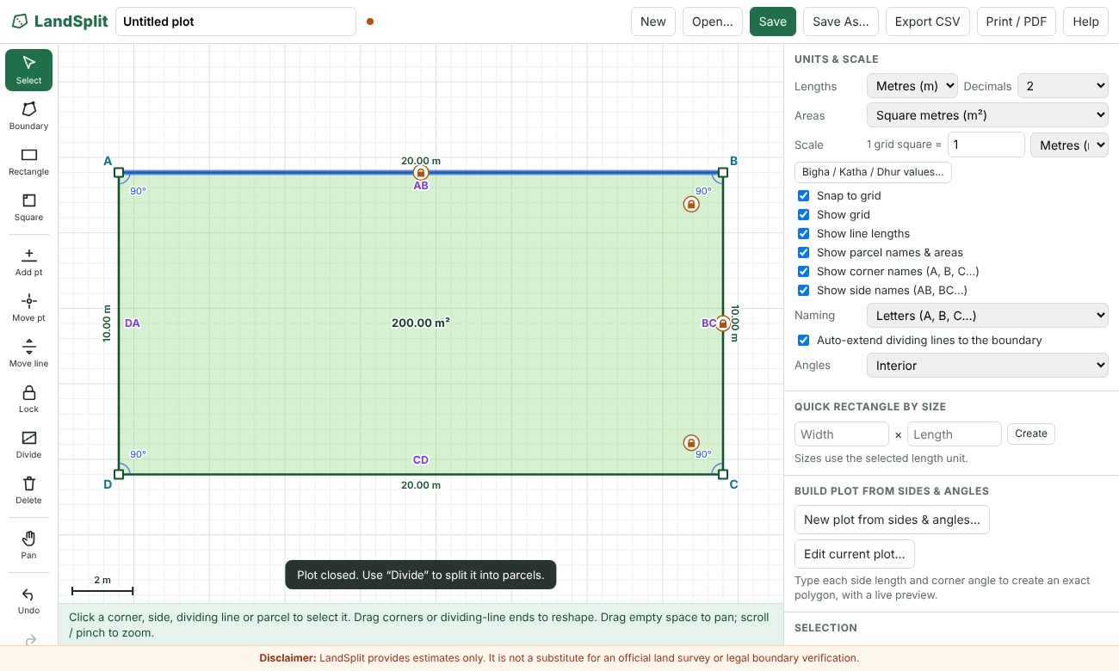
Figure 6 – Side AB, side BC and the angles at B and C locked (lock icons); side AB selected

3.9 Names for corners and sides
Corners are named A, B, C… in drawing order, and each side is named by its two corners (AB, BC … and the closing side, for example DA). Under "Naming" you can switch to numbers (corners 1, 2, 3…, sides 1–2, 2–3…). Plots with more than 26 corners continue as AA, AB… with sides written A–B style.
- "Show corner names" puts the name just outside each corner. While drawing, points are named as you place them.
- "Show side names" puts the name inside each side, so it never overlaps the length label, and it moves away from points where dividing lines meet the side.
- Both are checkboxes in the settings panel, next to "Show line lengths" and "Show parcel names & areas". The names are used in the selection panel, the original-plot table, the CSV export, the print report, the sides & angles editor and the Lock tool messages. Parcel tables use plain numbers, because a parcel's corners include points created by dividing lines.

3.10 Divide the plot
- Choose Divide, then click a start point and an end point (or press and drag). Ends snap to the boundary or to another dividing line.
- With "Auto-extend dividing lines to the boundary" on, a line that stops inside the plot is extended to the nearest boundary or earlier dividing line.
- Select a dividing line to move it by an exact distance, or delete it. Areas, perimeters and angles update live.
- A second line that ends on the first divides only the parcel it crosses, giving T-shaped layouts.

3.11 Save, export and print
- Save / Save As download a .landsplit.json project file. Open loads one (you can also drag a file onto the page).
- Export CSV writes names, every side length, interior and exterior angles, areas and perimeters (UTF-8 with BOM, so Excel shows Hindi names correctly).
- Print / PDF builds the report and opens the print dialog. Choose "Save as PDF" there.

4. Reference

4.1 Toolbar
Tool | Key | What it does
Select | V | Select a corner, side, dividing line or parcel; drag corners; pan by dragging empty space.
Boundary | B | Click corners to draw a polygon; live lengths and angles are shown.
Rectangle / Square | – | Drag to draw; right-angle markers and parallel markers shown.
Parallelogram | P | Set the first side (drag or two clicks), then click a third point; the fourth corner is calculated.
Add pt | A | Click a side to insert a corner.
Move pt | M | Drag a corner (or the end of a dividing line).
Move line | L | Drag a side, or a dividing line sideways.
Lock | K | Click a side to lock its length; click a corner or angle label to lock its angle.
Divide | D | Draw a dividing line from boundary to boundary.
Delete | X | Remove a corner, collapse a side, delete a dividing line.
Pan | – | Drag to pan (also: hold Space and drag).
Undo / Redo | Ctrl+Z / Ctrl+Y | Step back or forward through changes (up to 200).
Zoom + / Zoom − / Reset view | – | Change the view; scroll wheel and pinch also zoom.
Clear | – | Clear the whole drawing after confirmation.

4.2 Settings panel
Setting | Effect
Lengths / Decimals | Length unit for all displays and the number of decimals.
Areas | Area unit for all displays (including bigha-katha-dhur).
Scale | "1 grid square = X unit" – sets the real-world size of the drawing.
Snap to grid | Points snap to the grid (hold Alt to ignore snapping for one move).
Show grid | Show or hide the grid.
Show line lengths | Show or hide side lengths on the canvas.
Show parcel names & areas | Show or hide parcel names and areas.
Show parallel-line markers (∥) | Show or hide the arrow marks and ∥ badges for parallel lines, also while drawing.
…with the distance between them | Add the perpendicular distance between each marked pair of parallel lines.
Show corner names | Show or hide A, B, C… (or 1, 2, 3…) at the corners.
Show side names | Show or hide AB, BC… (or 1–2, 2–3…) on the sides.
Naming | Letters or numbers for corner and side names.
Auto-extend dividing lines | Extend a short dividing line to the boundary or an earlier dividing line.
Angles | Interior, Exterior, Both or Hidden (also controls live angles while drawing).

4.3 Keyboard shortcuts
Key | Action
V, B, P, A, M, L, K, D, X | Select, Boundary, Parallelogram, Add point, Move point, Move line, Lock, Divide, Delete
Ctrl+Z, Ctrl+Y | Undo, Redo (Ctrl+Shift+Z also redoes)
Ctrl+S | Save project file
Enter, Backspace, Esc | Close the plot, remove last point, cancel
Delete | Delete the selected corner, side or dividing line
Space + drag | Pan the view
Alt while dragging | Turn off grid snapping for that move

5. Technical approach

5.1 Coordinates and scale
Points are stored in drawing units, where one unit is one grid square. A single scale value (metres per grid square, entered as "1 grid square = X unit") converts every length and area to real-world values, so the drawing and the numbers always use the same scale. Changing the scale or the display unit never moves the drawing.

5.2 Formulas
- Area: shoelace formula, A = ½ |Σ (xᵢ·yᵢ₊₁ − xᵢ₊₁·yᵢ)|, multiplied by the scale squared.
- Length: distance formula, √(Δx² + Δy²), multiplied by the scale.
- Interior angle: for each corner the vectors to the next and previous points are combined with atan2(cross, dot). The polygon orientation (sign of the signed area) decides which side is interior, so reflex corners over 180° are correct. Exterior angle = 360° − interior.
- Perimeter: sum of side lengths.

5.3 Dividing a plot
Each dividing line is applied in order to every parcel it fully crosses. A parcel is cut along each chord where the line runs inside the polygon, which also handles concave plots with several crossings. Parcels are derived from the boundary every time, so they always lie inside the original plot and cannot overlap. Neighbouring parcels share identical vertices along common lines, and straight-through vertices are removed from parcel tables. The ends of a dividing line remember whether they sit on a boundary side or another dividing line, so they follow the boundary when corners move.

5.4 Building a polygon from sides and angles
The editor walks around the plot: it starts at the first corner, draws side 1, turns by (180° − interior angle) at each following corner and draws the next side. After n − 1 sides and n − 2 angles the last corner is placed, and the closing side and the last two angles follow from the geometry. The result must be a simple (non-crossing) polygon whose computed interior angles match the typed ones; otherwise the values are reported as impossible. Loading the current plot reverses this, reading the same values from the plot.

5.5 Locks and the constraint solver
Each lock stores an exact value (a length in drawing units, or an angle in degrees). When you edit something, LandSplit solves for new corner positions that satisfy every locked value and the edit, changing the plot as little as possible. The solver uses damped Gauss–Newton iterations on all constraints at once, with a weighted minimum-movement step; the derivatives are computed numerically. Edits first try to hold the corners next to the edited side or angle in place; if the locks do not allow that, every corner shares the adjustment. A result is accepted only if all locks are met to high precision, the boundary does not cross itself and its orientation is unchanged; otherwise the edit is refused with a message.
For a dragged corner, the corner is first moved to the pointer and the other corners then adjust to restore the locks, which gives the natural behaviour of the corner following the pointer for as long as the locks allow.

5.6 Rounding
Parcel areas are rounded with the largest-remainder method so the displayed parcel areas add up exactly to the displayed original area. For example, a 100 m² plot split into thirds shows 33.33, 33.33 and 33.34. The exact (unrounded) difference is also shown and is zero to within floating-point error.

5.7 Validation
- Self-intersecting or zero-area boundaries are rejected while drawing and dragging, and flagged in red if they occur otherwise.
- A dividing line that does not cut the plot (outside it, or stopping short) produces a warning that says why.
- Zero-area parcels are ignored with a warning; a mismatch between parcel total and original area is reported.
- The sides & angles editor reports impossible values with a reason instead of creating a plot.

5.8 Parallelogram construction and parallel-line detection
The parallelogram tool takes three points A, B and C. The fourth corner is D = A + C − B, so AD is parallel and equal to BC, and AB is parallel and equal to DC. The points are stored in an order that keeps the plot's orientation consistent. Three points whose cross product is (almost) zero are refused. The quick version places A at the origin of the view, B at distance "base" along the x-axis, and D at distance "side" at the chosen angle, with C = B + D − A.
For parallel-line detection, every boundary side and every dividing line is treated as a line. Lines are put into groups: two lines belong to the same group when the sine of the angle between their directions is below sin(0.05°). In each group the lines are sorted by their perpendicular offset. Two lines form a pair when their offsets differ and their shadows along the common direction overlap; a pair is dropped if another line of the group lies between them and also overlaps. All lines on one straight line are not treated as a group. The same routine is used for the finished plot and for the live previews while drawing, so the result is the same either way.

6. Units

6.1 Lengths
Metres, centimetres, millimetres, kilometres, feet, inches and yards.

6.2 Areas
Unit | Definition
Square metre (m²), cm², in² | 1 m² = 10,000 cm² = 1,550.0031 in²
Square foot (ft²) | 0.09290304 m²
Square yard (yd²) | 0.83612736 m²
Acre | 4,046.8564224 m²
Hectare | 10,000 m²
Bigha (default) | 27,225 ft² ≈ 2,529.29 m² (editable)
Katha (default) | 1,361.25 ft² ≈ 126.46 m² (editable)
Dhur (default) | 68.0625 ft² ≈ 6.32 m² (editable)
Bigha-katha-dhur | Combined display using the bigha, katha and dhur values above

The Bihar defaults assume 1 bigha = 20 katha and 1 katha = 20 dhur. These values vary between districts and villages, so the application lets you enter your own values (in m²). Please check the defaults against local practice before relying on them.

7. Project file format
A saved project is a readable JSON file that stores everything needed to rebuild the drawing exactly, with full numeric precision.
Field | Content
app, version, savedAt, name | File identification, format version, save time and project name
plot | Boundary points and whether the plot is closed
divisions | Each dividing line: id, both end points and what each end is attached to
parcelNames | Custom parcel names
locks | Locked sides (corner number → length) and locked angles (corner number → degrees)
scale | Grid value and grid unit
units | Length unit, area unit and decimal places
biharConversions_m2 | The user's bigha, katha and dhur values
options, view | Snap, grid, label, angle, name and parallel-marker settings (corner names, side names, naming style, parallel markers, distance); zoom and pan position

The automatic browser copy uses the browser's local storage. It is separate from any downloaded file, tied to one browser on one device, and lost if browser data is cleared. The downloaded JSON file is the real backup. Files saved by earlier versions still open; missing newer settings take their defaults.

8. Testing
The geometry engine was tested in Node.js, and the whole application was exercised in a headless Chromium browser (Playwright) by driving the real mouse, keyboard and dialogs and checking the resulting numbers and screenshots. No script errors were reported.
Test | Result
10 m × 10 m square, either drawing direction | Area 100 m², perimeter 40 m, four 90° corners
L-shaped plot (concave) | Area 300 m², one 270° corner, angles sum to 720°
Vertical, T-shaped, diagonal and L-shape splits | Parcel areas correct and always add up to the original
Line that stops inside the plot; bow-tie boundary | Clear warning; boundary rejected
Thirds of 100 m² with 2 decimals | 33.33, 33.33, 33.34; sum 100.00
Live angles while drawing | Angle at each placed corner and at the cursor shown (for example 115.32°, 79.75°); 90° markers on rectangle and square drags
Sides & angles editor: sides 20, 12, 15, 8 and angles 100°, 110°, 95° | Closing side 13.54 m, last angles 164.44° and 70.56° (all five total 540°), area 292.27 m²
Regular hexagon, side 20 m | Angles 120°, area 1,039.23 m²
Impossible values | Reason shown, "Create new plot" disabled
Corner angle edit (90° to 75°) | Angle set exactly; adjacent side lengths kept
Locks: rectangle with three angles locked, side changed from 10 to 15 | Stays a rectangle, now 20 × 15, all angles 90°
Locks: two sides locked, corner dragged with the mouse | Both locked lengths unchanged while the corner follows the pointer
Everything locked, corner dragged | Lengths and angles unchanged; shape moves as a whole
Edit blocked by locks | Message shown, shape unchanged
Undo after locking and editing | Shape and locks restored
Lock tool: click a side, a corner, an angle label, empty space; key K | Side lock, angle lock, angle lock, hint message; tool selected
Load current plot, change side 1, Update current plot | First corner and side direction kept; side 1 = 14 m
Change number of sides with Update | Dividing lines and locks removed after confirmation
Save and reopen a project with locks and name settings | All restored
Names: letters, numbers, corners off, sides off | Display and tables follow the settings
Parallelogram tool: drag first side 10 m, click third point | Corners and sides correct (sides 10 m and 7.21 m, angles 56.31° and 123.69°, area 60 m²); tool returns to Select
Parallelogram tool: three separate clicks | Parallelogram created (sides 11 m and 8.06 m, area 77 m²)
Parallelogram tool: three points on one line; Esc; key P | Refused with a message and the third point is asked again; Esc cancels; P selects the tool
Quick parallelogram: base 10, side 6, angle 60° | Angles 60°, 120°, 60°, 120°; sides 10, 6, 10, 6; area 51.96 m² (expected 51.96)
Parallel detection: rectangle, trapezoid, parallelogram, general quadrilateral | 2 groups, 1 group, 2 groups, none
Parallel detection: rectangle with a dividing line parallel to two sides | Neighbouring pairs only (distances 12 m and 8 m), not the outer pair
Parallel detection: L-shaped plot | Pairs only where lines face each other
Parallel detection: sides about 0.3° off parallel | Not reported as parallel
Live indicators while drawing a boundary | Appear when the new side is parallel to an earlier one, with the "∥ AB" label; absent when not parallel; absent when continuing straight
Live indicators on parallelogram, rectangle and square previews | Markers shown on both pairs of sides
Parallel-marker settings | Off hides the markers; the settings are saved in the project file

Not tested: real phones and tablets (touch gestures such as pinch-to-zoom), Safari and Firefox, and printing to a physical printer. Please try those once before relying on them.

9. Known limitations
- Dividing lines are straight lines only; there are no arcs or curved boundaries.
- A browser cannot silently overwrite a file. Saving again downloads a new file that the browser may rename (for example "name (1).json"). The application warns before saving again.
- Custom parcel names are attached to the parcel number, so they can move to a different parcel if edits change the parcel order.
- A dividing line is treated as covering a parcel if it reaches within about 1.5% of the plot size of the far side. Lines that stop clearly short are flagged and do not cut.
- Boundary sides cannot be deleted outright; "Collapse side" merges its two corners.
- Parallel markers cover the plot's boundary sides and dividing lines. Sides of a parcel that come only from the split are not marked separately, and the closing side of a boundary you are still drawing is not shown.
- Lines count as parallel only within 0.05°. For hand-drawn plots with "Snap to grid" off, a side that is a little off will correctly not be marked.
- The parallelogram tool needs three points; it cannot draw a rhombus or trapezoid directly (use the Boundary tool with the parallel indicators as a guide).
- Locked values are kept in drawing units, so changing the scale ("1 grid square = …") changes their real-world values with it.
- Too many locks make a shape rigid (an n-sided plot has 2n − 3 independent measurements); further edits are then refused or move the whole shape.
- Locks are removed when a corner is added or deleted, because corner numbers change.
- The sides & angles editor handles up to 40 corners.
- Confirmations and "Save As" use the browser's standard dialogs, which some embedded browsers block.

10. Disclaimer
LandSplit provides estimates only. It is not a substitute for an official land survey or legal boundary verification.

