Data Collection and Preprocessing Framework for E-Governance Analytics
Week 2 Deliverable: Plan for data collection, preprocessing and cleaning
Data Analytics Internship Project | Python: pandas, NumPy, scikit-learn

1. Executive Summary
Public data about digital government services is rarely ready for analysis. It arrives in different formats, with inconsistent state names, numbers stored as text, mixed units, duplicate records and missing values. This document sets out a framework that takes such data from the moment it is identified to the point where it is clean, validated and analysis-ready.
The framework has ten stages: identify sources, collect, store raw data, parse and standardise, validate, clean, integrate, transform, validate again, and publish an analysis-ready dataset. Every stage is implemented in Python using pandas, NumPy and scikit-learn, and every stage leaves a record (metadata log, cleaning log, validation report) so that results can be traced and repeated.
To test the framework, a prototype notebook processes simulated raw data that mimics the problems found in real public data. It standardised 178 state-name variants, converted 65 processing times from hours to days, removed 15 duplicate rows, capped 13 outliers and filled 106 missing or invalid cells. Validation rules passed rose from 5 of 10 to 10 of 10. The data is simulated, so these numbers describe the method only and are not real statistics.

2. Objectives, Scope and Assumptions

2.1 Objectives
- Identify public datasets that represent digital services and e-governance initiatives, and describe them with metadata.
- Define a repeatable, documented process for collecting data and storing it safely.
- Define preprocessing steps (missing values, normalisation, transformation) and the Python techniques for each.
- Define data quality checks and validation methods that prove the data is fit for analysis.
- Map the workflow from extraction to clean data with time estimates.

2.2 Scope
The framework covers state-level and service-level data on online government services (for example processing time, requests, resolution rate and citizen satisfaction) together with digital readiness indicators (internet access and digital literacy). Personal or confidential data is out of scope; only aggregated public data is used.

2.3 Rational assumptions
- Most public datasets are available as CSV or Excel files; some will only exist as PDF tables, which need extraction and manual checks.
- State is the common key for joining datasets, because many sources do not go below state or telecom-circle level.
- Raw files must never be edited; all changes are made by code so every change is traceable.
- Missing data is more likely to be at random within a service than across services, so group-based imputation is a reasonable starting point.
- Outliers may be real or errors, so they are capped and logged instead of deleted, which keeps all records.
- Dataset availability, formats and terms change over time and must be re-checked at collection time.

3. Public Data Sources and Metadata

3.1 Candidate datasets
The datasets below are representative of digital services and e-governance. The full catalog with terms-of-use notes is in the Dataset Catalog sheet of the Excel workbook. Formats and update frequencies are typical; each must be verified on the source website before use.
ID | Source | Publisher | Typical format | Granularity | Key fields | Expected issues
DS-01 | OGD Platform India (data.gov.in) | Govt. of India (NIC) | CSV, XLS, API | State, district, year | State, year, service, counts | Name variants, missing years
DS-02 | CPGRAMS grievance reports | DARPG | Web reports, PDF | Ministry or state, month | Receipts, disposals, pending | PDF tables, layout changes
DS-03 | NeSDA assessment | DARPG | PDF reports | State, department | Portal scores, service availability | Extraction effort, edition changes
DS-04 | Digital India dashboards | MeitY | Web pages, PDF | National, state | Programme progress | Mostly aggregate
DS-05 | Telecom performance indicators | TRAI | PDF, Excel | Telecom circle | Internet subscribers, tele-density | Circles differ from states
DS-06 | Household digital access surveys | MoSPI (NSO) | PDF, unit data | State | Internet access, digital skills | Different survey years
DS-07 | UN E-Government Survey (EGDI) | UN DESA | Excel, CSV | Country | EGDI and sub-indices | Country level only
DS-08 | World Bank Open Data | World Bank | CSV, API | Country, year | Internet users, mobile subscriptions | Missing years

3.2 Metadata recorded for every file
Metadata makes each dataset traceable and lets another person reproduce the collection. It is stored in a metadata log (a CSV file written by the pipeline).
Metadata field | Meaning | Example
dataset_id | Short unique identifier | DS-A
source and publisher | Who published the data | Government portal or regulator
url or page title | Where the file was obtained | Dataset page name or link
date_accessed | Date of download | 2026-11-10
period covered / version | Time period and edition | Calendar year 2025
format | File type | CSV
licence / terms note | Reuse conditions to respect | Open licence, cite source
rows, columns | Size check after download | 591 rows, 8 columns
checksum | SHA-256 fingerprint to prove the file is unchanged | First 16 characters stored
known issues | Problems noted on inspection | Mixed date formats

4. Data Collection Plan

4.1 Step-by-step plan
Step | Activity | Method of extraction | Python tools | Format
1 | Identify and shortlist datasets | Review portals and reports, record in catalog | pandas (catalog table) | Catalog
2 | Download structured files | Manual download or direct file link | pandas read_csv, read_excel | CSV, XLSX
3 | Pull data from open APIs | HTTP request with parameters and an API key if required | requests, json, json_normalize | JSON to CSV
4 | Extract tables from PDF reports | Table extraction plus manual spot checks against the PDF | tabula-py or camelot (optional) | CSV
5 | Pages with no download option | Only if the site terms allow it; otherwise ask for the data or skip | requests, BeautifulSoup (optional) | CSV
6 | Log metadata and checksum | Run automatically after each download | hashlib, pandas | metadata_log.csv
7 | Archive raw files | Read-only copy with a dated file name | os, shutil | Original format

4.2 Extraction methods and cautions
- Files: Direct downloads are the most reliable. Save the file as received and record the checksum.
- APIs: APIs give repeatable, up-to-date data. Respect rate limits and terms, and store the date of each pull.
- PDFs: PDF tables are error-prone. Extract, then compare a sample of rows with the original document.
- Web pages: Scraping is a last resort. Read the website terms and robots.txt first, and do not collect personal data.

4.3 Storage design
A fixed folder structure separates untouched raw data from intermediate and final data. This is the structure used by the prototype:
project/
data/raw/ original files, never edited
data/interim/ partly processed files
data/processed/ cleaned_service_data.csv, analysis_ready.csv
logs/ metadata_log.csv, cleaning_log.csv,
validation_report.csv, metrics.json
charts/ figures for reports

4.4 Storage issues and how they are handled
Issue | Risk | Handling
Raw file edited by mistake | Results cannot be reproduced | Keep raw files read-only; compare checksums
Different text encodings | Garbled characters in names | Read with explicit encoding (utf-8, fall back to latin-1)
Large files | Slow loading, memory use | Read only needed columns; use chunks; store processed copies as Parquet if needed
Many versions of a file | Confusion about which was used | Date in file name and entry in the metadata log
Files that cannot be shared | Licence or privacy problems | Store only allowed data; record the terms note

5. Preprocessing and Cleaning Strategy
Order matters: standardise first, validate, then clean, integrate and transform. The numbered steps below match the prototype notebook.

5.1 Standardisation and type conversion
- Convert column names to snake_case and rename them to canonical names from the data dictionary.
- Strip spaces and fix case in text columns; map state names with a dictionary built from normalised labels, and log any label that cannot be mapped.
- Read all columns as text first, then convert numbers by removing commas and percent signs and treating tokens such as NA and a dash as missing.
- Parse each known date format separately and combine the results, instead of guessing.
def to_num(s):
s = s.astype(str).str.strip().str.lower()
s = s.where(~s.isin(NA_TOKENS), np.nan)
s = s.str.replace(',', '', regex=False).str.replace('%', '', regex=False)
return pd.to_numeric(s, errors='coerce')

5.2 Handling missing values
First decide why a value is missing, because the cause affects the best remedy. A flag column is created before any filling so analysts can later test whether imputation changed the results.
Situation | Technique | Python
Key column missing (state, service, month) | Do not fill; investigate or drop the record | dropna on key columns
Numeric measure missing, group pattern is strong | Fill with the median of the same group (for example service) | groupby().transform(lambda s: s.fillna(s.median()))
Several related measures missing | K-nearest-neighbour imputation on scaled values | scikit-learn KNNImputer (n_neighbors=5)
Whole source missing for an entity (for example one state absent from a source) | Fill with an overall median and flag the rows | fillna plus a boolean flag column
Very high missingness in a column | Consider dropping the column or finding another source | isna().mean()

Median is preferred over mean because it is not pulled by extreme values. Imputed values are limited to valid ranges (for example resolution rate 0 to 100).

5.3 Invalid values, duplicates and units
- Invalid values: Values outside valid ranges (percentage above 100, rating of 99) are errors, so they are set to missing and then imputed.
- Duplicates: Duplicates are defined on the business key (state, service, month); the first record is kept.
- Units: When one source mixes hours and days, all values are converted to one unit (hours divided by 24).

5.4 Outliers
Outliers are detected with the interquartile range (IQR) rule within each service, because different services have different normal ranges. A value below Q1 minus 1.5 IQR or above Q3 plus 1.5 IQR is flagged and capped at the boundary (winsorising). Capping keeps the record, which matters when each state-month is a valid observation. The z-score method is an alternative when data is close to normal, and RobustScaler is an option when outliers should be down-weighted instead of capped.
def iqr_bounds(s):
q1, q3 = s.quantile(0.25), s.quantile(0.75)
return q1 - 1.5 * (q3 - q1), q3 + 1.5 * (q3 - q1)
lo, hi = iqr_bounds(group['processing_days'])
df.loc[mask, 'processing_days'] = df.loc[mask, 'processing_days'].clip(lo, hi)

5.5 Integration of sources
Service performance data is joined to digital readiness data on the standard state name using a left join, so no service record is lost. Records with no match are flagged and filled with an overall median. Row counts are checked before and after the join to confirm that the join did not create duplicates.

5.6 Transformation, normalisation and encoding
Technique | What it does | When to use | Python
Standardisation (z-score) | Mean 0, standard deviation 1 | Regression, clustering, KNN | StandardScaler
Min-max scaling | Rescales to 0 to 1 | Indices, distance-based methods, charts | MinMaxScaler
Robust scaling | Uses median and IQR | Data with many outliers | RobustScaler
Log transform | Reduces right skew | Counts such as requests | np.log1p
Binning | Converts a number into categories | Speed groups (fast, medium, slow) | pd.cut
One-hot encoding | One 0/1 column per category | Categorical inputs for models | pd.get_dummies or OneHotEncoder
Derived features | Index, quarter, gap measures | Capture domain meaning | pandas, NumPy

Scaled columns are stored next to the original columns (suffix _z and _mm), so results can be reported in real units while models use scaled values. When scalers are used in modelling, they are fitted on training data only to avoid information leaking from test data.

6. Python Libraries and Techniques
Library | Used for | Key functions
pandas | Loading, cleaning, merging, grouping, validation | read_csv, to_numeric, to_datetime, drop_duplicates, groupby, merge, cut, get_dummies
NumPy | Numerical operations and conditional logic | where, nan, log1p, clip, percentile
scikit-learn | Imputation and scaling in a reusable way | KNNImputer, SimpleImputer, StandardScaler, MinMaxScaler, RobustScaler, OneHotEncoder, Pipeline, ColumnTransformer
scipy (optional) | Statistical checks such as z-scores | stats.zscore
requests / json | API access and JSON handling | requests.get, json_normalize
re and hashlib | Text normalisation and file checksums | re.sub, sha256
matplotlib / seaborn | Before-and-after quality charts | hist, boxplot, bar
pandera or great_expectations (optional) | Declarative validation as the project grows | Schema and expectation definitions

A scikit-learn Pipeline with a ColumnTransformer is the planned way to package imputation and scaling so that the same steps can be re-applied to new data without manual repetition.

7. Data Quality Issues and Validation Methods

7.1 Quality dimensions
Dimension | Typical issue | Verification method | Python check
Completeness | Missing or NA values | Count missing per column; set a threshold (for example under 5%) | df.isna().mean()
Validity | Values outside possible ranges | Range rules per column | between(), comparison masks
Uniqueness | Repeated records | Key must be unique | duplicated(KEY).sum()
Consistency | Mixed units, spelling variants | Check unique labels and a single unit | value_counts(), isin(STATES)
Timeliness | Dates outside the study period | Date range rule | between('2025-01', '2025-12')
Accuracy | Values that do not match the source | Spot-check a sample against the original publication | df.sample(n) and manual comparison
Integrity of files | Raw file changed | Compare checksums with the metadata log | hashlib.sha256

7.2 Validation rule set
The prototype runs ten rules before and after cleaning. A rule returns the number of failing rows; a rule passes when that number is zero.
Rule | Description | Failing rows before | Failing rows after
R1 | Key columns (state, service, month) are complete | 0 | 0
R2 | Measure columns have no missing values | 97 | 0
R3 | Each state-service-month appears once (unique key) | 15 | 0
R4 | Requests are zero or positive | 0 | 0
R5 | Processing time is greater than zero | 0 | 0
R6 | Resolution rate is between 0 and 100 | 5 | 0
R7 | Satisfaction is between 1 and 5 | 6 | 0
R8 | Processing time is recorded in days (single unit) | 65 | 0
R9 | Month is inside the study period 2025-01 to 2025-12 | 0 | 0
R10 | State is one of the 12 study states | 0 | 0

7.3 Additional verification methods
- Compare row counts and summary statistics before and after every step and record them in the cleaning log.
- Use assertions in the pipeline so it stops if a critical rule fails.
- Plot distributions and boxplots before and after cleaning to confirm the effect of each step.
- Spot-check a random sample of cleaned rows against the original source.
- Keep flag columns for imputed values so later analysis can test sensitivity to imputation.

8. Process Workflow from Extraction to Clean Data
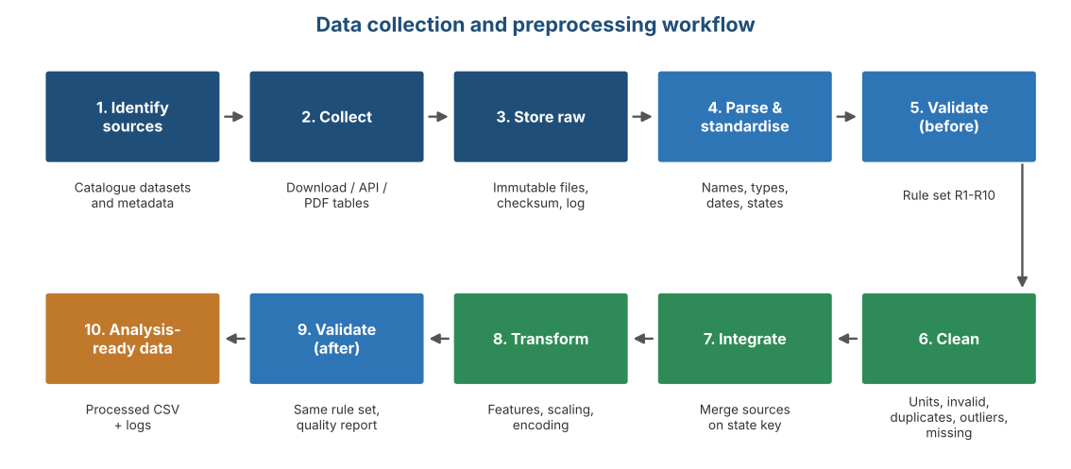
Figure 1: Workflow from source identification to analysis-ready data
Stage | Input | Process | Output
1-2 Identify and collect | Catalog of sources | Download, API pull, PDF extraction | Raw files
3 Store raw | Raw files | Save unchanged, checksum, metadata log | data/raw and metadata_log.csv
4 Parse and standardise | Raw text data | Names, types, dates, state mapping | Typed tables
5 Validate (before) | Typed tables | Run rule set R1 to R10 | Baseline validation report
6 Clean | Typed tables | Units, invalid values, duplicates, outliers, missing values | Cleaned service table and cleaning log
7 Integrate | Cleaned tables from each source | Join on standard state key, flag unmatched | Merged table
8 Transform | Merged table | Features, scaling, encoding | Analysis-ready table
9 Validate (after) | Analysis-ready table | Run the same rules, compare with baseline | Quality report
10 Publish | Verified tables | Save to processed folder with logs | analysis_ready.csv

9. Timeline and Effort Estimates
Task | Phase | Hours
Research and shortlist public datasets, build catalog | Collection | 4
Design collection methods and storage structure | Collection | 4
Set up raw storage, metadata log and checksums | Collection | 3
Parse and standardise (names, types, dates, units) | Preprocessing | 4
Missing value strategy and imputation | Preprocessing | 3
Duplicates, outliers and invalid values | Preprocessing | 3
Integrate sources and engineer features | Preprocessing | 3
Scaling and encoding | Preprocessing | 2
Validation rules and quality report | Validation | 4
Documentation and final DOC | Reporting | 4
Total |  | 34

The estimate totals 34 hours, inside the 30 to 35 hour range expected for this task. The same plan, with editable hours and automatic totals, is in the Timeline sheet of the Excel workbook. If real datasets turn out to be harder to extract (for example PDF-only sources), the extra effort would come from the collection and parse stages.

10. Prototype Results
The prototype notebook applies the framework to two simulated raw files: a service performance extract (Source A, 591 rows) and a digital readiness table (Source B, 12 rows). The raw data was deliberately made messy. The results below show that the framework detects and fixes each problem type.
Measure | Result
Raw records in Source A | 591
Clean records after processing | 576
State-name variants standardised | 178
Processing times converted from hours to days | 65
Impossible values removed | 11
Duplicate rows removed | 15
Outliers capped | 13
Missing or invalid cells imputed (Source A and B) | 106
Rows needing median readiness values (state absent from Source B) | 48
Validation rules passed (before to after) | 5 of 10 to 10 of 10
Failing rows (before to after) | 188 to 0

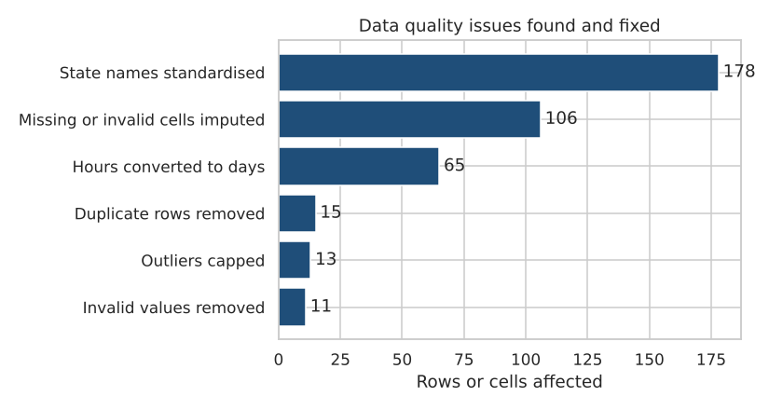
Figure 2: Data quality issues found and fixed (simulated data)
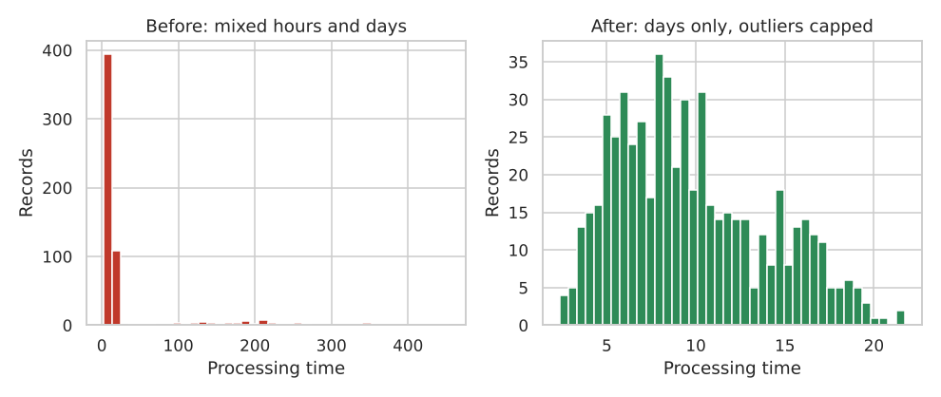
Figure 3: Processing time before and after cleaning
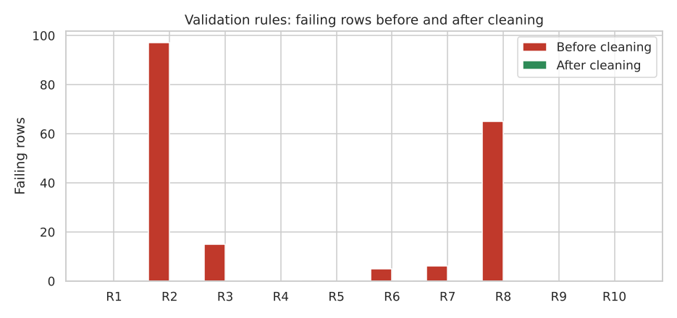
Figure 4: Failing rows per validation rule, before and after cleaning
Note: the data used here is simulated to demonstrate the method. It must not be quoted as real government statistics.

11. Risks and Mitigation
Risk | Mitigation
Dataset removed, renamed or its format changed | Archive raw files and record access date and checksum
Different definitions of the same indicator across sources | Record definitions in the data dictionary; avoid mixing incompatible indicators
Imputation changes conclusions | Keep flag columns and run a sensitivity check with and without imputed rows
Over-cleaning removes real extremes | Cap and log instead of delete; review flagged values
PDF extraction errors | Spot-check against the PDF and keep the extraction script
Terms of use not followed | Record the terms note for each dataset and cite sources

12. Conclusion and Deliverables
The framework gives a clear path from raw public data to clean, validated, analysis-ready data. It is technical, because each step names the Python method used, and strategic, because it explains why each step is needed, how it is verified and how long it takes. The next stage (Week 3) will use the analysis-ready dataset for exploratory analysis.
File | Contents
egov_week2_framework.docx | This document
egov_week2_preprocessing.ipynb | Notebook: collection log, standardisation, validation, cleaning, integration, transformation, charts, HTML export
egov_week2_workbook.xlsx | Dataset catalog, collection plan, preprocessing plan, validation rules, timeline, raw and clean sample data, quality report formulas
egov_quality_report.html | Self-contained quality report with charts and validation results
README.md | How to run and use the files

