Release Note (Qbuzz_release0.0.13_EAM12-Qbuzz-New Changes_Release 12thApr.zip)
EAM12-Qbuzz
Title:  EAM11.7-Qbuzz | Date Issued  12th-Apr-2023

General comments
This implementation is based on INFOR EAM 12

List of observations addressed in this patch/fixes/modifications
S. No. | Description of Observation | Files
1. | EAM12- Qbuzz-New Changes_Release 11 Apr | Db scripts  - SPC-327.sql  EF  - external_wsjobo.txt

Pre-Installation instructions
In an effort to ensure that your INFOR EAM system continues to operate with maximum efficiency and minimal problems, Infor strongly recommends that you:
- Apply this fix to a test environment and perform your own user acceptance testing before applying this customization to your production environment.
- Db scripts can only be run when user defined screen has been generated.

Configuration Instructions
1. User Defined Fields:

Screen Name | Tab Name | User Defined Fields | Fields Name
WSJOBO | Record View | Evt_udfnum09 | Total Costs

2. Create the status: Administration Setup System Code
Setup: Statuses
For Entity: EVST

User Code | System Code | Description
CAL | R | Checked, agreed supplier

Save the record
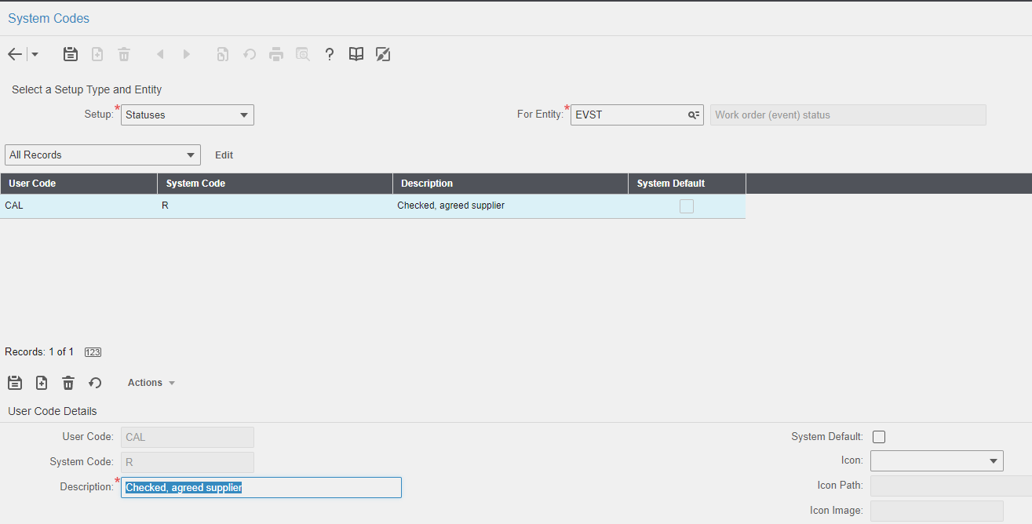

3. Status Authorization: Administration Security Status Authorizations

User Group | Entity | From Status | To Status
VLOOT-MAN | EVNT | CAL | CA
SUPPLIER | EVNT | DI | CAL

Save the record
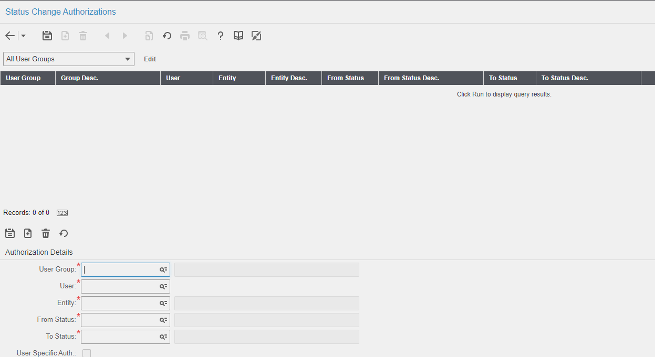

Note: Please delete status authorization for Vloot-man: DI - CA

4. Extensible Framework: Administration Security Extensible Framework
Name: external_WSJOBO
Screen: WSJOBO

Contents List
The release is contained in compressed file, which contains the following files:
Db scripts
- SPC-327.sql
EF

- external_wsjobo.txt
Release Note: Qbuzz_release0.0.13_EAM12-Qbuzz-NewChanges.doc

