Release Note (Qbuzz_release0.0.11_EAM11.7-Qbuzz- New Changes_Release2ndFeb.zip)
EAM11.7-Qbuzz
Title:  EAM11.7-Qbuzz | Date Issued  2nd-Feb-2023

General comments
This implementation is based on INFOR EAM 11.7

List of observations addressed in this patch/fixes/modifications
S. No. | Description of Observation | Files
1. | EAM11.7- Qbuzz- Changes_Release 2 Feb | EF  - QBUZZ_external_OUGNPO.txt

Pre-Installation instructions
In an effort to ensure that your INFOR EAM system continues to operate with maximum efficiency and minimal problems, Infor strongly recommends that you:
- Apply this fix to a test environment and perform your own user acceptance testing before applying this customization to your production environment.

Configuration Instructions
- Add screen to the menu:
User group | Menu: Administration Security User Group
User Group: KOPIE-R5 / R5-MOB-ADMIN
Screen: KUPRCS

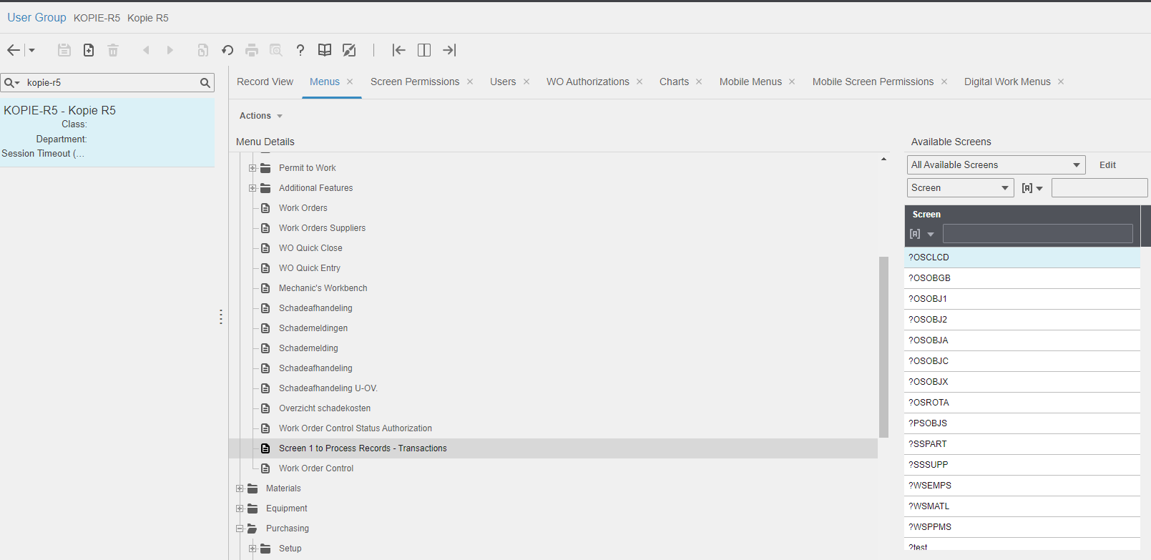

- Logout and then login and once open the added screen KUPRCS.
Then, hide KUPRCS screen from the menu.

Contents List
The release is contained in compressed file, which contains the following files:

EF
- QBUZZ_external_OUGNPO.txt

Release Note: Qbuzz_release0.0.11_EAM11.7-Qbuzz_ New Changes_Release2Feb.

