Release Note (Qbuzz_release0.0.4_EAM11.7-Qbuzz-New Changes_Release 4 Nov.zip)
EAM11.7-Qbuzz
Title:  EAM11.7-Qbuzz | Date Issued  4th-Nov-2022

General comments
This implementation is based on INFOR EAM 11.7

List of observations addressed in this patch/fixes/modifications
S. No. | Description of Observation | Files
1. | EAM11.7- Qbuzz-New Changes_Release 4 Nov | Db scripts  - SPC-288.sql  EF  - external_wsjobo.txt  - external_pspord.txt

Pre-Installation instructions
In an effort to ensure that your INFOR EAM system continues to operate with maximum efficiency and minimal problems, Infor strongly recommends that you:
- Apply this fix to a test environment and perform your own user acceptance testing before applying this customization to your production environment.
- Db scripts can only be run when user defined screen has been generated.

Configuration Instructions
1. User Defined Fields:

Screen Name | Tab Name | User Defined Fields | Fields Name
OSOBJS | Record View | Obj_udfchkbox01 | VVO
SSSUPP | Record View | Com_udfchkbox03 | Primary VVO

2. Extensible Framework: Administrator --> Security --> Extensible Framework
Name: external_WSJOBO
Screen: WSJOBO

Name: external_PSPORD
Screen: PSPORD)

3, User Defined Screen: WUJOBO (Supplier Book Hours and Materials)
Add new fields
Field name | Description | Field Label | Field Type | Sequence
OU_COMMENT | Comment | Comment | Free format text | 17

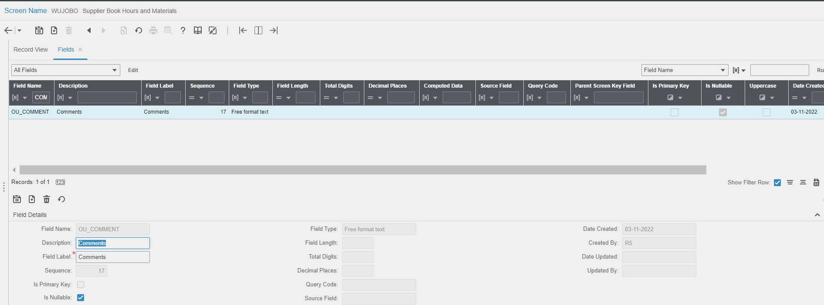

Contents List
The release is contained in compressed file, which contains the following files:
Db scripts
- SPC-288.sql
EF
- external_wsjobo.txt
- external_pspord.txt
Release Note: Qbuzz_release0.0.4_EAM11.7-Qbuzz-Changesissues

