Release Note (Qbuzz_release0.0.12_EAM12-Qbuzz- Changes_Release7Apr.zip)
EAM12-Qbuzz
Title:  EAM12-Qbuzz | Date Issued  7th-Apr-2023

General comments
This implementation is based on INFOR EAM 12

List of observations addressed in this patch/fixes/modifications
S. No. | Description of Observation | Files
1. | EAM12- Qbuzz- New Changes_Release 5Apr | Db scripts  - SPC-325.sql  EF  - QBUZZ_external_wsjobo.txt

Pre-Installation instructions
In an effort to ensure that your INFOR EAM system continues to operate with maximum efficiency and minimal problems, Infor strongly recommends that you:
- Apply this fix to a test environment and perform your own user acceptance testing before applying this customization to your production environment.

Configuration Instructions
  - Create status: Administration Setup System codes

User Code | Entity | System Code | Description
IBH | CXST | O | In behandeling

Save the record
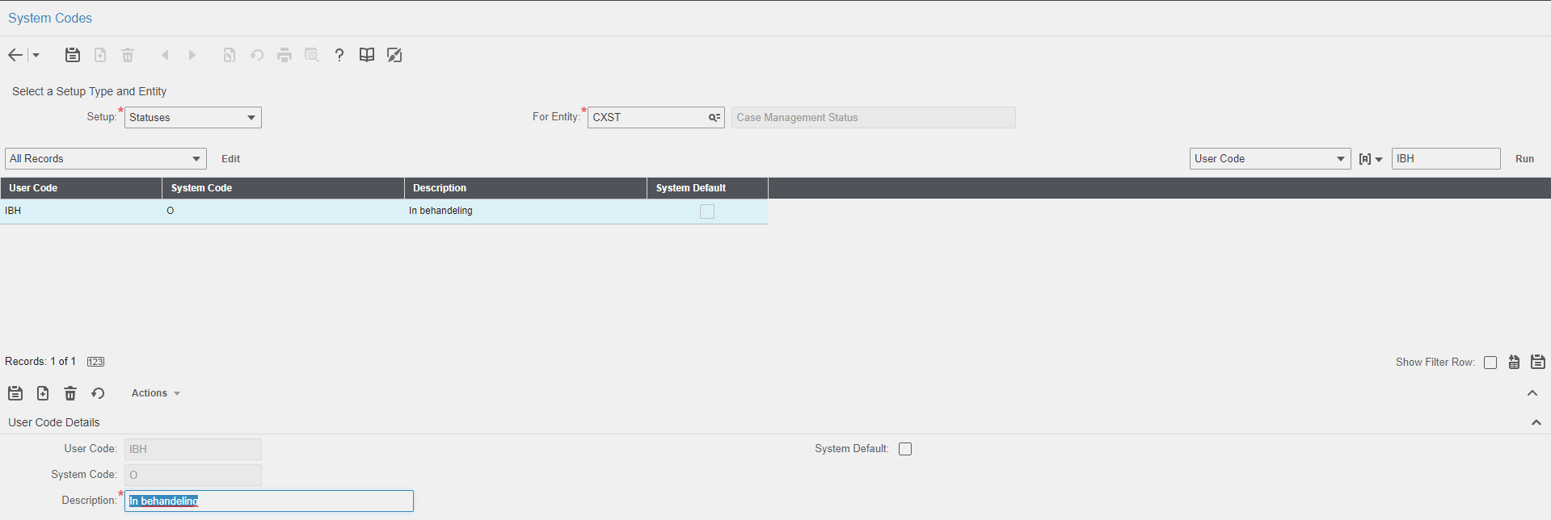

  - Extensible Framework: Administrator Security Extensible Framework
Name: external_WSJOBO
Screen: WSJOBO

Contents List
The release is contained in compressed file, which contains the following files:
Db scripts
- SPC-325.sql

EF
- QBUZZ_external_wsjobo.txt

Release Note: Qbuzz_release0.0.12_EAM12-Qbuzz_ New Changes_Release7Apr.

