Release Note (Qbuzz_release0.0.2_EAM11.7-Qbuzz-WorkOrderControl.zip)
EAM11.7
Title:  EAM11.7-Qbuzz | Date Issued  07th -Oct-2022

General comments
This implementation is based on INFOR EAM 11.7

List of observations addressed in this patch/fixes/modifications
S. No. | Description of Observation | Files
1. | EAM11.7- Qbuzz-Work Order Control | Db scripts  - SPC-256.sql  EF  - external_wsjobo.ef.txt  - QBUZZ_external_OUWOCF.ef.txt

Pre-Installation instructions
In an effort to ensure that your INFOR EAM system continues to operate with maximum efficiency and minimal problems, Infor strongly recommends that you:
- Apply this fix to a test environment and perform your own user acceptance testing before applying this customization to your production environment.
- Db scripts can only be run when user defined screen has been generated.

Configuration Instructions
1. Create User Defined Screen: Administrator -- > Screen Configuration -- > User defined screens

Screen Name | OUWOCF
Description | Work Order Control
Table name | WOCONT
Entity | CNT

Save the record
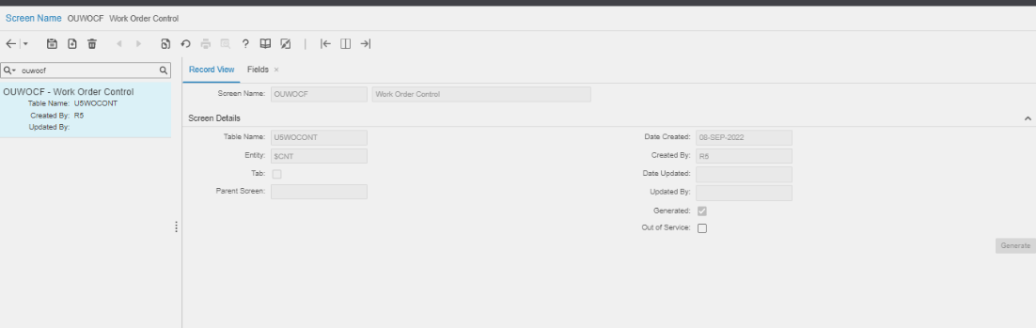

Navigate to Fields

Please refer attached excel file for fields

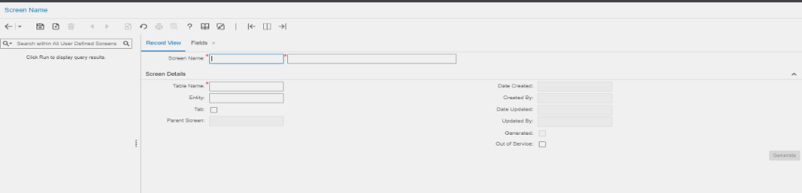

2. Create User Defined Screen: Administrator -- > Screen Configuration -- > User defined screens

Screen Name | OUSTAT
Description | Work Order Control Status Authorization
Table name | OUSTATUS
Entity | STA

Save the record
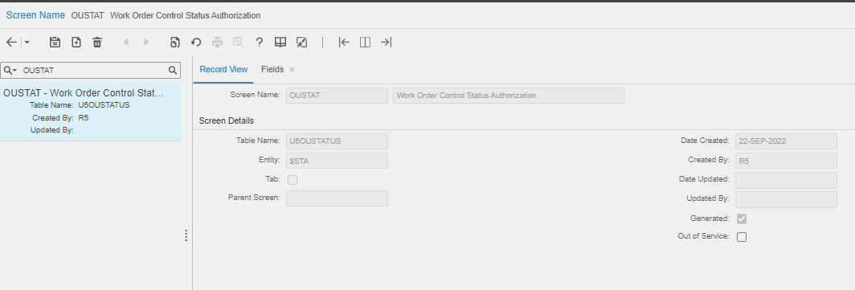

Navigate to Fields

Please refer attached excel file for field
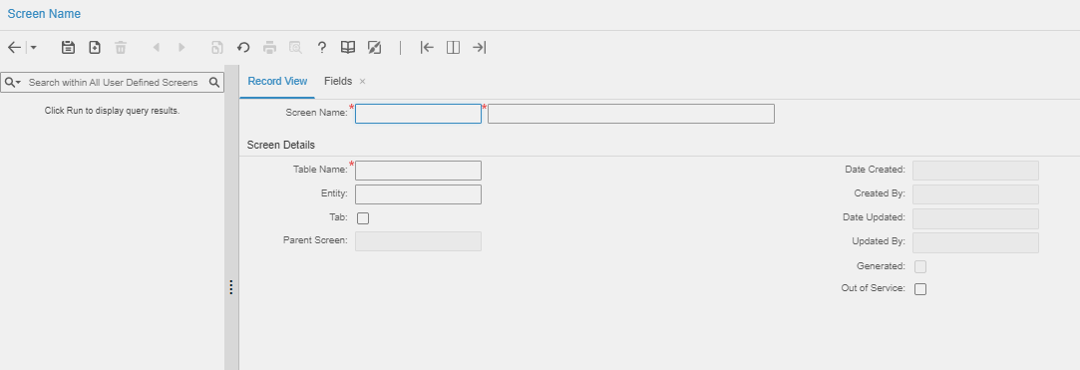

Note: → If there is any error then please contact MCT.
Contents List
The release is contained in compressed file, which contains the following files:

- Db scripts: SPC-256.sql

- EF: external_wsjobo.ef.txt
QBUZZ_external_OUWOCF.ef.txt

- Release Note: Qbuzz_release0.0.2_EAM11.7-Qbuzz-WorkOrderControl

