Release Note (Qbuzz_release0.0.3_EAM11.7-Qbuzz-PO.zip)
EAM11.7-Qbuzz
Title:  EAM11.7-Qbuzz | Date Issued  21st-Oct-2022

General comments
This implementation is based on INFOR EAM 11.7

List of observations addressed in this patch/fixes/modifications
S. No. | Description of Observation | Files
1. | EAM11.7- Qbuzz-PO | Db scripts  - SPC-257.sql  EF  - external_ouwocf.txt  - external_pspord.txt

Pre-Installation instructions
In an effort to ensure that your INFOR EAM system continues to operate with maximum efficiency and minimal problems, Infor strongly recommends that you:
- Apply this fix to a test environment and perform your own user acceptance testing before applying this customization to your production environment.
- Db scripts can only be run when user defined screen has been generated.

Configuration Instructions
1. Create User Defined Screen: Administrator -- > Screen Configuration -- > User defined screens

Screen Name | KUPRCS
Description | Screen 1 to Process Records - Transactions
Table name | R5PROCESS
Entity

Save the record
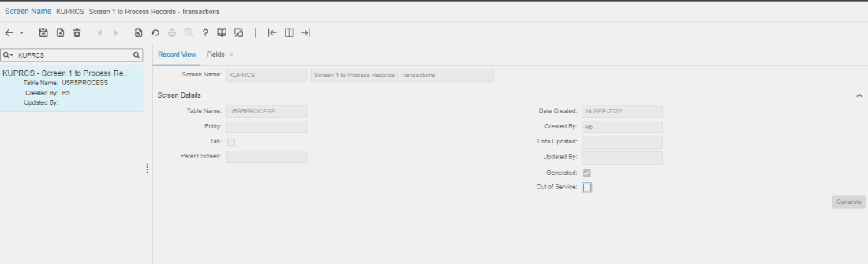
Navigate to Fields

Please refer attached excel file for fields

2. User Defined Fields:

Screen Name | Tab Name | User Defined Fields | Fields Name | Lookup
WSJOBO | Record View | Evt_udfchar23 | Work Order num
WSJOBO | Record View | Evt_udfdate09 | Date Ready
WSJOBO | Record View | Evt_udfchkbox02 | Agree
SSSUPP | Record View | Com_udfchkbox02 | Monthly Invoice
WSJOBO | Record View | Evt_udfchar24 | PO Number
PSPORD | Record View | Ord_udfchar05 | Receipt
PSPORD | Record View | Ord_udfchar04 | AFAS PO No.

3. Extensible Framework: Administrator → Security → Extensible Framework
Name: external_OUWOCF
Screen: OUWOCF

Name: external_PSPORD
Screen: PSPORD

4. Status Change Authorizations: Administrator > Security > Status Authorizations.

User Group | User | Entity | From status | To status
R5 | * | EVNT | TF | C
R5 | * | EVNT | CA | C
R5 | * | EVNT | AG | C

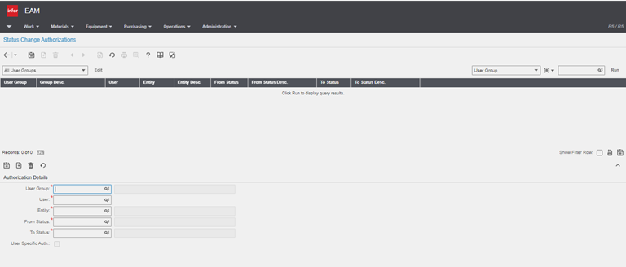

Contents List
The release is contained in compressed file, which contains the following files:

Db scripts
- SPC-257.sql
EF
- external_ouwocf.txt
- external_pspord.txt

Release Note: Qbuzz_release0.0.3_EAM11.7-Qbuzz-PO

