Q1: Create an instance, install apache server and add an index.html file and view that file in the browser. Take snapshot of this instance and deploy it in another region.
Deliverable: Mention the steps for achieving this

1: Launch an instance through the AWS console
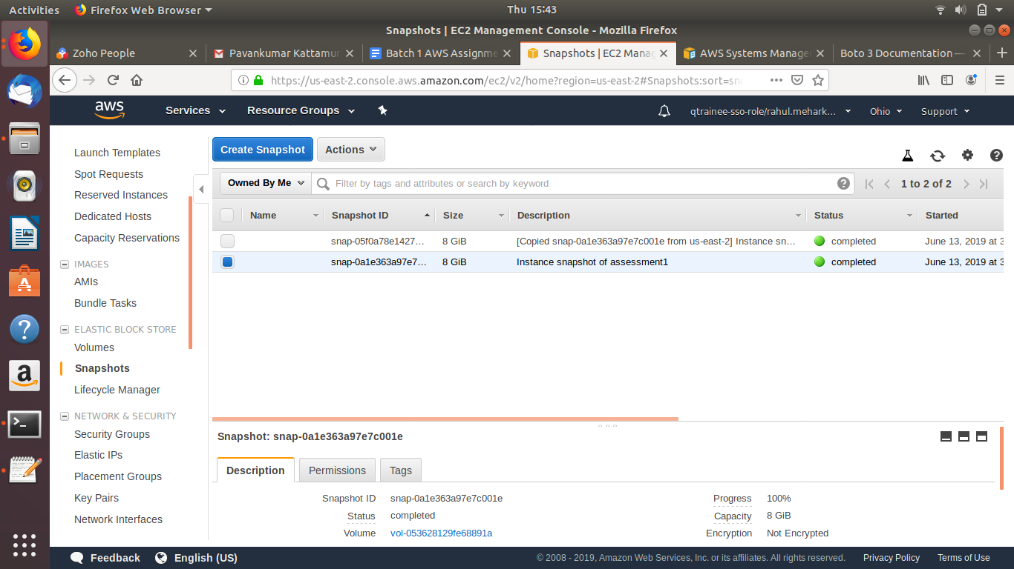
2) Connect to the instance through SSH

3) Then install apache2 on the instance and start apache2
4) Create an html file
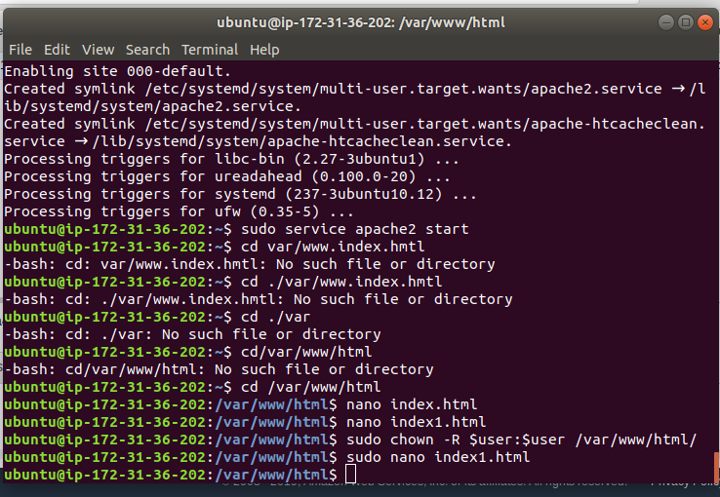

4) html file when hosted on instance

