Q6: Your company has recently hired a group of 10 freelancers for a specific project for a short period of time. Your manager wants them to access the AWS account only when they are within the organization’s network. Design an IAM policy to achieve this following the best practices.
Deliverable: Description of your strategy and IAM policy

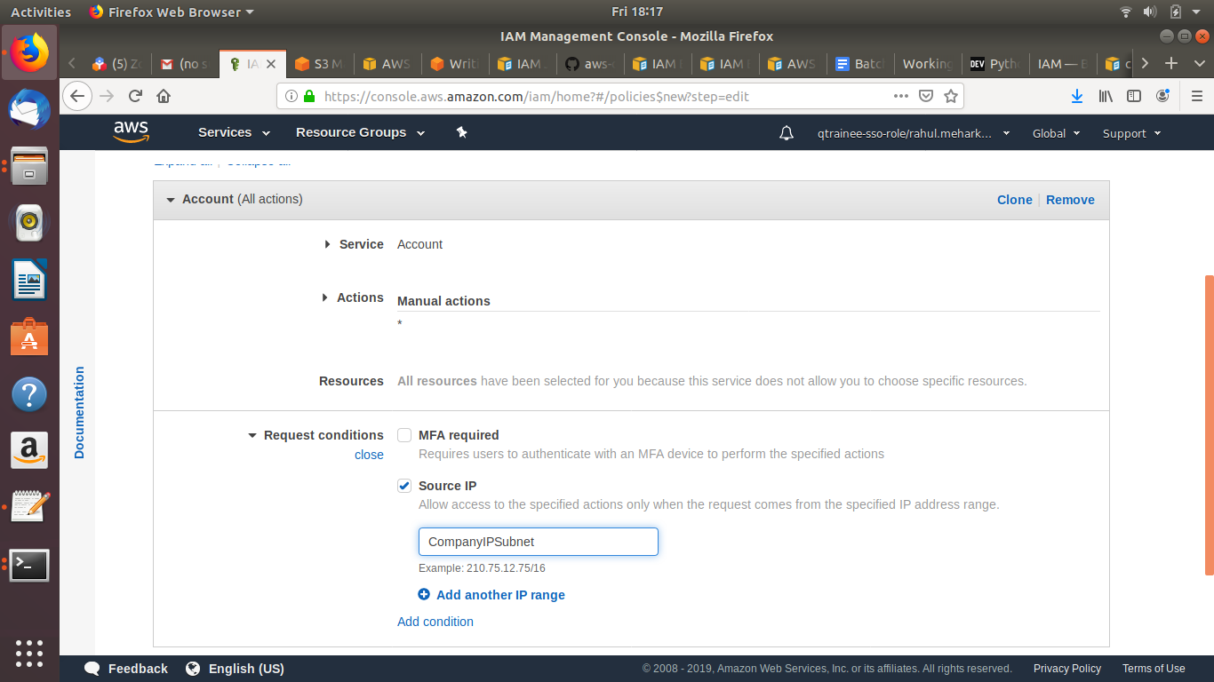

IAM Policy:

{
"Version": "2012-10-17",
"Statement": [
{
"Sid": "VisualEditor0",
"Effect": "Allow",
"Action": "account:*",
"Resource": "*",
"Condition": {
"IpAddress": {
"aws:SourceIp": "210.75.12.75/16"
}
}
}
]
}

