Q1)

Create an auto scaling group with the launch configuration that contains the bash script
that you want to run when the instance runs.
2. Create a target group and register the instances that you created to it.
3. Create a load balancer and attach the target group to it that you have created.
4. Copy the DNS of load balancer and keep refreshing. You will find the load being balanced by the change in script

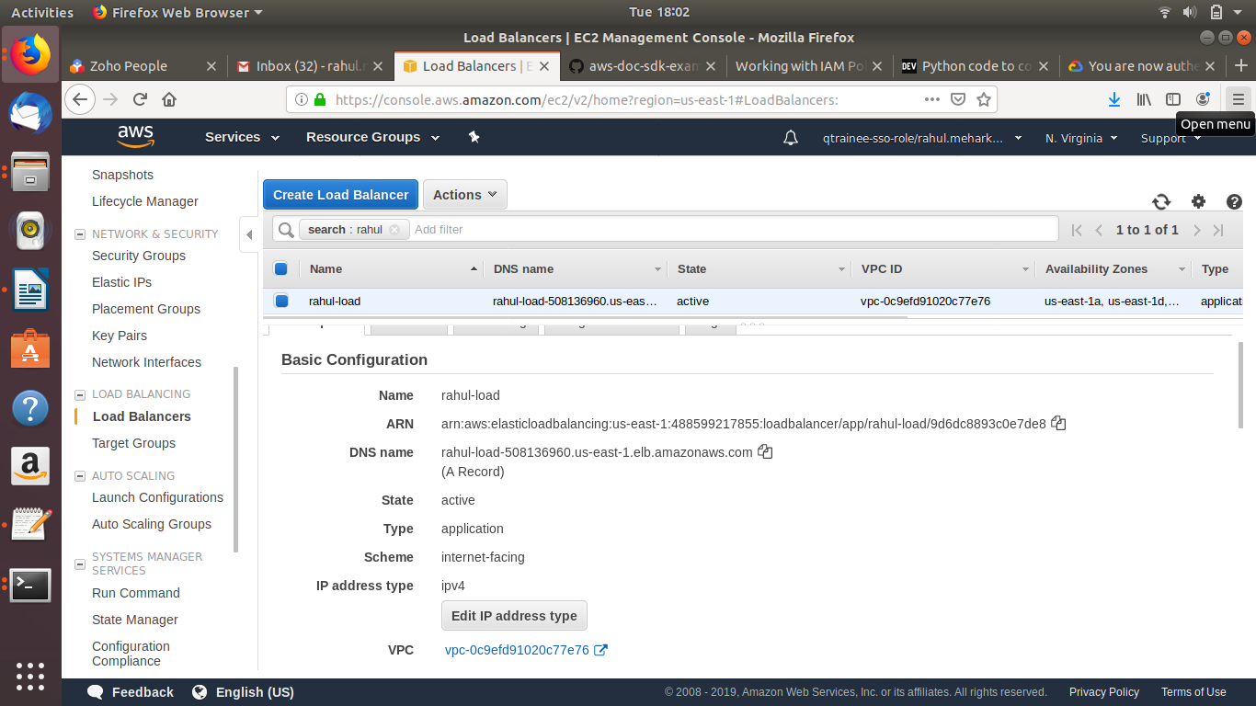

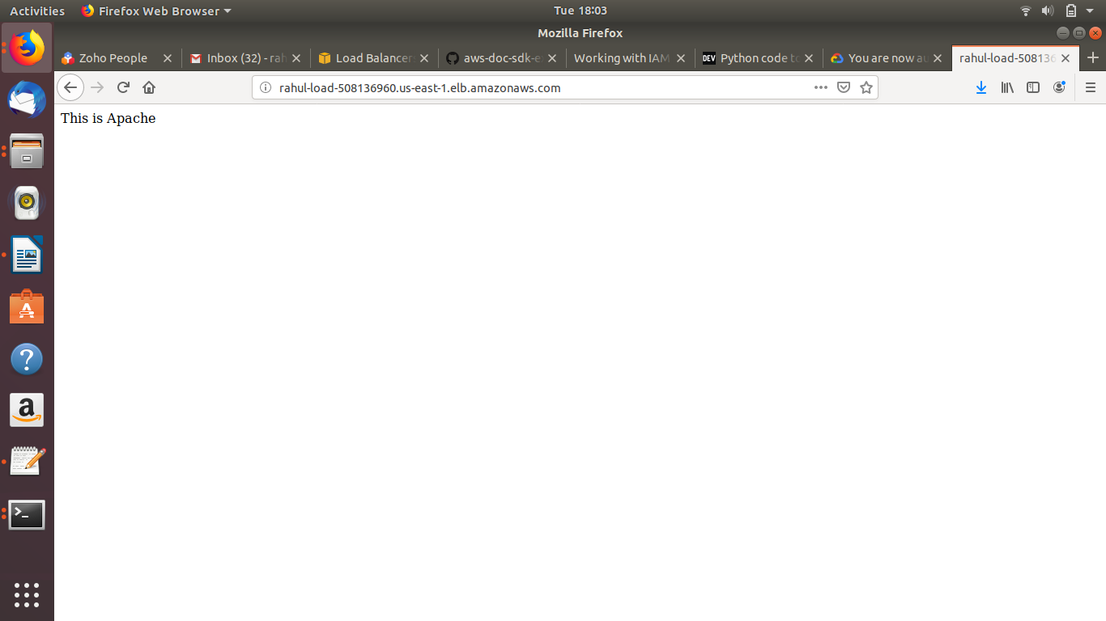

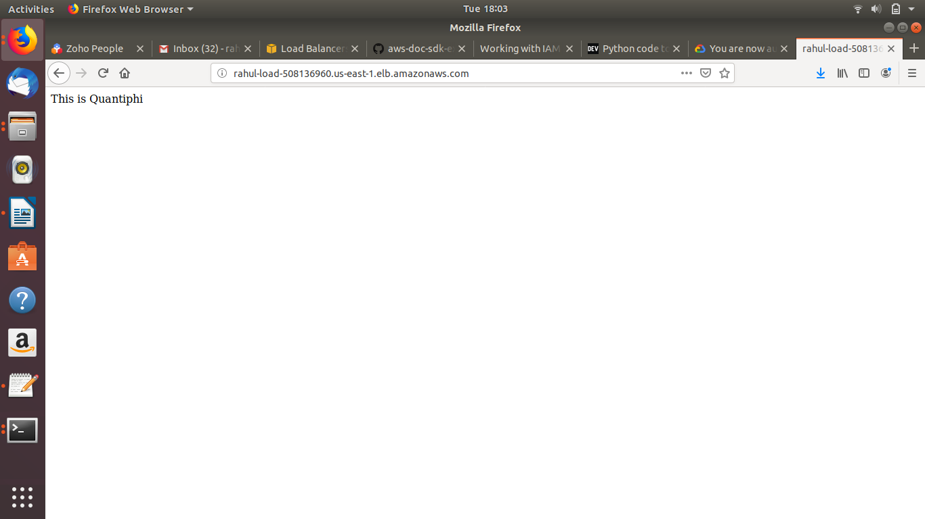

Launch script
#!/bin/bash
sudo apt -y update
sudo apt install -y apache2
sudo service apache2 start

