Q1)

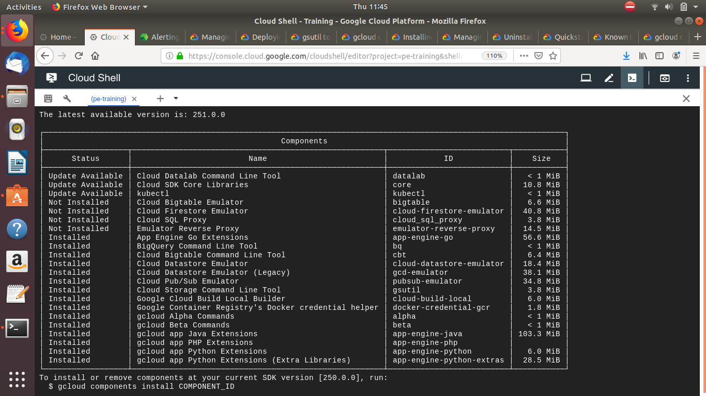
Q2)
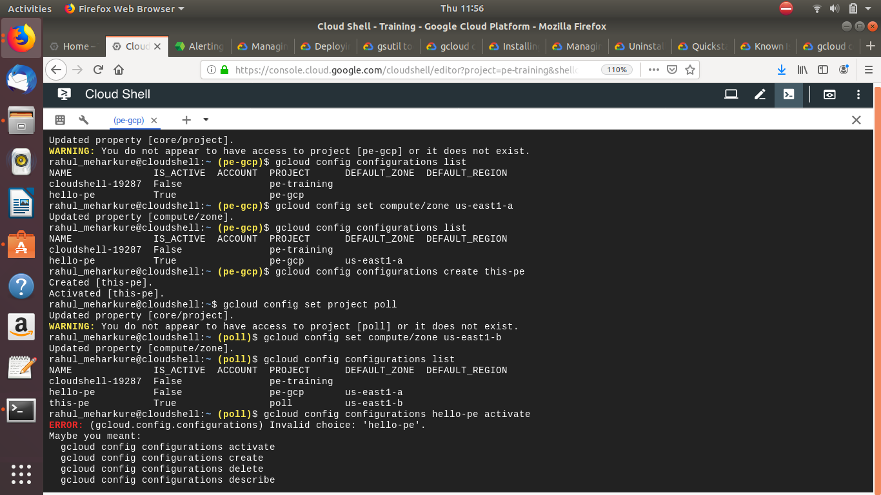
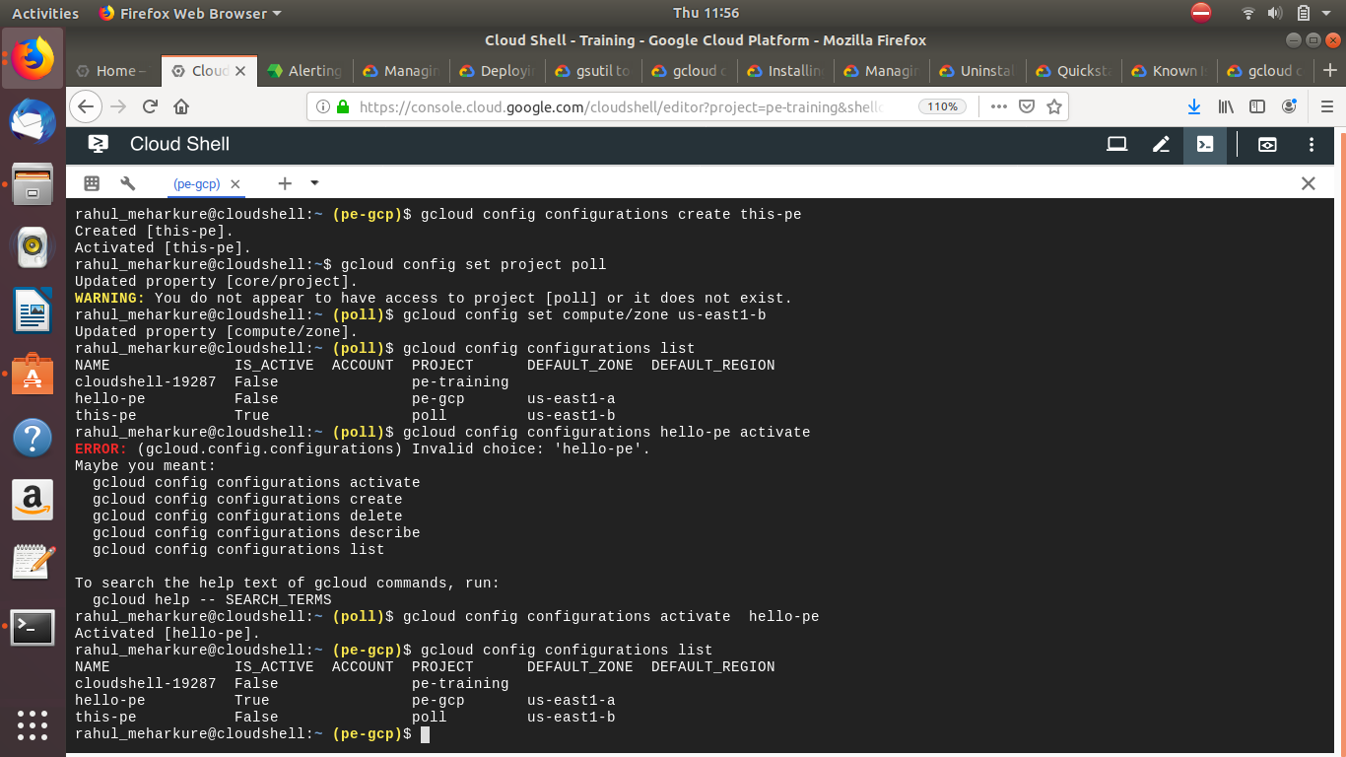
Q3)
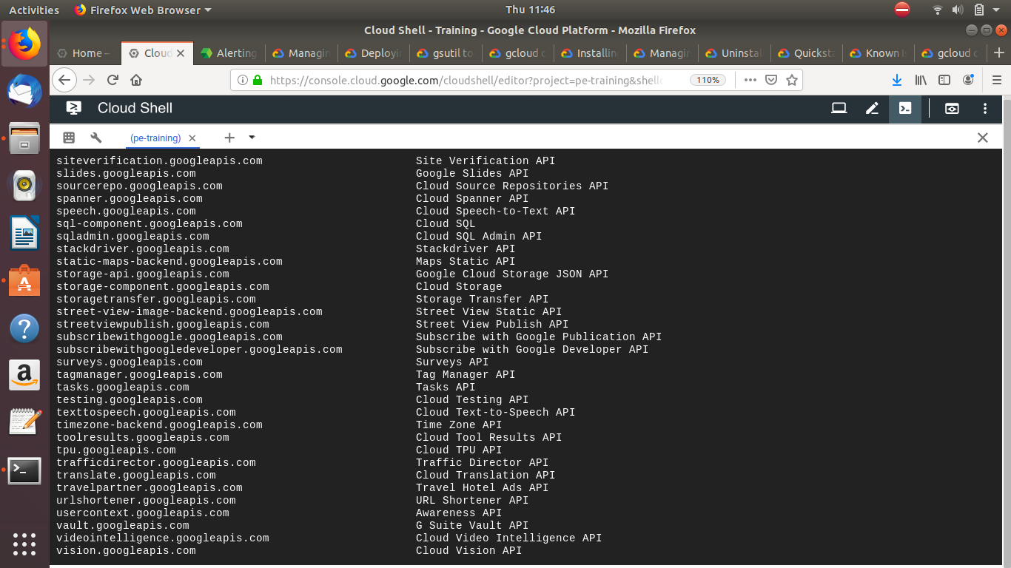
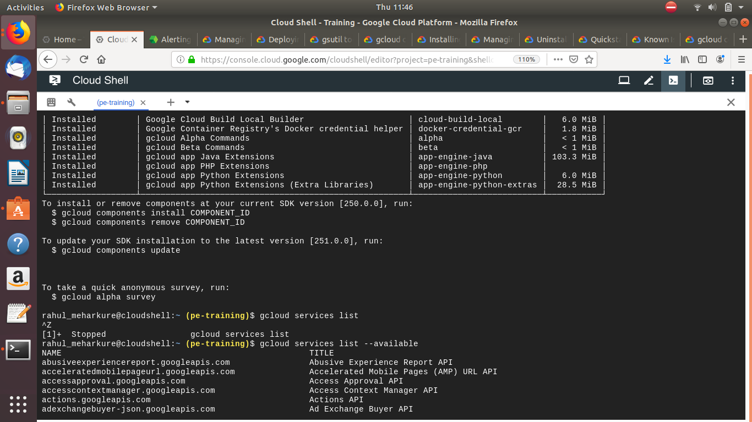
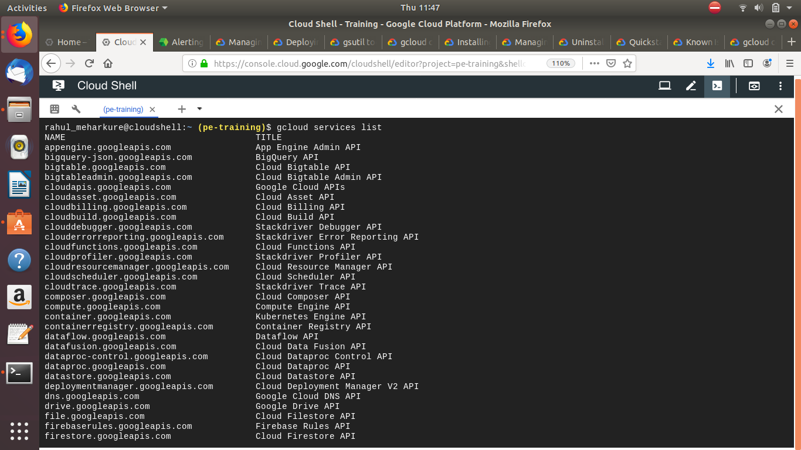

Q4)

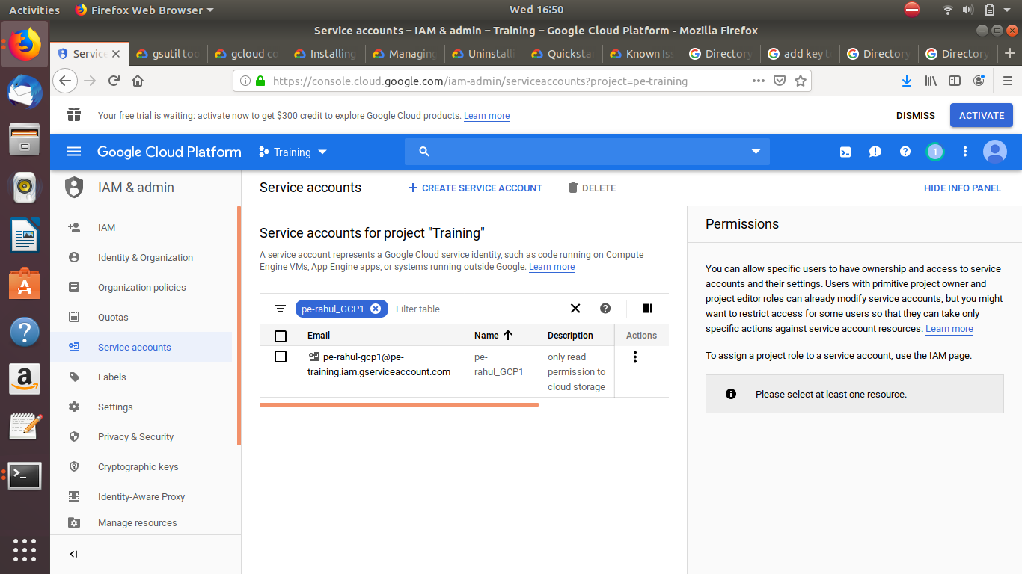

Attach the above service account to GCE VM instance

Q5)
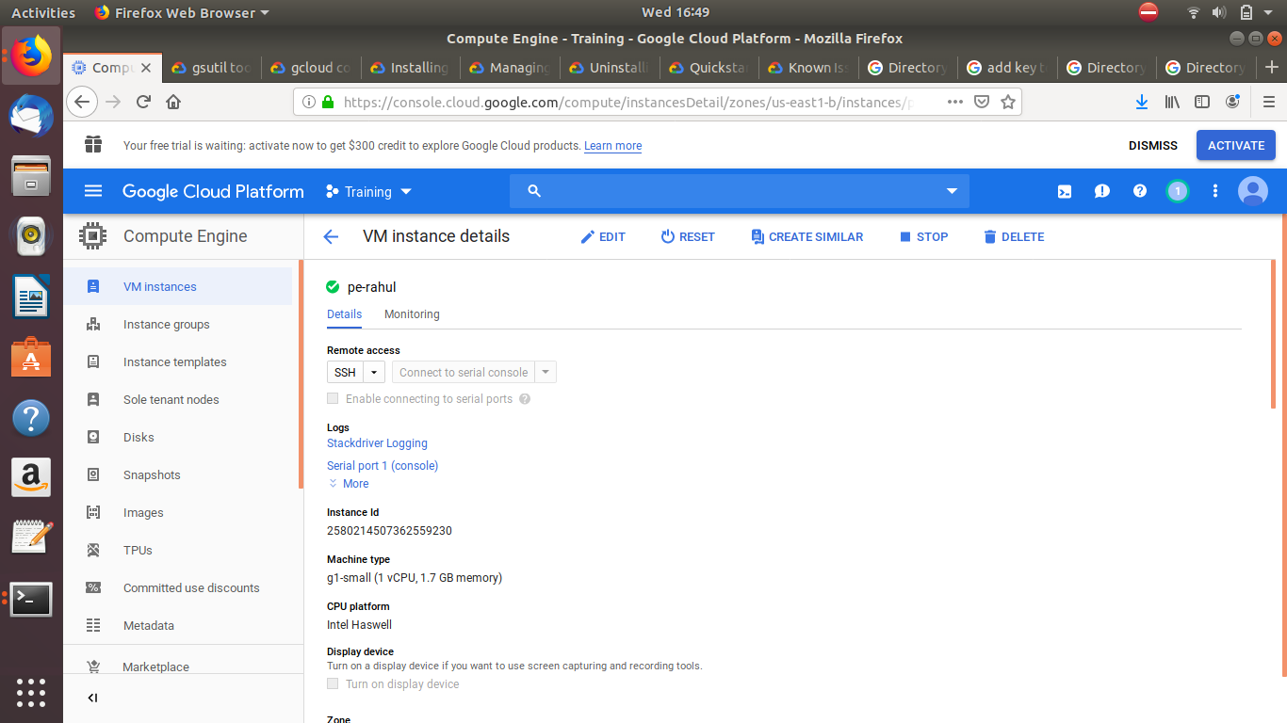

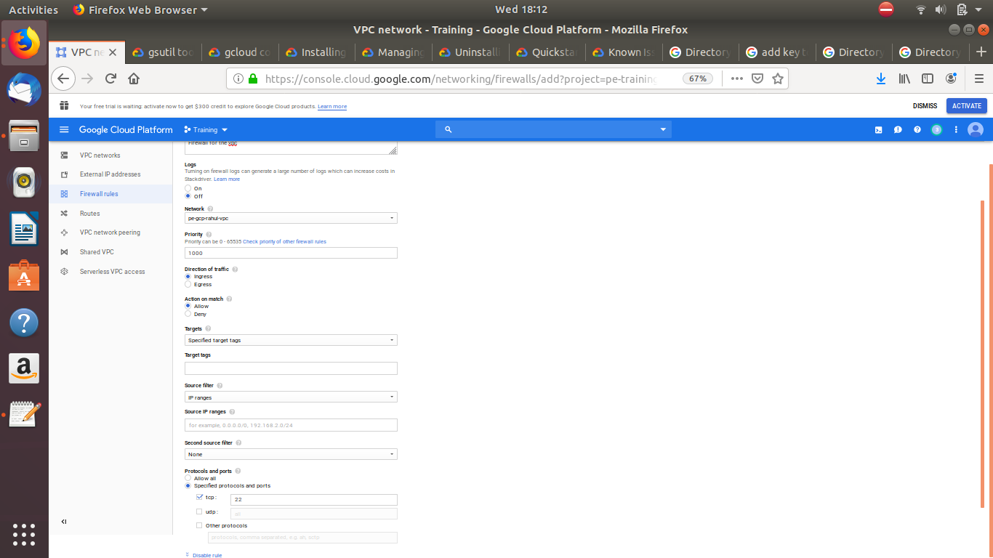

Q5)
Following are the commands:
Copy:
$ gsutil cp gs://pe-rahul//hello.txt gs://pe-rahul-2//cpyhello.txt

Move:
$ gsutil mv gs://pe-rahul//hello.txt gs://pe-rahul-2//cpyhello.txt

Download an Object:
$ gsutil cp gs://pe-rahul//hello.txt Desktop

Upload an Object:
$ gsutil cp Desktop/this.txt gs://pe-rahul/

Delete an Object:
$ gsutil rm gs://pe-rahul/this.txt

Q6)
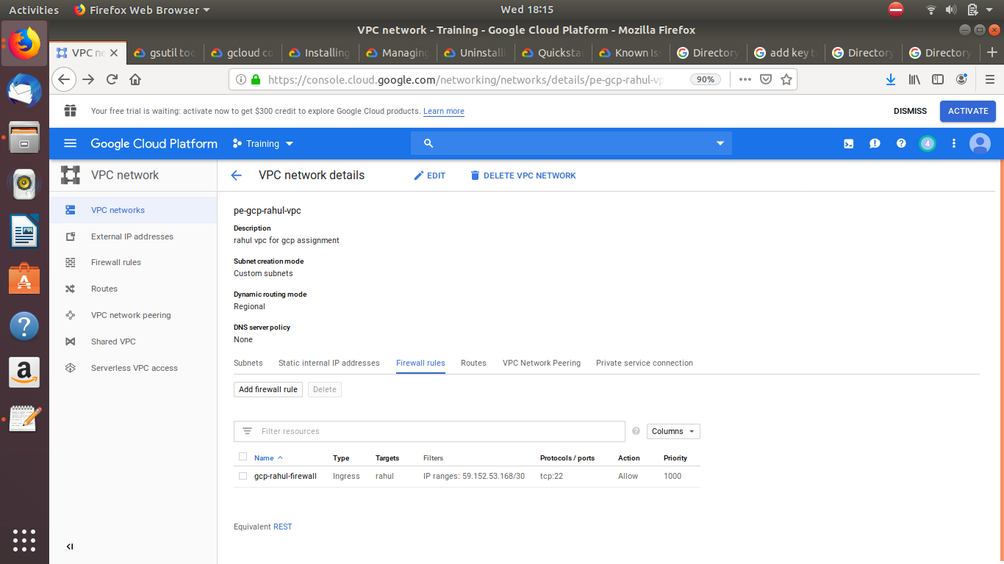

Q7)

-> Create a firewall rule in that make sure you tick/select “Logs On” so that logs can be made in stackdriver
-> In stackdriver go to logging -> Exports -> Create Exports -> Select your metric (i.e firewall rule) in “Edit Export” add Sink Name, Sink Service (Bigquery), Sink Destination and Create Sink
-> After your Dataset can be seen in the BigQuery

Q8)

-> Create instance template using console
-> Create instance groups using:
gcloud compute instance-groups managed set-instance-template [INSTANCE_GROUP] \
--template [INSTANCE_TEMPLATE] \
--zone [ZONE]

-> AutoScaling:
gcloud compute instance-groups managed set-autoscaling example-managed-instance-group \
--max-num-replicas 20 \
--target-cpu-utilization 0.75 \
--cool-down-period 90
-> Create Load balancer using Console
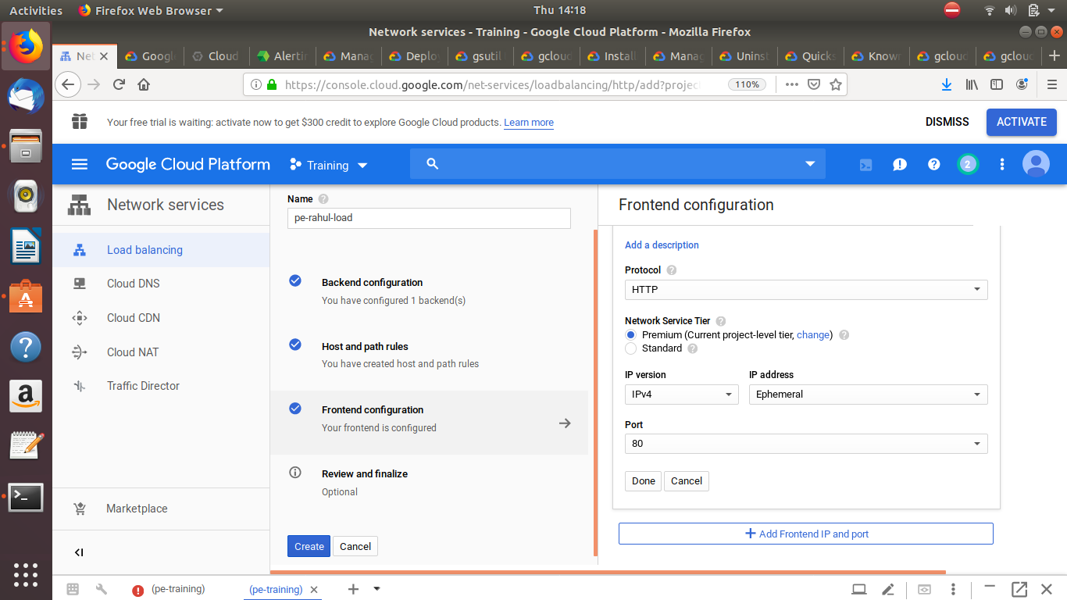
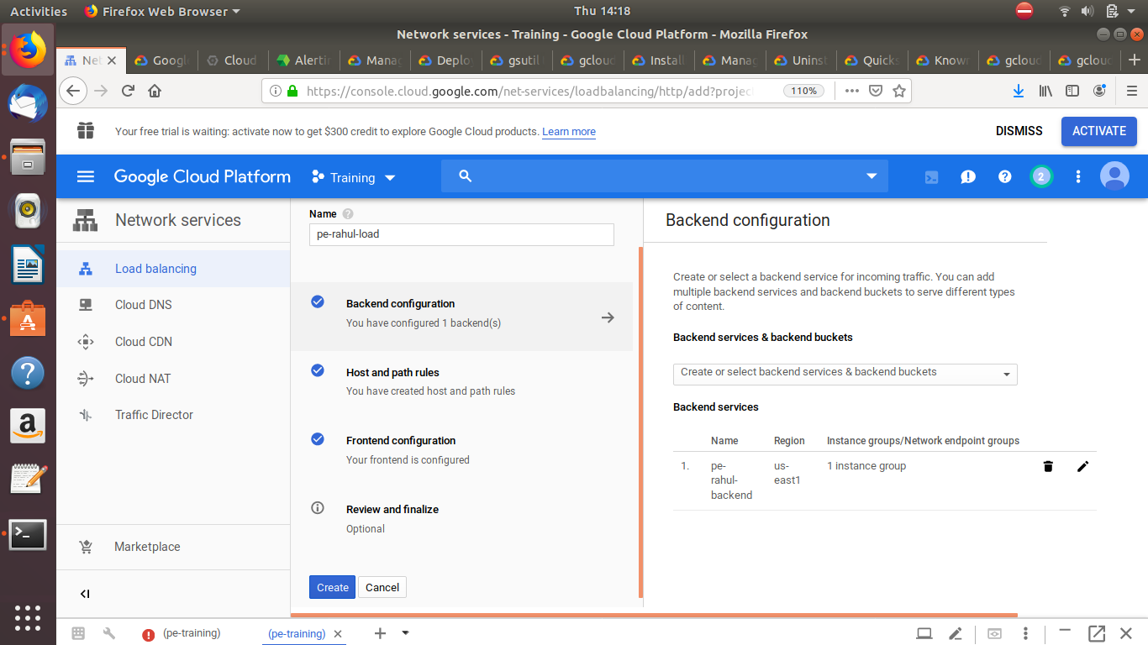
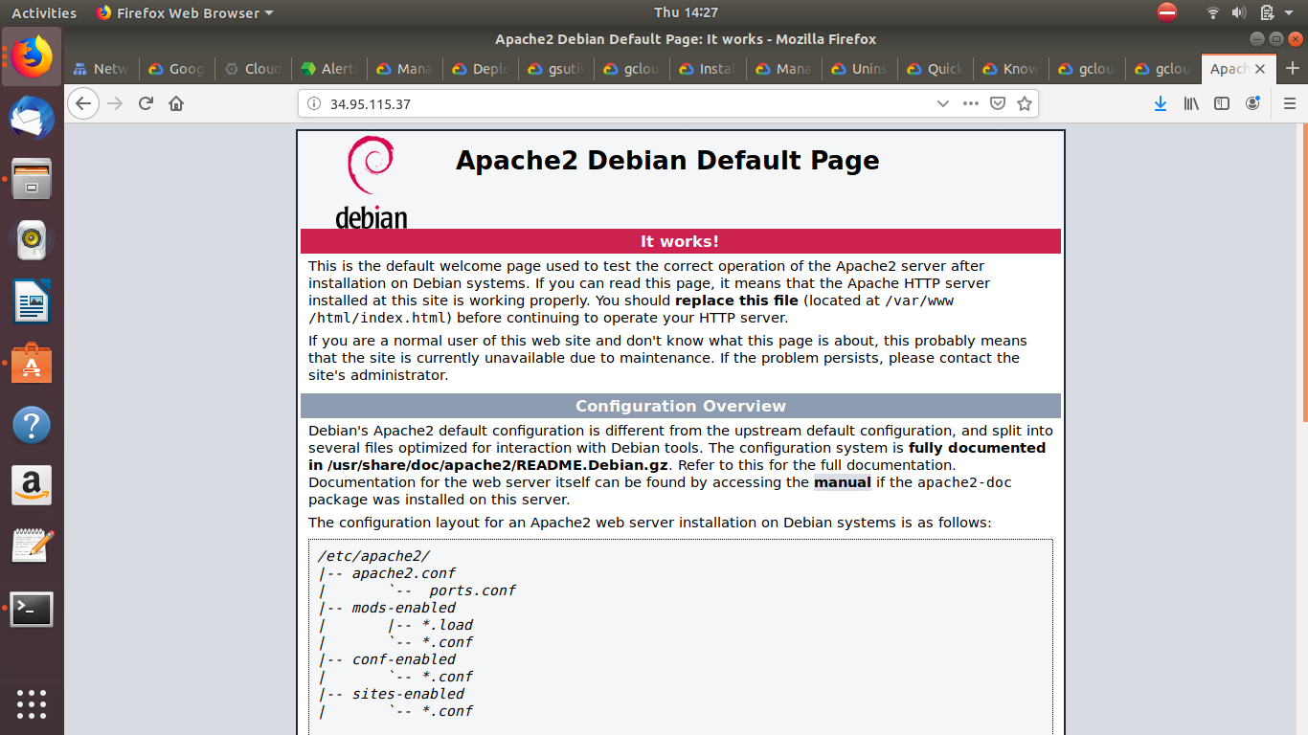
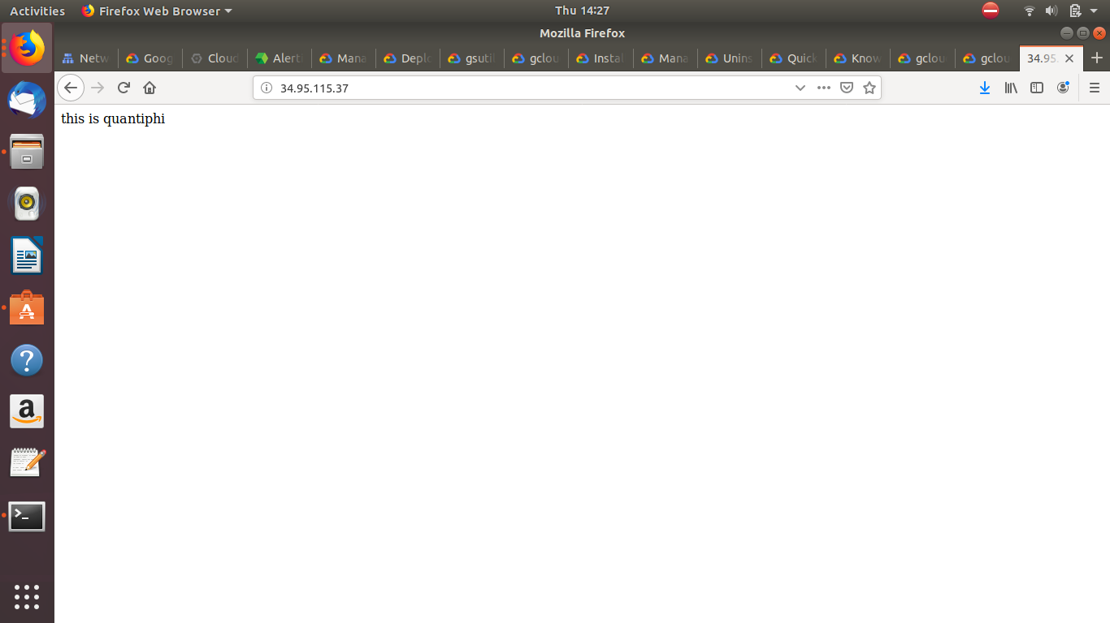
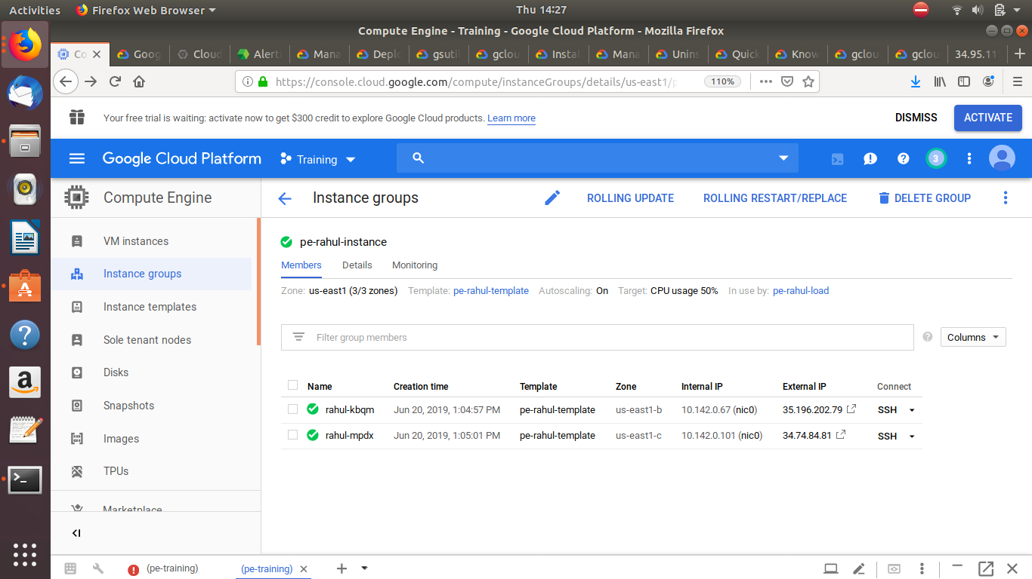

Q10)

