Q1)

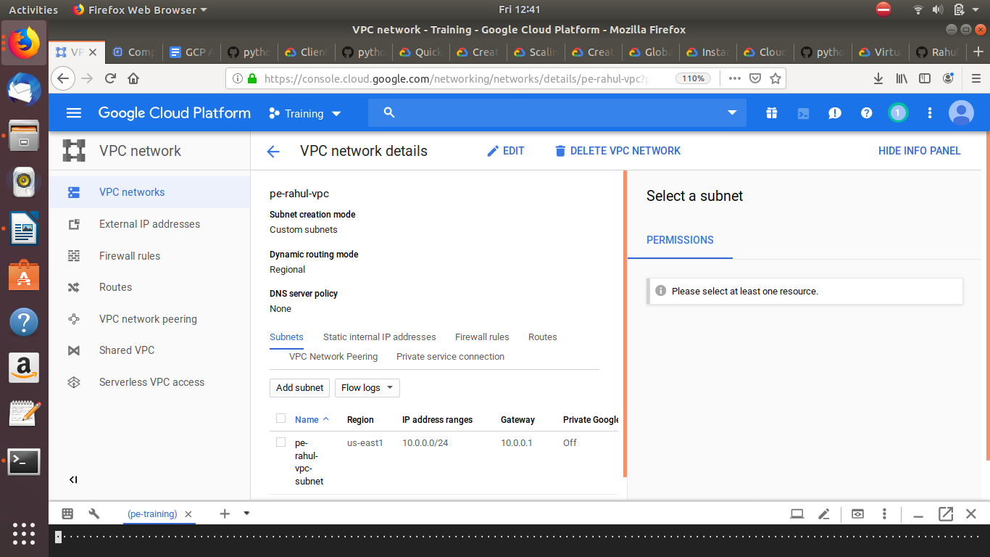
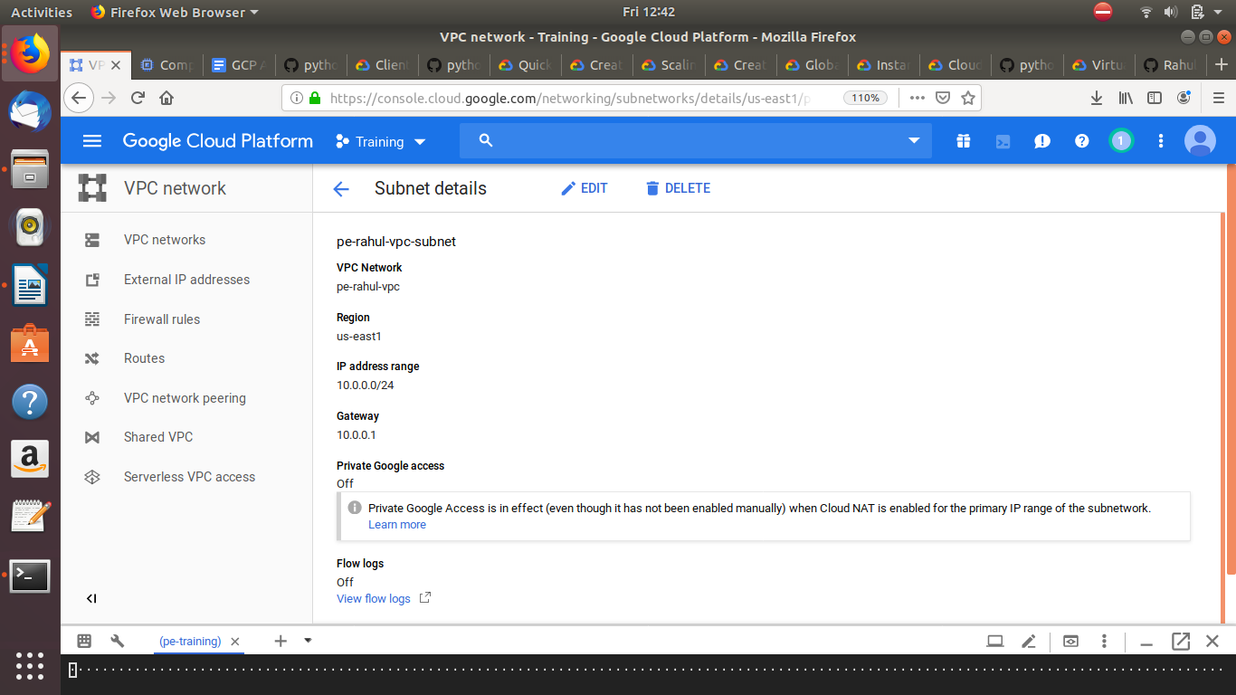
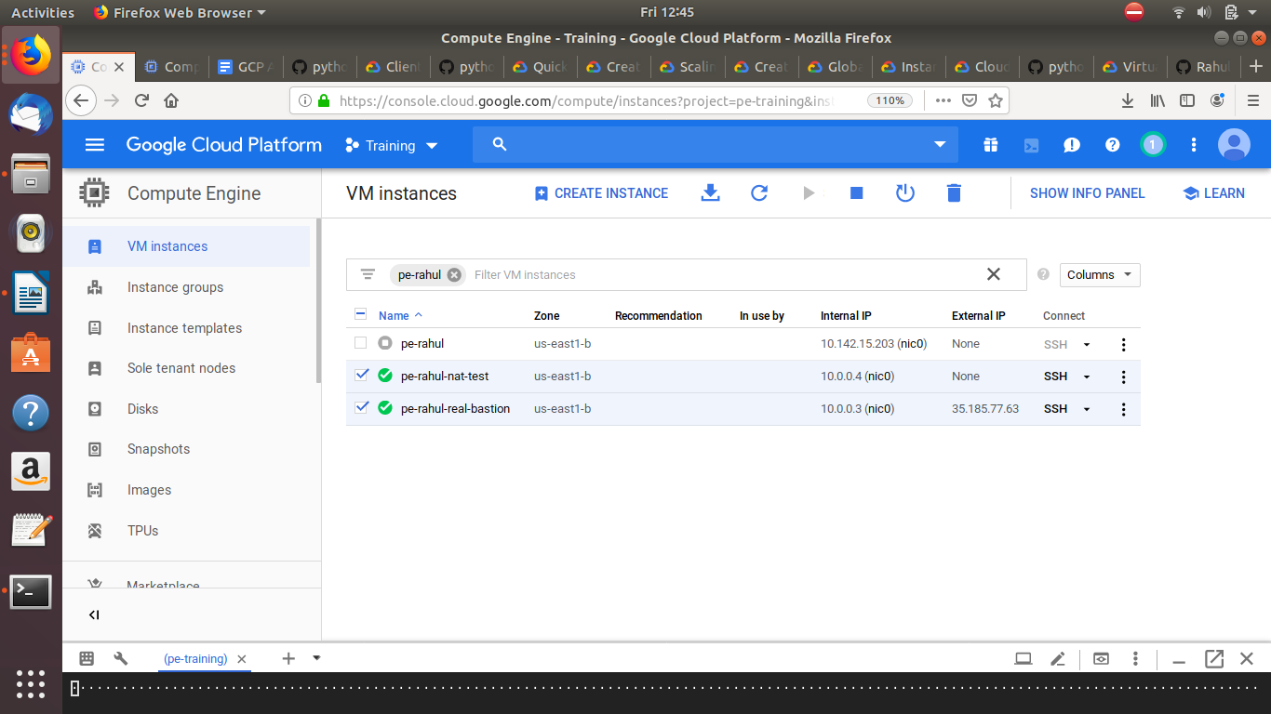

Q3)
gcloud compute instances create example-instance --tags http-server \
--metadata startup-script='#! /bin/bash
sudo apt update
sudo apt install -y apache2
sudo service apache2 start
cat <<EOF > /var/www/html/index.html
<html><body><h1>Hello World</h1>
<p>This page was created from a simple start up script!</p>
</body></html>
EOF'

Q4)

code:
class CustomException(Exception):
#Raise custome exception

def __init__(self,msg):
self.msg=msg

def hello_gcs(data, context):
"""Triggered by a change to a Cloud Storage bucket.
Args:
event (dict): Event payload.
context (google.cloud.functions.Context): Metadata for the event.
"""
try:
path = "gs://"+data['bucket']+"/"+data['name']
print(path)
#path= "gs://pe-rahul-bucket/zoo.jpeg
localize_objects_uri(path)
except:
raise CustomException("Error in reading args in hello_gcs")

def localize_objects_uri(uri):
"""Localize objects in the image on Google Cloud Storage

Args:
uri: The path to the file in Google Cloud Storage (gs://...)
"""
from google.cloud import vision
try:
client = vision.ImageAnnotatorClient()

image = vision.types.Image()
image.source.image_uri = uri

objects = client.object_localization(
image=image).localized_object_annotations

print('Number of objects found: {}'.format(len(objects)))
for object_ in objects:
print('\n{} (confidence: {})'.format(object_.name, object_.score))
print('Normalized bounding polygon vertices: ')
for vertex in object_.bounding_poly.normalized_vertices:
print(' - ({}, {})'.format(vertex.x, vertex.y))
except:
raise CustomException("Error in image detection")

