Git Assesment

1) Creating the DSCS that contains initial file as file.txt:

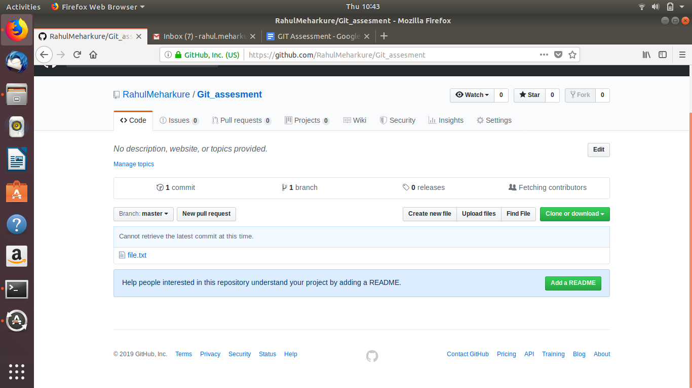
2)

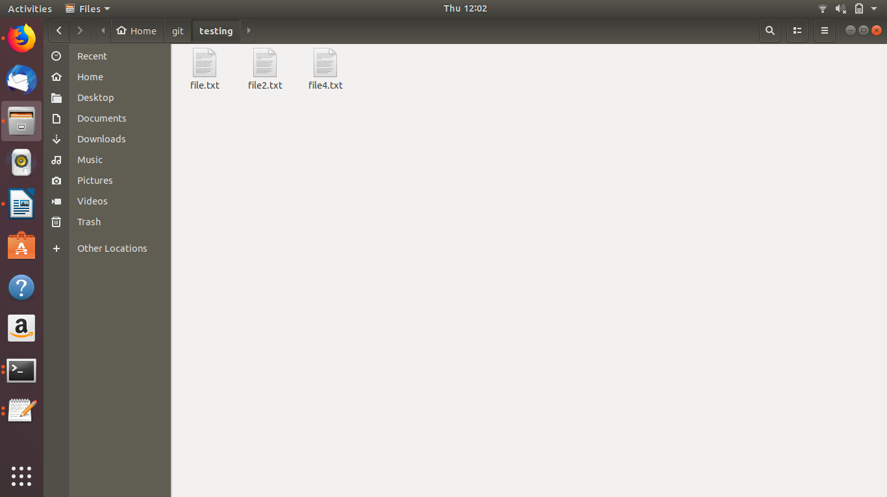
This is after pulling files from remote repository to local machine
using: $git pull origin master
3) List all the files in last commit
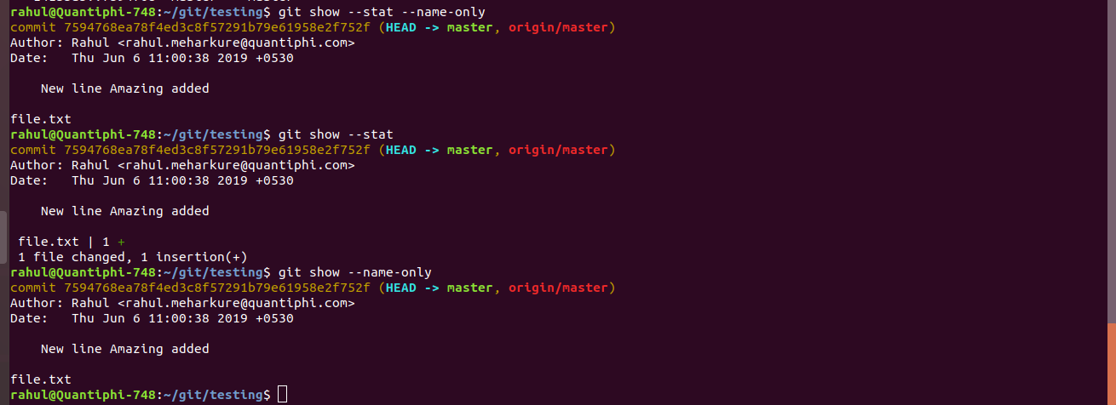

4) You’ve accidentally added some files on a DVCS. Remove those files from the DVCS without deleting them from your local system.

Initiall following files were present in the git repository
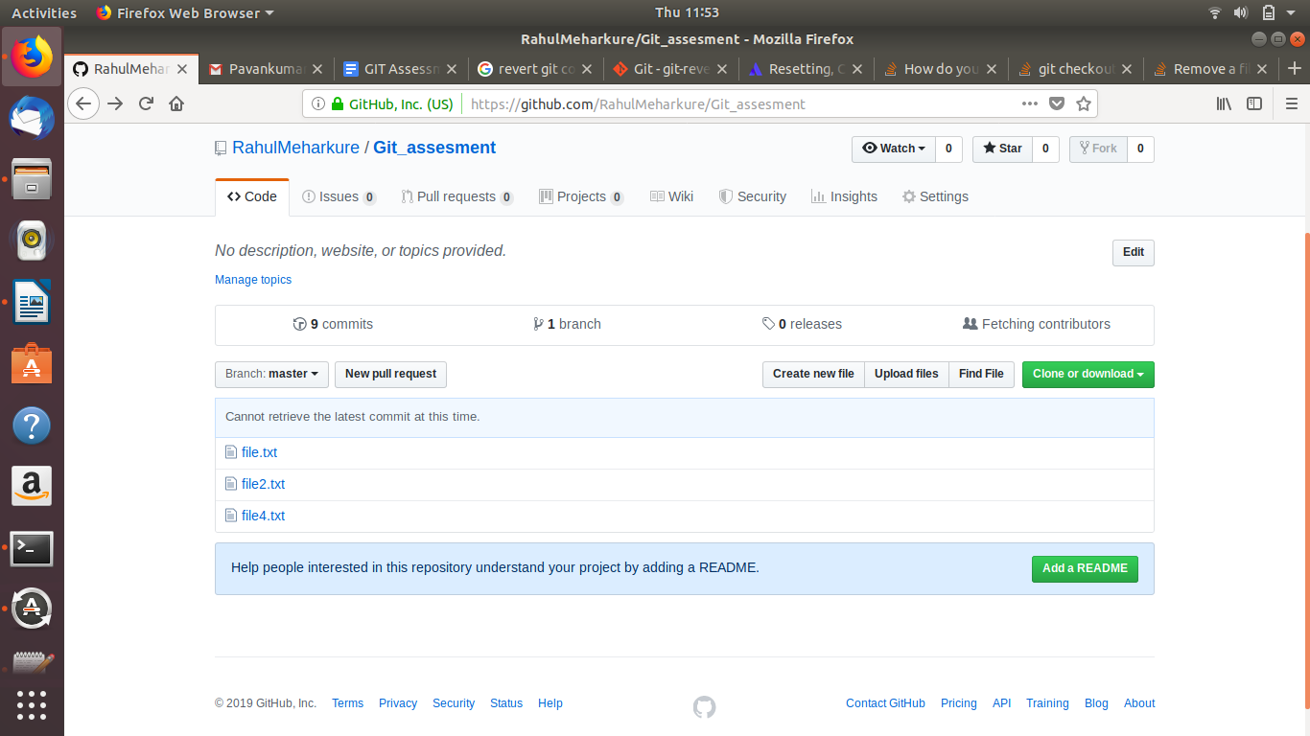

after using following commands:
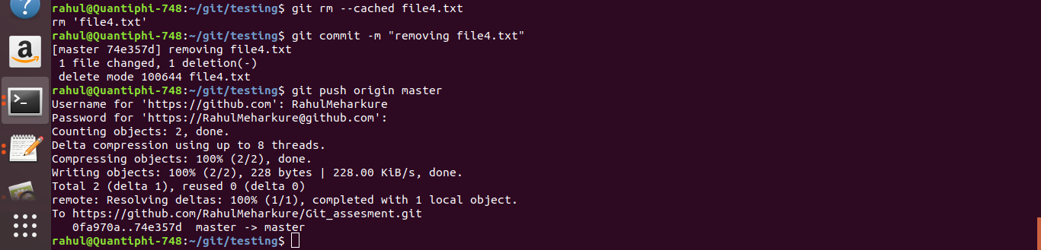
We get the output as:
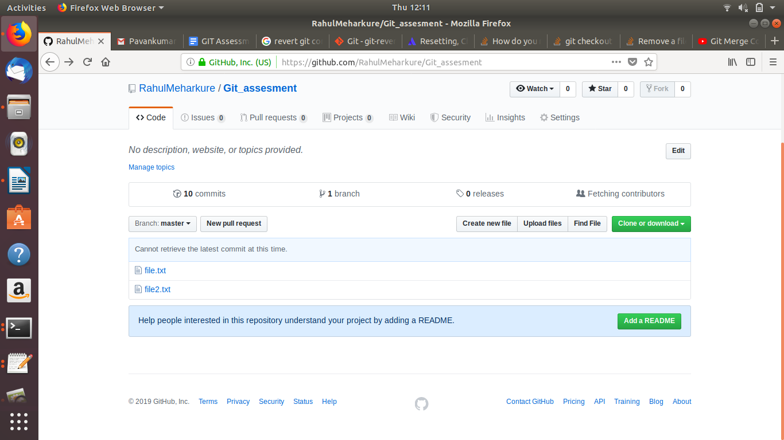

5)

adding file 3 and file 4 to git repository:

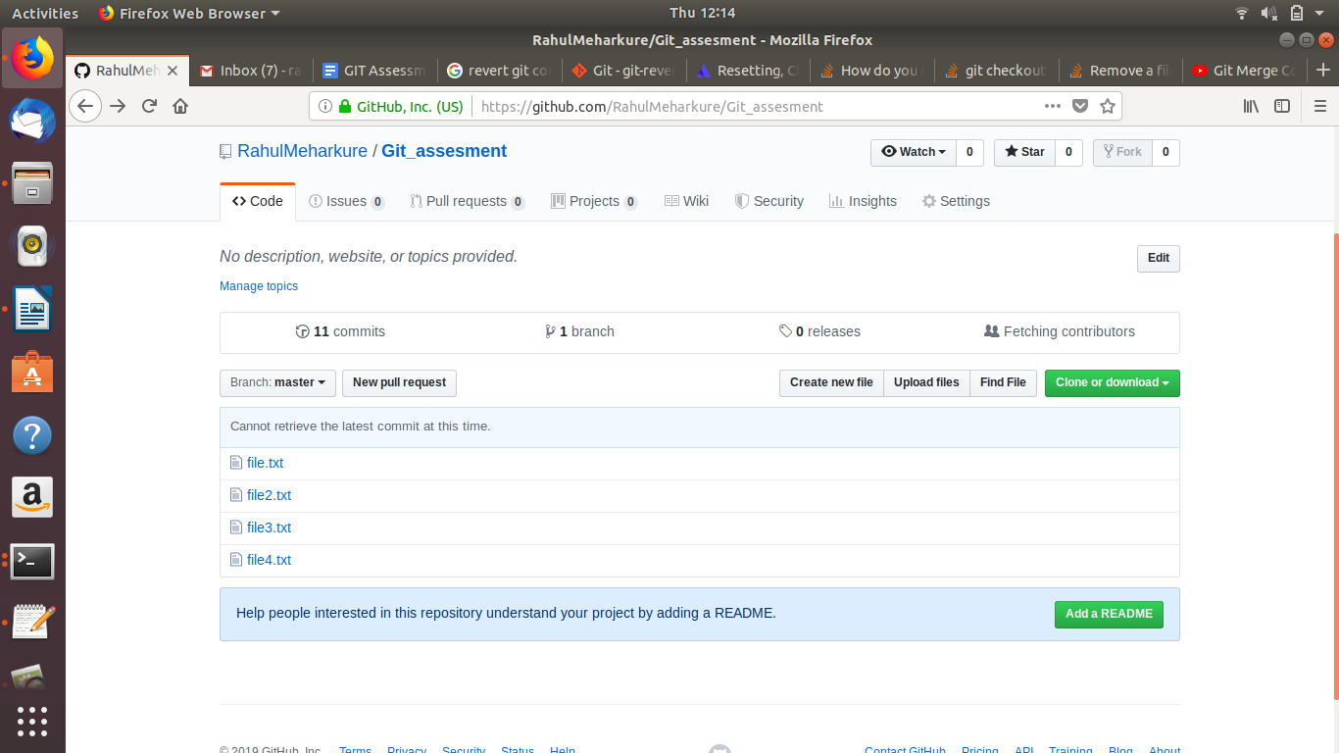
Reverting to stable state

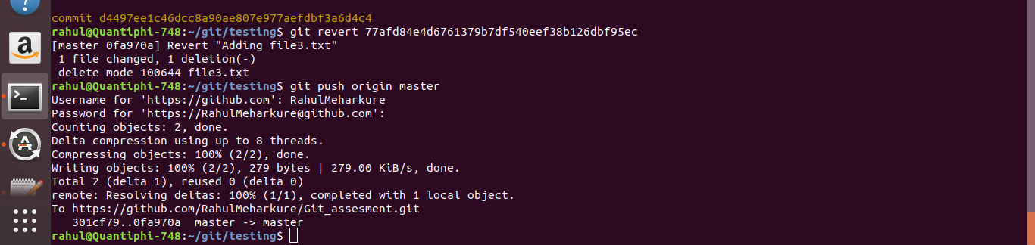

6)
Alice and bob are working on same repository
bob changes the file.txt
initial file.txt
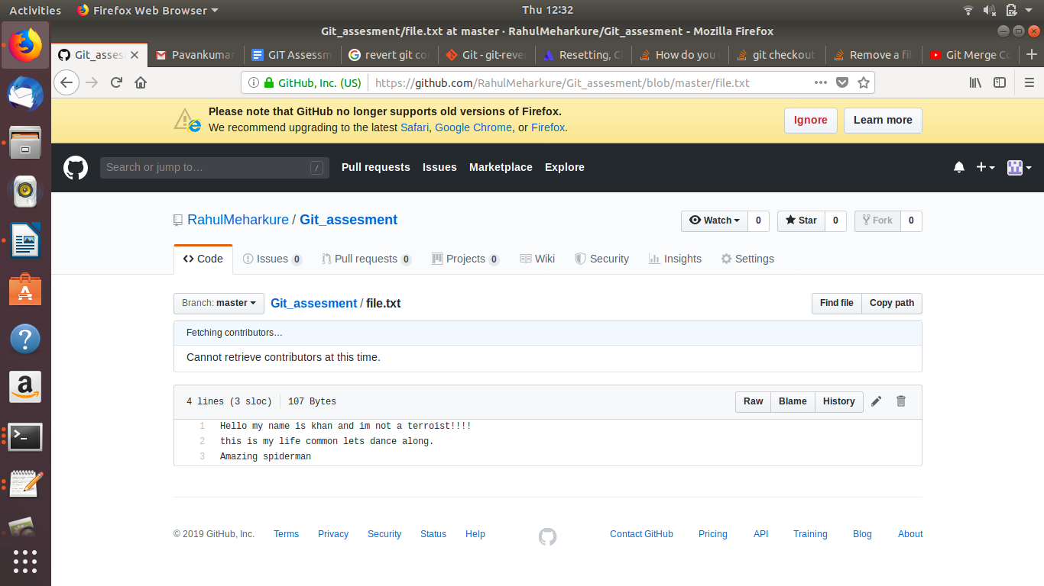

after bob makes changes to file.txt
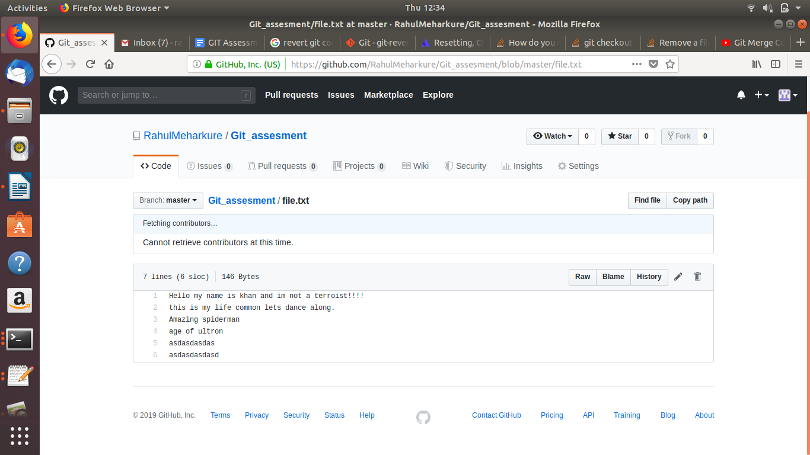
now alice is also making changes to same file.txt but she dosent have the update copy of file.txt (bob)
conflict occurs:
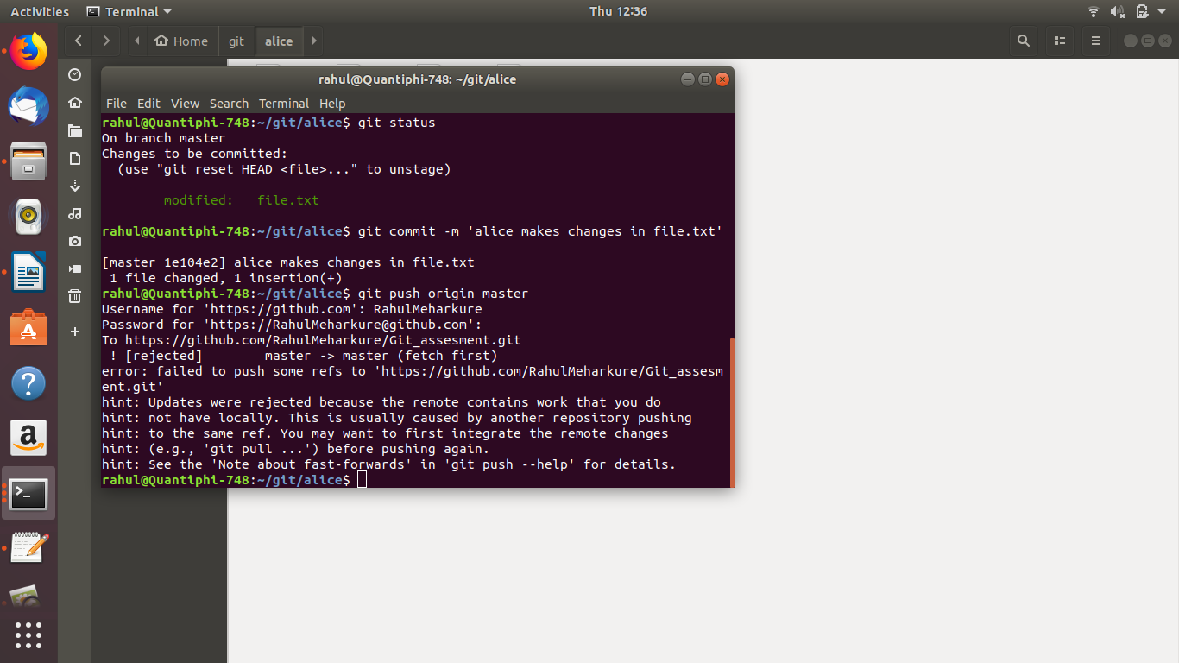
now clearing conflicts:
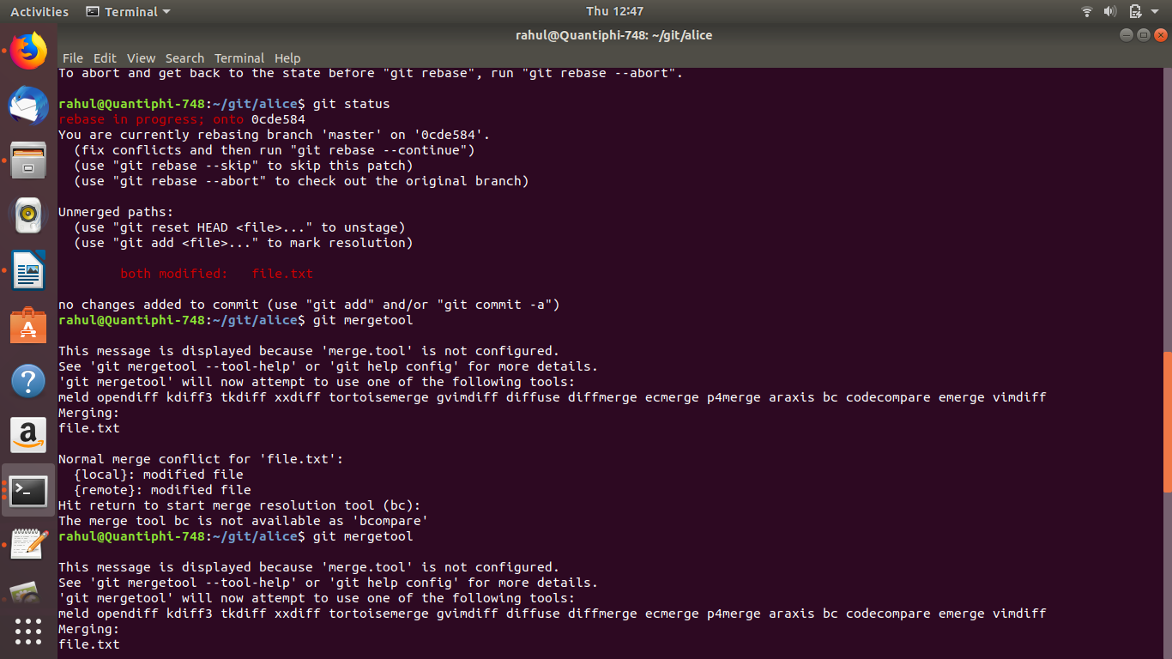
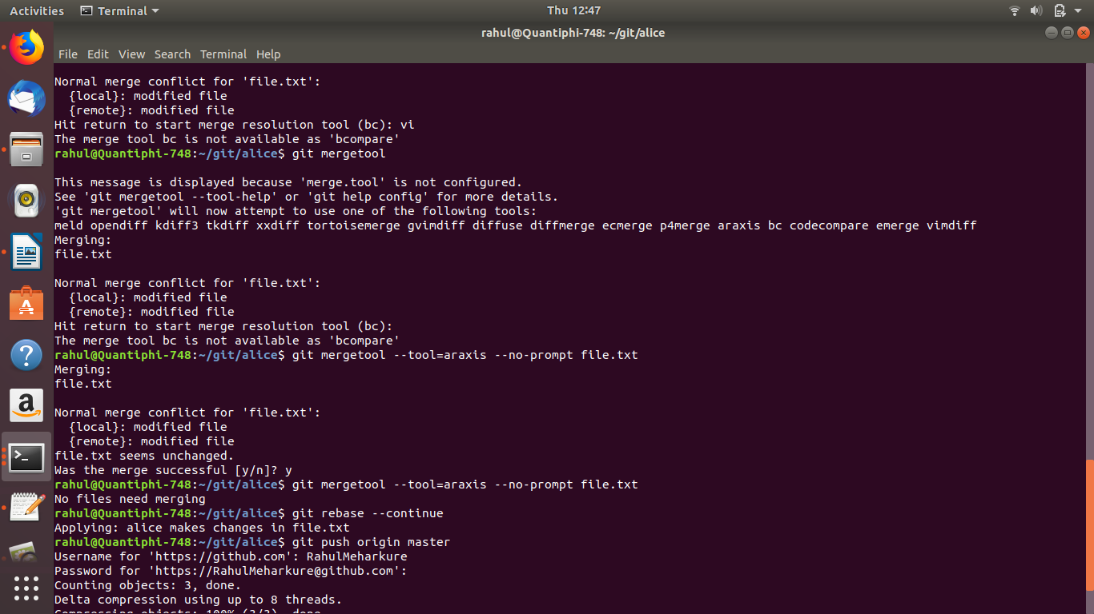
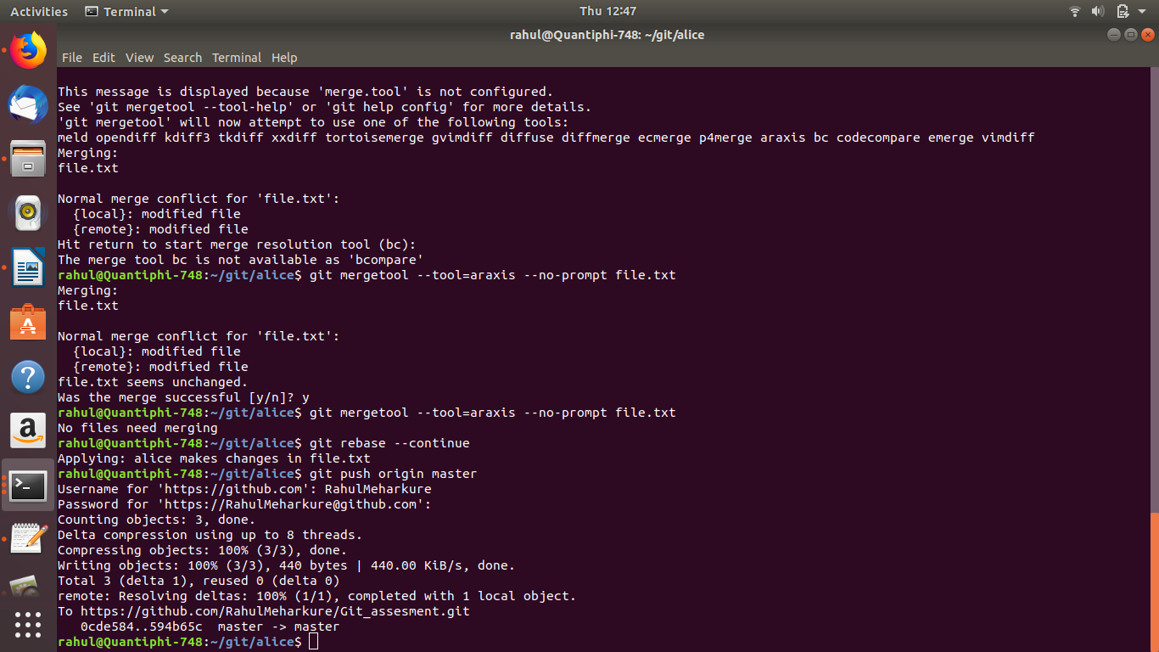
7)
