Linux Assessment

1)Consider a text file which has multi-lines text, output all the lines which has a specific word and also output the total number of occurrences of that word.

2) Search for all the files that have a ‘.txt’ extension in the current working directory
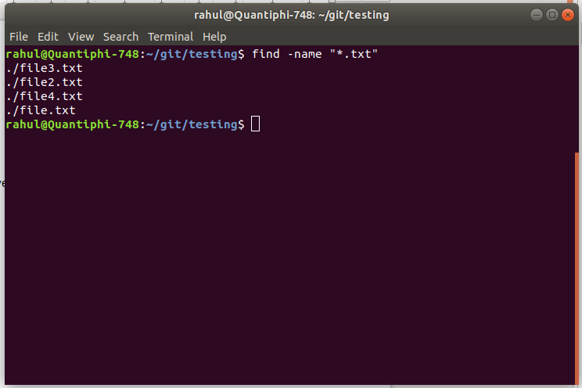

3) Execute a specific command in all the subdirectories whose names starts with “aws”. For example, your sub-directories are “aws_1”, “aws_2”, “gcp_1”, “aws_3”., Execute “pwd” command in the directories “aws_1”, “aws_2” and “aws_3”.

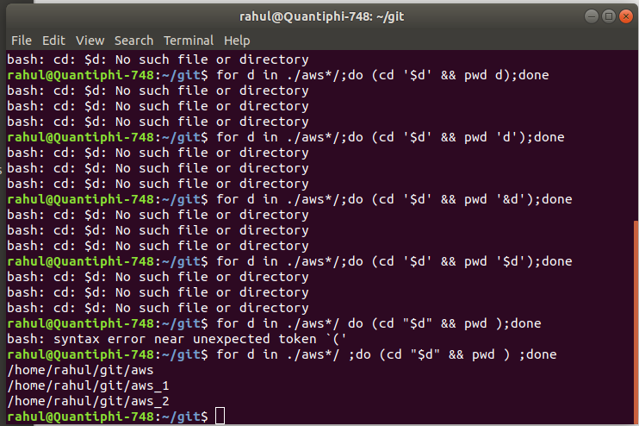

4) Consider a text file and replace a specific word with any word of your choice.

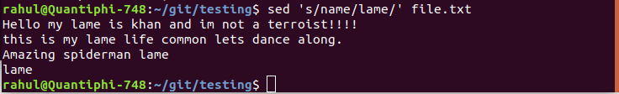

5) Use jq command line tool to get the arn of the s3 bucket from the file “s3_info.txt” which has the below content

