**Testing Class InternedStringsDemo :**

1. **With Java8**

After *java.lang.OutOfMemoryError: Java heap space* Error

HeapSize

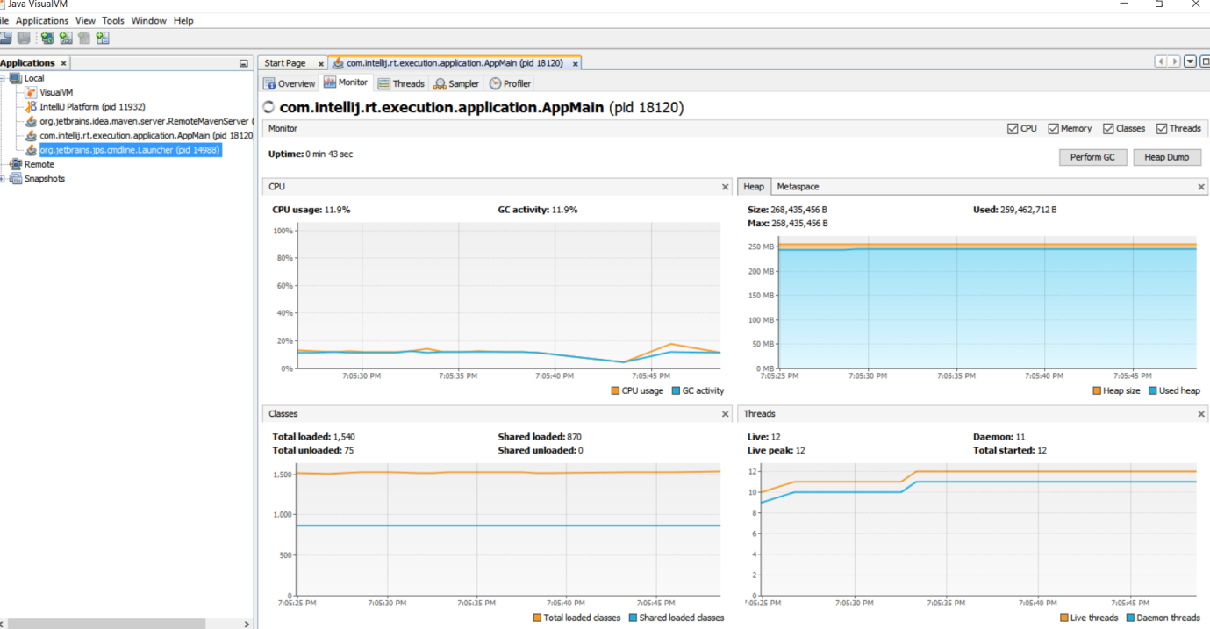

MetaSpace

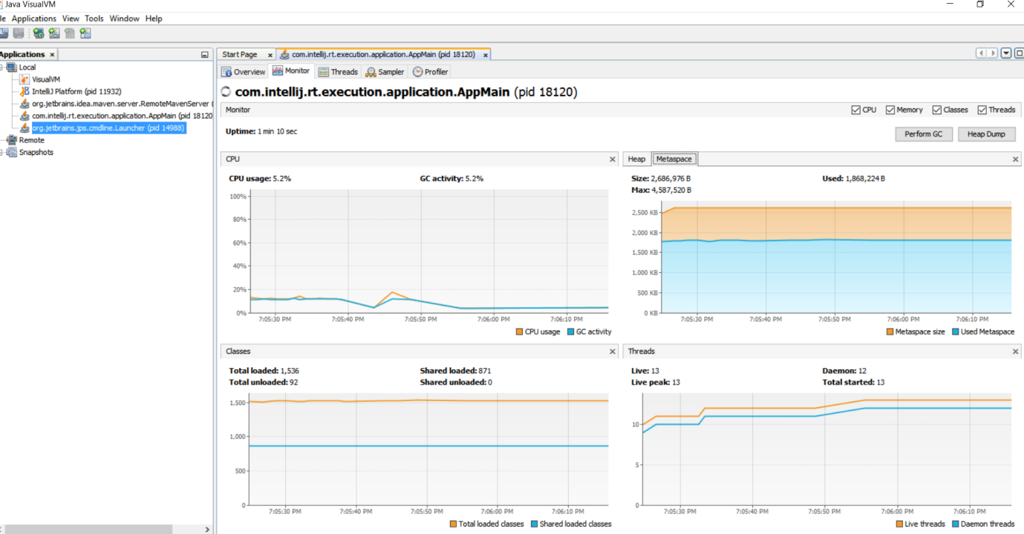

After GC:

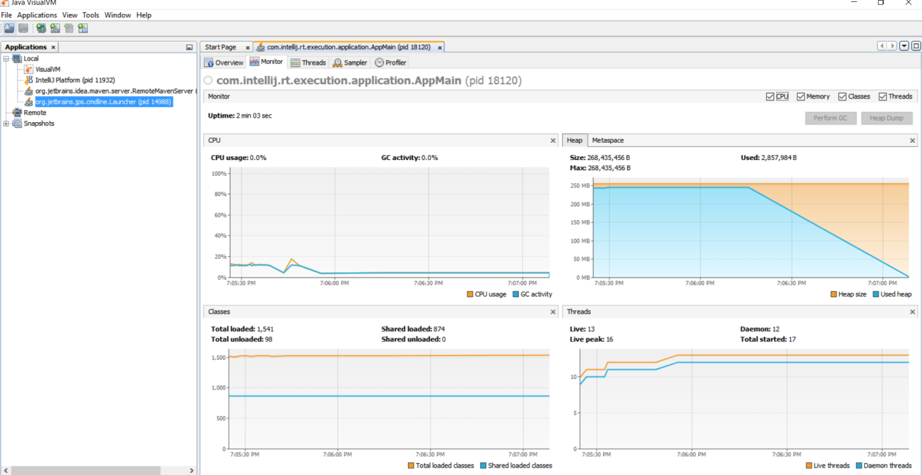

1. With Java6

After *java.lang.OutOfMemoryError: Java heap space* Error

HeapSize: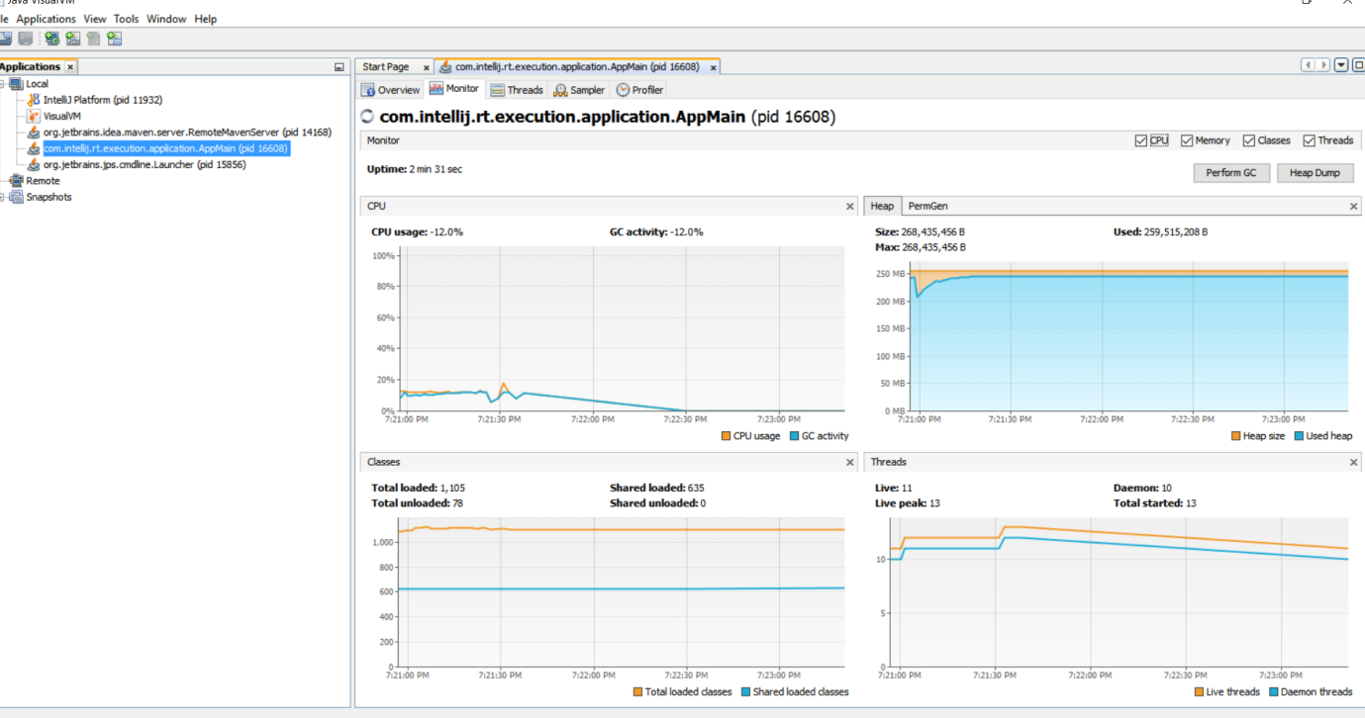

PermGen:

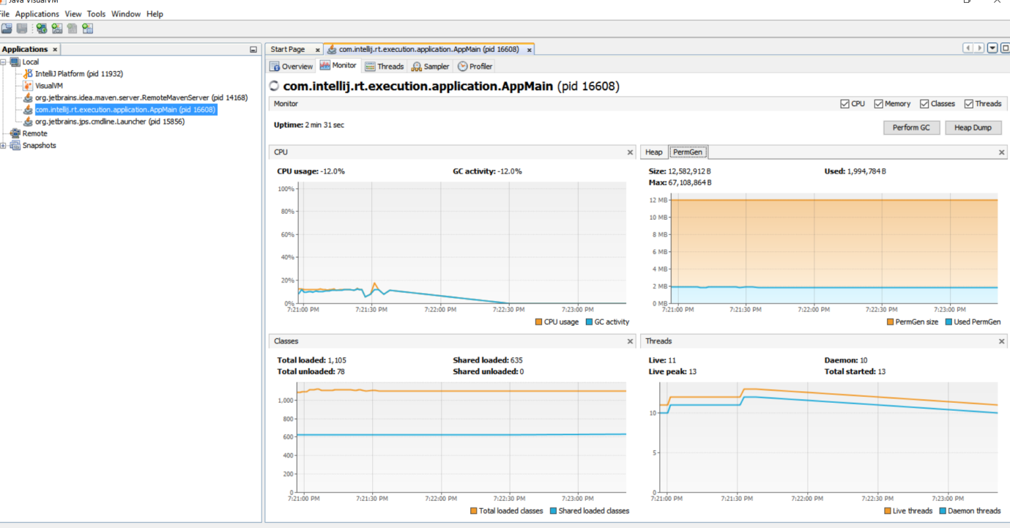

After GC:

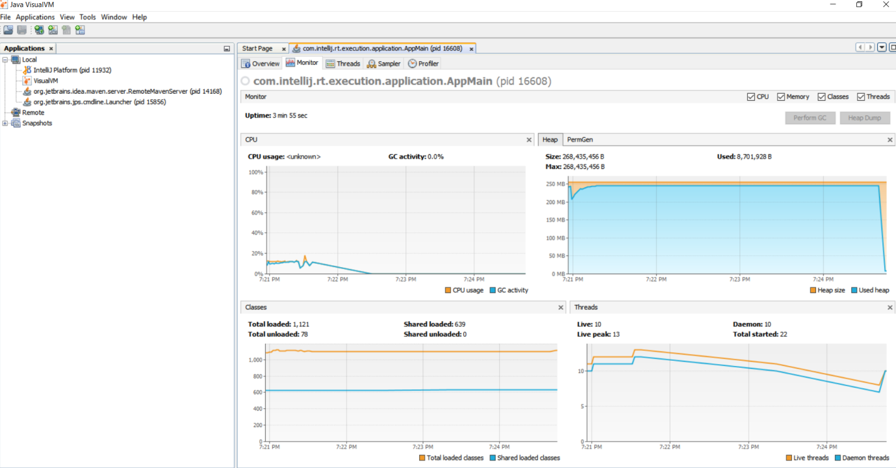

1. With Java7:

After *java.lang.OutOfMemoryError: Java heap space* Error

HeapSize

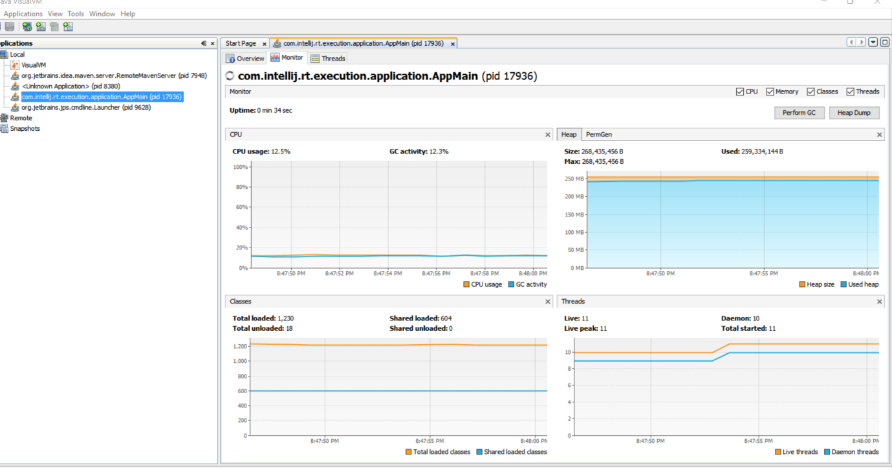

PermGen:

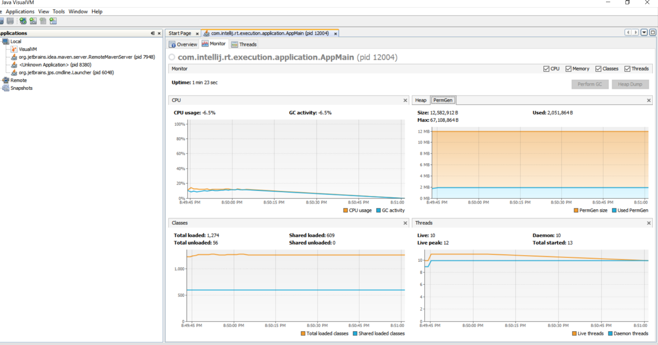

After GC:

