HeapDump before OOM: java_pid8792.0001.hprof

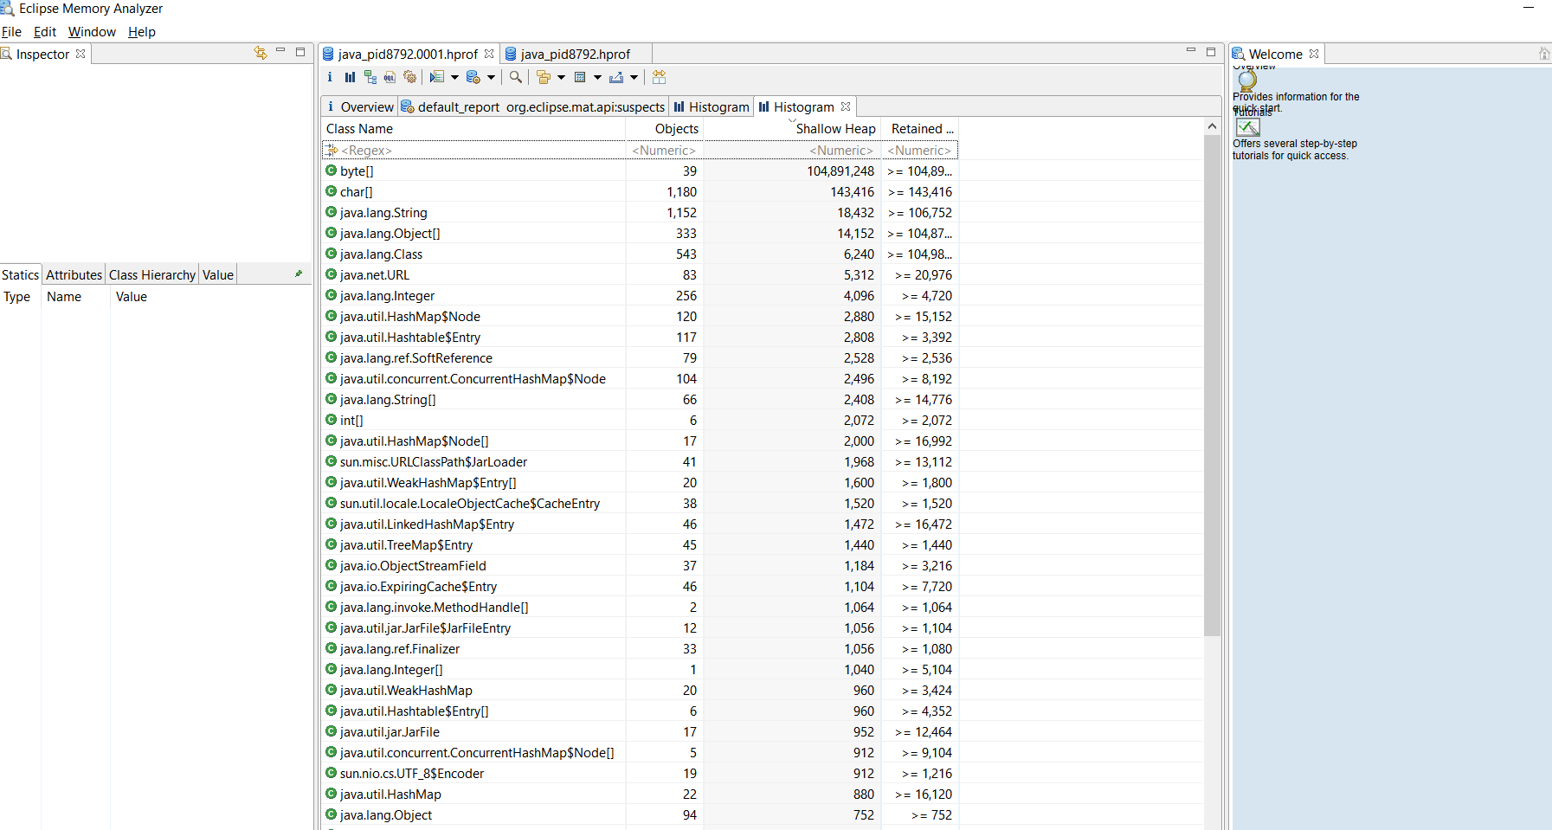

After OOM : java_pid8792.hprof

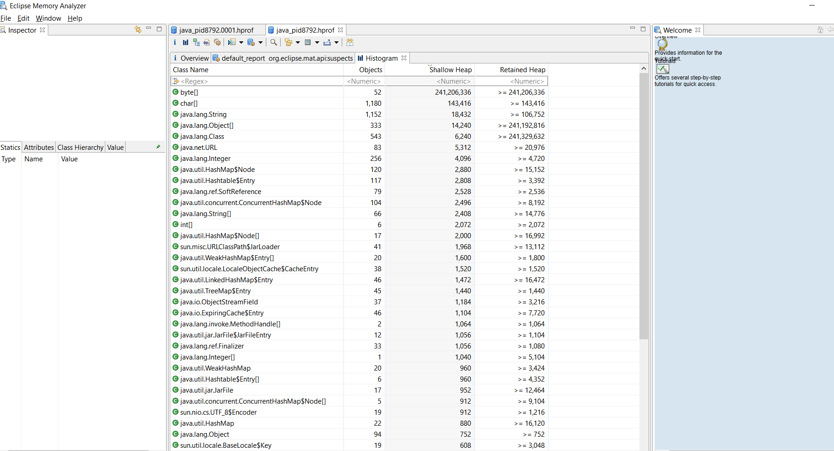

Comparison:

