* Deployed Sample SOAP Web service App to check the usage of AppDynamics tool.
* I was able to easily troubleshoot Slow Responses time with the clean Dashboard, within the selected time range.
* Configured Health Rules to track CPU, Memory Utilization & Garbage collection.Scalibility Analysis provide s further info about CPU, Load and Response Time.
* Used features like App Server and Business Transaction health to check the live status. Easily created Application Health report from the tool scheduling hourly health check .

Deployed Application

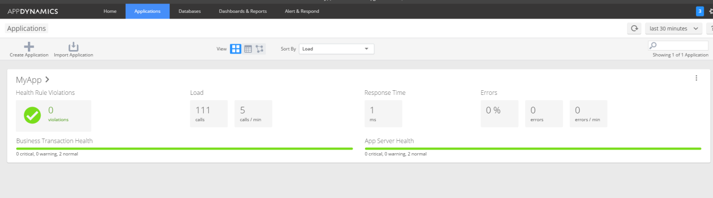

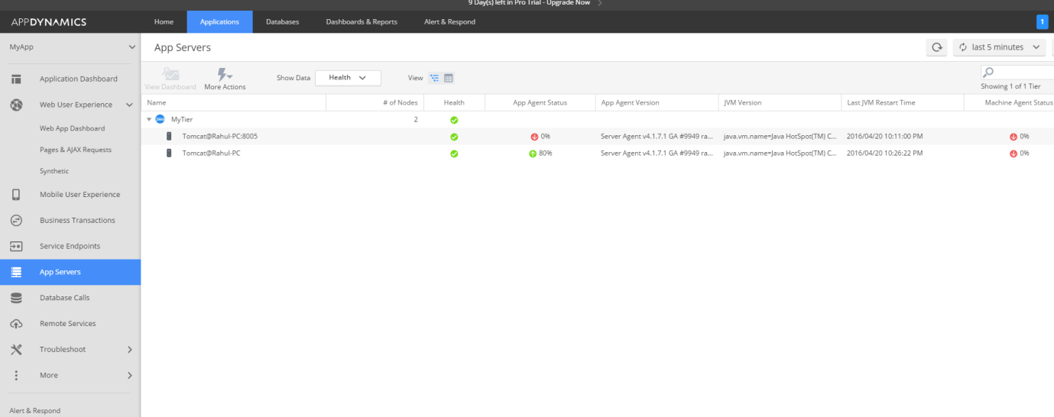

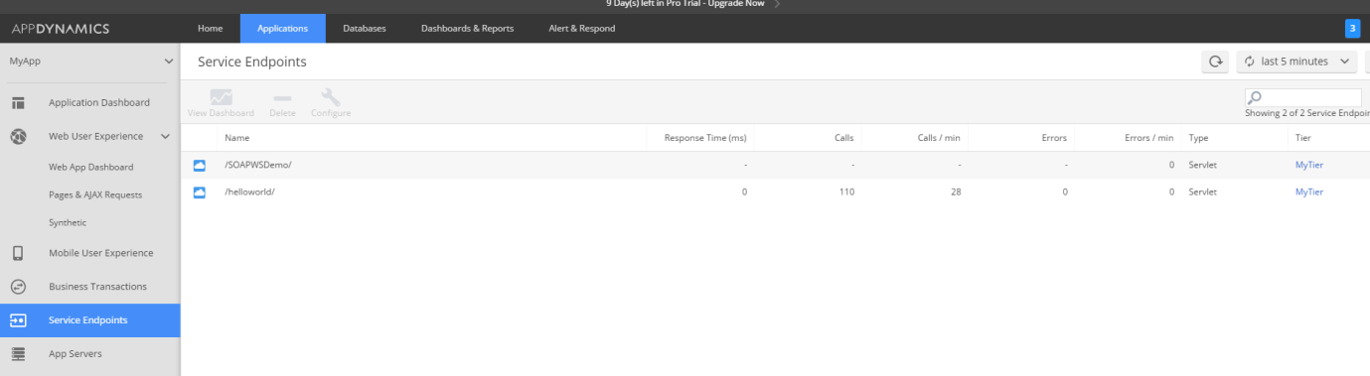

Health Check Rules for Memory, garbage collection

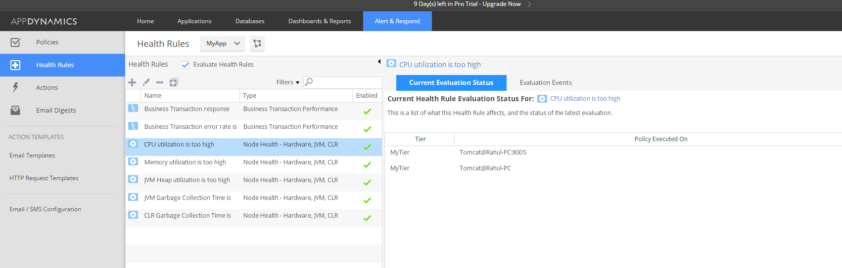

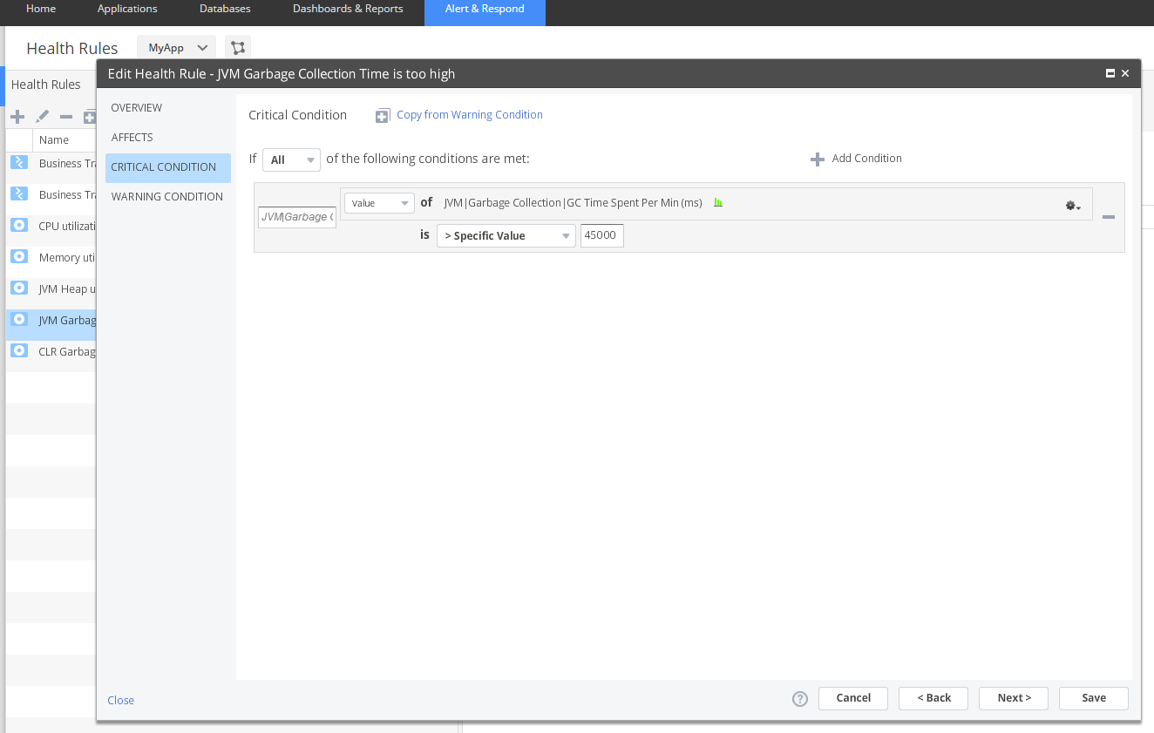

Application DashBoard

