CA-1

1.

CODE:

i)

package com.selenium.TestProject;

import org.openqa.selenium.By;

import org.openqa.selenium.WebDriver;

import org.openqa.selenium.WebElement;

import org.openqa.selenium.edge.EdgeDriver;

import io.github.bonigarcia.wdm.WebDriverManager;

public class CA1 {

public static void main(String[] args) {

WebDriverManager.*edgedriver*().setup();

WebDriver driver=new EdgeDriver();

driver.get("https://www.amazon.in/");

driver.manage().window().maximize();

String title=driver.getTitle();

System.***out***.println("title:"+title);

String htitle="Online Shopping site in India: Shop Online for Mobiles, Books, Watches, Shoes and More - Amazon.in";

if(title.equals(htitle)) {

System.***out***.println("sucess");

}

else {

System.***out***.println("failed");

}

// driver.findElement(By.xpath("//*[@id=\"DN_UygQtFGWLQDugWQth-w\"]/div[2]/div[1]/div[1]/a/div[1]/img")).click();

driver.findElement(By.*xpath*("//*[@id=\"twotabsearchtextbox\"]")).click();

driver.findElement(By.*xpath*("//*[@id=\"twotabsearchtextbox\"]")).sendKeys("DW watches");

driver.findElement(By.*xpath*("//*[@id=\"nav-search-submit-button\"]")).click(); //Thread.sleep(2000);

driver.navigate().to("https://www.amazon.in/Fossil-Smartwatch-Snapdragon Smartphone-Notifications/dp/B09DGS966L/ref=sr_1_25?crid=2LOQNXJII74SZ &keywords=fossil+watches&qid=1681295284&sprefix=fossil+watche%2Caps%2 C405&sr=8-25") ;

driver.findElement(By.*xpath*("//*[@id=\"add-to-cart-button\"]")).click();

WebElement cart=driver.findElement(By.*xpath*("//*[@id=\"nav-cart-count\"]"));

if(cart.getText().equals("1")) {

System.***out***.print("Added to cart is working successfully");

}

else {

System.***out***.print("Added to cart is not working successfully"); }

}

}

ii)

package com.selenium.TestProject;

import org.openqa.selenium.By;

import org.openqa.selenium.WebDriver;

import org.openqa.selenium.WebElement;

import org.openqa.selenium.edge.EdgeDriver;

import io.github.bonigarcia.wdm.WebDriverManager;

public class CA1 {

public static void main(String[] args) {

WebDriverManager.*edgedriver*().setup();

WebDriver driver=new EdgeDriver();

driver.get("https://www.amazon.in/");

driver.manage().window().maximize();

String title=driver.getTitle();

System.***out***.println("title:"+title);

String htitle="Online Shopping site in India: Shop Online for Mobiles, Books, Watches, Shoes and More - Amazon.in";

if(title.equals(htitle)) {

System.***out***.println("sucess");

}

else {

System.***out***.println("failed");

}

driver.findElement(By.*xpath*("//*[@id=\"twotabsearchtextbox\"]")).click();

driver.findElement(By.*xpath*("//*[@id=\"twotabsearchtextbox\"]")).sendKeys("fossil watches");

driver.findElement(By.*xpath*("//*[@id=\"nav-search-submit-button\"]")).click();

//Thread.sleep(2000);

driver.navigate().to("https://www.amazon.in/Fossil-Smartwatch-Snapdragon Smartphone-Notifications/dp/B09DGS966L/ref=sr_1_25?crid=2LOQNXJII74SZ &keywords=fossil+watches&qid=1681295284&sprefix=fossil+watche%2Caps%2 C405&sr=8-25") ;

driver.findElement(By.*xpath*("//*[@id=\"add-to-cart-button\"]")).click();

driver.navigate().to("https://www.amazon.in/gp/cart/view.html?ref_=nav_cart" );

WebElement cart=driver.findElement(By.*xpath*("/html/body/div[1]/div[2]/div[3]/div[5]/div/div [2]/div[1]/div/form/div[2]/div[3]/div[4]/div/div[2]/div[1]/span[1]/span/span[1]/span/ span/span/span/span[2]"));

if(cart.getText().equals("0")) {

System.***out***.print("Removing from cart is working successfully"); }

else {

System.***out***.print("Removing from cart is not working successfully");

}

}

}

iii)

package com.selenium.TestProject;

import org.openqa.selenium.By;

import org.openqa.selenium.WebDriver;

import org.openqa.selenium.WebElement;

import org.openqa.selenium.edge.EdgeDriver;

import io.github.bonigarcia.wdm.WebDriverManager;

public class CA1 {

public static void main(String[] args) throws Exception {

WebDriverManager.*edgedriver*().setup();

WebDriver driver=new EdgeDriver();

driver.get("https://www.amazon.in/");

driver.manage().window().maximize();

String title=driver.getTitle();

System.***out***.println("title:"+title);

String htitle="Online Shopping site in India: Shop Online for Mobiles, Books, Watches, Shoes and More - Amazon.in";

if(title.equals(htitle)) {

System.***out***.println("success");

}

else {

System.***out***.println("failed");

}

driver.findElement(By.*xpath*("//*[@id=\"twotabsearchtextbox\"]")).click();

driver.findElement(By.*xpath*("//*[@id=\"twotabsearchtextbox\"]")).sendKeys("f ossil watches");

driver.findElement(By.*xpath*("//*[@id=\"nav-search-submit-button\"]")).click();

Thread.*sleep*(2000);

driver.navigate().to("https://www.amazon.in/Fossil-Smartwatch-Snapdragon Smartphone-Notifications/dp/B09DGS966L/ref=sr_1_25?crid=2LOQNXJII74SZ &keywords=fossil+watches&qid=1681295284&sprefix=fossil+watche%2Caps%2 C405&sr=8-25") ;

driver.findElement(By.*xpath*("//*[@id=\"add-to-cart-button\"]")).click();

driver.navigate().to("https://www.amazon.in/gp/cart/view.html?ref_=nav_cart" );

driver.findElement(By.*xpath*("//*[@id=\"a-autoid-0\"]")).click(); driver.findElement(By.*xpath*("//*[@id=\"quantity_2\"]")).click(); Thread.*sleep*(2000);

WebElement

cart=driver.findElement(By.*xpath*("//*[@id=\"nav-cart-count\"]")); if(cart.getText().equals("2")) {

System.***out***.print("Updating cart is working successfully");

}else {

System.***out***.print("Updating cart is not working successfully"); }

}

}

iv) and v)

package com.selenium.TestProject;

import org.openqa.selenium.By;

import org.openqa.selenium.WebDriver;

import org.openqa.selenium.WebElement;

import org.openqa.selenium.edge.EdgeDriver;

import io.github.bonigarcia.wdm.WebDriverManager;

public class CA1 {

public static void main(String[] args) throws Exception {

WebDriverManager.*edgedriver*().setup();

WebDriver driver=new EdgeDriver();

driver.get("https://www.amazon.in/");

driver.manage().window().maximize();

String title=driver.getTitle();

System.***out***.println("title:"+title);

String htitle="Online Shopping site in India: Shop Online for Mobiles, Books, Watches, Shoes and More - Amazon.in";

if(title.equals(htitle)) {

System.***out***.println("success");

}

else {

System.***out***.println("failed");

}

driver.findElement(By.*xpath*("//*[@id=\"twotabsearchtextbox\"]")).click();

driver.findElement(By.*xpath*("//*[@id=\"twotabsearchtextbox\"]")).sendKeys("f ossil watches");

driver.findElement(By.*xpath*("//*[@id=\"nav-search-submit-button\"]")).click(); //Thread.sleep(2000);

driver.navigate().to("https://www.amazon.in/Fossil-Smartwatch-Snapdragon Smartphone-Notifications/dp/B09DGS966L/ref=sr_1_25?crid=2LOQNXJII74SZ &keywords=fossil+watches&qid=1681295284&sprefix=fossil+watche%2Caps%2 C405&sr=8-25") ;

driver.findElement(By.*xpath*("//*[@id=\"add-to-cart-button\"]")).click();

driver.navigate().to("https://www.amazon.in/gp/cart/view.html?ref_=nav_cart" );

driver.findElement(By.*xpath*("//*[@id=\"a-autoid-0\"]")).click(); driver.findElement(By.*xpath*("//*[@id=\"quantity_2\"]")).click(); Thread.*sleep*(2000);

WebElement

cart=driver.findElement(By.*xpath*("//*[@id=\"nav-cart-count\"]")); if(cart.getText().equals("2")) {

System.***out***.print("checkout is working successfully and the cost details are correct");

}

else {

System.***out***.print("checkout working is unsuccessful , therefore cost details are not displayed");

}

}

}

OUTPUT:

i)

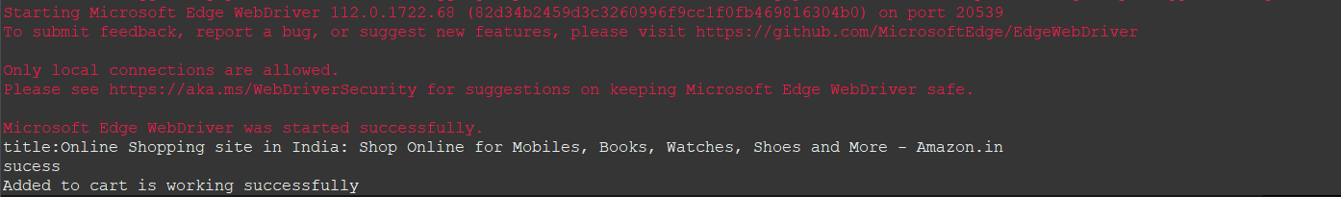

ii)

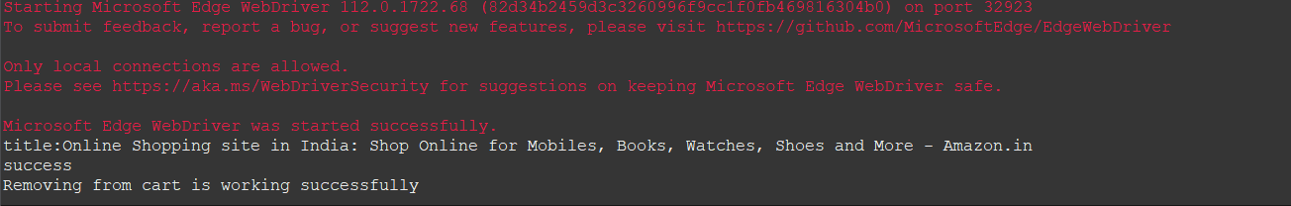

iii)

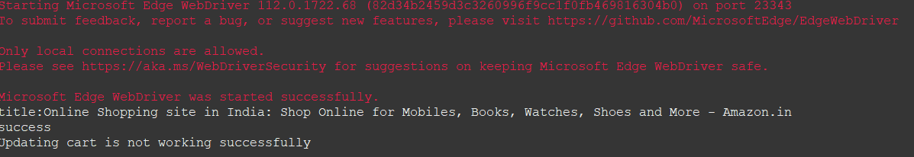

iv) and v)

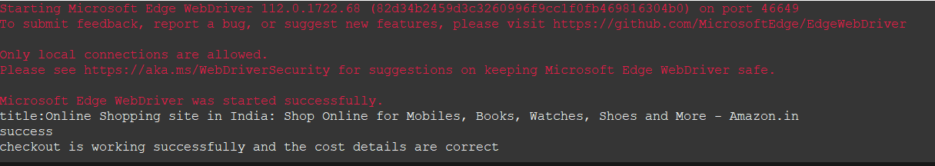

2.

CODE:

package com.selenium.TestProject;

import java.util.List;

import org.openqa.selenium.By;

import org.openqa.selenium.Keys;

import org.openqa.selenium.WebElement;

import org.openqa.selenium.edge.EdgeDriver;

import io.github.bonigarcia.wdm.WebDriverManager;

public class CA2 {

public static void main(String[] args) {

int productCount = 0;

WebDriverManager.*edgedriver*().setup();

EdgeDriver driver = new EdgeDriver();

driver.get("https://www.amazon.in/");

driver.manage().window().maximize();

driver.findElement(By.*id*("twotabsearchtextbox")).sendKeys("dress");

driver.findElement(By.*id*("twotabsearchtextbox")).sendKeys(*Keys*.***ENTER***);

List<WebElement> tiltleElements = driver.findElements(By.*xpath*("//h2[@class='a-size-mini a-spacing-none a-color-base s-line-clamp-2']"));

for (WebElement titleElement : tiltleElements) {

System.***out***.println(titleElement.getText());

productCount++;

if(productCount == 5) {

break;

}

}

WebElement sort = driver.findElement(By.*xpath*("//*[@id=\"a-autoid-0-announce\"]"));

sort.click();

System.***out***.println("Filter Applied!");

WebElement lhfilter = driver.findElement(By.*xpath*("//*[@id=\"s-result-sort-select_1\"]"));

lhfilter.click();

System.***out***.println("Based on Price");

sort.click();

WebElement reviewfilter = driver.findElement(By.*xpath*("//*[@id=\"s-result-sort-select_3\"]"));

reviewfilter.click();

System.***out***.println("Based on Reviews");

}

}

OUTPUT:



3.

CODE:

package com.selenium.TestProject;

import org.openqa.selenium.By;

import org.openqa.selenium.WebDriver;

import org.openqa.selenium.WebElement;

import io.github.bonigarcia.wdm.WebDriverManager;

import org.openqa.selenium.edge.EdgeDriver;

public class CA3 {

public static void main(String[] args) {

// **TODO** Auto-generated method stub

WebDriverManager.*edgedriver*().setup();

WebDriver driver=new EdgeDriver();

driver.get("https://www.amazon.in/");

driver.manage().window().maximize();

String title=driver.getTitle();

System.***out***.println("title:"+title);

String htitle="Online Shopping site in India: Shop Online for Mobiles, Books, Watches, Shoes and More - Amazon.in";

if(title.equals(htitle)) {

System.***out***.println("sucess");

}

else {

System.***out***.println("failed");

}

driver.findElement(By.*xpath*("//*[@id=\"ap_email\"]")).click();

driver.findElement(By.*xpath*("//*[@id=\"ap_email\"]")).sendKeys("9489137020") ;

driver.findElement(By.*xpath*("//*[@id=\"continue\"]")).click();

driver.findElement(By.*xpath*("//*[@id=\"ap_password\"]")).click();

driver.findElement(By.*xpath*("//*[@id=\"ap_password\"]")).sendKeys("Navadeesh15");

driver.findElement(By.*xpath*("//*[@id=\"signInSubmit\"]")).click(); driver.findElement(By.*xpath*("//*[@id=\"nav-link-accountList\"]")).click();

WebElement acc=driver.findElement(By.*xpath*("//*[@id=\"a-page\"]/div[2]/div/div[1]/h1")); String actual=acc.getText();

String expected="Your Account";

if(actual.equals(expected)) {

System.***out***.println("Your Account page is displayed");

}

driver.findElement(By.*xpath*("//*[@id=\"a-page\"]/div[2]/div/div[2]/div[1]/a/div")). click();

WebElement

ord=driver.findElement(By.*xpath*("//*[@id=\"a-page\"]/section/div[1]/div[2]/div[1 ]/h1"));

String act=ord.getText();

String exp="Your Orders";

if(act.equals(exp)) {

System.***out***.println("Your Order page is displayed");

}

//

driver.findElement(By.*xpath*("//*[@id=\"a-page\"]/div[2]/div/div[2]/div[1]/a/div")) .click();

WebElement trac=driver.findElement(By.*xpath*("//*[@id=\"a-page\"]/section/div[1]/div[2]/div[ 1]/h1"));

String act1=ord.getText();

String exp1="Your orders";

if(act.equals(exp)) {

System.***out***.println("User is able to track package");

}

//

driver.findElement(By.*xpath*("//*[@id=\"pop\"]/div/div[2]/div/div[1]/div/div[3]/di v/div/div/div/div[2]/div/div/a")).click();

System.***out***.println("User is able to view their products");

}

}

OUTPUT:

