A Report on Major project

**Smart Parking System Using IOT***SUBMITTED IN PARTIAL FULFILLMENT OF THE REQUIREMENTS FOR THE DEGREE OF*

#### BACHELOR OF TECHNOLOGY IN

**COMPUTER ENGINEERING OF**

**VISHWAKARMA INSTITUTE OF TECHNOLOGY**

## Savitribai Phule Pune University

*BY*

#### Harsh Poddar (GR No. 12011330) Mandar Kalse (GR No. 12010343) Rahul Nagpure (GR No. 12120013) Deepak Gavit (GR No. 12120265)

*UNDER THE GUIDANCE OF*

**Prof. Dr. Jyoti Kanjalkar**



DEPARTMENT OF COMPUTER ENGINEERING

BANSILAL RAMNATH AGARWAL CHARITABLE TRUST’S

VISHWAKARMA INSTITUTE OF TECHNOLOGY

(An Autonomous Institute affiliated to Savitribai Phule Pune University)

PUNE - 411037

2023 - 2024

**BANSILAL RAMNATH AGARWAL CHARITABLE TRUST’S**

## VISHWAKARMA INSTITUTE OF TECHNOLOGY

**(An Autonomous Institute affiliated to Savitribai Phule Pune University)**

## PUNE – 411037



**CERTIFICATE**

This is to certify that the Major Project titled **Smart Parking Using IOT** submitted by **Harsh Poddar (GR No. 12011330), Mandar Kalse (GR No. 12010343), Rahul Nagpure (GR No. 12120013)** and **Deepak Gavit (GR No. 12120265)** is in partial fulfillment for the award of Degree of Bachelor of Technology in Computer Engineering of Vishwakarma Institute of Technology, Savitribai Phule Pune University. This project report is a record of bonafide work carried out by them under my guidance during the academic year 2023-24.

### Guide Head of Computer Department Prof .Dr. Jyoti Kanjalkar Prof. Dr. S. R. Shinde

Dept. of Computer Engg. Vishwakarma Institute of Technology, Pune

#### Sign of External Examiner Date

Bansilal Ramnath Agarwal Charitable Trust’s

### Vishwakarma Institute Of Technology, Pune-37

**Department Of Computer Engineering**

## PROJECT SYNOPSIS

**Group No : 8 Group Members:**

|  |  |  |  |  |
| --- | --- | --- | --- | --- |
| **Roll No** | **Name** | **Class** | **Contact No** | **Email-ID** |
| 35 | Harsh Poddar | B. Tech | 7038441866 | [harsh.poddar20@vit.edu](mailto:harsh.poddar20@vit.edu) |
| 34 | Mandar Kalse | B. Tech | 9370023811 | [mandar.kalse20@vit.edu](mailto:mandar.kalse20@vit.edu) |
| 83 | Rahul Nagpure | B. Tech | 9762734720 | [rahul.nagpure21@vit.edu](mailto:rahul.nagpure21@vit.edu) |
| 44 | Deepak Gavit | B. Tech | 9960104943 | deepak.gavit21@vit.edu |

Academic Year : 2023-24

Project Title : Smart Parking System Using

Project Area : IOT

Sponsor Company : NA

Company Address : NA

Internal Guide : Prof. Dr. Jyoti Kanjalkar

Name of the External Guide:

Contact No:

**Signature of Internal Guide**

## ACKNOWLEDGEMENT

It gives us great satisfaction to be able to present this project on Aspect and Opinion Extraction for Amazon Reviews. We would like to express our deep gratitude towards our project guide Prof. Jyoti Kanjalkar, for all the guidance and the co-operation, without whom this project would have been an uphill task. We would also like to thank Prof. Dr. Sandeep Shinde for his invaluable guidance on how to robustly secure the web application.

Harsh Poddar

Mandar Kalse

Rahul Nagpure

Deepak Gavit

**INDEX**

|  |  |  |
| --- | --- | --- |
| **Sr.no.** | **Table of contents** | **Pg. no** |
| 1 | Software Project Synopsis | 6 |
| 2 | Feasibility Status Report | 9 |
| 3 | Use Case Analysis Document | 23 |
| 5 | Software Project Plan | 26 |
| 6 | Software Implementation Document | 32 |
| 7 | Conclusion | 52 |

# Software Project Synopsis



#### Approvals Signature Block

|  |  |  |
| --- | --- | --- |
| **Project Responsibility** | **Signature** | **Date** |
| *Project Guide (Internal)* |  |  |
| *Project Guide (External)* |  |  |
| *Documentation Leader* |  |  |



The "Smart Car Parking System using IoT" project is designed to modernize conventional parking management systems by harnessing the power of Internet of Things (IoT) technology. This initiative directly addresses the escalating challenges of urban parking, aiming to optimize the utilization of parking spaces while delivering a seamless experience for both drivers and parking administrators. Through the strategic deployment of a network of IoT devices and sensors, including ultrasonic, infrared, and cameras, the system continuously monitors parking space availability in real-time. The data collected from these sensors is wirelessly transmitted to a central control unit, enabling efficient and dynamic management of parking facilities. This innovation holds the potential to revolutionize urban parking, enhancing convenience, reducing congestion, and contributing to a more sustainable and connected urban environment.



The current state of urban parking management systems is beset by inefficiencies, congestion, and a lack of real-time insights. Traditional approaches fall short in optimizing parking space utilization, resulting in increased traffic, frustrated drivers, and environmental impact. In response to these challenges, the implementation of a Smart Car Parking System utilizing IoT is proposed. However, the adoption of such a system encounters significant obstacles, including high infrastructure costs, interoperability issues among diverse IoT devices, concerns regarding data security and privacy, challenges in managing power consumption and maintenance, and the need for seamless integration with existing systems. User adoption and behavior, scalability considerations, and environmental factors further complicate the successful deployment of this innovative solution. Addressing these challenges is essential for ushering in a new era of intelligent, efficient, and user-friendly urban parking management.

The proposed Smart Car Parking System using IoT offers a holistic set of solutions to address pressing challenges in urban parking management. By providing real-time space availability updates through a network of sensors and digital signage, the system aims to alleviate congestion and frustration for drivers. Integration of the Unified Payments Interface streamlines the payment process, enhancing user convenience. Parking administrators benefit from a web-based dashboard, empowering efficient resource allocation and decision-making. Timed parking slots with dynamic pricing optimize demand, while occupancy detection and prediction using cameras and sensors enhance user confidence in finding parking. The pre-booking feature with online payment, coupled with security measures like image sensors, ensures a streamlined and secure parking experience. Analytics derived from parking usage patterns contribute to better urban planning, and the system's environmental impact mitigation is realized through reduced carbon emissions and traffic congestion. Together, these features offer a comprehensive solution to revolutionize traditional parking management systems and create a more efficient and user-friendly urban parking environment.

# Feasibility Study Report



#### Approvals Signature Block

|  |  |  |
| --- | --- | --- |
| **Project Responsibility** | **Signature** | **Date** |
| *Project Guide (Internal)* |  |  |
| *Project Guide (External)* |  |  |
| *Documentation Leader* |  |  |

**1. INTRODUCTION**

In the contemporary landscape of urban mobility, the intricate challenges posed by parking inefficiencies, traffic congestion, and environmental ramifications necessitate a paradigm shift in conventional parking management methodologies. Existing systems exhibit limitations in optimizing resource allocation and providing timely information to drivers, resulting in heightened frustration and ecological impact. In response to these imperatives, the proposition of a Smart Car Parking System utilizing Internet of Things (IoT) technologies emerges as a pioneering solution. This system, leveraging advanced features such as sensors, cameras, and real-time analytics, endeavors to redefine the dynamics of urban parking. Offering functionalities such as dynamic space availability updates, seamless Unified Payments Interface (UPI) transactions, predictive analytics, and heightened security protocols, the Smart Car Parking System aspires to reimagine urban parking experiences. Positioned at the intersection of technological innovation and urban planning, this solution seeks to foster operational efficiency, sustainability, and a seamlessly interconnected relationship between drivers and administrators.

**1.1 Purpose**

The feasibility study for the implementation of a Smart Car Parking System using IoT indicates a favorable outlook. Technical assessments affirm the maturity of IoT technologies, with proposed solutions addressing interoperability challenges. Economic analyses project a positive return on investment through increased user adoption and potential revenue streams. Operational considerations prioritize user acceptance and adaptability, guided by continuous feedback and stakeholder collaboration. The established project schedule, regulatory compliance, and risk mitigation strategies reinforce the viability of this innovative solution, positioning it as a promising initiative to address urban parking challenges, optimize resource utilization, and enhance overall urban mobility.

**1.2 Methodology**

In the first phase of the Smart Parking System, users interact with the web-based user interface, seamlessly crafted with HTML, CSS, and JavaScript. This interface provides an intuitive and real-time view of parking slot availability, ensuring a user-friendly experience. Concurrently, IoT sensors embedded in parking slots detect occupancy, sending crucial data to the central server. In response, the server promptly updates the status of each slot, distinguishing between occupied and available spaces.

Moving on to the second phase, the system facilitates a streamlined booking process. Users, upon requesting a parking slot, trigger a thorough availability check based on the current date and time. If a slot is available, users can proceed with the booking, and the system efficiently updates the slot status. Simultaneously, the system calculates the parking duration and determines the payment amount based on vehicle type and duration. Secure payment transactions are facilitated through integrated payment gateways.

In the final phase, an admin page takes center stage for real-time monitoring and management. This page allows administrators to track user bookings and, crucially, identify instances where users exceed their booked time. Admins can then take necessary actions, such as notifying users or managing parking slots. Continuous system monitoring, regular updates, and maintenance efforts ensure optimal performance, contributing to the reliability and efficiency of the Smart Parking System.

**2. General Information**

In this section, we will describe various aspects of the project, including the current procedures, project stakeholders' objectives, unresolved issues, and general assumptions and constraints that were considered during the feasibility study.

##### Current Procedures:

To comprehensively evaluate the feasibility and impact of the proposed Smart Car Parking System using IoT, an understanding of the current procedures in urban parking management is imperative. Currently, parking facilities predominantly rely on traditional, manual methods for space allocation, payment processing, and occupancy monitoring. Drivers navigate parking areas without real-time information on space availability, often resulting in congestion and frustration. Payment systems are typically cash-based or involve manual ticketing, contributing to inefficiencies. Parking administrators lack real-time insights into space utilization and face challenges in optimizing resource allocation. The absence of dynamic pricing models and pre-booking options further contributes to suboptimal parking experiences. By juxtaposing these current procedures with the proposed IoT-based system, the feasibility study aims to underscore the potential transformative impact and benefits of the innovative solution.

##### Project Stakeholders' Objectives:

Understanding and aligning these diverse objectives is crucial for the successful implementation and acceptance of the Smart Car Parking System using IoT. Balancing these interests will contribute to a solution that benefits all stakeholders involved.

* Drivers:
  + Seamless and convenient parking experiences.
  + Quick identification of available parking spaces.
  + Easy payment options.
  + Reduced time spent searching for parking.
* Parking Administrators:
  + Efficient management of parking resources.
  + Optimization of space utilization.
  + Real-time insights into occupancy.
  + Streamlined allocation of parking slots.
  + Effective enforcement of parking policies.
* City Authorities:
  + Alleviation of traffic congestion.
  + Reduction of environmental impact.
  + Improvement of overall urban mobility.
  + Implementation of smart parking solutions for efficient traffic flow.
* Technology Providers:
  + Successful deployment of sensors, cameras, and communication networks.
  + Demonstration of feasibility and scalability of IoT technology.
* Businesses and Advertisers:
  + Opportunities for targeted advertising and promotional activities.
  + Engagement with a captive audience of drivers.
  + Enhancement of brand visibility within the parking environment.
* Regulatory Bodies:
  + Compliance with data protection and privacy regulations.
  + Oversight of implementation in adherence to legal requirements.
  + Safeguarding user data and maintaining public trust.
* Environmental Advocates:
  + Reduction of environmental impact in urban commuting.
  + Support for initiatives that decrease carbon emissions.
  + Contribution to sustainable urban development.

##### Unresolved Issues:

Several issues remain unresolved in the current process:

* Upfront investment challenges for infrastructure deployment.
* Need for seamless interoperability among diverse IoT devices.
* Concerns regarding data security and privacy compliance.
* User adoption and behavior influencing system success.
* Integration complexities with existing parking management systems.

##### General Assumptions and Constraints:

During the feasibility study, certain assumptions and constraints were considered. These include:

Assumptions:

* Assumption that users will adapt positively to the new IoT-based parking system.
* Expectation that regulatory frameworks will remain consistent during the project implementation.
* Anticipation that technological advancements will continue to support IoT integration without major disruptions.

Constraints:

* + - Budget constraints may limit the extent of technology deployment and sensor density.
    - Potential challenges in obtaining necessary permits and approvals for sensor installation.
    - Dependency on reliable internet connectivity for real-time data transmission.
    - Environmental factors, such as extreme weather conditions, may affect sensor performance.
    - Adherence to evolving data protection and privacy regulations may impose constraints on system functionality.

**2.1 Current Systems and Processes**

The "Current Systems and Processes" section provides an overview of the existing systems and the associated manual and automated business processes related to the analysis of Amazon product reviews.

##### Existing Systems:

* Traditional Parking Management:
  + Manual methods for space allocation, payment processing, and occupancy monitoring.
  + Lack of real-time information for drivers on space availability, contributing to congestion.
* Cash-Based Payment Systems:
  + Predominantly cash-driven payment methods or manual ticketing processes.
* Static Parking Slot Allocation:
  + Fixed parking slot allocations with limited flexibility for dynamic adjustments based on demand.
* Limited User Engagement:
  + Absence of features such as pre-booking, dynamic pricing, and real-time updates for users.
* Non-Integrated Security Measures:
  + Security measures primarily focused on physical infrastructure, lacking integration with parking management systems.

**2.2 System Objectives**

Understanding the limitations of these existing systems provides context for the proposed Smart Car Parking System using IoT, aiming to address these deficiencies and introduce innovative features for enhanced efficiency and user experience.

* Real-time Parking Availability Notification:
  + Deliver instant information to drivers regarding parking space availability, reducing search time and alleviating traffic congestion.
* Seamless Payment Integration:
  + Incorporate a streamlined Unified Payments Interface (UPI) system for efficient and secure mobile app-based payment transactions.
* Administrative Insights via Web Dashboard:
  + Empower parking administrators with a web-based dashboard, offering immediate insights into parking occupancy for optimized resource allocation.
* Dynamic Pricing for Timed Parking Slots:
  + Enable users to select parking time slots with variable pricing, encouraging optimal parking demand distribution and off-peak usage.
* Occupancy Monitoring and Predictive Analysis:
  + Utilize cameras and sensors to monitor parking space occupancy, employing machine learning for predictive analysis to assist users in planning.
* Advance Reservation and Cashless Payment:
  + Facilitate users in reserving parking spaces in advance through the website, streamlining entry and exit with QR code access and providing a convenient cashless payment experience.
* Enhanced Security with Image Sensors:
  + Implement image sensors at entry and exit points to verify vehicle safety and minimize theft risks.
* Data Analytics for Operational Optimization:
  + Analyze collected data on parking usage patterns to optimize layout, pricing strategies, and overall operational efficiency.
* Reduction of Environmental Impact:
  + Minimize carbon emissions and traffic congestion by reducing the time spent in search of parking spaces.

#### System Characteristics:

* + Continuous real-time monitoring of parking space availability using sensors and cameras.
  + Integration of a Unified Payments Interface (UPI) for seamless cashless transactions.
  + User-friendly web dashboard for administrators to make informed decisions.
  + Dynamic pricing model adjusting rates based on demand and availability.
  + Predictive analytics through machine learning for anticipating parking space availability.
  + Pre-booking and payment system with QR code-based entry and exit process.
  + Enhanced security with image sensors at entry and exit points.
  + Data analytics optimizing parking layout, pricing, and operational efficiency.
  + Contribution to reduced environmental impact by minimizing search time for parking spaces.

#### Justification:

The implementation of real-time monitoring through sensors and cameras is justified by its immediate impact on reducing driver frustration and optimizing parking space utilization, addressing a critical need for timely information. The seamless integration of a Unified Payments Interface (UPI) is essential for enhancing user convenience, expediting transactions, and aligning with the contemporary preference for cashless payments. The introduction of a web-based administrative dashboard empowers administrators with real-time insights, ensuring informed decision-making and efficient resource allocation. The dynamic pricing mechanism is justified by its ability to optimize parking demand, encourage off-peak usage, and maximize revenue potential for the parking facility, adapting to changing user patterns. Predictive analytics contribute to an improved user experience by anticipating parking space availability, allowing users to plan effectively and reducing uncertainty. The pre-booking and payment system streamlines the parking process, providing user convenience, guaranteeing parking availability, and aligning with the demand for digital and pre-planned services. Enhanced security measures, such as image sensors, address user concerns, reassuring them about the safety of their vehicles within the parking facility. Data analytics for optimization ensures continuous improvement of parking layout, pricing strategies, and overall operational efficiency, facilitating data-driven decision-making and adaptability. The environmental impact reduction objective aligns with broader sustainability goals by minimizing the time spent circling for parking, ultimately contributing to reduced carbon emissions and traffic congestion.

**2.3 Issues**

* Infrastructure Costs:
  + Challenge: High upfront costs for deploying IoT devices, sensors, and communication networks.
  + Impact: Financial barriers may limit the widespread adoption of the Smart Car Parking System, especially in resource-constrained locations.
* Interoperability Challenges:

-Challenge: Ensuring seamless interoperability among diverse IoT devices and sensors.

- Impact: Integration issues may arise, hindering the system's overall efficiency and effectiveness.

* Data Security and Privacy Concerns:
  + Challenge: Addressing potential vulnerabilities in the collection and transmission of real-time parking data.
  + Impact: Breaches or privacy issues could erode user trust and result in legal ramifications.
* User Adoption and Behavior:
  + Challenge: Encouraging users to embrace and trust the new IoT-based parking system.
  + Impact: Low user adoption may undermine the system's success and potential benefits.
* Integration with Existing Systems:
  + Challenge: Seamless integration with current parking management systems or city infrastructure.
  + Impact: Disruptions or incompatibility issues may hinder the coexistence of the new system with established practices.
* Environmental Factors:
  + Challenge: External elements like weather conditions affecting sensor accuracy.
  + Impact: Reduced reliability and potential inaccuracies in real-time data may impact the overall effectiveness of the system.
* Regulatory Compliance:
  + Challenge: Adhering to evolving data protection and privacy regulations.
  + Impact: Non-compliance could result in legal consequences and damage the reputation of the Smart Car Parking System.
* Power Consumption and Maintenance:
  + Challenge: Managing power consumption and addressing maintenance issues for devices.
  + Impact: System reliability may be compromised, leading to potential downtime and decreased efficiency.
* Scalability:
  + Challenge: Adapting the system to different sizes and types of parking facilities.
  + Impact: Lack of scalability may limit the widespread implementation of the Smart Car Parking System.

Identifying and addressing these issues is crucial for the successful implementation and sustainability of the Smart Car Parking System using IoT.

**2.4 Assumptions and Constraints**

* Assumptions:
  + Users will positively adapt to the new IoT-based parking system.
  + Regulatory frameworks will remain consistent during project implementation.
  + Continued technological advancements will support IoT integration without major disruptions.
* Constraints:
  + Budget limitations may restrict the extent of technology deployment.
  + Obtaining permits and approvals for sensor installation may pose challenges.
  + Reliable internet connectivity is essential for real-time data transmission.
  + Environmental factors, such as extreme weather, may impact sensor performance.
  + Adherence to evolving data protection and privacy regulations may impose constraints on

system functionality.

**3. Alternatives**

1. Traditional Parking Management Enhancement:

* Description: Enhance traditional manual parking management systems by incorporating digital elements like online reservation platforms and digital payment options.
* Pros: Minimal infrastructure changes, potentially lower upfront costs.
* Cons: Limited real-time data, less efficient space utilization, may not meet emerging user expectations for smart parking solutions.

2. Mobile Parking Apps:

* Description: Develop standalone mobile applications that provide real-time parking information, reservations, and payment options.
* Pros: Quick implementation, potential for user adoption.
* Cons: Limited impact on overall parking efficiency, may not integrate seamlessly with existing systems.

3. Smart Parking Meters:

* Description: Upgrade parking meters with sensors to monitor space occupancy, allowing for dynamic pricing and improved payment options.
* Pros: Enhances payment efficiency, provides real-time data.
* Cons: Limited impact on overall space utilization, may not address the full scope of parking challenges.

4. License Plate Recognition Systems:

* Description: Implement systems based on license plate recognition for entry, exit, and payment, enhancing security and streamlining processes.
* Pros: Improved security, streamlined entry/exit.
* Cons: Limited in providing real-time space availability, potential privacy concerns.

5. Parking Guidance Systems:

* Description: Deploy systems that guide drivers to available parking spaces using sensors and signage.
* Pros: Improves user experience, potentially reduces congestion.
* Cons: Limited impact on overall space utilization, may not address payment efficiency.

6. Collaboration with Ride-Sharing Services:

* Description: Partner with ride-sharing platforms to integrate parking information into their apps, encouraging efficient use of parking spaces.
* Pros: Leverages existing user bases, potential for reduced traffic.
* Cons: Limited control over parking operations, may not address the full spectrum of parking challenges.

These alternatives provide a range of approaches, each with its own set of advantages and limitations, offering flexibility for urban planners and administrators to tailor solutions based on their specific needs and priorities.

**3.1 Comparisons of Alternatives**

In the realm of parking management, several alternatives present varying approaches to address urban challenges. Enhancing traditional systems introduces digital elements, offering familiarity at potentially lower costs. Mobile parking apps prioritize user convenience but may lack system-wide impact. Upgrading to smart parking meters enhances payment efficiency but has limited effects on overall space utilization. License plate recognition systems focus on security but may fall short in providing real-time occupancy data. Parking guidance systems improve user experience yet offer modest gains in space optimization. Collaborating with ride-sharing services leverages existing platforms but sacrifices control over parking operations. Each alternative caters to specific needs, with considerations such as user experience, infrastructure integration, and real-time data shaping the choice. Combining these solutions may offer a holistic approach to smart parking, meeting diverse urban requirements.

**4. Recommendations and Conclusion**

Recommendations:

1. Integrated Approach: Considering the diverse challenges in urban parking, a comprehensive and integrated approach that combines elements of various alternatives may provide the most effective solution. This could involve incorporating real-time data from mobile apps, smart meters, and license plate recognition systems into a centralized management system.
2. User Engagement: Prioritize user engagement strategies, such as marketing campaigns and incentives, to encourage the adoption of smart parking solutions. This could include promotional offers for app users or educational programs to familiarize the public with the benefits of the new system.
3. Public-Private Partnerships: Explore opportunities for public-private partnerships, especially in collaborations with ride-sharing services. Leveraging existing platforms and user bases can enhance the efficiency and reach of the smart parking system.
4. Scalability: Design the chosen solution with scalability in mind to accommodate future growth and changes in urban infrastructure. This ensures that the smart parking system remains adaptable to evolving needs and technology advancements.

Conclusion:

In conclusion, addressing urban parking challenges requires a nuanced approach that considers the unique characteristics of each alternative. The integration of real-time data, user-friendly interfaces, and strategic partnerships emerges as a promising direction. While no single solution may fully encapsulate the complexity of urban parking management, a carefully orchestrated combination of these alternatives has the potential to transform the urban parking landscape. As technology continues to advance, ongoing monitoring, user feedback, and flexibility in implementation will be crucial to ensuring the success and sustainability of the recommended smart parking solution.

# Use Case Analysis Document



#### Approvals Signature Block

|  |  |  |
| --- | --- | --- |
| **Project Responsibility** | **Signature** | **Date** |
| *Project Guide (Internal)* |  |  |
| *Project Guide (External)* |  |  |
| *Documentation Leader* |  |  |

**USE CASE TEMPLATE**

|  |  |  |
| --- | --- | --- |
| **USE CASE #** |  | |
| Goal | The primary goal is to enable users to successfully park their vehicles in available parking slots efficiently. | |
| Purpose | The purpose of this use case is to streamline the process of parking, ensuring a hassle-free experience for users. | |
| Preconditions | The user is logged into the Smart Parking System.  The system has real-time information about the availability of parking slots. | |
| Success Condition | The user successfully parks the vehicle in an available slot, and the system updates the slot status. | |
| Failed Condition | No available parking slots.  Technical issues preventing the user from completing the parking process. | |
| Primary Actors | User - The individual who wants to park their vehicle.  Smart Parking System - The automated system managing and monitoring parking slots. | |
| Secondary Actors | Parking Sensors - Devices providing real-time data on slot availability.  Payment Gateway (if applicable) - Manages payment for parking services. | |
| Trigger | The user initiates the parking process through the Smart Parking System application. | |
| DESCRIPTION | Step | Basic Course of Action |
|  | 1 | User does the Registration |
|  | 2 | User Login in the system |
|  | 3 | User is shown the slots page |
|  | 4 | User goes to the Booking Page |
|  | 5 | User selects the vehicle type as car/bike |
|  | 6 | User selects the Start and End Time |
|  | 7 | System retrieves and displays available parking slots |
|  | 8 | User selects a slot. |
|  | 9 | User makes the payment |
|  | 10 | System reserves the slot and updates its status. |
|  | 11 | User parks the vehicle in the reserved slot. |
|  | 12 | System updates the slot status to "Occupied." |

# Software Project Plan



#### Approvals Signature Block

|  |  |  |
| --- | --- | --- |
| **Project Responsibility** | **Signature** | **Date** |
| *Project Guide (Internal)* |  |  |
| *Project Guide (External)* |  |  |
| *Documentation Leader* |  |  |

**1. Overview**

The proposed smart parking project aims to revolutionize urban parking management by leveraging a combination of innovative technologies and strategic solutions. The core objective is to address the growing challenges of parking in urban areas, optimizing space utilization, and providing a seamless experience for both drivers and administrators. The project deploys a network of Internet of Things (IoT) devices and sensors equipped with ultrasonic, infrared, and camera technologies to monitor real-time parking space availability. The collected data is transmitted wirelessly to a central control unit, enabling instant updates on parking status.

Key features of the project include a real-time space availability display for drivers, an automated payment system through Unified Payments Interface (UPI), a web-based dashboard for administrators to gain insights into parking occupancy, timed parking slots with dynamic pricing, occupancy detection and prediction through machine learning algorithms, pre-booking and payment options for users, enhanced security measures with image sensors, and analytics for optimizing parking layout and pricing strategies. The project also aims to reduce environmental impact by minimizing the time spent searching for parking spots, ultimately decreasing carbon emissions and traffic congestion in urban areas.

The proposed alternatives, such as traditional parking management enhancement, mobile parking apps, smart parking meters, license plate recognition systems, parking guidance systems, and collaboration with ride-sharing services, provide a comprehensive overview of potential approaches to address urban parking challenges. The recommendation suggests an integrated approach that combines elements of these alternatives for a holistic and effective smart parking solution. Prioritizing user engagement, exploring public-private partnerships, and ensuring scalability are key recommendations to enhance the project's success and sustainability.

**2. Goals and scope**

**2.1 Project goals**

The primary goals of the smart parking project are to revolutionize urban parking management by optimizing space utilization and enhancing the overall experience for both drivers and parking administrators. The project aims to provide real-time information to drivers about parking space availability, streamline payment processes through the integration of a Unified Payments Interface (UPI), and empower administrators with a web-based dashboard for informed decision-making. Additionally, the implementation of timed parking slots with dynamic pricing, occupancy detection and prediction, pre-booking and payment options, enhanced security measures, and data analytics for optimization collectively contribute to creating a more efficient, secure, and environmentally conscious urban parking system. The overarching objective is to reduce congestion, improve user convenience, and minimize the environmental impact of circling for parking spaces, ultimately transforming traditional parking practices into a forward-thinking and technologically advanced solution.

**Functional Goals:**

1. Real-Time Parking Information:

* Objective: Provide drivers with instant, accurate information on parking space availability to minimize search time and enhance the overall user experience.

2. Seamless Payment Process:

* Objective: Implement a Unified Payments Interface (UPI) to streamline and secure payment transactions, offering users a hassle-free and cashless payment experience.

3. Occupancy Detection and Prediction:

* Objective: Utilize advanced sensors and machine learning algorithms for precise occupancy detection and predictive analysis, enabling users to plan parking in advance.

4. Pre-Booking and Payment System:

* Objective: Offer users the convenience of pre-booking parking spaces through a user-friendly website, simplifying entry and exit processes with QR code-based access.

5. Security Measures:

* Objective: Enhance security through image sensors at entry and exit points, providing verification of vehicle safety and minimizing theft risks.

**Business Goals:**

1. Revenue Optimization:

* Objective: Implement dynamic pricing based on demand to optimize revenue generation, encouraging users to choose less busy times for parking.

2. Customer Retention and Loyalty:

* Objective: Foster customer loyalty by providing a user-friendly experience, efficient services, and incentives for frequent users.

3. Partnerships and Collaborations:

* Objective: Explore partnerships with ride-sharing services and other relevant entities to broaden the system's reach and enhance user convenience.

4. Brand Image and Recognition:

* Objective: Enhance the brand image by delivering a technologically advanced and user-centric smart parking solution, contributing to positive public perception.

5. Sustainability and Social Impact:

* Objective: Promote environmental sustainability by reducing carbon emissions and traffic congestion, aligning the project with broader social and environmental goals.

**Technological Goals:**

1. IoT Infrastructure Implementation:

* Objective: Successfully deploy a robust IoT infrastructure with sensors and devices for real-time data collection and transmission.

2. Integration with Emerging Technologies:

* Objective: Explore and integrate emerging technologies, such as augmented reality (AR) and blockchain, to enhance the system's capabilities and security.

3. Scalability and Adaptability:

* Objective: Design the system to be scalable and adaptable, capable of accommodating future technological advancements and urban growth.

**Quality Goals:**

1. Accuracy and Reliability:

* Objective: Ensure high accuracy and reliability in parking space occupancy information, minimizing errors and false alerts.

2. Usability and User Experience:

* Objective: Prioritize usability and user experience in mobile applications, digital signage, and the web-based dashboard for both drivers and administrators.

3. Data Security and Privacy:

* Objective: Implement robust data security measures to protect user information and ensure compliance with privacy regulations.

4. System Availability and Uptime:

* Objective: Maintain high system availability and uptime to provide uninterrupted services to users and administrators.

These functional, business, technological, and quality goals collectively outline the comprehensive objectives of the smart parking project, ensuring a holistic and successful implementation aligned with the project's vision and objectives.

**Constraints:**

* Budget limitations constrain the extent of technology deployment.
* Adherence to evolving data protection regulations poses compliance challenges.
* Seamless integration with existing infrastructure faces potential disruptions.
* Time-consuming permitting and approvals are required for sensor installation.
* Reliance on consistent and reliable internet connectivity is crucial.
* External factors like extreme weather can impact sensor accuracy.
* Encouraging user adoption may face resistance and requires effective communication.
* Interoperability challenges exist among diverse IoT devices.
* Managing power consumption and addressing maintenance are ongoing concerns.
* Adapting the system to different parking facilities poses scalability challenges.
* Integrating with emerging technologies may require ongoing adjustments.
* Public trust in security and privacy measures is critical for system success.

Identifying and addressing these constraints is essential for effective project management and successful implementation of the smart parking system. Mitigation strategies, continuous monitoring, and adaptability to changing conditions will be crucial in navigating these challenges.

**Project Scope:**

The scope of the smart parking project is to revolutionize urban parking management through the deployment of a sophisticated Internet of Things (IoT) infrastructure. The project encompasses the strategic installation of sensors and devices equipped with ultrasonic, infrared, and camera technologies across parking facilities. These devices will continuously monitor and transmit real-time data on parking space availability to a central control unit, facilitating wireless communication. The user-facing aspect involves developing intuitive interfaces, including mobile applications and digital signage, to provide drivers with instantaneous parking information. Integration of a Unified Payments Interface (UPI) will streamline and secure payment transactions through a dedicated mobile app. For administrators, a web-based dashboard will offer real-time insights into parking occupancy, supporting efficient resource allocation and decision-making. The project further includes dynamic pricing mechanisms, occupancy detection, and prediction using machine learning algorithms, as well as features like pre-booking and payment systems for user convenience. Enhanced security measures, data analytics for optimization, and an emphasis on reducing environmental impact collectively define the ambitious scope of the project, aiming to transform traditional urban parking into a technologically advanced and sustainable system.

# System Implementation Document



#### Approvals Signature Block

|  |  |  |
| --- | --- | --- |
| **Project Responsibility** | **Signature** | **Date** |
| *Project Guide (Internal)* |  |  |
| *Project Guide (External)* |  |  |
| *Documentation Leader* |  |  |



Block Diagram :

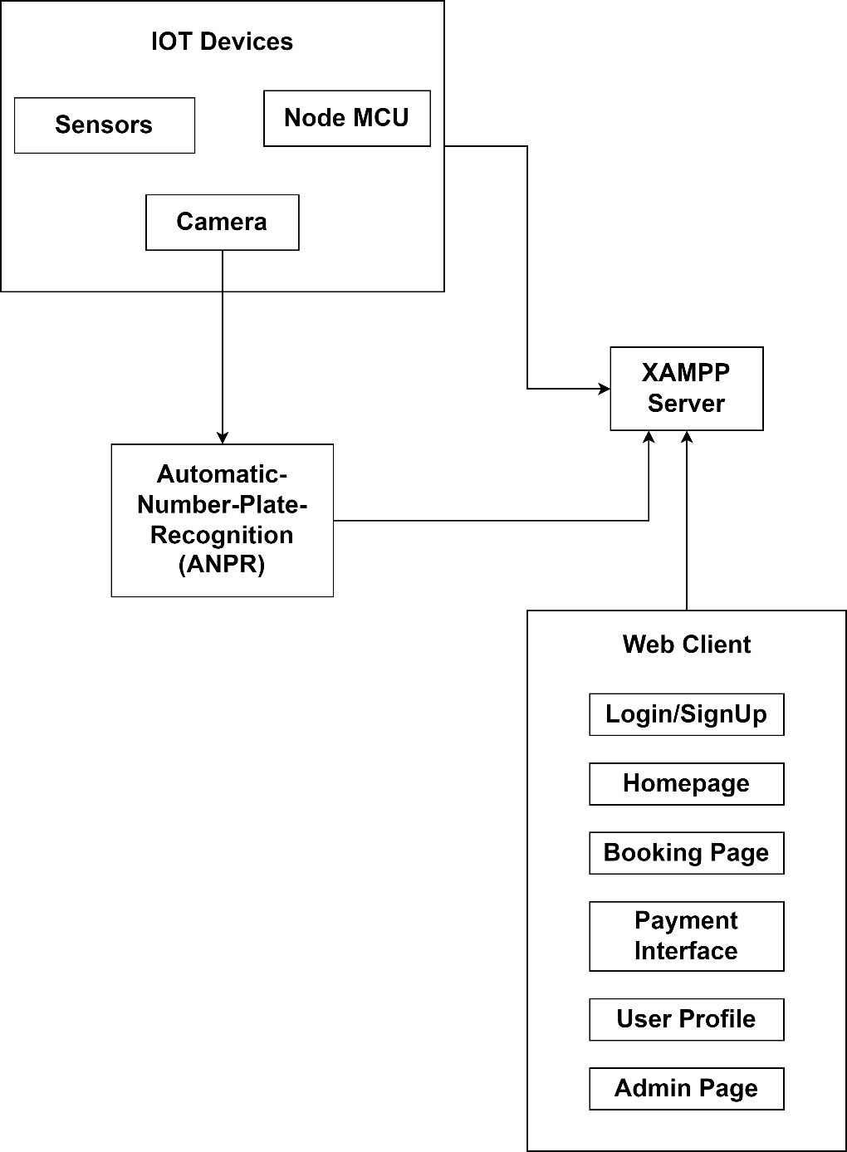

Flow Chart :

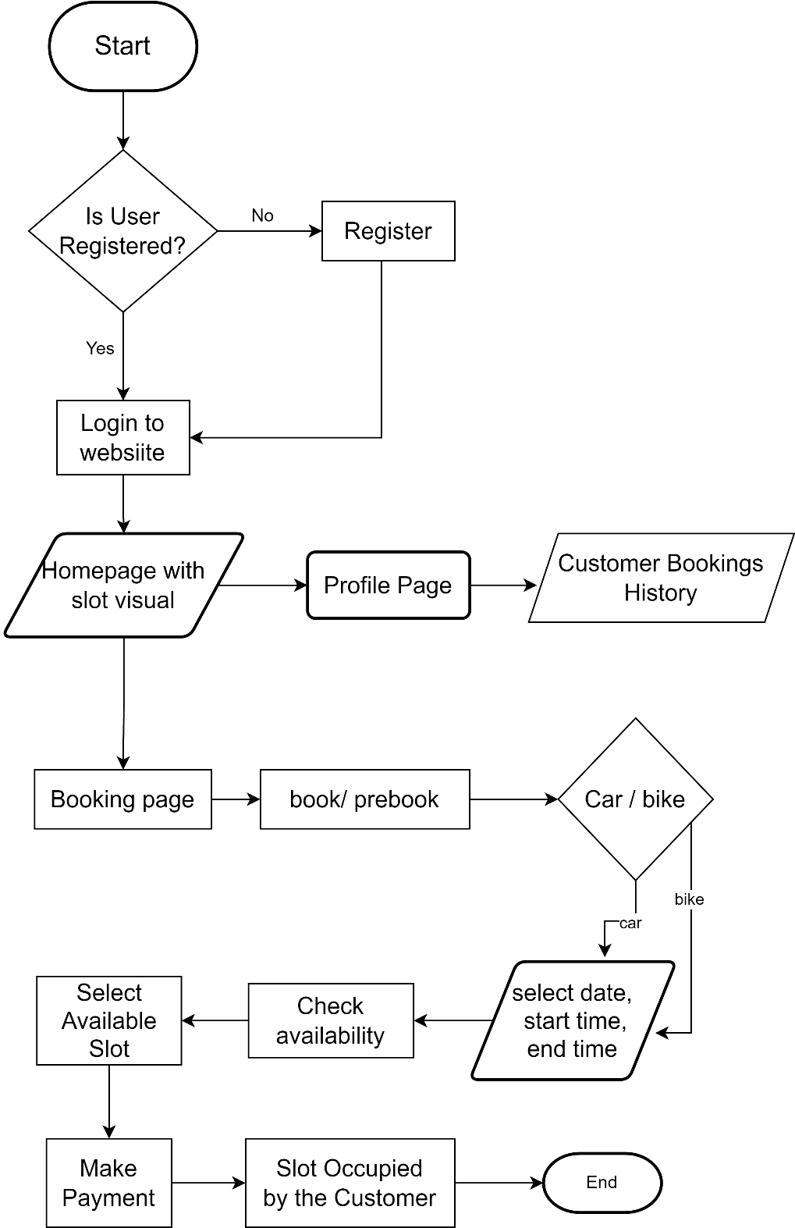

Use Case Diagram :

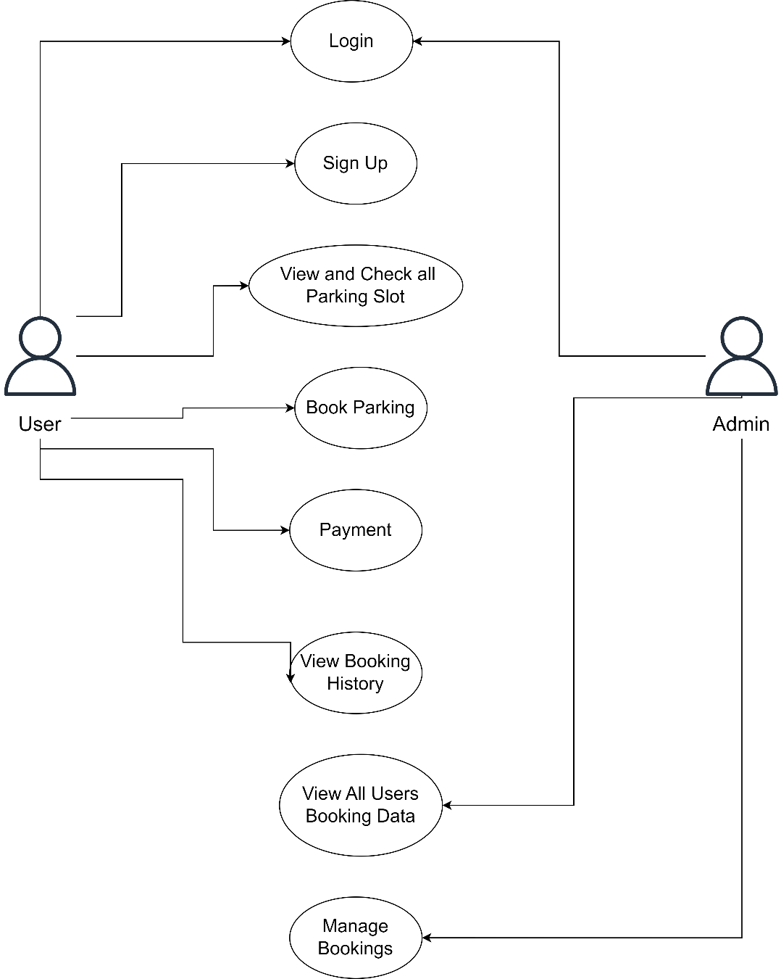

Sequence Diagram :  
  
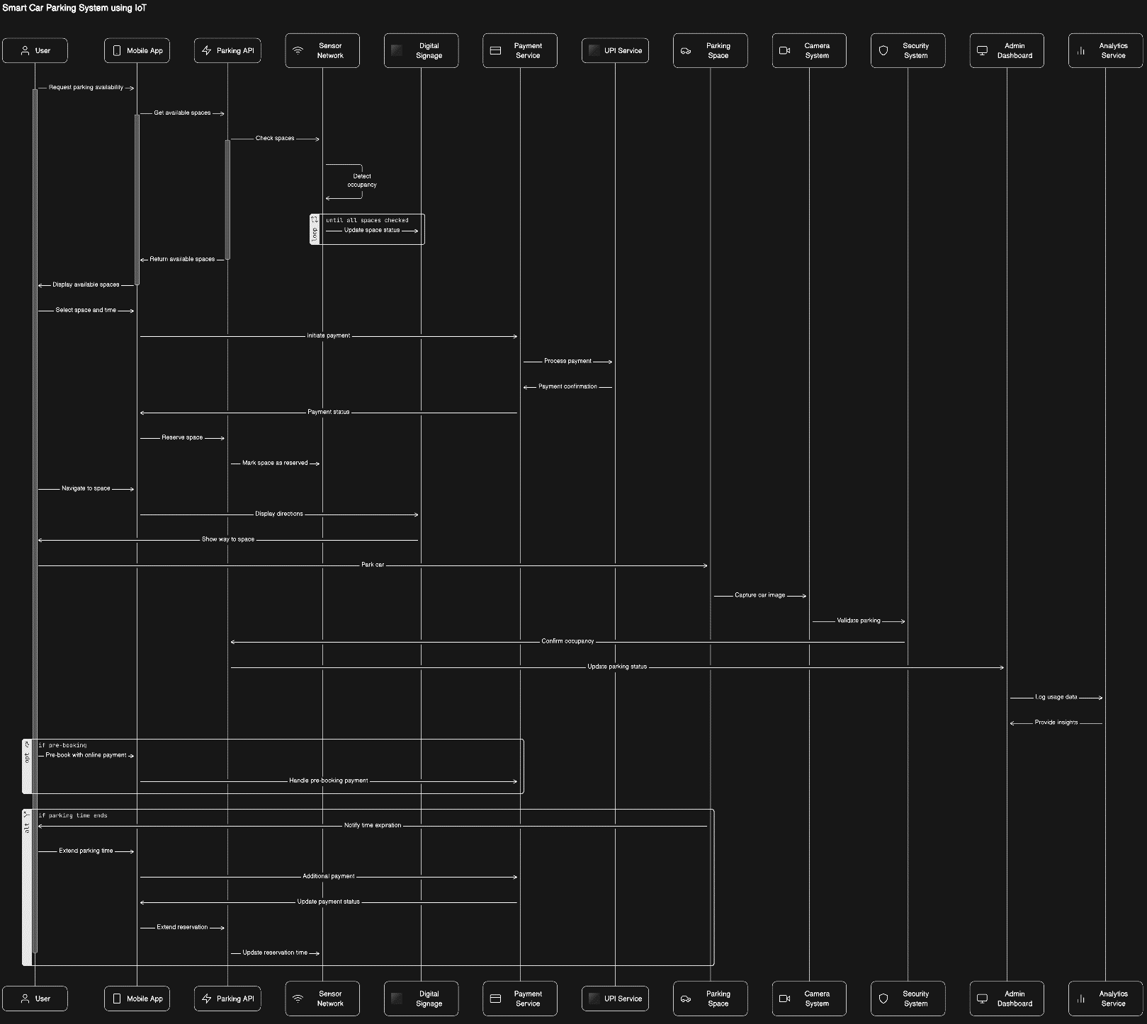

**Technology Stack**

* HTML (HyperText Markup Language):

HTML is the standard markup language used for creating the structure of web pages. It defines the elements and their arrangement, facilitating the organization and presentation of content on the user interface.

Role in the Project: HTML is likely used to structure the various pages of your Smart Parking System, defining elements like forms, buttons, and layout.

CSS (Cascading Style Sheets):

* CSS (Cascading Style Sheets):  
    
  CSS is a styling language that controls the presentation and layout of HTML elements on a web page. It allows for the customization of colors, fonts, spacing, and overall visual design.

Role in the Project: CSS is essential for styling the HTML elements, ensuring a visually appealing and user-friendly interface for your Smart Parking System.

* JavaScript

JavaScript is a versatile programming language used to add interactivity and dynamic behavior to web pages. It runs on the client-side, allowing for real-time updates without the need to reload the entire page.

Role in the Project: JavaScript is likely employed to implement client-side functionalities, such as form validation, asynchronous requests (AJAX) for data retrieval, and dynamic updates to the user interface.

* PHP (Hypertext Preprocessor) :  
    
  PHP is a server-side scripting language designed for web development. It is used to execute server-side logic, interact with databases, and generate dynamic content for web pages.

Role in the Project: PHP is probably utilized to handle server-side processes, such as database operations, user authentication, and server-client communication.

* XAMPP  
    
  XAMPP is a free and open-source cross-platform web server solution stack that includes Apache (web server), MySQL (database), PHP, and Perl. It simplifies the setup of a local development environment for testing and debugging web applications.

Role in the Project: XAMPP is used for local development and testing, providing an environment that mirrors the production server setup.

* Arduino IDE:  
    
  Arduino IDE (Integrated Development Environment) is a software application used for programming Arduino microcontrollers. It includes a code editor, compiler, and uploader.

Role in the Project: Arduino microcontrollers are part of your Smart Parking System for IoT (Internet of Things) functionalities, the Arduino IDE is used to write, compile, and upload the code to these devices.

Each component in technology stack plays a crucial role in different aspects of your Smart Parking System, contributing to its functionality, appearance, and overall performance



**Development**

* Database Schema Design  
    
  The schema design for the Smart Parking System is a critical aspect of ensuring efficient data storage, retrieval, and maintaining data integrity. The system's database is designed to capture and organize information related to users, parking slots, and booking records. Here's a detailed breakdown of the schema :  
    
  1) Signup Table:  
    
  The users table stores information about registered users, including their unique user ID (user_id), fname, lname, password (hashed for security), email, and phone number any other relevant details.This table is crucial for user authentication and managing individual user profiles.   
    
  CREATE TABLE signup (  
  user_id INT PRIMARY KEY AUTO_INCREMENT,  
  fname VARCHAR(255) NOT NULL,

lname VARCHAR(255) NOT NULL,

email VARCHAR(255) NOT NULL,  
password VARCHAR(255) NOT NULL,

phone INT(10) NOT NULL;  
);  
  
2) Slots Table :  
  
The slots table is designed to represent the parking slots available in the system. Each slot has a unique identifier (slot1, slot2, slot3, slot4), Current Timestamp and a status (status) indicating whether it's occupied or vacant.  
  
CREATE TABLE slots (  
id INT PRIMARY KEY AUTO_INCREMENT,  
time TIMESTAMP DEFAULT CURRENT_TIMESTAMP ON UPDATE CURRENT_TIMESTAMP,  
slot1 TINYINT(1) NOT NULL DEFAULT 0,  
slot2 TINYINT(1) NOT NULL DEFAULT 0,  
slot3 TINYINT(1) NOT NULL DEFAULT 0,  
slot4 TINYINT(1) NOT NULL DEFAULT 0  
);

3) Bookings Table  
  
The bookings table is crucial for recording user bookings. It includes details such as the booking ID (booking_id), the associated user (user_id), vehicle type, booking date, start time, end time, and price.  
  
CREATE TABLE bookings (  
user_id INT,  
vehicleType VARCHAR(50) NOT NULL,  
bookingDate DATE NOT NULL,  
startTime TIME NOT NULL,   
endTime TIME NOT NULL,  
price DECIMAL(8, 2) NOT NULL,  
FOREIGN KEY (user_id) REFERENCES users(user_id)

);

The schema is normalized, ensuring that data is organized logically and efficiently. Relationships between tables are maintained using foreign keys, contributing to data integrity. For instance, the user_id in the bookings table is a foreign key referencing the user_id in the users table, establishing a connection between user information and their bookings.

This schema design provides a solid foundation for the Smart Parking System, facilitating seamless data management and retrieval for various system functionalities.

* Server-Side Logic (PHP):

PHP was utilized to develop robust server-side logic. This included handling user authentication, processing booking requests, and managing interactions with the MySQL database. API endpoints were implemented to facilitate seamless communication between the client and server.

* Client-Side Functionality (JavaScript):  
    
  JavaScript played a pivotal role in enhancing the user interface and experience. Client-side functionalities included dynamic form validation, asynchronous communication with the server for real-time updates, and interactive features to improve overall usability.
* User Authentication:

A secure user authentication mechanism was implemented to safeguard user accounts. This ensured that only authorized users could access the system, preventing unauthorized interactions and enhancing overall security.

* Payment Integration:   
    
  Secure payment gateway integration was implemented to facilitate seamless and safe transactions. The system calculated parking fees based on the duration and type of vehicle, providing users with a convenient and efficient payment process.
* Testing Environment Setup:

A testing environment was set up using XAMPP to simulate the production server environment. This allowed for thorough testing to ensure consistent behavior and performance across different environments.

The development phase focused on creating a reliable, user-friendly, and feature-rich Smart Parking System. With careful consideration of database design, server-side and client-side logic, user authentication, IoT integration, and payment processing, the development process aimed to deliver a robust and scalable solution. The next steps involved rigorous testing to identify and address any issues before deployment.

**Testing**

* Unit Testing:  
    
  Conduct unit tests for individual components to ensure they function as expected. Test functions, methods, and database queries independently.
* Integration Testing:  
    
  Verify that different components work together seamlessly. Test interactions between the server-side and client-side components, including API endpoints.
* User Interface (UI) Testing:  
    
  Perform UI testing to ensure a responsive and visually appealing user interface. Check for proper rendering, styling, and responsiveness on various devices and screen sizes.
* Security Testing:  
    
  Conduct security testing to identify and address vulnerabilities. Verify that user inputs are sanitized to prevent SQL injection and other security threats.
* IoT Device Testing:  
    
  If IoT devices are part of the system, test their connectivity, data transmission, and synchronization with the application.
* User Acceptance Testing (UAT):  
    
  Involve end-users or stakeholders in UAT to gather feedback on the system's usability, functionality, and overall performance. Address any issues identified during this phase.
* Performance Testing:  
    
  Evaluate the system's performance under different conditions, including peak usage. Identify and address any bottlenecks in terms of response time and resource utilization



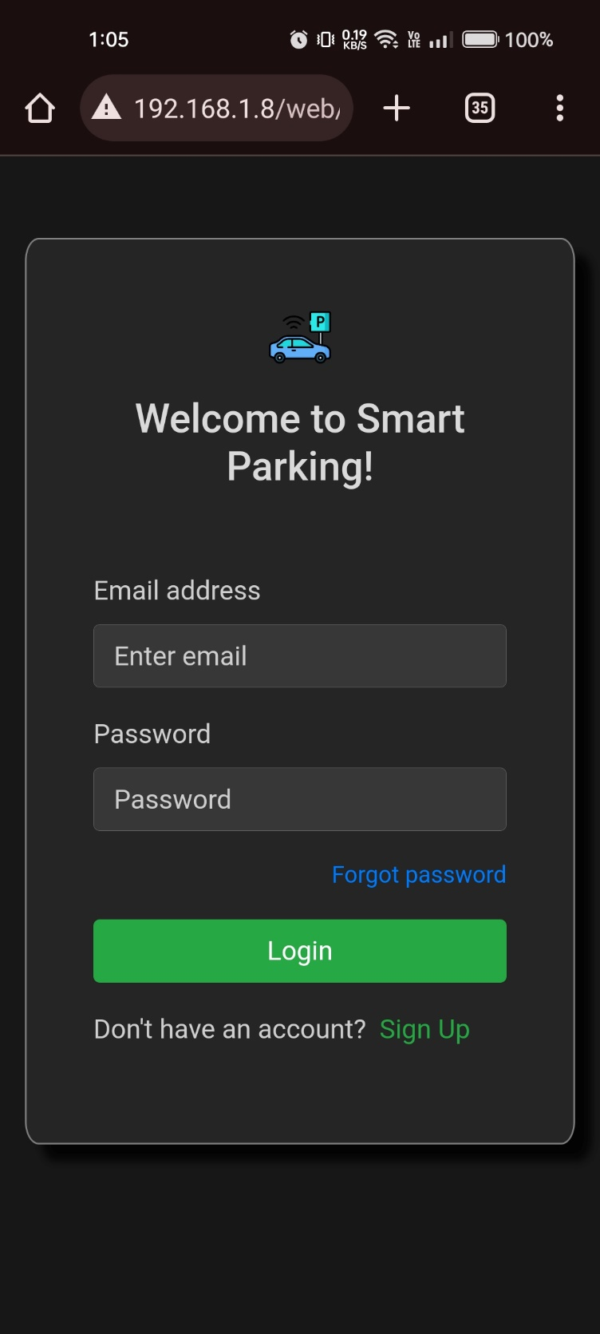

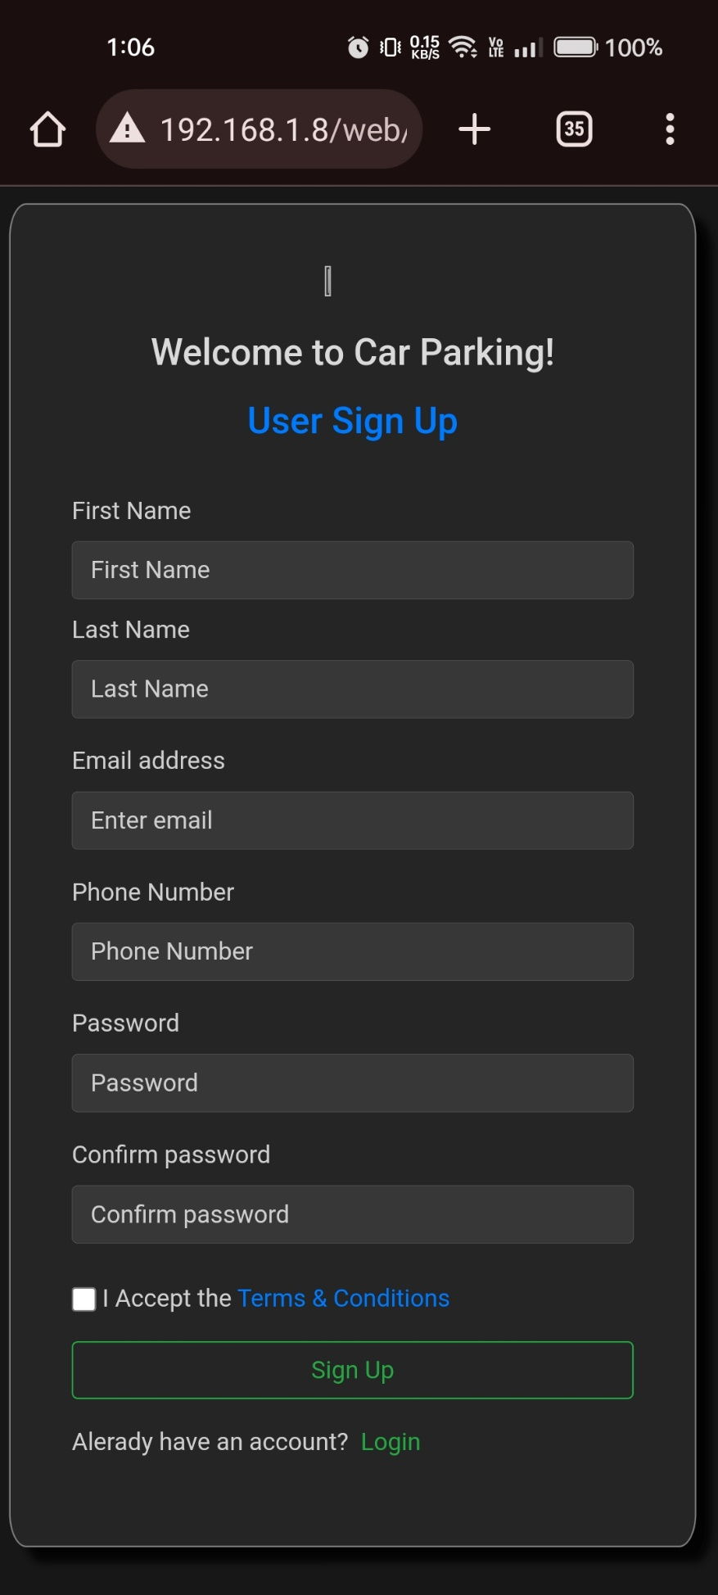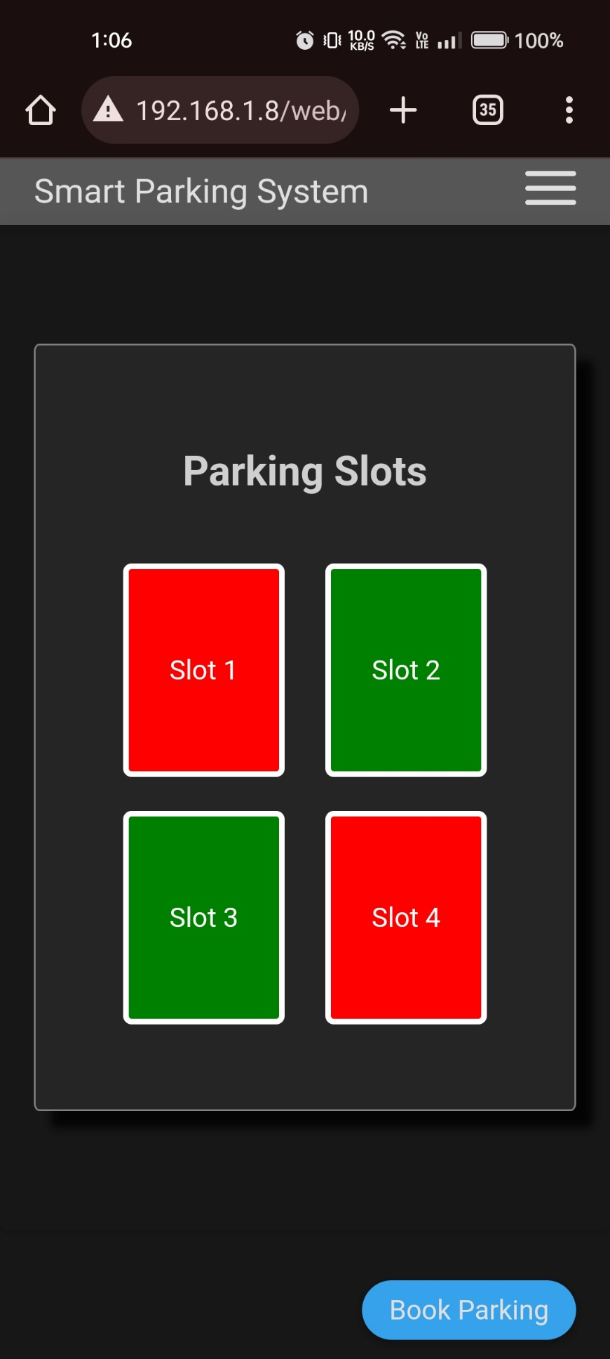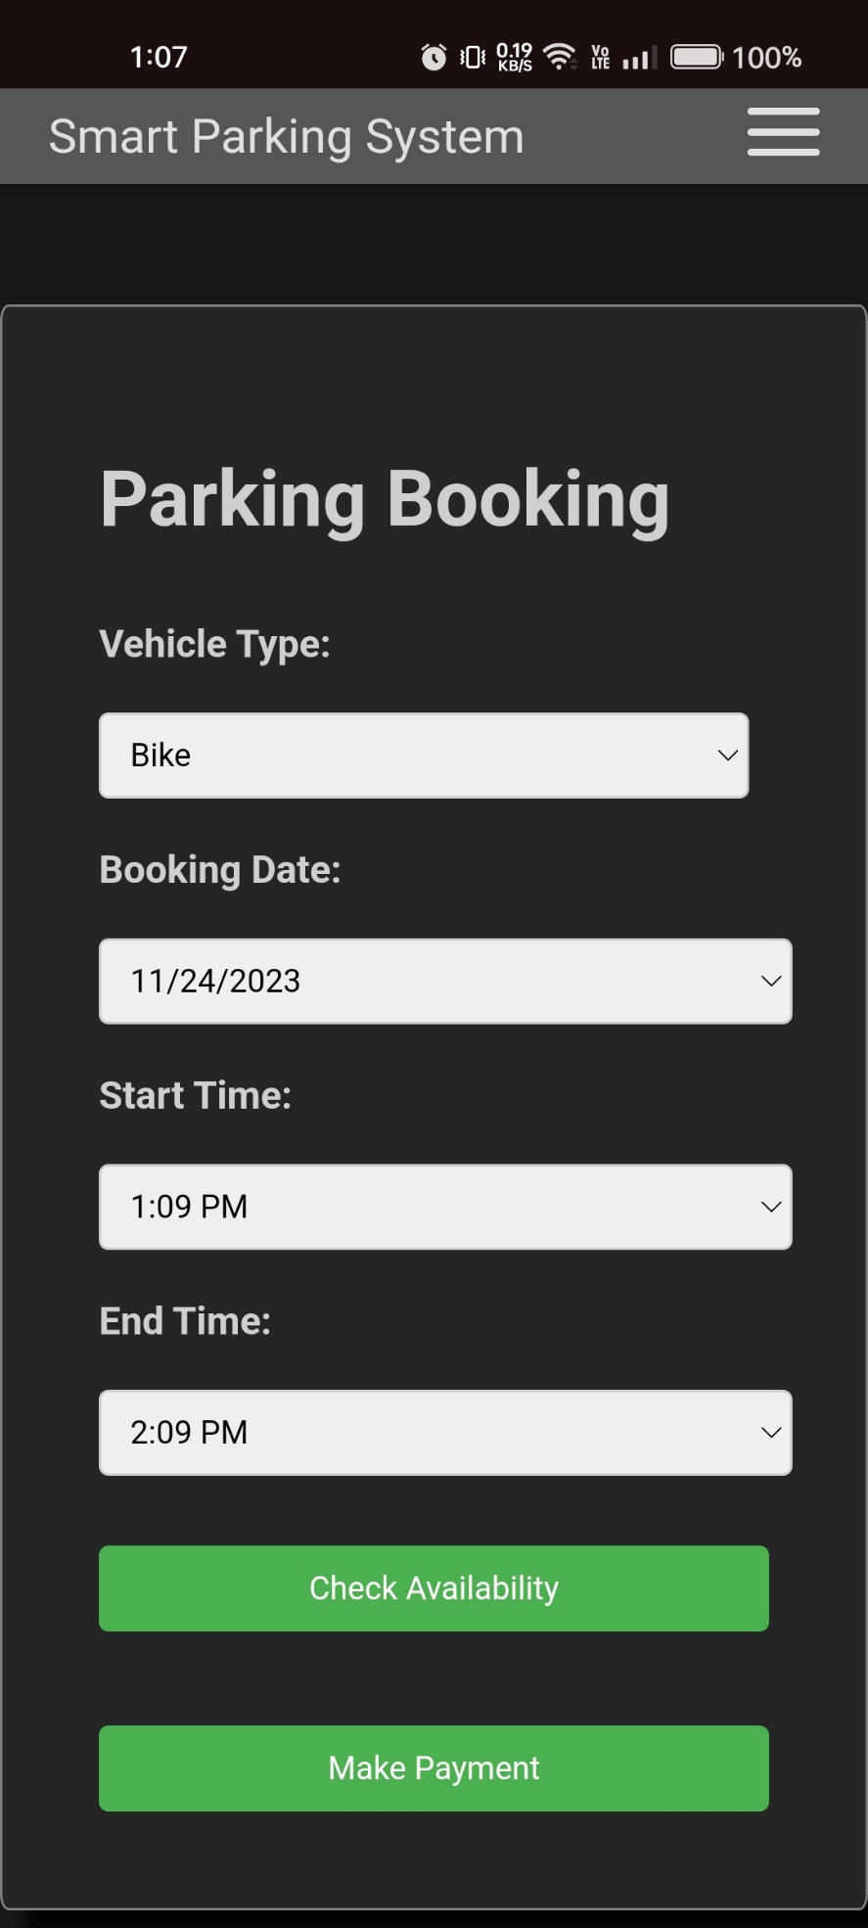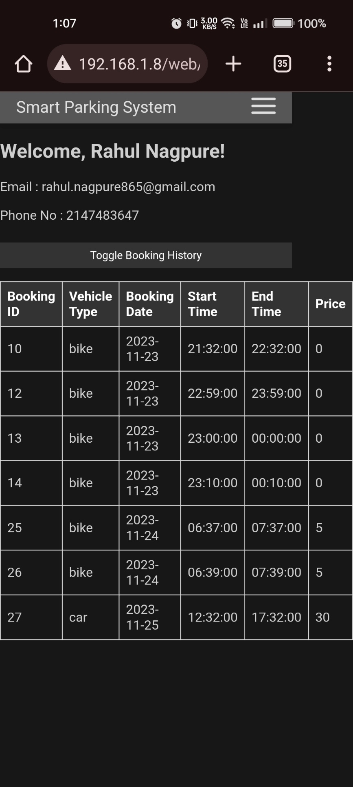



**Data Security and Privacy Concerns:** Ensure robust security measures and address privacy concerns associated with user data collection and storage.

**Reliability of Sensor Technologies:** Achieve consistent and reliable sensor performance in diverse conditions for accurate real-time data.

**Integration with Existing Infrastructure:** Seamlessly integrate the system with current parking management infrastructure without causing disruptions.

**User Adoption and Behavioral Changes:** Overcome resistance and encourage widespread user adoption, navigating behavioral changes from traditional parking methods.

**Regulatory Compliance:** Navigate complex and evolving regulations related to data protection, privacy, and urban planning.

**System Scalability:** Adapt the system to different parking facilities while maintaining scalability for urban growth.

**Power Consumption and Maintenance:** Manage power consumption and address maintenance requirements to ensure system reliability.

**Interoperability Among IoT Devices:** Ensure seamless communication and interoperability among diverse IoT devices for system efficiency.

**Technological Obsolescence:** Address the rapid evolution of technology, requiring continuous updates and adaptation to emerging innovations.

**Public Perception and Trust:** Build and maintain public trust in the system's security, accuracy, and reliability.

**Network Connectivity Issues:** Overcome potential challenges related to network connectivity for consistent real-time data transmission.

**Cost and Budget Constraints:** Manage costs and budget constraints associated with deployment, maintenance, and system improvement.

**Educational Initiatives:** Implement effective educational initiatives to inform users and administrators about the system's benefits and functionality.

**Environmental Impact:** Mitigate unintended environmental impact from the production, deployment, and disposal of IoT devices and technologies.



* The future scope envisions dynamic evolution with cutting-edge technologies and features.
* Integration of advanced sensors like LiDAR and augmented computer vision for precision.
* Predictive AI algorithms for dynamic forecasting beyond occupancy predictions.
* Collaborations with smart city initiatives for seamless urban infrastructure connectivity.
* Augmented reality navigation to optimize the user experience.
* Exploration of blockchain, vehicular communication, and compatibility with autonomous vehicles.
* Emphasis on energy-efficient practices, customizable user profiles, and open APIs for sustainability.
* Community engagement mechanisms contribute to an intelligent, sustainable, and user-centric smart parking system, aligning with urban and technological evolution.

**CONCLUSION**

A successful real time smart parking system was build for the management of cars in a parking slot. The important features that the system provides is a real time slot availablity notification that will help the user to check when there is a slot in which they can park which will save their time and fuel to physically go at the place. Then the concept of UPI for the booking of a slot which will help to simplify the transaction and use digital money ,it being more secure and easy to handle now a days.

A dynamic pricing has been sought in response to people paying large sums for entire day or half day of parking when they need only for 2-3 hours .Now they will be charged hour or half hourly and will be notified as and when their time is about to end. All these features will be presented on a website with a secure login system having the credentials of user and everything can be managed so that the user does not have to do different tasks at different places rather it is all under one roof and can be managed, modified by them easily.

**REFERENCES**

[1]” model of associate underground multi-storied machine-controlled automotive parking system” P. Eswara ,A V M Manikandan ,Saurabh 2013 IEEE International Conference ON rising Trends in Computing, Communication and engineering science (ICECCN)

[2]“IOT Based Smart Parking System using NODEMCU” TejasPund, HarshavardhanSidagam, Asif Pinjari,Journal of emerging technologies and innovative research(JETIR) December 2021

[3]” Smart Parking System based on IOT” Hardik Tanti, Pratik Kasodariya , Shikha Patel , Dhaval H. Rangrej , Laxmi Institute Of Technology, Sarigam in International Journal of Engineering Research & Technology (IJERT) may 05 ,2020

[4]“ IoT Based Smart Parking System for big Parking Lot Manikam Ramsamy, Sunil Govinda Solanki, Elang Natarajan, - IEEE on 2011 May 11

[5]” An Approach for IoT based Car Parking and Reservation system using Cloud “Vabhav Hans, Parminder Singh Sethi, Jatin Kira in 2015 International Conference on Green Computing and Internet of Things (ICGCIoT)

[6] “Review Paper on Smart Parking System”, Anusha, Arshitha M S, Anushri, Geetanjali Bishtannavar, Ms. Megha D Hegde. International Journal of Engineering Research & Technology (IJERT) ISSN: 2278-0181 Published by, www.ijert.org RTESIT - 2019 Conference Proceedings

[7] “A Research On Smart Vehicle Parking System”, Dipali Balmiki , Manas Singhal , Anupama Singh , Divyangi Tyagi. International Journal of Scientific Research and Management Studies (IJSRMS)

ISSN: 2349-3771 Volume 4 Issue 7, pg: 124-127

[8] “Detection of Empty Slots in Car Parking System Using Neural Network Method ”,Ahmad Ihsan, Nurul Fadillah, C R Gunawan, Mursyidah Mursyidah. IOP Conference Series: Materials Science and Engineering2020:854 012052

[9] P. Melnyk, S. Djahel and F. Nait-Abdesselam, "Towards a Smart Parking Management System for Smart Cities," 2019 IEEE International Smart Cities Conference (ISC2), Casablanca, Morocco, 2019, pp. 542-546, doi: 10.1109/ISC246665.2019.9071740

[10]” Radio frequency identification: technologies, applications,and research issues” Xiao, Y., Yu, S., Wu, K., Ni, Q., Janecek., C., Nordstad, J., 2006.. Wiley Journal of Wireless Communications and Mobile Computing.

[11] “Model for Intelligent Car Parking Monitoring and Assistance System”Asghar Ali Shah, G. M. (2019). Video Stitching with Localized 360..IJCSNS International Journal of Computer Science and Network Security , 6.

[12] “The Development of Smart Parking System based on NodeMCU 1.0 using the Internet of Things.” Anjari, L. & Budi, A. (2018) International Symposium on Materials and Electrical Engineering. 384. p. 1-6.

[13] “Understanding Smart and Automated Parking Technology.” Sajeev, A., Mallick, C., Vidwans, S. and Jog, Y. (2018) International Journal of u- and e- ssService, Science and Technology. 8 (2). p.251-262.

[14] “Park here! A smart parking based on smart phones’ embedded sensors and short range communication technologies ”Rosario Salpietro, Luca Bedogni, Marco Di Felice, LucianoBononi

[15] “ Study on Automated Car Parking System based on Microcontroller” Ahmed, M. and Wei, W. 2018. International Journal of Engineering Research & Technology IJERT. 3 (1). p. 256-259.