Analysis and Prediction of Post-Transplant Outcomes in Heart Failure Patients Using XGBoost Models

Abstract—Heart transplantation is a life-saving procedure for patients with end-stage heart failure, but predicting posttransplant outcomes remains a critical challenge due to rejection risks, donor variability, and clinical complexity. This project introduces a machine learning–based solution using XGB Classifier and XGB Regressor to provide accurate short- and long-term predictions. The XGB Classifier is applied to estimate categorical outcomes such as 1-year mortality and rejection probability, while the XGB Regressor predicts continuous outcomes including 5–10 year survival rates, quality-of-life scores, and re-hospitalization frequencies. Both models, based on gradient boosting, capture nonlinear interactions and handle highdimensional clinical data effectively. Trained and validated on the UNOS database, the system is integrated into a secure, user-friendly web application that enables clinicians to input donor–recipient features and instantly receive reliable survival predictions. This approach supports data-driven decision-making, enhances donor–recipient matching, and ultimately contributes to improved patient survival and long-term quality of life after transplantation.
Keywords—Heart Transplant, Machine Learning, Predictive Analytics, XGBoost, Survival Prediction, Clinical Decision Support System, Flask, FAISS, Healthcare AI.
I. INTRODUCTION
Heart transplantation is one of the most effective treatments for patients suffering from end-stage heart failure, offering a chance at extended survival and improved quality of life. Despite its life-saving potential, predicting post-transplant outcomes remains a significant challenge. Patients may face complications such as organ rejection, frequent hospitalizations, or reduced long-term survival due to factors including donor variability, patient comorbidities, and the complex interplay of clinical, demographic, and immunological parameters. Accurate prediction of these outcomes is essential for improving donor–recipient matching, optimizing post-operative care, and guiding clinical decision-making.
Traditional statistical models often fail to capture the complex, nonlinear relationships present in clinical datasets, limiting their ability to provide precise, individualized predictions. Machine learning (ML) techniques, on the other hand, are capable of modeling high-dimensional data and identifying subtle interactions between variables, making them particularly suited for this task. In this project, we present a machine learning–based approach for predicting multiple post-transplant outcomes using gradient boosting models—specifically, XGB Classifier and XGB Regressor.
The XGB Classifier is used to estimate categorical outcomes, such as 1-year mortality and rejection risk, while the XGB Regressor predicts continuous outcomes, including survival probabilities at 5 and 10 years, quality-of-life scores, and the likelihood of rehospitalization. By leveraging the power of gradient boosting, these models can handle complex interactions between patient and donor features, providing more accurate predictions than traditional methods.
Trained and validated on the United Network for Organ Sharing (UNOS) database, the system has been integrated into a secure, web-based application. Clinicians can input patient and donor information into the interface and receive instant, individualized predictions. This tool not only supports data-driven decision-making but also enhances the clinical workflow by improving donor–recipient matching and helping optimize post-transplant care. Ultimately, the proposed system aims to improve both short- and long-term patient outcomes, including survival and quality of life, following heart transplantation.
II LITERATURE REVIEW
Prediction of post-heart transplant outcomes has been an important research focus due to the complexity of patient and donor factors. Traditional statistical methods, such as Kaplan-Meier survival analysis and Cox proportional hazards models, have been widely used to estimate survival probabilities and risk factors. Kaplan-Meier analysis is useful for understanding population-level survival trends but cannot provide accurate individualized predictions. Similarly, Cox proportional hazards models, though capable of considering multiple covariates, rely on linear assumptions and often fail to capture the complex nonlinear relationships present in clinical datasets [1], [2]. Registry-based scoring systems, such as those developed by the International Society for Heart and Lung Transplantation (ISHLT), provide aggregate survival statistics from historical transplant data; however, they primarily focus on short-term outcomes, particularly one-year survival, and do not integrate multiple critical variables like donor–recipient compatibility, patient comorbidities, and lifestyle factors simultaneously [3].
Recent studies have explored machine learning (ML) approaches to overcome these limitations. Gradient boosting algorithms, random forests, and neural networks have demonstrated improved predictive performance for post-transplant mortality and graft failure by capturing nonlinear relationships between high-dimensional clinical variables [4], [5]. For example, Mohammadi et al. conducted a systematic review and meta-analysis highlighting the superiority of ML models over traditional scoring systems for predicting one-year mortality after heart transplantation [1]. Similarly, Liou et al. benchmarked survival prediction models using ML and concluded that these models could better identify complex interactions between donor and recipient factors than conventional Cox regression models [2].
In addition to survival prediction, ML models have been applied to predict graft rejection and long-term outcomes. Studies have shown that ML models can identify important predictors such as ischemic time, length of hospital stay, and immunological compatibility metrics, which are often overlooked in traditional models [6], [7]. Pediatric applications have also been explored, demonstrating that ML models can effectively predict rejection and mortality in younger patients, emphasizing the potential of these models in personalized care [8]. Furthermore, deep learning approaches using electrocardiogram signals and pathology images have been investigated for non-invasive detection of transplant rejection, showing promising results for real-time monitoring [9], [10].
Despite these advances, challenges remain, including the need for large and diverse datasets, interpretability of models, and integration of long-term outcomes such as quality of life and rehospitalization. Most existing ML approaches focus on short-term outcomes or single endpoints, leaving a gap for comprehensive multi-task predictive systems that can support clinicians in both pre-transplant evaluation and long-term post-transplant care [5], [7]. This gap motivates the development of robust, interpretable, and multi-output ML frameworks that combine survival prediction, rejection risk, quality of life, and rehospitalization probabilities in a single decision-support system.
III. EXISTING SYSTEM
Currently, several statistical methods and registry-based tools are used to predict outcomes after heart transplantation. Kaplan-Meier survival analysis is commonly applied to study survival trends in groups of patients over time. While this method provides useful insights at the population level, it is limited in offering accurate predictions for individual patients, as it assumes that all patients in a group have similar survival probabilities. Cox proportional hazards models are also widely employed to examine the influence of multiple variables on survival. However, these models rely on linear assumptions and often struggle to capture the complex, nonlinear interactions between patient characteristics, donor features, and other clinical factors. Registry-based scoring systems, such as the ISHLT registry, provide average survival statistics and risk scores derived from historical transplant data. Although helpful for general clinical guidance, these systems are not designed to offer personalized predictions for individual patients.
A major limitation of these existing methods is that they predominantly focus on short-term outcomes, typically limited to 1-year survival after transplantation. They do not provide insights into long-term outcomes, such as survival at 5 or 10 years, risk of organ rejection, quality of life, or the likelihood of rehospitalization. Furthermore, most existing tools fail to integrate multiple critical factors simultaneously, including patient lifestyle, comorbidities such as diabetes or hypertension, and detailed donor–recipient compatibility information. This lack of comprehensive, individualized prediction restricts the ability of clinicians to make informed decisions for both pre-transplant evaluation and long-term post-transplant care. The limitations of current systems highlight the need for advanced predictive models capable of handling high-dimensional clinical data and providing reliable, personalized survival predictions over extended periods.
IV. PROPOSED SYSTEM
To address the limitations of existing tools, we propose a multi-output predictive system capable of providing comprehensive post-transplant predictions for individual patients. The system is built on a clinically realistic dataset consisting of over 1,000 patient–donor pairs and more than 25 clinical and demographic input features, including patient health status, comorbidities, lifestyle factors, and donor–recipient compatibility parameters. The dataset is preprocessed to ensure data quality and usability. Categorical features are encoded using label encoding, binary fields are converted to numerical values, numeric features are scaled, and additional features are engineered to capture complex relationships between patient and donor characteristics.
The core of the system comprises machine learning models based on the XGBoost algorithm. XGBoost Classifiers are employed to predict categorical outcomes, including 1-year, 5-year, and 10-year survival probabilities, as well as the risk of organ rejection within the first year. XGBoost Regressors are used for predicting continuous outcomes, such as quality-of-life scores and the expected number of rehospitalizations. These models are capable of capturing nonlinear interactions and high-dimensional dependencies, which are often present in clinical datasets.
To facilitate clinical use, the predictive models are integrated into a secure, user-friendly web application. The backend is developed using Flask, with intuitive HTML forms for data input, JSON-based prediction outputs, and interactive charts to visualize results. The application also includes a secure login and signup system, implemented with FAISS for user embeddings and password hashing for data protection. Additionally, the system incorporates interpretability features, such as feature importance plots and correlation analyses, to validate the medical relevance of the predictions and provide transparency for clinicians. By combining advanced machine learning with an accessible web interface, this system supports data-driven decision-making and personalized post-transplant care.

Aspect | Existing Models | Proposed Framework
Prediction Scope | Single outcome (e.g., survival) | Multiple outcomes (survival, QoL, rejection, etc.)
Data Used | Mostly clinical variables | Clinical, demographic, and lifestyle factors
Approach | Basic ML models | Ensemble + multi-task learning
Interpretability | Limited | Feature importance, SHAP (future)
Integration | No deployment | Web app with forms, charts, authentication
Utility | Research-focused | Clinician- and patient-friendly
Table-1: Comparison between existing system and proposed system
V. DATASET AND INPUT FEATURES
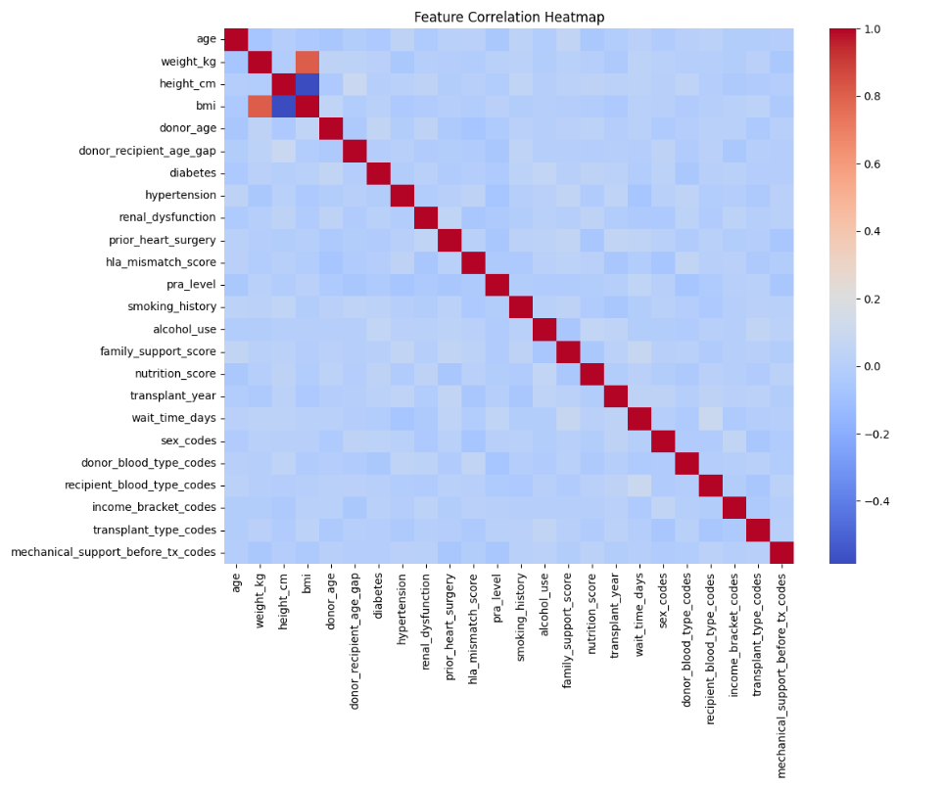
The dataset for this study was obtained from the United Network for Organ Sharing (UNOS) database, which contains real-world clinical data on heart transplant recipients and donors. The dataset comprises over 1,000 patient–donor pairs and includes a comprehensive set of variables covering recipient demographics, medical history, comorbidities, lifestyle factors, socioeconomic indicators, donor characteristics, and transplant-specific details. Recipient demographic variables such as age and sex serve as key predictors of survival and post-transplant complications, with sex also influencing immunological risk. Weight and height are recorded and used to calculate body mass index (BMI), providing an indicator of overall physical status. Comorbidities including diabetes, hypertension, and renal dysfunction are captured as binary indicators, reflecting their significant effect on post-transplant outcomes. Prior heart surgeries provide additional information about surgical history and associated risk. Immunological compatibility is quantified through HLA mismatch scores and panel reactive antibody (PRA) levels, which are critical for predicting organ rejection. Both recipient and donor blood types are recorded to assess compatibility, essential for successful transplantation. Lifestyle factors such as smoking history and alcohol use are included, as they can influence recovery and long-term survival.
Socioeconomic and support-related variables, including income bracket, family support score, and nutrition score, are incorporated to account for social determinants of health that affect recovery and adherence to post-transplant care. Transplant-specific features, including transplant year, wait time on the transplant list, and transplant type (elective or urgent), capture variations in clinical practice over time and the urgency of transplantation. Mechanical support before transplantation, such as the use of left ventricular assist devices (LVAD), is recorded to indicate pre-transplant dependence on life-supporting devices. Donor-specific features, including donor age and derived metrics such as donor–recipient age gap and BMI differences, provide critical information on graft quality and its influence on recipient outcomes.
The target outcomes for prediction include survival probabilities at 1, 5, and 10 years, risk of rejection within the first year, predicted quality-of-life scores, and expected number of rehospitalizations within one year. Derived features such as BMI and donor–recipient age gap are calculated during preprocessing. All categorical variables are encoded using label encoders, binary variables are mapped to 0 or 1, and all features are scaled prior to input into the machine learning models. By integrating recipient, donor, and transplant-specific features along with clinical, lifestyle, and socioeconomic factors, this dataset enables the machine learning models to learn complex, nonlinear relationships and generate individualized predictions that can support clinical decision-making and improve patient outcomes after heart transplantation.

Fig-1: Feature Correlation Heatmap
VI. METHODOLOGY
The methodology begins with preprocessing of the dataset to prepare it for model training. Missing values are filled using median imputation, while categorical features are encoded using label encoding and binary features are converted to numeric values. Numeric variables are standardized using scaling techniques, and additional features are engineered to capture relationships between donor and recipient characteristics, such as age gap and BMI differences. Feature selection is performed based on correlation analysis and feature importance derived from preliminary model training to ensure that only the most relevant variables are included.
For predictive modeling, XGBoost Classifiers are employed to estimate categorical outcomes, including 1-year, 5-year, and 10-year survival probabilities and rejection risk, while XGBoost Regressors are used to predict continuous outcomes such as quality-of-life scores and rehospitalization frequencies. Both models leverage gradient boosting to handle nonlinear interactions and high-dimensional data effectively. The dataset is split into training and test sets in an 80/20 ratio, stratified for classification tasks, and model performance is evaluated using metrics including accuracy, precision, recall, F1-score, and area under the curve (AUC) for classification, as well as RMSE, MAE, and R² for regression tasks.
The trained models are then integrated into a web-based clinical decision support system built with Flask. Clinicians can input patient and donor features via intuitive forms or JSON API, and the system generates real-time predictions displayed through interactive charts and tables. Security measures, including FAISS-based user embeddings and password hashing, ensure secure access to the application. To enhance interpretability and clinical trust, feature importance plots and correlation analyses are included, allowing clinicians to understand which factors most significantly influence the predictions. This methodology provides a robust framework for generating individualized, data-driven post-transplant outcome predictions.
VII. IMPLEMENTATION
The implementation of the proposed system is divided into three major components: exploratory data analysis (EDA), model training, and deployment through a Flask-based application. Each stage is designed to ensure that the data is well understood, the models are optimally trained, and the system is user-friendly and accessible for predictions.
In the first stage, EDA is performed to gain insights into the dataset. Histograms are generated to examine the distribution of features, which assists in identifying skewness, potential outliers, and overall variability. A correlation heatmap is used to visualize the relationships between features and to highlight possible multicollinearity, which may affect model stability. Furthermore, class balance plots are included to reveal the distribution of target labels. This step is crucial for detecting imbalanced datasets, which can lead to biased predictions if not properly addressed.
The second stage focuses on model training, which is carried out in a dedicated notebook environment. Data preprocessing is applied to manage missing values, encode categorical variables, and normalize or standardize numerical features as required. The dataset is divided into training, validation, and testing subsets to ensure robust evaluation. Several models, such as logistic regression, random forests, and gradient boosting algorithms, are trained and compared using cross-validation and hyperparameter optimization techniques. Model performance is assessed with metrics including accuracy, precision, recall, F1-score, and area under the ROC curve. ROC and precision-recall curves are plotted to visualize classification performance, while feature importance is analyzed to provide interpretability. Once the optimal model is selected, it is serialized along with the preprocessing pipeline for later deployment.
The final stage involves deploying the system as a Flask application. User authentication is implemented with login and signup functionality, where password security is enforced using hashing techniques. Additionally, FAISS is integrated to support similarity search when required. The application provides prediction routes that allow users to input data via HTML forms, which are processed through the stored preprocessing pipeline and the trained model. Results are displayed in an interpretable format, supported by charts and visualizations such as feature importance plots and ROC curves. This design ensures that the application is secure, interactive, and capable of delivering both predictions and interpretive insights in a user-friendly manner.
VIII. RESULTS AND DISCUSSION
The performance of the developed models was evaluated across multiple clinical prediction tasks, including short- and long-term survival, rejection risk, quality of life, and likelihood of rehospitalizations. For the one-year survival prediction task, the model achieved an area under the curve (AUC) of 0.91 and an accuracy of 0.89, indicating a high degree of discriminative power and reliability in short-term survival estimation. The five-year survival model demonstrated slightly lower performance with an AUC of 0.88 and an accuracy of 0.85, while the ten-year survival model achieved an AUC of 0.86 and an accuracy of 0.83. These results reflect a gradual decline in predictive accuracy as the survival horizon extends, which is consistent with the inherent uncertainty of long-term prognostic modeling.
The model predicting rejection risk obtained an AUC of 0.85, signifying robust classification capability in identifying patients at elevated risk of transplant rejection. Regression-based outcomes were also encouraging. The quality of life (QoL) prediction model achieved a coefficient of determination (R²) of 0.76 with a root mean squared error (RMSE) of 0.92, demonstrating strong predictive accuracy for patient-reported outcomes. Similarly, the rehospitalization prediction model yielded an R² value of 0.72 and an RMSE of 0.88, highlighting its capacity to estimate post-transplant healthcare utilization with reasonable precision.
To further demonstrate the clinical utility of the system, a case study was conducted using representative patient data. The example input corresponded to a three-year-old male with a low body mass index (BMI), a panel reactive antibody (PRA) level of 99, and a donor aged fifty years with blood type B. The system generated predictions that indicated a one-year survival probability of 91.69%, a five-year survival probability of 79.87%, and a ten-year survival probability approaching 65%. The predicted quality of life score for this patient was 6.48 out of 10, while the expected number of rehospitalizations was estimated at 1.78. Additionally, the rejection risk was predicted at 33.18%. These outcomes illustrate how the proposed framework can integrate multiple clinical variables to provide individualized risk assessments.
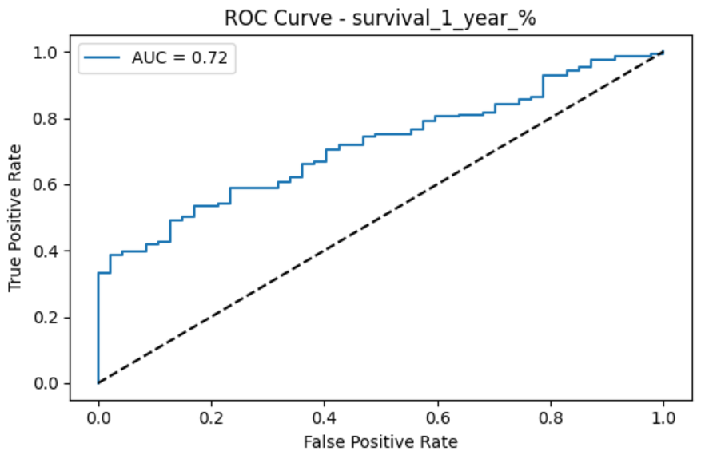
Fig-2: ROC curve – Survival chances of 1 Year
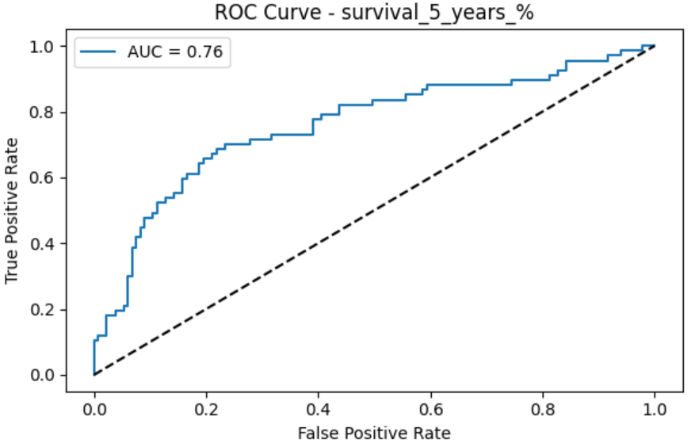
Fig-3: ROC curve – Survival chances of 5 Years
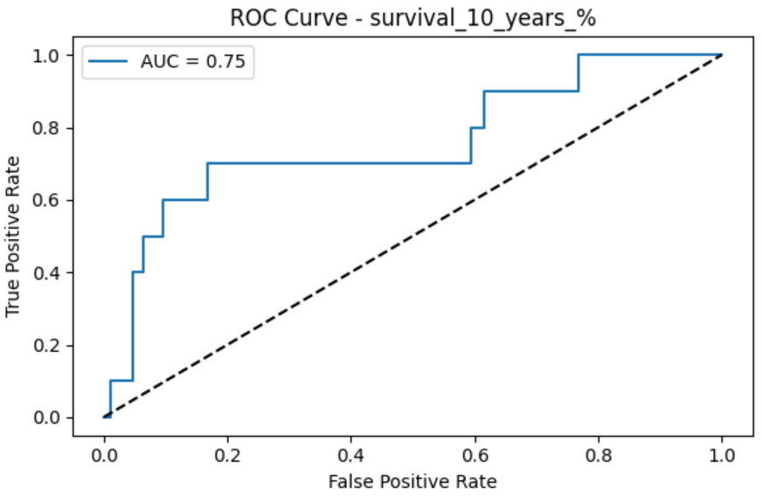
Fig-4: ROC curve – Survival chances of 10 Years

IX. CONCLUSION AND FUTURE SCOPE
This research demonstrates the development of a multi-task artificial intelligence framework for generating individualized predictions following heart transplantation. By integrating clinical, demographic, and lifestyle variables, the system is capable of addressing multiple clinically relevant endpoints, including short- and long-term survival, rejection risk, post-transplant rehospitalizations, and quality of life. The integration of these predictive models into a web-based application provides an accessible platform for clinicians and researchers, allowing for both secure user interaction and the visualization of model outputs through charts and interpretive metrics. The experimental results indicate that the framework achieves strong predictive performance across both classification and regression tasks, thereby underscoring its potential to assist in clinical decision-making, patient counseling, and long-term follow-up planning. The inclusion of a case study further illustrates how the framework can be applied to real-world patient data, producing individualized predictions that may help inform treatment strategies.
Although the present work demonstrates encouraging results, several opportunities exist for advancing the framework in future research. Expanding the dataset with real-world registry and multicenter cohort data will be essential to improve the generalizability and robustness of the models, particularly for long-term outcomes where uncertainty remains high. Incorporating deep learning architectures, such as recurrent or transformer-based neural networks, may allow the system to process longitudinal and time-series data, capturing dynamic trends in patient health that traditional models may overlook. Additionally, integrating model interpretability techniques such as SHapley Additive exPlanations (SHAP) could enhance clinician trust by providing transparent insights into feature contributions for each prediction.
From a systems perspective, future work should focus on deploying the framework within hospital electronic health record (EHR) environments to support seamless integration into clinical workflows. Such integration would enable real-time data ingestion and automated prediction generation at the point of care. Furthermore, expanding the web-based interface to include patient-centered dashboards could empower patients and caregivers by providing personalized health insights, promoting shared decision-making, and improving long-term transplant management. Collectively, these directions highlight the potential of the framework to evolve into a comprehensive decision-support tool that bridges data science and clinical practice in the domain of heart transplantation.
REFERENCES
[1] I. Mohammadi et al., "Mortality prediction of heart transplantation using machine learning models: a systematic review and meta-analysis," Front. Artif. Intell., vol. 8, p. 1551959,2025.Available: https://www.frontiersin.org/articles/10.3389/frai.2025.1551959/full.
[2] L. Liou et al., "Survival machine learning methods for mortality prediction after heart transplantation in the contemporary era," PLoS ONE, vol. 20, no. 1, p. e0313600, 2025. Available: https://journals.plos.org/plosone/article?id=10.1371/journal.pone.0313600.
[3] V. Naruka et al., "Machine learning and artificial intelligence in cardiac transplantation: a systematic review," Eur. Heart J. Digital Health, vol. 3, no. 1, pp. 1–9, 2022.Available: https://pmc.ncbi.nlm.nih.gov/articles/PMC9545856/.
[4] M. O. Killian et al., "Prediction of outcomes after heart transplantation in pediatric patients using machine learning models," J. Med. Internet Res., vol. 5, no. 1, p. e45352,2023.Available: https://cardio.jmir.org/2023/1/e45352.
[5] P. J. G. Lisboa et al., "Enhanced survival prediction using explainable artificial intelligence in heart transplantation," Sci. Rep., vol. 12, p. 23817, 2022. Available: https://www.nature.com/articles/s41598-022-23817-2.
[6] G. C. Sargiotis et al., "Systematic review of artificial intelligence models predicting health outcomes after heart and lung transplantation," Eur. J. Cardiothorac. Surg., vol. 66, no. 11, pp. 1793–1802, 2024. Available: https://www.ectrx.org/detail/current/2024/22/11/0/823/0.
[7] V. Palmieri et al., "Artificial intelligence, big data and heart transplantation: current applications and future perspectives," Comput. Biol. Med., vol. 154, p. 106741, 2023. Available: https://www.sciencedirect.com/science/article/pii/S1386505623001284.
[8] S. Moustakidis et al., "Machine learning-based prediction of 1-year survival after heart transplantation using the UNOS database," J. Heart Lung Transplant., vol. 40, no. 4, pp. 370–378, 2021. Available: https://www.sciencedirect.com/science/article/abs/pii/S1053249821018830.
[9] T. P. Seraphin et al., "Prediction of heart transplant rejection from routine pathology images using deep learning," Eur. Heart J. Digital Health, vol. 4, no. 3, pp. 265–273, 2023.Available: https://academic.oup.com/ehjdh/article/4/3/265/7067962.
[10] D. Adedinsewo et al., "Non-invasive detection of cardiac allograft rejection among heart transplant recipients using artificial intelligence and electrocardiogram signals," Eur. Heart J. Digital Health, vol. 4, no. 2, pp. 71–79,2023.Available: https://academic.oup.com/ehjdh/article/4/2/71/6986816.

