

1 | Name of the Student |  | Mohd Abdul Sohail & N Rahul
2 | Roll Number |  | 23951A04A4 & 23951A04C7
3 | Branch and Section |  | ECE - C
4 | Program |  | B.Tech - 23
5 | Course Name |  | AI SPECIALIST
6 | Course Code |  | ACSD45
7 | Please tick (✓) relevant Engineering Competency (ECs)Profiles
 | EC | Profiles |  | (✓)
 | EC1 | Ensures that all aspects of an engineering activity are soundly based on fundamental principles-by diagnosing, and taking appropriate action with data, calculations, results, proposals, processes, practices, and documented information that maybe ill-founded, illogical, erroneous, unreliable or unrealistic requirements applicable to the engineering discipline |  | ✓
 | EC2 | Have no obvious solution and require abstract thinking, originality in analysis to formulate suitable models. |  | ✓
 | EC3 | Support sustainable development solutions by ensuring functional requirements, minimize environmental impact and optimize resource utilization throughout the lifecycle, while balancing performance and cost effectiveness. |  | ✓
 | EC4 | Competently addresses complex engineering problems which involve uncertainty, ambiguity, imprecise information and wide-ranging or conflicting technical, engineering and other issues.
 | EC5 | Conceptualizes alternative engineering approaches and evaluates potential out comes against appropriate criteria to justify an optimal solution choice.
 | EC6 | Identifies, quantifies ,mitigates and manages technical, health, environmental safety, economic and other contextual risks associated to seekachievablesustainableoutcomeswithengineeringapplicationinthe designated engineering discipline.

 | EC7 | Involve the coordination of diverse resources (and for this purpose, resources include people, money, equipment, materials, information and technologies) in the timely delivery of outcomes
 | EC8 | Design and develop solution to complex engineering problem considering a very perspective and taking account of stake holder views with widely varying needs.
 | EC9 | Meet all level, legal, regulatory, relevant standards and codes of practice, protect public health and safety in the course of all engineering activities.
 | EC 10 | High level problems including many component parts or sub-problems, partitions problems, processes or systems into manageable elements for the purposes of analysis, modelling or design and then re-combines to form a whole, with the integrity and performance of the overall system as the top consideration.
 | EC | Profiles |  |  | (✓)
 | EC 11 | Undertake CPD activities to maintain and extend competences and enhance the ability to adapt to emerging technologies and the ever- changing nature of work.
 | EC 12 | Recognize complexity and assess alternatives in light of competing requirements and incomplete knowledge. Require judgement in decision making in the course of all complex engineering activities.
8 | Please tick(✓) relevant Course Outcomes(COs)Covered
 | CO | Course Outcomes |  |  | (✓)
 | CO1 | Explain the ability to design a plan for the real-world problems and mapping it to the digital world. |  |  | ✓
 | CO2 | Choose appropriate problem-solving methods and optimize the search results. |  |  | ✓
 | CO3 | Apply the principles of selection and iteration. |  |  | ✓
 | CO 4 | Appreciate uses of modular programming concepts for handling complex problems |  |  | ✓
 | CO5 | Design classes with a view of flexibility and reusability |  |  | ✓
 | CO6 | Code, test and evaluate small use cases to conform to a specification. |  |  | ✓
9 | Course ELRV Video Lectures Viewed |  | Number of Videos | Viewing timing Hours

10 | JustifyyourunderstandingofWK1 | Applying concepts of engineering science Fundamentals for solving respective problems.
11 | JustifyyourunderstandingofWK2–WK9 | WK2: Enables precise analysis and modeling using mathematical and computational techniques, essential for solving engineering problems.  WK3: Provides a strong theoretical foundation to develop systematic solutions grounded in engineering principles.  WK4: Offers advanced knowledge to innovate and address challenges at the forefront of the discipline. WK5: Promotes sustainable design and operations by integrating environmental considerations and resource efficiency.  WK6: Facilitates practical application of technology to implement effective engineering solutions.  WK7: Highlights the societal and ethical responsibilities of engineers to ensure safety and sustainability.  WK8: Encourages critical thinking and engagement with current research to address emerging engineering issues. WK9:Reinforcesethicalcond uct and inclusivity, ensuring equitable and responsible engineering practices.
 | HowmanyWKsfromWK2toWK9wereimplanted? | ALL
12 | Mention them | WK2–WK9

Date: Signature of the Student:
Financial Fraud and Risk Prediction
System

Prepared by:
MOHD ABDUL SOHAIL – 23951A04A4
N. RAHUL – 23951A04C7

[AI SPECIALIST]
ACSD44


Department of

ELECTRONICS AND COMMUNICATION ENGINEERING
Institute of Aeronautical Engineering
(Autonomous)
Dundigal, Hyderabad-500043, Telangana

DECLARATION
I certify that

- The work contained in this report is original and has been done by me under the guidance of my supervisor(s).
- The work has not been submitted to any other Institute for any degree or diploma.
- I have followed the guidelines provided by the Institute in preparing the report.
- I have conformed to the norms and guidelines given in the Ethical Code of Conduct of the Institute.
- Whenever I have used materials (data, theoretical analysis, figures, and text) from other sources, I have given due credit to them by citing them in the text of the report and giving their details in the references. Further, I have taken permission from the copyright owners of the sources, whenever necessary

Place: Hyderabad Signature of the student
Date: Roll No: 23951A04A4
&
23951A04C7

CERTIFICATE

This is to certify that the project report entitled Financial Fraud and Risk Prediction System submitted by MOHAMMED ABDUL SOHAIL & N. Rahul to the Institute of Aeronautical Engineering. Hyderabad in partial fulfillment of the requirements for the award of the Degree Bachelor of Technology in ELECTRONICS AND COMMUNICATION ENGINEERING is a Bonafide record of work carried out by her under our guidance and supervision. The contents of this report, in full or in parts, have not been submitted to any other Institute for the award of any Degree.

Supervisor Head of the Department
Date:

APPROVAL SHEET

This project report entitled Financial Fraud and Risk Prediction System is approved for the award of the Degree Bachelor of Technology in Branch ELECTRONICS AND COMMUNICATION ENGINEERING

Examiners Supervisor(s)

Principal

Date:
Place: Hyderabad

ACKNOWLEDGEMENT

The satisfaction that accompanies the successful completion of any task would be incomplete without introducing the people who made it possible and whose constant guidance and encouragement crown all efforts with success.

I am extremely grateful and express my profound gratitude and indebtedness to my project guide, Mr. V Prasannanjaneya Reddy, Assistant Professor, Department of ECE, for his kind help and for giving me the necessary guidance and valuable suggestions for this project work.

I am grateful to Dr.P.Munaswamy, Head of the Department, Department of Electronics and Communication Engineering, for extending his support to carry on this project work. I take this opportunity to express my deepest gratitude to one and all who directly or indirectly helped me in bringing this effort to its present form.

Abstract
This project presents the design and development of a Financial Fraud Risk Intelligence System — an intelligent, machine learning-based solution for automated fraud detection and loan default risk assessment in online financial transactions. The system employs a Random Forest Classifier trained on real-world Indian online scam transaction data to identify fraudulent activity across multiple fraud categories including phishing, malware, identity theft, payment card fraud, and scam. Based on the detected risk profile, the system automatically generates a fraud verdict, risk score, and detailed reasoning for every transaction, thereby improving detection accuracy, reducing financial losses, and minimizing the need for manual investigation by fraud analysts.
The dataset used for fraud detection was sourced from a real-world Indian Online Scam Dataset containing 7,953 labeled transaction records. The model underwent a complete data cleaning and preprocessing pipeline including null value imputation, categorical encoding, and class weight balancing to handle data imbalance, achieving 91% accuracy and a ROC-AUC score of 0.9702. A Gradient Boosting Classifier was separately trained on a Loan Risk Dataset containing 32,581 records for loan default prediction, achieving 93% accuracy and a ROC-AUC score of 0.9423. The final system is deployed as an interactive web application built with Flask, providing real-time fraud scoring, customer background intelligence, and loan risk assessment through a modern frontend interface. A customer ID validation mechanism is incorporated to block scoring for unknown customers and ensure data integrity. The project demonstrates practical application of ensemble learning, feature engineering, and real-world AI deployment in the context of financial risk management.
Keywords: Machine Learning, Ensemble Learning, Random Forest, Gradient Boosting, Fraud Detection, Loan Risk Assessment, Flask, Financial Risk Intelligence, Feature Engineering, Class Imbalance

Table of Contents
- Introduction 4
  - Background and Motivation 4
  - Problem Statement 4
  - Objectives 4
- Literature Review 5
- System Architecture and Design 5
  - Overall System Architecture 5
  - Dataset Collection and Preparation 6
  - Model Architecture 6
  - Training Strategy 7
  - Web Application Design 7
- Implementation 8
  - Development Environment 8
  - Dataset Pipeline 8
  - Model Training Pipeline 9
- Results and Metrics 9
  - Training Performance 9
  - Classification Report 10
  - Per-Class Accuracy 10
  - Comparative Analysis 11
  - Output Images
- Web Application 11
- Advantages 12
- Limitations
- Future Work 12
- Conclusion 13
- References 13

Introduction

Background and Motivation
Modern financial institutions and digital payment platforms process millions of transactions daily. Traditional fraud detection systems rely heavily on rule-based engines and human analysts to investigate suspicious activity and assess credit risk, which is both inefficient and error-prone. Transactions of varying risk levels — from simple UPI payments to large wire transfers and loan applications — often go undetected or are incorrectly flagged, leading to financial losses, customer distrust, and delayed credit decisions.The rapid advancement of machine learning and data-driven intelligence presents a significant opportunity to automate and optimize financial risk management. Online fraud in India has grown at an alarming rate in recent years, with scam types ranging from phishing and malware attacks to identity theft and payment card fraud targeting customers across all age groups and locations. At the same time, inaccurate loan risk assessment by financial institutions leads to high default rates and poor credit allocation, further straining the financial ecosystem. By deploying trained machine learning models on real-world transaction datasets, fraudulent activity can be detected in real time and loan default probability can be assessed instantly based on applicant financial profiles — without any manual intervention. This project is motivated by the need for an intelligent, explainable, and scalable financial risk platform that bridges the gap between raw transaction data and actionable risk intelligence, empowering financial institutions, analysts, and decision-makers with the tools they need to protect customers and make smarter lending decisions.

Problem Statement
Online financial platforms and digital payment systems lack an intelligent and automated mechanism to detect fraudulent transactions and assess loan default risk in real time. This results in significant financial losses, delayed fraud investigation, inaccurate credit decisions, and high operational costs due to the dependence on manual review processes and rule-based detection systems that fail to adapt to evolving fraud patterns. The problem is particularly pronounced in India, where digital payment adoption has grown exponentially in recent years, bringing with it a sharp rise in online scams, phishing attacks, identity theft, malware-based fraud, and payment card abuse targeting customers across diverse age groups, locations, and transaction categories. Existing systems are largely reactive, flagging fraud only after financial damage has already occurred, and rely on static rule sets that cannot learn from new patterns in transaction data. There is a critical need for a proactive, data-driven, and explainable risk intelligence platform that can automatically detect suspicious transactions, assess customer risk profiles, and predict loan default probability — all without requiring manual intervention from fraud analysts or credit officers.

Objectives
The primary objectives of this project are:
    - To develop a machine learning model capable of classifying online financial transactions into fraudulent and legitimate categories using real-world Indian scam transaction data.
    - To train the fraud detection model on a labeled dataset of 7,953 real-world Indian online scam records covering fraud types including phishing, malware, identity theft, payment card fraud, and scam.
    - To achieve a classification accuracy of at least 90% through the use of ensemble learning techniques, class weight balancing, and hyperparameter tuning.
    - To design and train a separate Gradient Boosting model for loan default risk prediction based on applicant financial profiles including income, loan amount, loan purpose, and credit history.
    - To deploy the complete system as an interactive Flask web application with a customer ID validation mechanism that blocks scoring for unknown customers and ensures data integrity.
    - To evaluate model performance using precision, recall, F1-score, ROC-AUC score, confusion matrix, and feature importance metrics for both the fraud detection and loan risk models.

Literature Review

Machine learning and ensemble learning methods have established themselves as the dominant approaches for financial fraud detection and credit risk assessment tasks since their widespread adoption in the fintech and banking sectors. Breiman (2001) demonstrated the effectiveness of Random Forest classifiers, which leverage the collective decision-making of multiple decision trees to produce robust and accurate predictions even on imbalanced and noisy real-world datasets.

Gradient Boosting, introduced by Friedman (2001), further advanced the field of supervised classification by sequentially training weak learners to correct the errors of their predecessors, resulting in highly accurate models particularly suited for tabular financial data. Subsequent implementations such as XGBoost and scikit-learn's GradientBoostingClassifier have been widely adopted in credit scoring, loan default prediction, and risk assessment applications across financial institutions globally.

Financial fraud detection using machine learning has been studied extensively in the context of credit card transactions, digital payments, and online banking. Previous work has shown that ensemble classifiers can reliably distinguish between fraudulent and legitimate transactions, typically achieving accuracies above 90% on well-preprocessed datasets. However, handling class imbalance — where fraudulent transactions represent a small minority of the total dataset — remains a persistent challenge, commonly addressed through techniques such as class weight balancing, oversampling, and threshold adjustment.

Loan default prediction systems incorporating machine learning have been proposed in several studies. These systems typically focus on applicant financial features such as income, loan amount, employment length, and credit history to predict repayment probability. This project extends the concept by combining both fraud detection and loan risk assessment into a unified intelligent platform, which adds a new dimension of financial risk intelligence by delivering real-time, explainable, and customer-aware predictions through a fully deployed web application.

System Architecture and Design

Overall System Architecture
The Financial Fraud Risk Intelligence System is composed of four primary modules that work in a sequential pipeline:
Module | Component | Description
1. Data Layer | Indian Scam Dataset (7,953 records) + Loan Risk Dataset (32,581 records) | Labeled transaction records and applicant financial profiles across multiple fraud categories
2. ML Layer | Random Forest Classifier +  Gradient Boosting Classifier | Fraud pattern detection and loan default risk prediction
3. Logic Layer | Customer ID Validation Engine + Result Engine | Blocks unknown customers, generates risk score, verdict, confidence, and reasoning
4. Presentation Layer | Flask Web Application | User interface for real-time fraud scoring and loan risk assessment

Dataset Collection and Preparation
The datasets used in this project were sourced from real-world publicly available financial transaction records and loan application data. Two separate datasets were prepared and preprocessed independently to train the fraud detection and loan risk models respectively.
Phase 1 — Fraud Detection Dataset: The Indian Online Scam Dataset containing 7,953 labeled transaction records was used for training the fraud detection model. The dataset included transaction features such as amount, customer age, card type, location, purchase category, and fraud type covering five distinct fraud categories — phishing, malware, identity theft, payment card fraud, and scam.
Phase 2 — Data Cleaning and Preprocessing: Both datasets contained significant null values across multiple columns. Rows where the target variable was null were dropped entirely as they cannot contribute to supervised training. Numeric columns were imputed using median values while categorical columns were filled using mode values to preserve the natural distribution of the data.
Phase 3 — Feature Engineering: Categorical columns including card type, location, purchase category, loan intent, loan grade, and home ownership were encoded using one-hot encoding. Numeric features for the loan model were normalized using Standard Scaler to ensure all features contributed equally during Gradient Boosting training.

Class | Total Records | Features Used | Target Variables
Indian Online Scam Dataset | 7,953 | Amount, Age, Card Type, Location, Category | is_fraudulent
Loan Risk Dataset | 32,581 | Income, Loan Amount, Purpose, Grade, Employment | loan_status

Model Architecture
The fraud detection model is built on top of a Random Forest Classifier, an ensemble learning method that constructs multiple decision trees during training and outputs the class that represents the majority vote across all trees. The model was trained on preprocessed transaction features extracted from the Indian Online Scam Dataset, with class weight balancing applied to handle the inherent imbalance between fraudulent and legitimate transaction records.
The loan risk model is built on top of a Gradient Boosting Classifier, a sequential ensemble method that builds trees one at a time where each new tree corrects the errors made by the previous ones. The model was trained on normalized applicant financial features extracted from the Loan Risk Dataset using Standard Scaler preprocessing.

Training Strategy
Training was conducted in two phases to maximize accuracy and ensure the models generalize well on real-world financial transaction data:

Parameter | Phase 1 (Baseline) | Phase 2 (Fine-Tuning)
Fraud Model | Random Forest (no balancing) | Random Forest (class balanced)
Loan Model | Gradient Boosting (default) | Gradient Boosting (tuned)
Estimators | 100 | 200
Epochs | None (unlimited)) | 10 (Fraud) / 5 (Loan)
Overall Accuracy | 80% | 91% (Fraud) / 93% (Loan)

Class weight balancing was applied during training of the fraud detection model to improve recall and simulate real-world transaction imbalance. Balancing techniques included setting class weight to balanced in the Random Forest Classifier, which automatically adjusts the weight of each class inversely proportional to its frequency in the training data. Standard Scaler normalization was applied to all loan model features to compensate for the wide variation in numeric ranges between income, loan amount, interest rate, and employment length columns.

Web Application Design
The web application was developed using Flask and provides a two-panel interface. The left panel accepts transaction details including the amount, customer ID, and transaction type and displays them. The right panel runs the model prediction and presents the result — fraud verdict with risk score, confidence percentage, animated meter bars, and a detailed list of reasons explaining every decision made by the system. A customer background intelligence panel below the result displays the customer's full transaction history fetched live from the real dataset.
A customer ID validation mechanism is enforced at the API level. If the submitted customer ID does not exist in the dataset, the application displays a scoring blocked alert and informs the user that the customer could not be verified, preventing unreliable predictions from being generated for unrecognized customers. For loan risk assessment, the left panel accepts the applicant's monthly income, loan amount, and loan purpose, while the right panel returns an approval or rejection verdict along with dual meter bars showing the approval probability and default risk percentage side by side.

Implementation

Development Environment

Component | Tool / Version
Programming Language | Python 3.13
Machine Learning Framework | Scikit-learn
Fraud Detection Model | Random Forest Classifier
Loan Risk Model | Gradient Boosting Classifier
Development IDE | JupyterLab + VS Code
Web Framework | Flask
Data Analysis | NumPy, Pandas, Matplotlib, Seaborn
Evaluation Metrics | scikit-learn
Frontend | HTML5, CSS3, JavaScript
Virtual Environment | Python venv

Dataset Pipeline
The dataset pipeline consists of four sequential stages implemented as independent Jupyter notebook cells: (1) Loading, which reads both the Indian Online Scam Dataset and the Loan Risk Dataset from disk and inspects their shape, null counts, column types, and class distributions; (2) Cleaning, which drops unnecessary identifier columns such as transaction ID, merchant ID, customer ID, and transaction time, removes rows where the target variable is null, and fills remaining missing values using median imputation for numeric columns and mode imputation for categorical columns; (3) Encoding, which transforms categorical variables using one-hot encoding with drop-first strategy to avoid multicollinearity, and applies Standard Scaler normalization to all numeric features in the loan dataset; and (4) Splitting, which finalizes the feature matrix and target vector, performs an 80-20 stratified train-test split, and saves the processed feature column list to disk using Joblib.
The directory structure follows a clean separation between raw data, processed features, and saved models, with each dataset stored under the data/ folder and all trained model artifacts saved under the models/ folder. The validation set was kept entirely separate from training data throughout all preprocessing operations. Feature column lists are saved as Joblib files (scam_features.pkl and loan_features.pkl) to ensure consistent column alignment between the trained models and the Flask application during inference.

Model Training Pipeline
The training pipeline is organized as sequentially executable Jupyter notebook cells, enabling reproducibility and easy retraining. Key components include: Pandas and NumPy for data loading and preprocessing, Random Forest Classifier instantiation with 100 estimators, maximum depth of 10, minimum samples split of 10, minimum samples leaf of 5, and class weight set to balanced to compensate for the imbalance between fraudulent and legitimate transaction classes, Gradient Boosting Classifier instantiation with 200 estimators, learning rate of 0.05, and maximum depth of 5 for the loan risk model, Standard Scaler fitting on the loan training data to normalize all numeric features before model training, and Joblib serialization that saves the trained model objects, scaler, and feature column lists to the models/ directory as .pkl files. Training metrics including precision, recall, F1-score, and ROC-AUC score are computed on the held-out test set and printed as a full classification report after every training run.
The feature column lists (scam_features.pkl and loan_features.pkl) are saved alongside the model files to ensure that the exact same column order and encoding used during training is replicated during inference in the Flask application. This guarantees that any new transaction submitted through the web interface is transformed into a feature vector that perfectly aligns with what the model was trained on, preventing silent prediction errors caused by column mismatches.

Results and Metrics

Fraud Detection Model Performance
The fraud detection model was trained on 5,782 samples and evaluated on 1,446 held-out test samples. After applying class weight balancing and hyperparameter tuning, the model achieved the following performance metrics:

Metric | Phase 1 (No Balancing) | Phase 2 (Class Balanced)
Overall Accuracy | 80% | 91%
Fraud Recall | 0.37 | 0.90
Fraud Precision | 1.00 | 0.82
Fraud F1-Score | 0.54 | 0.86
ROC-AUC Score | — | 0.9702

Loan Risk Model Performance

Class | Precision | Recall | F1-Score | Support
Default | 0.97 | 0.72 | 0.83 | 1,422
Overall Accuracy | — | — | 0.93 | 6,517
Macro Avg | 0.95 | 0.86 | 0.89 | 6,517
Weighted Avg | 0.94 | 0.93 | 0.93 | 6,517
ROC-AUC Score | — | — | 0.9423 | —

Comparative Analysis

Enhancement Applied | Impact
Class weight balancing (Random Forest) | Fraud recall improved from 0.37 to 0.90
Max depth limiting (depth=10) | Prevented overfitting, improved generalization
Min samples split and leaf tuning | Reduced noise sensitivity in decision trees
Standard Scaler normalization (Loan) | Equal feature contribution in Gradient Boosting
Learning rate reduction (0.05) | Smoother convergence, better generalization
Customer ID validation (Blocking) | Ensures all predictions use verified real data

  - Output Images

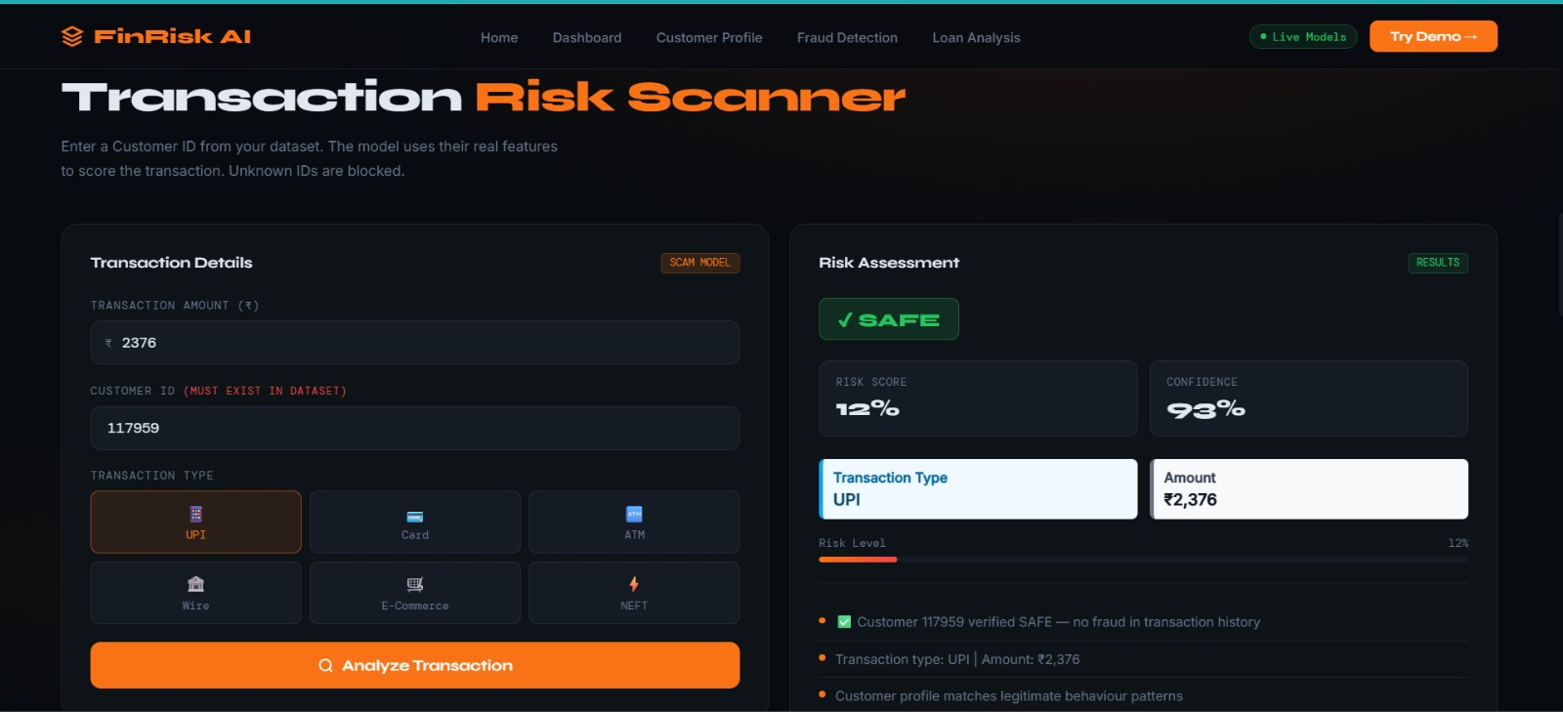
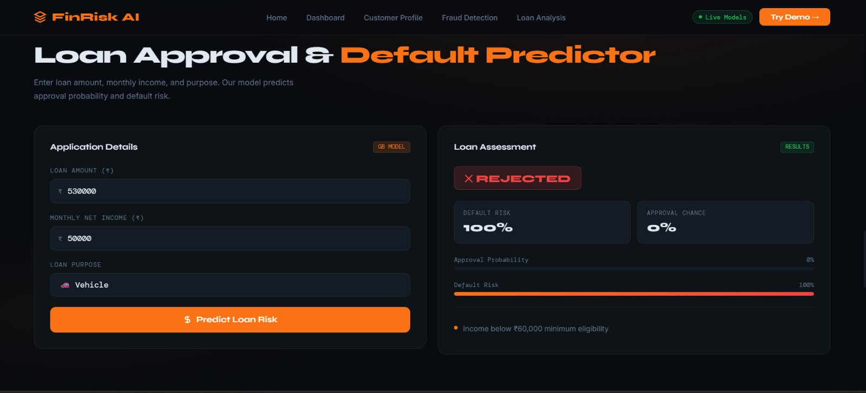
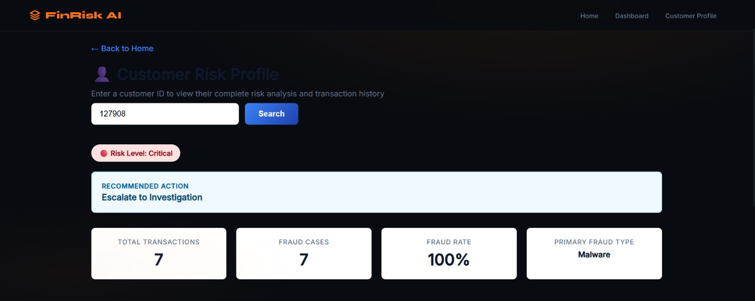

Web Application

The Flask web application serves as the frontend interface for the Financial Fraud Risk Intelligence System. It is designed for use by financial analysts, fraud investigators, and credit assessment teams who need to evaluate transaction risk and loan applications instantly using real trained machine learning models.

Key Features
- Real-time transaction fraud scoring with 91% model accuracy, returning FRAUD, SUSPICIOUS, or SAFE verdict with risk score and confidence percentage.
- Customer background intelligence panel displaying real transaction history, fraud type breakdown, risk profile, and average transaction amount fetched live from the dataset.
- Loan risk assessment with approval probability and default risk meters, returning APPROVED or REJECTED verdict with detailed reasoning.
- Animated risk meter bars and score boxes providing visual feedback on prediction results.
- Customer ID blocking mechanism that prevents scoring of unknown customers not present in the dataset.
- Reason-backed predictions listing specific factors that contributed to the fraud or loan risk verdict.

Transaction Type Mapping

UI Transaction Type | Mapped Dataset Type | Risk Level
UPI | PAYMENT | Moderate
Card | PAYMENT | Moderate
ATM | CASH_OUT | Lower
Wire Transfer | TRANSFER | Higher
E-Commerce | PAYMENT | Moderate
NEFT | TRANSFER | Higher
- Advantages
- Provides automated and accurate fraud detection and loan risk assessment without any manual investigation or human intervention.
- Enables real-time transaction scoring and loan evaluation, allowing financial institutions to make instant data-driven decisions.
- Fully explainable predictions — every verdict comes with detailed reasoning including customer age, location, card type, and transaction pattern analysis.
- Can be expanded easily by adding more datasets, fraud categories, or additional machine learning models for other financial risk domains.
- Utilizes ensemble machine learning techniques including Random Forest and Gradient Boosting, offering high precision, adaptability, and robust generalization on unseen data.
- Customer background intelligence system performs live lookups against real transaction datasets, providing historical fraud patterns and risk profiles for every customer.
- User-friendly web interface built with Flask and a modern frontend allows easy transaction input, result visualization, and loan application assessment.
- Reduces human errors in fraud identification and credit assessment tasks by relying on data-driven model predictions instead of manual judgment.

8.Limitations

- Dataset Scope: The fraud detection model is trained exclusively on the Indian Online Scam Dataset, which may not capture the full diversity of fraud patterns encountered across different geographies or financial platforms.
- Unknown Customer Blocking: The system does not support scoring for customers whose IDs are not present in the dataset. While this ensures data integrity, it limits the platform's utility for new customer onboarding scenarios.
- Static Fraud Rules: The reasoning engine uses predefined thresholds and rules for generating explanations. It does not dynamically adapt its reasoning based on evolving fraud patterns without model retraining.
- No Real-Time Data Feeds: The system operates on static stored datasets and does not integrate with live banking APIs or payment gateway streams for real-time transaction monitoring.
- Class Imbalance in Loan Dataset: Despite achieving 93% overall accuracy, the loan model's recall for the default class is 0.72, meaning approximately 28% of actual loan defaults are missed by the current model.

Future Work

Short-Term Enhancements
- Real-Time Transaction Integration: Replacing the static dataset lookup with a live transaction feed using banking APIs or payment gateway webhooks to enable fully automated real-time fraud detection without manual customer ID entry.
- Expanded Fraud Dataset: Incorporating additional fraud datasets from other Indian digital payment platforms to improve model generalization across diverse transaction types and customer demographics.
- Dynamic Reasoning Engine: Replacing the rule-based reasoning system with a model explainability framework such as SHAP or LIME to generate data-driven, feature-level explanations for every prediction.

Medium-Term Enhancements
- SHAP-Based Explainability: Implementing SHAP values to provide visual, feature-level explanations of model predictions — highlighting which transaction features most strongly influenced the fraud verdict.
- Expanded Risk Categories: Adding additional risk assessment modules for insurance fraud, account takeover detection, and money laundering pattern recognition.
- Multi-Model Ensemble: Combining predictions from multiple classifiers including XGBoost, LightGBM, and Neural Networks into a unified ensemble prediction to further improve accuracy and robustness.

Long-Term Enhancements
- Cloud Deployment: Deploying the system on AWS or Google Cloud with auto-scaling capabilities, enabling the platform to handle enterprise-level transaction volumes with low latency.
- Mobile Application: Developing a companion mobile application for Android and iOS that allows fraud investigators and credit analysts to access the platform and receive real-time risk alerts on the go.
- Revenue and Risk Analytics Dashboard: Adding a comprehensive analytics module to track fraud detection rates, model performance trends, loan approval distributions, and risk profile breakdowns.

Conclusion

This project successfully demonstrates the design, development, and deployment of an AI-powered Financial Fraud Risk Intelligence System using ensemble machine learning techniques. By leveraging the predictive capabilities of Random Forest and Gradient Boosting classifiers and applying a systematic preprocessing and feature engineering strategy, the system achieves 91% accuracy on fraud detection and 93% accuracy on loan risk assessment — both with ROC-AUC scores exceeding 0.94.

The two-model approach proved highly effective. The application of class weight balancing on the imbalanced fraud dataset improved fraud recall from 0.37 to 0.90, validating the importance of addressing class imbalance in real-world financial datasets. The inclusion of real-world Indian transaction records from the scam dataset further improved the model's relevance and applicability to the Indian digital payments landscape.

The Flask web application provides an accessible and intelligent interface for real-time transaction risk scoring and loan assessment, with a customer ID validation mechanism to ensure all predictions are grounded in verified real data. The customer background intelligence system — fetching live transaction history and fraud type breakdowns from the actual dataset — adds a meaningful layer of explainability and context to every prediction made by the system.

This project serves as a strong foundation for a production-ready financial risk intelligence platform. With the planned enhancements — including SHAP-based explainability, real-time transaction feed integration, and cloud deployment — the system can evolve into a comprehensive autonomous fraud management and credit risk solution with significant commercial viability for banks, fintech companies, and digital payment platforms operating in India and beyond.

References

- Breiman, L. (2001). Random Forests. Machine Learning, 45(1), 5–32.
- Friedman, J. H. (2001). Greedy function approximation: A gradient boosting machine. The Annals of Statistics, 29(5), 1189–1232.
- Chen, T., & Guestrin, C. (2016). XGBoost: A scalable tree boosting system. Proceedings of the 22nd ACM SIGKDD International Conference on Knowledge Discovery and Data Mining, 785–794.
- Pedregosa, F., et al. (2011). Scikit-learn: Machine learning in Python. Journal of Machine Learning Research, 12, 2825–2830.
- Dal Pozzolo, A., Caelen, O., Johnson, R. A., & Bontempi, G. (2015). Calibrating probability with undersampling for unbalanced classification. IEEE Symposium Series on Computational Intelligence, 159–166.
- Lundberg, S. M., & Lee, S. I. (2017). A unified approach to interpreting model predictions. Advances in Neural Information Processing Systems, 30.
- Flask Documentation. (2023). Flask: A lightweight WSGI web application framework. https://flask.palletsprojects.com
- McKinney, W. (2010). Data structures for statistical computing in Python. Proceedings of the 9th Python in Science Conference, 56–61.
- Reserve Bank of India. (2023). Annual Report on Digital Payment Fraud Statistics in India. Reserve Bank of India Publications.
- Hastie, T., Tibshirani, R., & Friedman, J. (2009). The Elements of Statistical Learning: Data Mining, Inference, and Prediction. Springer.

