End-to-End Anti-Money Laundering (AML) Detection
Machine Learning, FastAPI, GitHub Actions, Azure Machine Learning and MLflow
Capstone Project Report
Track chosen: Anti-Money Laundering (SAML-D transaction dataset)

Student name: [to be filled in]
Roll number / Programme: [to be filled in]
Guide / Institution: [to be filled in]
Report generated: 2026-10-11

Contents
- 1. Abstract and problem statement
- 2. Dataset description and preprocessing
- 3. Exploratory data analysis
- 4. Feature engineering, imbalance handling and validation strategy
- 5. Model building, tuning, evaluation and selection
- 6. Model serialisation (.pkl) and validation
- 7. FastAPI design, testing and CI pipeline
- 8. Azure MLflow implementation: tracking, registry, deployment, monitoring
- 9. Results, limitations, ethical considerations and future work
- 10. References
- Appendices A to C

1. Abstract and problem statement

Abstract
This project builds a complete machine-learning system for detecting suspicious transactions in the SAML-D anti-money-laundering dataset. Three scikit-learn models (Logistic Regression, Decision Tree, Random Forest) were compared under several class-imbalance strategies using a chronological train/validation/test split. The selected model, Random Forest, reached a PR-AUC of 0.797 and ROC-AUC of 0.983 on the held-out test window, with precision 0.847, recall 0.700 and F1 0.767 at a threshold chosen on the validation window. The model is served through a FastAPI service, tested automatically and prepared for deployment as an Azure ML managed online endpoint with MLflow tracking.

Problem statement
Financial institutions must detect and report suspicious activity. Missed cases bring regulatory penalties, while excessive false alerts overload investigators. The task is to classify each transaction as normal or laundering when only 0.1039% of transactions are laundering, so accuracy alone is misleading and model selection uses precision, recall, F1 and precision-recall AUC.
Track chosen: Anti-Money Laundering detection (SAML-D). The label column is Is_laundering.

2. Dataset description and preprocessing
The raw file contains 9,504,852 transactions. After merging Date and Time into one Timestamp column the working table has 11 columns, covering 2022-10-07 10:35:19 to 2023-08-23 10:57:12, with 292,715 distinct sender and 652,266 receiver accounts. Memory footprint after typed loading is 332.7 MB.
Table 1. Schema, data types and missing values
Column | Type | Missing
Sender_account | int64 | 0
Receiver_account | int64 | 0
Amount | float32 | 0
Payment_currency | category | 0
Received_currency | category | 0
Sender_bank_location | category | 0
Receiver_bank_location | category | 0
Payment_type | category | 0
Is_laundering | int8 | 0
Laundering_type | category | 0
Timestamp | datetime64[us] | 0

Table 2. Summary statistics of Amount
Statistic | Amount
count | 9,504,852.0000
mean | 8,762.9676
std | 25,614.9529
min | 3.7300
25% | 2,143.6874
50% | 6,113.7202
75% | 10,458.4624
max | 12,618,498.0000

Table 3. Target distribution and class imbalance
Target statistic | Value
Positives (laundering) | 9,873
Negatives (normal) | 9,494,979
Positive rate (%) | 0.1039
Imbalance ratio (negative : positive) | 961.7000

Cleaning decisions
- Exact duplicate rows removed: 0.
- Rows removed for missing required fields: 0.
- Rows removed for non-positive amounts: 0.
- Self-transfers found: 0.
- Rows kept: 9,504,852 of 9,504,852.
- Amount outliers above the IQR fence (22,930.62): 429,848 rows, with laundering rate 0.208% against 0.099% below the fence. They are retained as signal and compressed with a log transform.
Leakage control: the column Laundering_type is a label-derived typology that fully determines the target, so it is never used as a feature. It is used only for error analysis.
[SCREENSHOT PLACEHOLDER]
Dataset preview and preprocessing steps (terminal or notebook output)
(insert your screenshot here)

3. Exploratory data analysis
All EDA was computed on the training window only; validation and test were not inspected for modelling decisions.
Table 4. Chronological split
Split | Rows | Positives | Positive rate | Start | End
train | 6,653,396 | 6,764 | 0.1017% | 2022-10-07 | 2023-05-18
valid | 1,425,728 | 1,412 | 0.0990% | 2023-05-18 | 2023-07-05
test | 1,425,728 | 1,697 | 0.1190% | 2023-07-05 | 2023-08-23

Leakage audit: Laundering_type has 28 values; 0 appear in both classes, confirming it cannot be used as a feature.
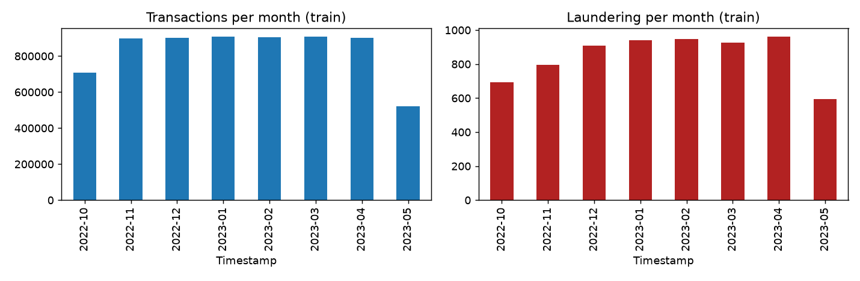
Figure 1. Monthly transactions and laundering cases (training window)
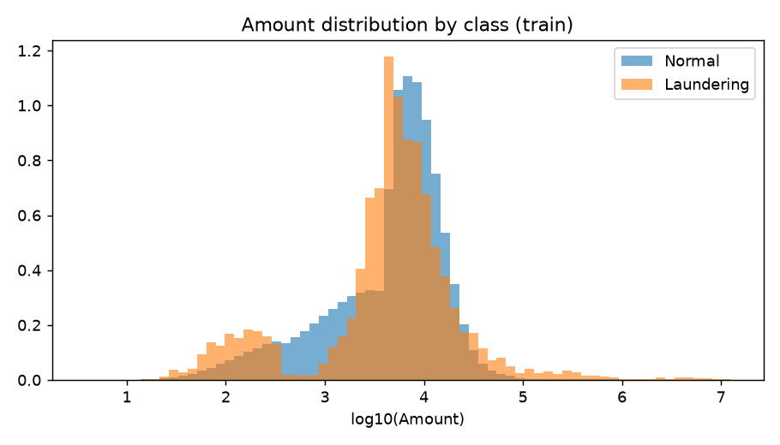
Figure 2. Amount distribution by class (log scale)
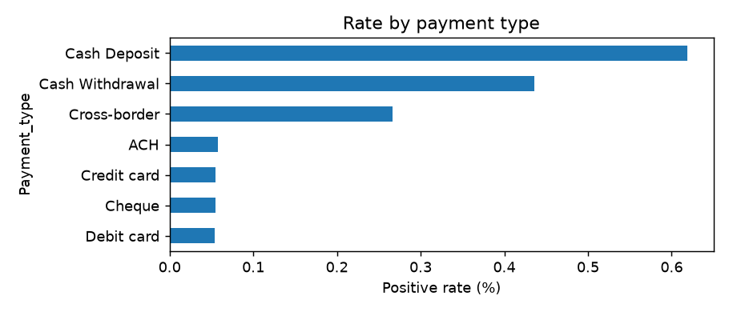
Figure 3. Laundering rate by payment type
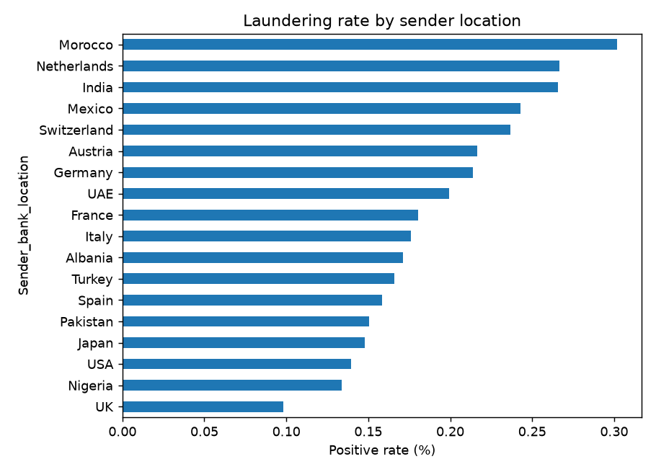
Figure 4. Laundering rate by sender bank location
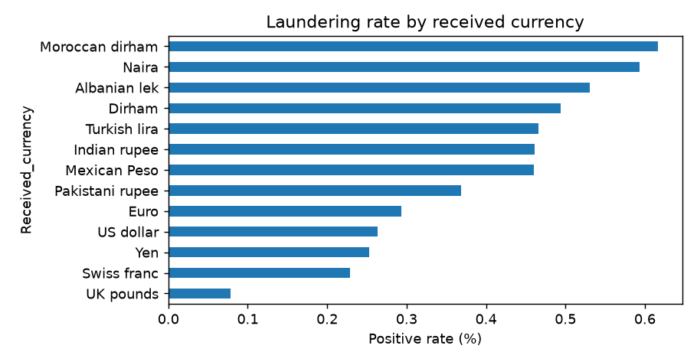
Figure 5. Laundering rate by received currency
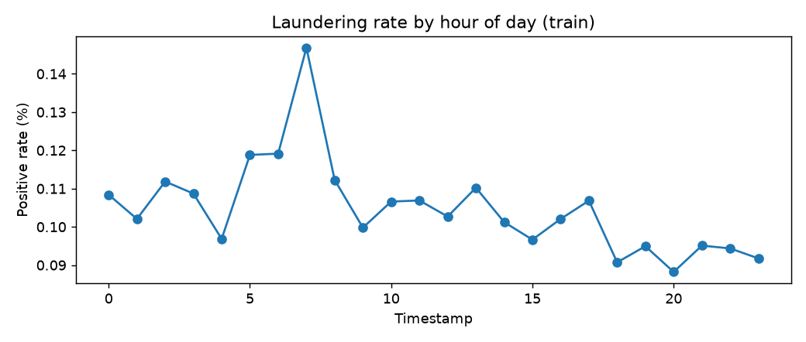
Figure 6. Laundering rate by hour of day
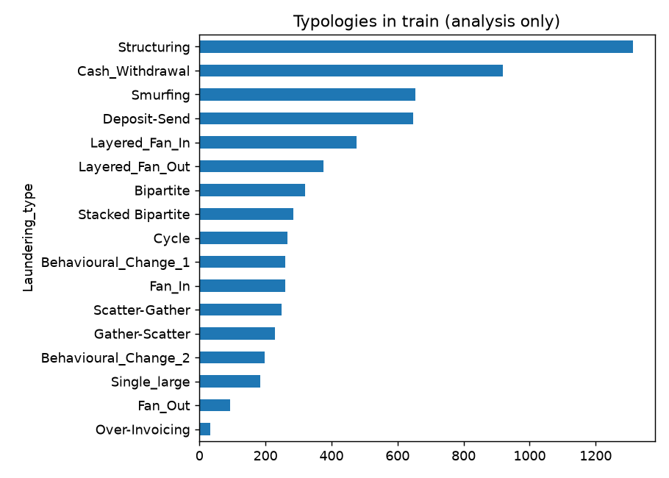
Figure 7. Laundering typologies in the training window (analysis only)
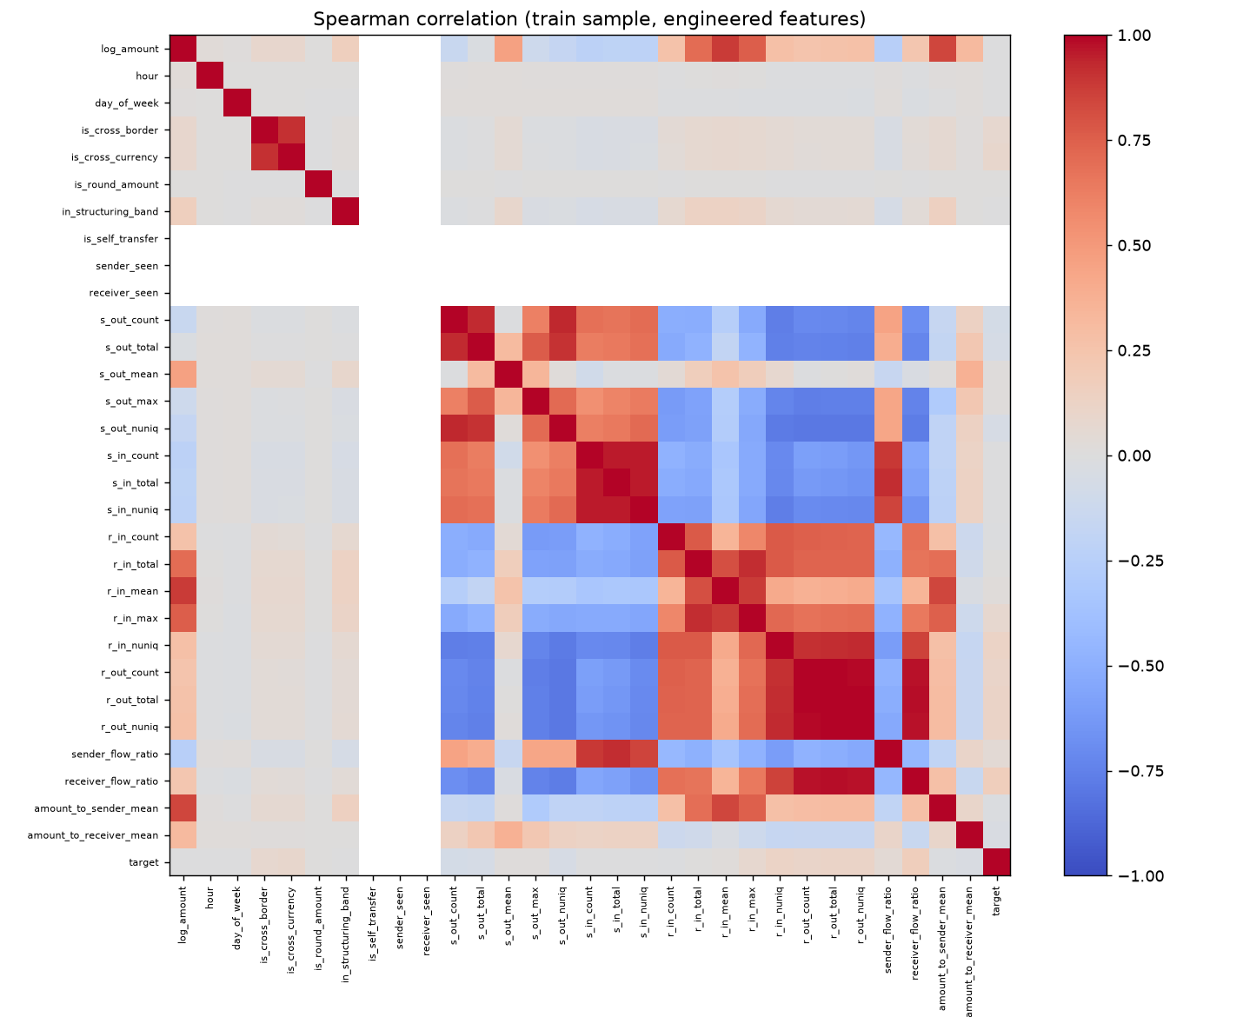
Figure 8. Spearman correlation of engineered features with the target
Table 5. Signal of engineered features: training versus validation
Feature | Univariate AUC (train) | Univariate AUC (validation)
receiver_flow_ratio | 0.8642 | 0.7618
r_in_nuniq | 0.7475 | 0.6833
r_out_nuniq | 0.7414 | 0.7101
r_out_total | 0.7376 | 0.7025
r_out_count | 0.7258 | 0.6953
r_in_max | 0.6807 | 0.6522
s_out_count | 0.3378 | 0.4677
s_out_total | 0.3555 | 0.4736

Insight: account-profile signals are weaker on validation than on training when profiles are computed over the whole training window. This motivated causal (lagged) profiles, described in the next section.
[SCREENSHOT PLACEHOLDER]
EDA visualisations and insights (optional: your own notebook screenshots)
(insert your screenshot here)

4. Feature engineering, imbalance handling and validation strategy

Feature engineering
- Row features: log amount, hour, day of week, cross-border flag, cross-currency flag, round-amount flag, 9,000-10,000 band flag, self-transfer flag.
- Categorical features: payment type, payment and received currency, sender and receiver bank location (unseen values map to a reserved level).
- Account profiles for sender and receiver: transaction counts, totals, mean and maximum amounts, number of distinct counterparties, and in/out flow ratios.
- Causal profiles: for every 7-day block the profiles are built only from the preceding 28 days, so no row sees its own or future activity and every row sees a history of the same length. The first 28 days are warm-up and excluded from training.
- Account identifiers are never used as raw features.
The feature builder produces 35 model inputs.

Validation strategy
A chronological 70/15/15 split is used. Training is fitted on the training window, hyper-parameters and the decision threshold are chosen on the validation window, and the test window is scored once with thresholds fixed beforehand. Resampling is applied inside the training fit only. Cross-validated average precision was used during tuning but is optimistic here because folds share accounts and time, so model selection relies on the validation window.

Imbalance experiments
Table 6. Imbalance strategies compared on the validation window (default hyper-parameters)
Model | Strategy | PR-AUC | ROC-AUC | Best F1 | Precision | Recall
Logistic Regression | none | 0.1658 | 0.9148 | 0.2169 | 0.2374 | 0.1997
Logistic Regression | class_weight | 0.1167 | 0.9246 | 0.1649 | 0.2289 | 0.1289
Logistic Regression | random_over | 0.1540 | 0.9213 | 0.2023 | 0.2204 | 0.1870
Logistic Regression | random_under | 0.1494 | 0.9211 | 0.2009 | 0.2027 | 0.1990
Decision Tree | none | 0.3393 | 0.9120 | 0.4653 | 0.5956 | 0.3817
Decision Tree | class_weight | 0.4796 | 0.9526 | 0.5134 | 0.4464 | 0.6041
Decision Tree | random_over | 0.5587 | 0.9361 | 0.6288 | 0.8551 | 0.4972
Decision Tree | random_under | 0.4380 | 0.9551 | 0.5564 | 0.6905 | 0.4660
Decision Tree | smotenc | 0.2561 | 0.9491 | 0.3932 | 0.3055 | 0.5517
Random Forest | none | 0.7741 | 0.9833 | 0.7727 | 0.8277 | 0.7245
Random Forest | class_weight | 0.6771 | 0.9857 | 0.6540 | 0.6755 | 0.6339
Random Forest | random_over | 0.7787 | 0.9837 | 0.7684 | 0.8015 | 0.7380
Random Forest | random_under | 0.6977 | 0.9831 | 0.6804 | 0.7554 | 0.6190
Random Forest | smotenc | 0.6678 | 0.9828 | 0.6410 | 0.6575 | 0.6254

Strategies: none; class weights; random oversampling of the minority class to a 1:10 ratio; random undersampling to 1:10; and SMOTENC (after undersampling) for tree models only, because it needs ordinal-coded categoricals. Precision, recall and F1 in this table use a validation-tuned threshold and are therefore optimistic.
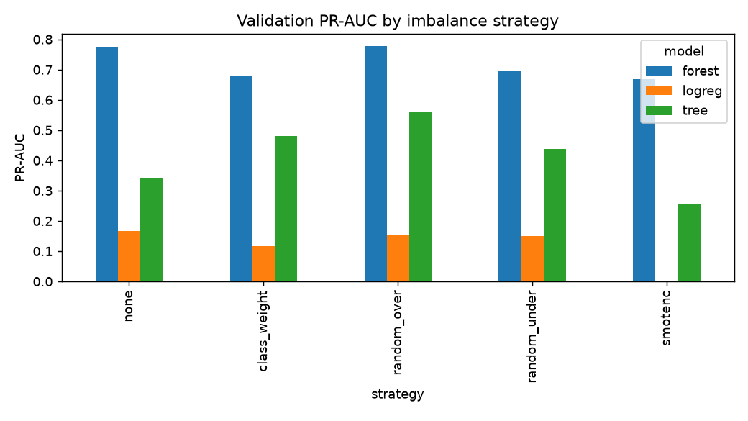
Figure 9. Validation PR-AUC by imbalance strategy and model
Table 7. Logistic Regression re-run with converged solver (max_iter=1000)
Strategy | PR-AUC | ROC-AUC
none | 0.1658 | 0.9148
class_weight | 0.1167 | 0.9246
random_over | 0.1540 | 0.9213
random_under | 0.1494 | 0.9211

5. Model building, tuning, evaluation and selection
Table 8. Randomised search (3-fold stratified CV, average precision)
Model | Strategy | Best hyper-parameters | CV average precision
Logistic Regression | none | {"C": 4.5705630998014515} | 0.5804
Decision Tree | random_over | {"min_samples_leaf": 50, "max_depth": 16, "criterion": "entropy"} | 0.8618
Random Forest | random_over | {"n_estimators": 60, "min_samples_leaf": 5, "max_features": 0.3, "max_depth": 20} | 0.9255

CV scores are computed on a sample with a higher positive share than the real data and are not comparable with validation or test PR-AUC.
Table 9. Validation metrics at the threshold that maximises validation F1
Model | Accuracy | Precision | Recall | F1 | ROC-AUC | PR-AUC | Positives
Logistic Regression | 0.9986 | 0.2347 | 0.2011 | 0.2166 | 0.9153 | 0.1652 | 1,412
Decision Tree | 0.9994 | 0.7070 | 0.7125 | 0.7097 | 0.9550 | 0.5658 | 1,412
Random Forest | 0.9996 | 0.8181 | 0.7358 | 0.7748 | 0.9856 | 0.7808 | 1,412

Table 10. Test metrics at the threshold that maximises validation F1
Model | Accuracy | Precision | Recall | F1 | ROC-AUC | PR-AUC | Positives
Logistic Regression | 0.9984 | 0.3017 | 0.2357 | 0.2646 | 0.9207 | 0.2161 | 1,697
Decision Tree | 0.9994 | 0.7704 | 0.7136 | 0.7409 | 0.9556 | 0.6168 | 1,697
Random Forest | 0.9995 | 0.8474 | 0.7001 | 0.7667 | 0.9828 | 0.7973 | 1,697

Table 11. Test confusion matrices
Model | TP | FP | FN | TN | Alerts raised
Logistic Regression | 400 | 926 | 1,297 | 1,423,105 | 1,326
Decision Tree | 1,211 | 361 | 486 | 1,423,670 | 1,572
Random Forest | 1,188 | 214 | 509 | 1,423,817 | 1,402

Operating point for higher recall (selected model, threshold 0.7456 chosen on validation for recall 0.80): test recall 0.780, precision 0.701, 1,889 alerts.
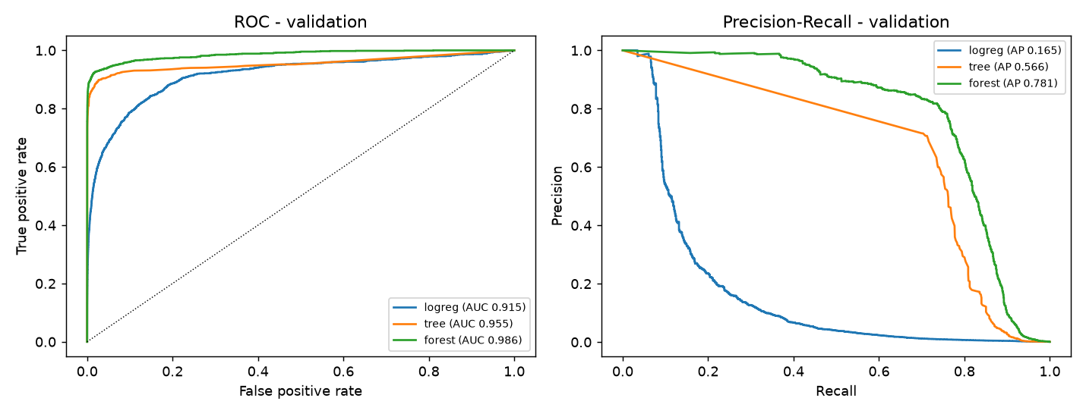
Figure 10. ROC and precision-recall curves (validation)
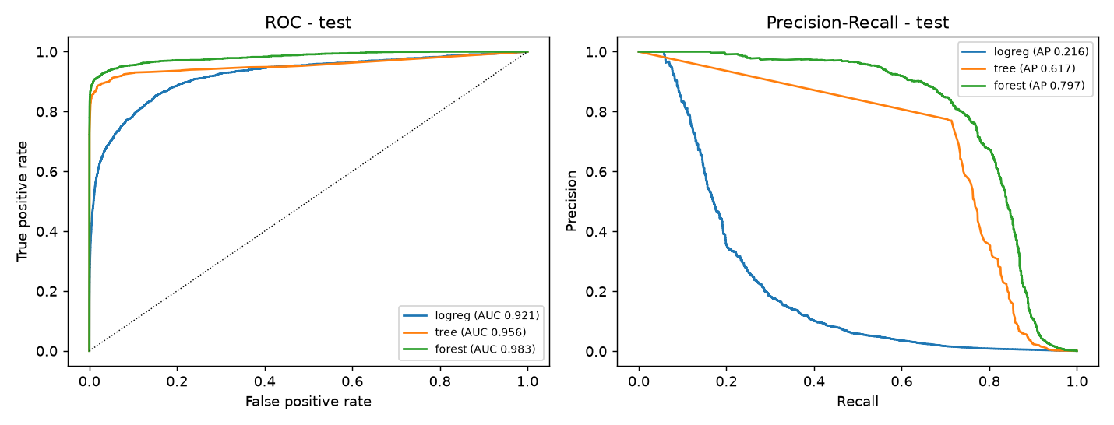
Figure 11. ROC and precision-recall curves (test)
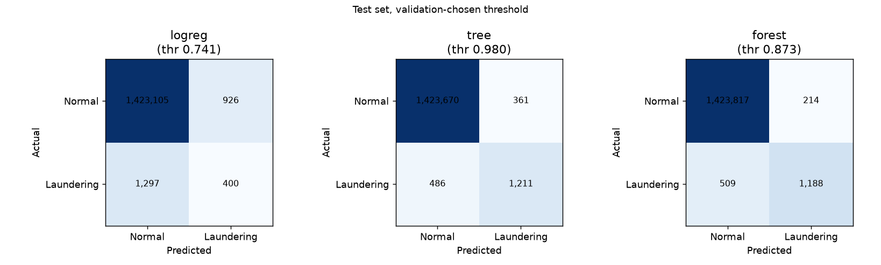
Figure 12. Confusion matrices on the test window
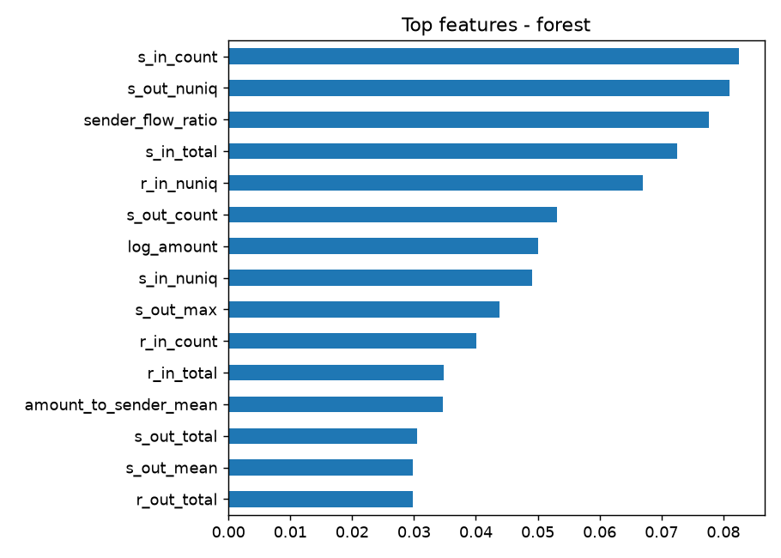
Figure 13. Feature importance of the selected model
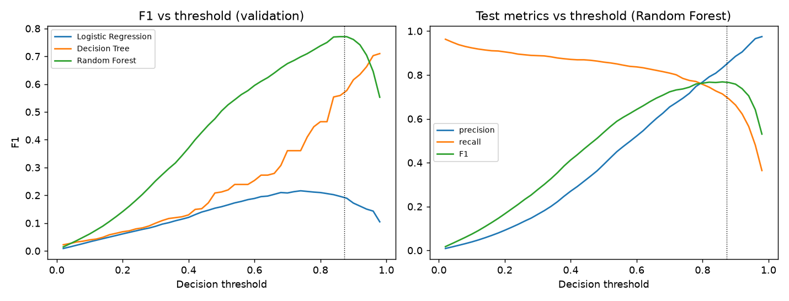
Figure 14. Precision, recall and F1 across decision thresholds
Selection: Random Forest has the highest validation PR-AUC (0.781). Accuracy is reported but not used for selection because a model that flags nothing already exceeds 99.8% accuracy on this data.
Table 12. Recall by laundering typology for the selected model (test)
Typology (analysis only) | Test cases | Recall
Bipartite | 26 | 0.5000
Fan_In | 36 | 0.5560
Cycle | 49 | 0.5710
Over-Invoicing | 7 | 0.5710
Gather-Scatter | 82 | 0.5980
Single_large | 34 | 0.6470
Layered_Fan_In | 88 | 0.6480
Stacked Bipartite | 128 | 0.6640
Smurfing | 152 | 0.6640
Fan_Out | 58 | 0.6720
Deposit-Send | 163 | 0.6870
Structuring | 363 | 0.7130
Scatter-Gather | 46 | 0.7390
Layered_Fan_Out | 100 | 0.7500
Cash_Withdrawal | 241 | 0.7630
Behavioural_Change_1 | 62 | 0.8390
Behavioural_Change_2 | 62 | 0.8710

[SCREENSHOT PLACEHOLDER]
Model training and evaluation results (terminal output)
(insert your screenshot here)

6. Model serialisation (.pkl) and validation
The deployable pipeline (feature builder with a frozen account-profile table, preprocessing, classifier) is saved with joblib as models/aml_pipeline.pkl, with the decision threshold in models/model_meta.json. Pickle files execute code when loaded: load only artifacts you built yourself.
Table 13. Serialisation and artifact validation
Check | Result
Reload prediction match (20,000 rows), max abs difference | 0.0000
Reloaded predictions identical | True
Scoring time for the whole test window (s) | 13.9000
Static profile ends at | 2023-07-05 15:24:39
Artifact test PR-AUC (raw rows, static profile) | 0.7645
Artifact test precision / recall / F1 | 0.808 / 0.681 / 0.739

The frozen profile becomes stale as time passes after its end date, which lowers performance slightly compared with refreshed profiles; a refresh job is part of the retraining plan.
[SCREENSHOT PLACEHOLDER]
Saved model output (.pkl) and reload check
(insert your screenshot here)

7. FastAPI design, testing and CI pipeline
Table 14. API endpoints
Endpoint | Purpose | Notes
GET /health | Service and model status | HTTP 503 when the model or the Azure backend is not configured
POST /predict | Score one transaction | Returns prediction, probability, threshold, model

- Request schema (Pydantic): Timestamp, Sender_account, Receiver_account, Amount (greater than 0, at most 1e9), Payment_type, Payment_currency, Received_currency, Sender_bank_location, Receiver_bank_location. Categories are restricted to the values seen in training; extra fields are rejected.
- Validation errors return HTTP 422 with location, message and type only; submitted values are never echoed or logged.
- Backends: local (loads the .pkl) or azure (forwards to the managed online endpoint using the key). Upstream failures map to HTTP 502 or 504 without leaking the key.
- The same inference code is used by the API, offline checks and the Azure scoring script, and tests assert identical probabilities.
- Automated tests (pytest and FastAPI TestClient) cover valid input, each missing field, wrong types, out-of-range values, unseen categories, extra fields, NaN, timezone-aware timestamps, model-load failure, corrupt model files, API versus local parity, and the Azure-backend error paths against a local stub.
[SCREENSHOT PLACEHOLDER]
FastAPI Swagger UI (/docs) and Postman or cURL testing
(insert your screenshot here)

Continuous integration: .github/workflows/ci.yml runs on every push and pull request with Python 3.11.9: install pinned requirements, pip check, ruff and pytest. A failing test fails the build.
[SCREENSHOT PLACEHOLDER]
GitHub Actions CI run (passing build)
(insert your screenshot here)

8. Azure MLflow implementation: tracking, registry, deployment, monitoring

Experiment tracking and registry
mlops/track_models.py retrains the three models with the tuned settings and logs, for each run, parameters, validation and test metrics (precision, recall, F1, ROC-AUC, PR-AUC, confusion counts), ROC/PR and confusion-matrix plots, a feature-importance plot, a data hash, the dependency lock file and the deployable model with its input signature. The best run by validation PR-AUC is registered as 'aml-detector' with version tags (stage, alias, threshold, selection rule, data hash).
Table 15. MLflow run comparison (local tracking store)
Model | Validation PR-AUC | Test PR-AUC | Test F1 | Difference vs earlier run
Random Forest | 0.7808 | 0.7973 | 0.7667 | 0.0000
Decision Tree | 0.5658 | 0.6168 | 0.7409 | 0.0000
Logistic Regression | 0.1652 | 0.2161 | 0.2646 | 0.0000

Champion: Random Forest, registered version 1. Registry model equals the saved .pkl on 20,000 rows (max abs difference 0.0).

Azure ML SDK v2 pipeline
mlops/azure/submit_pipeline.py (or the notebook notebooks/azureml_sdk2_pipeline.ipynb, run on the 'Python 3.10 - SDK v2' kernel) creates in the Azure ML workspace: a data asset (saml-d-raw), an environment (aml-train-env, Python 3.11.9), five command components (prepare, features, imbalance, tune, final), a pipeline job that connects them, and a registered model (aml-detector-scoring). Each step logs parameters, metrics, stepped precision/recall/F1 curves, and PNG and JSON artifacts through MLflow. The step scripts were run end to end locally with the job environment's pinned libraries and reproduced the reported model metrics exactly; the Azure run itself is not reported here.
Pipeline run status: [fill in after you run the pipeline in Azure ML].
[SCREENSHOT PLACEHOLDER]
Azure ML pipeline graph (Jobs > aml-detection-pipeline) and step outputs
(insert your screenshot here)

[SCREENSHOT PLACEHOLDER]
Azure ML Data, Environments, Components and Models pages
(insert your screenshot here)

The results above were produced with a local MLflow store. Logging to the Azure ML workspace is done by setting MLFLOW_TRACKING_URI to the workspace tracking URI (see INSTRUCTION.md); that step has not been verified by this report.
[SCREENSHOT PLACEHOLDER]
MLflow experiment tracking dashboard and Model Registry
(insert your screenshot here)

Deployment
Design: a managed online endpoint (key authentication) with a deployment named 'blue' on one Standard_DS2_v2 instance, a custom scoring script (mlops/azure/score.py) that reuses the same inference code, a conda environment with pinned dependencies, and Application Insights enabled. The scoring package and the Azure inference server were tested locally; no statement about the Azure deployment itself is made here.
Deployment status: [fill in after you run mlops/azure/deploy.ps1 and record the outcome].
[SCREENSHOT PLACEHOLDER]
Azure deployment (endpoint and deployment status in Azure ML studio)
(insert your screenshot here)

[SCREENSHOT PLACEHOLDER]
Endpoint testing (curl or Python client output, with the key hidden)
(insert your screenshot here)

Monitoring, retraining and safe rollout
- Monitoring: Application Insights for request volume, latency and errors; track the share of alerts per day and population drift of Amount, payment-type mix and cross-border share against the training window.
- Performance monitoring needs confirmed investigation outcomes; compare precision and recall on labelled cases each period.
- Retraining triggers: scheduled (for example monthly, to refresh account profiles) and event-based (drift beyond agreed limits or a fall in precision or recall).
- Safe rollout: deploy a candidate as 'green' beside 'blue', route a small traffic share, compare, then promote or roll back by moving traffic; delete the unused deployment to stop its cost.
- Cost: a managed deployment bills per hour while it exists. Delete the endpoint after testing (teardown script).

9. Results, limitations, ethical considerations and future work

Limitations
- The dataset is synthetic; results do not demonstrate real-world AML performance.
- Typologies such as bipartite, fan-in and cycle patterns are detected less well than others; see the per-typology table.
- The deployed profile table is a snapshot and goes stale; one transaction is scored without live account history.
- Training used a sampled negative pool because of compute limits; full-data training may change results.
- The model was trained on the training window only, not refit on training plus validation.

Ethical considerations
- False positives burden customers and investigators; thresholds should reflect investigator capacity, and alerts should trigger human review, not automatic action.
- Bias: location and currency features can proxy for nationality; fairness should be assessed on real data before use.
- Privacy: transaction and account data are sensitive; the API does not log request values, keys stay in environment variables or secret stores, and access should be restricted.
- Explainability: feature importance and alert reasons should be available to investigators and auditors.

Future work
- Gradient-boosted models and graph features for the weak typologies.
- Live account-profile store and drift-triggered retraining.
- Optional CI/CD to train, register and deploy to Azure with a service principal.
Selected model: Random Forest.

10. References
- SAML-D synthetic anti-money-laundering dataset (the source named in the project brief).
- scikit-learn, imbalanced-learn, pandas, FastAPI, Pydantic, pytest documentation.
- MLflow documentation (tracking, model registry); Azure Machine Learning documentation (managed online endpoints).

Appendix A: environment
Table 16. Library versions
Package | Version (this report run)
pandas | 3.0.6
numpy | 2.4.6
scikit-learn | 1.9.1
imbalanced-learn | 0.14.2
fastapi | 0.143.0
pydantic | 2.14.0
mlflow-skinny | 3.17.0
python-docx | 1.2.0

Appendix B: reproduction commands (PowerShell, project root, PYTHONPATH=src)
python -m aml.profile_data
python -m aml.eda
python -m aml.train features
python -m aml.train imbalance
python -m aml.train tune --cv-neg 120000
python -m aml.train final
python -m aml.verify artifact
python -m aml.verify logreg
python -m aml.verify auc
python -m mlops.track_models
python -m aml.report

Appendix C: additional screenshots and notes
[SCREENSHOT PLACEHOLDER]
Additional screenshot or notes
(insert your screenshot here)

