Mini Project Documentation
MemeVault
GitHub Repo URL: https://github.com/RahulPB08/MEME_VAULT

1. Chosen Stack
The MemeVault NFT Marketplace is built on a custom Web3 MERN Stack. This architecture expands the standard MERN paradigm by integrating decentralized blockchain technologies, creating a highly scalable and robust Web3 distributed application (dApp).
The complete stack consists of: * Frontend: React.js, Vite (bundler), Framer Motion (animations), and Ethers.js v6 (for Web3 provider access). * Backend: Node.js, Express.js (REST API framework). * Database: MongoDB (using Mongoose Object Data Modeling). * Storage Protocol: Pinata (IPFS - InterPlanetary File System) for decentralized, immutable image hosting. * Blockchain: Solidity (Smart Contracts), Local Anvil (Ethereum test node), and Foundry (compilation & development toolchain).

2. User Interface
The User Interface (UI) is designed as a responsive, dark-mode Single Page Application (SPA). It leverages CSS glassmorphism and Framer Motion for premium-feeling micro-animations. It successfully bridges web2 authentication with advanced web3 wallet signing, providing a fluid user experience.
Key UI Pages Constructed: * Login / Register: JWT-based authentication workflows with animated UI toggles. * Home Page: Landing screen featuring hero banners, trending memes, category filters, and platform features. * Explore Page: An advanced marketplace grid to browse all minted meme NFTs, supporting search queries and status filters. * Create Wizard: A multi-step animated form allowing users to select an image, interact with Pinata IPFS, set metadata (royalties, price), and mint the asset to the blockchain. * NFT Detail Page: Deep-dive view of individual NFTs showing chain history, live offers, and instantaneous “Buy” functionality. * Auctions View: Dedicated interface for real-time English auctions tracking the highest bidder and countdown timers. * Dashboard / Profile: Private and public spaces for users to track their total earnings, collection stats, created NFTs, and followers.

Application Screenshots:
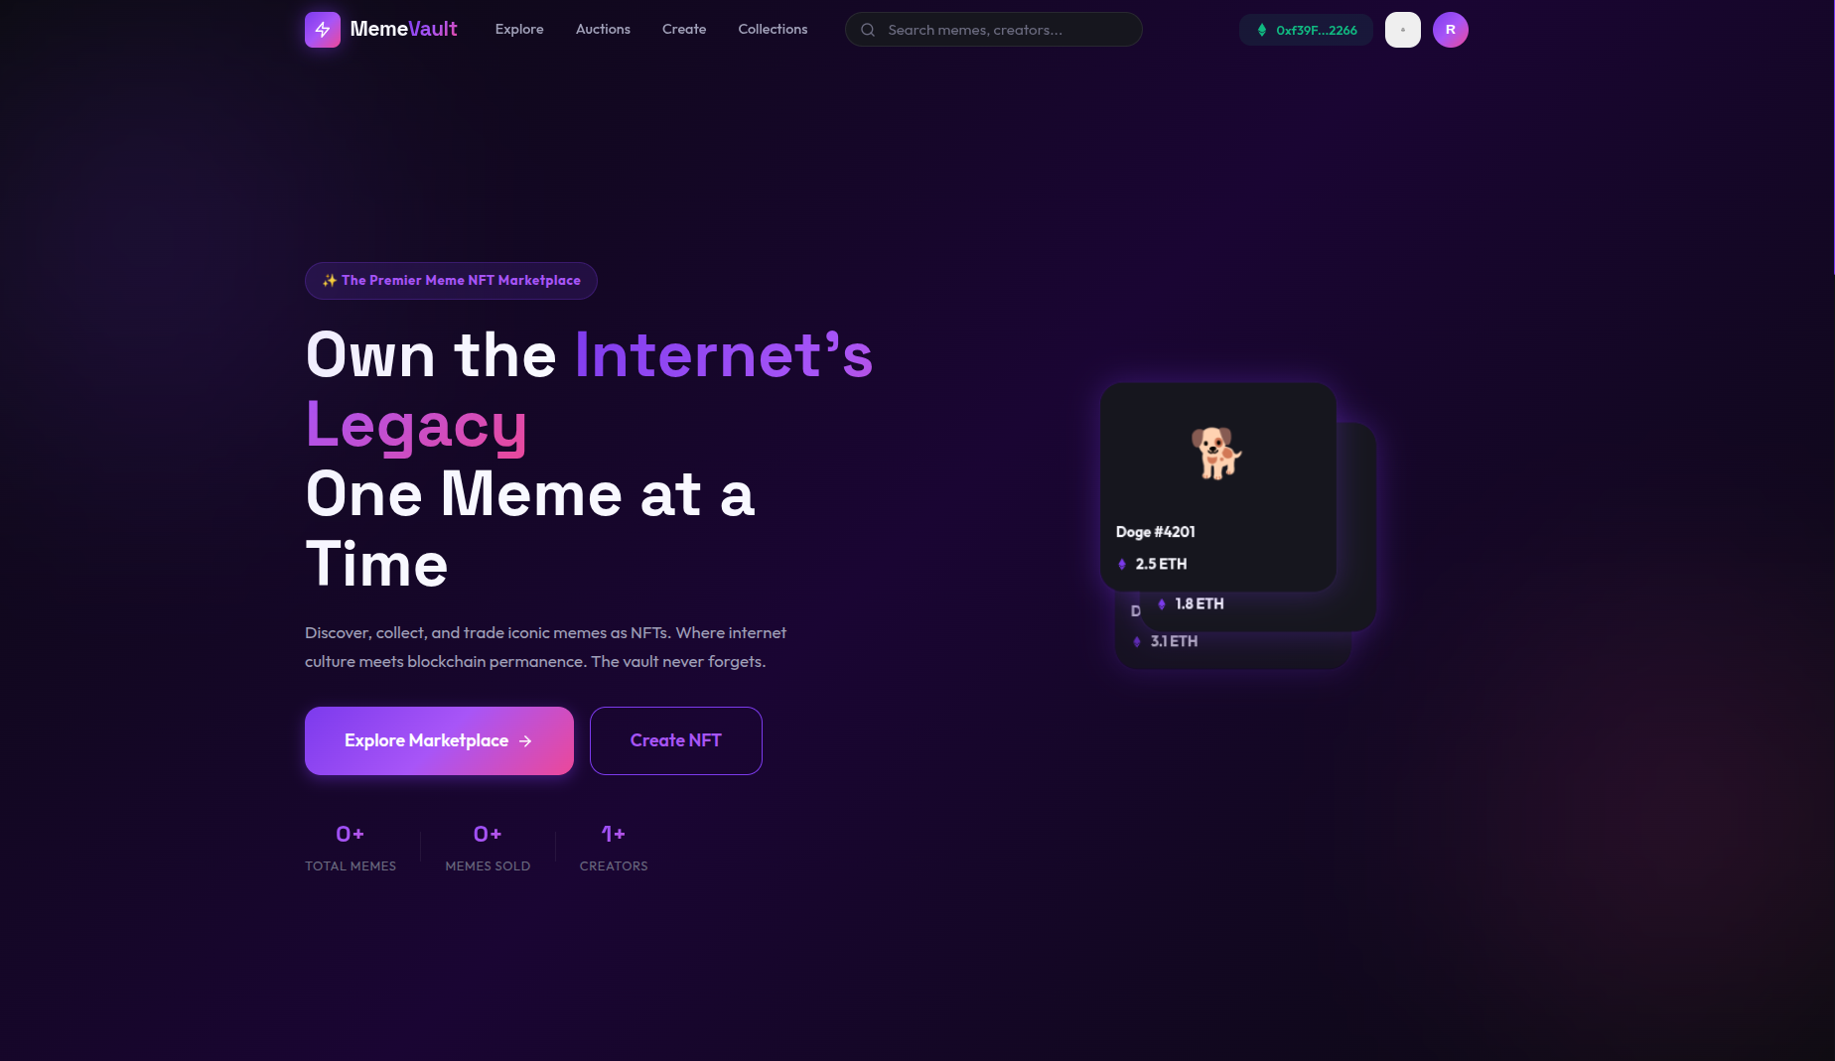

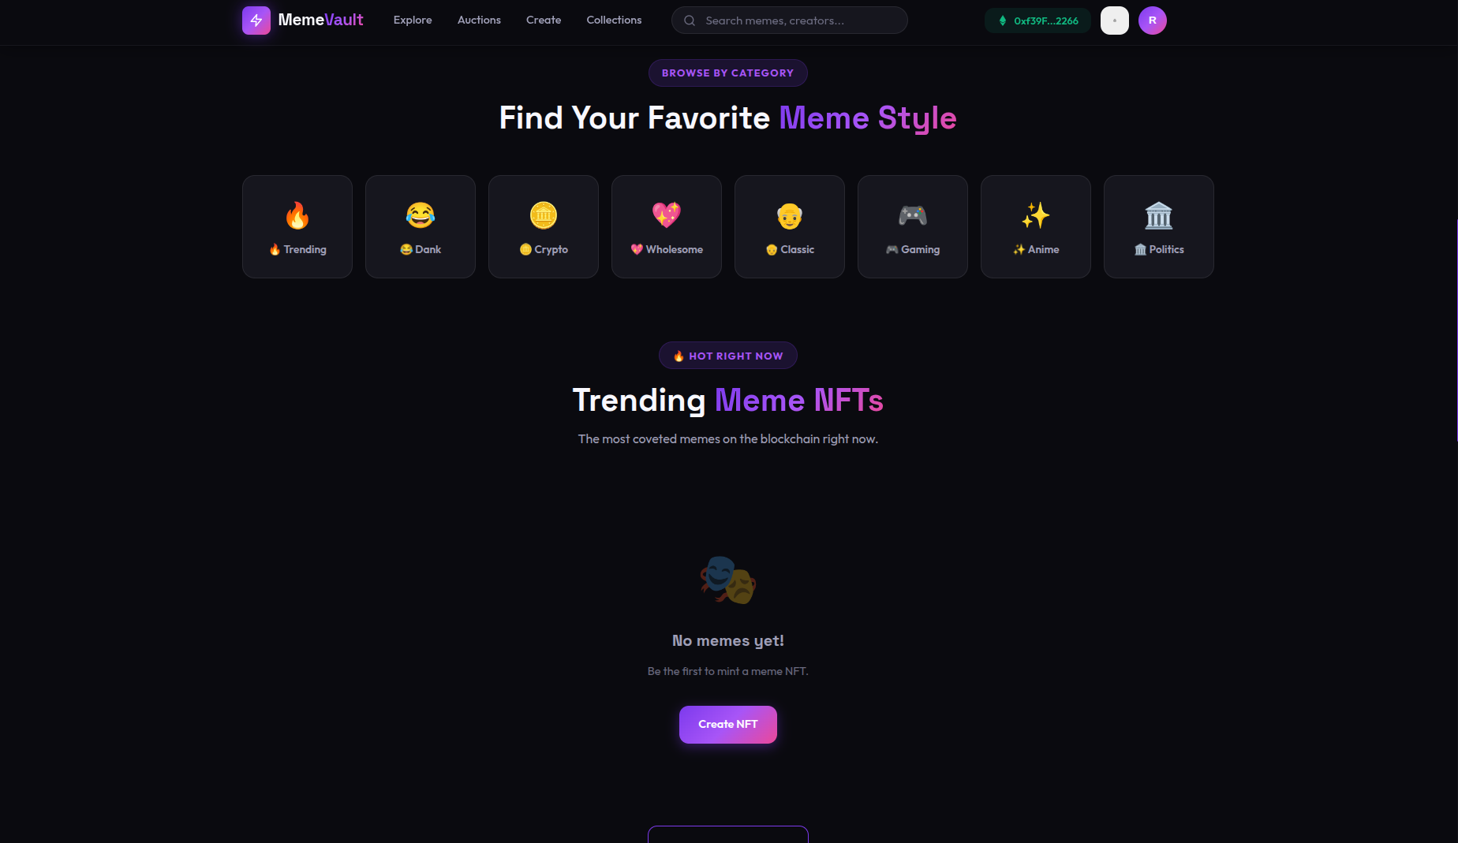

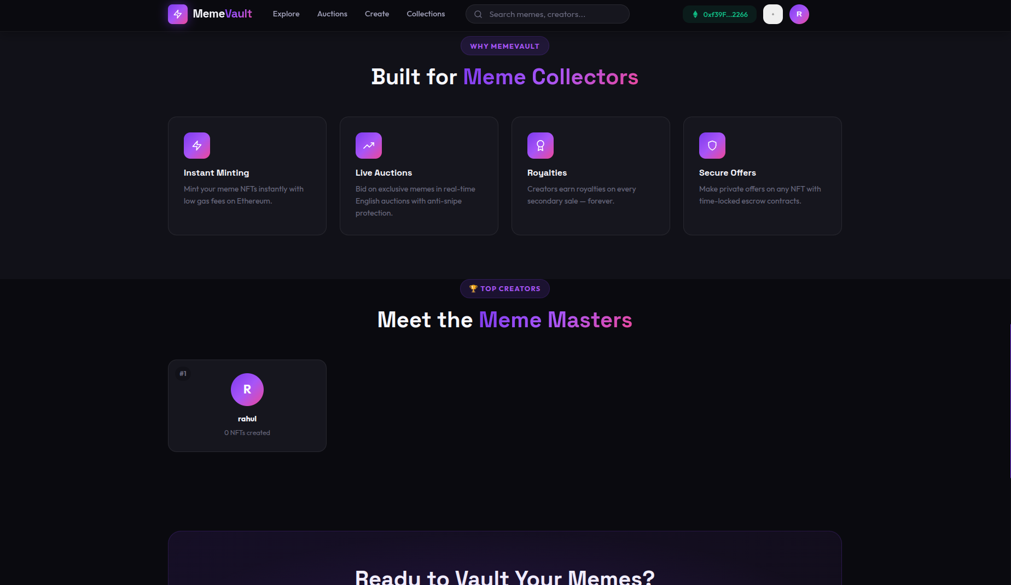

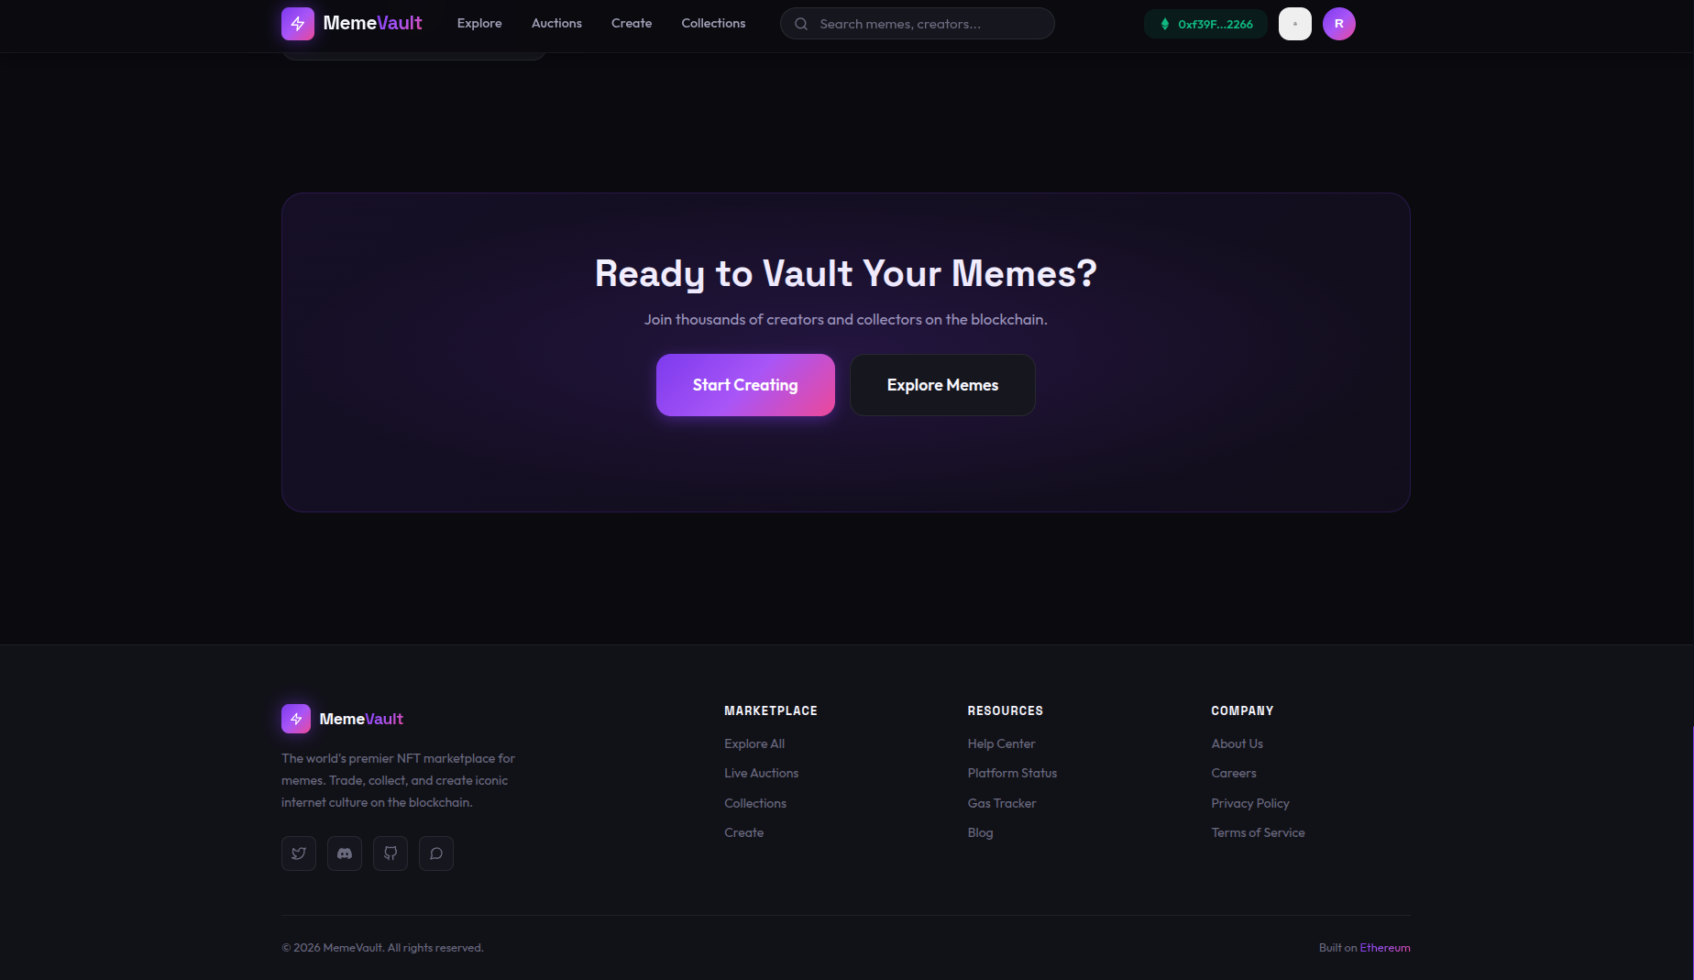

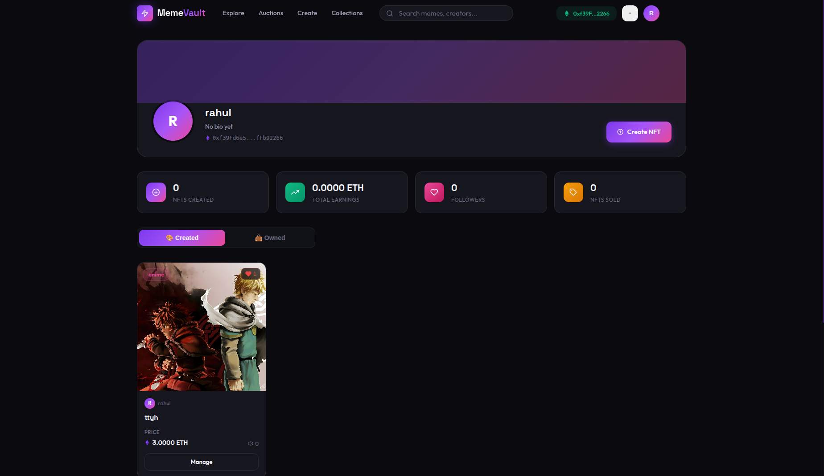

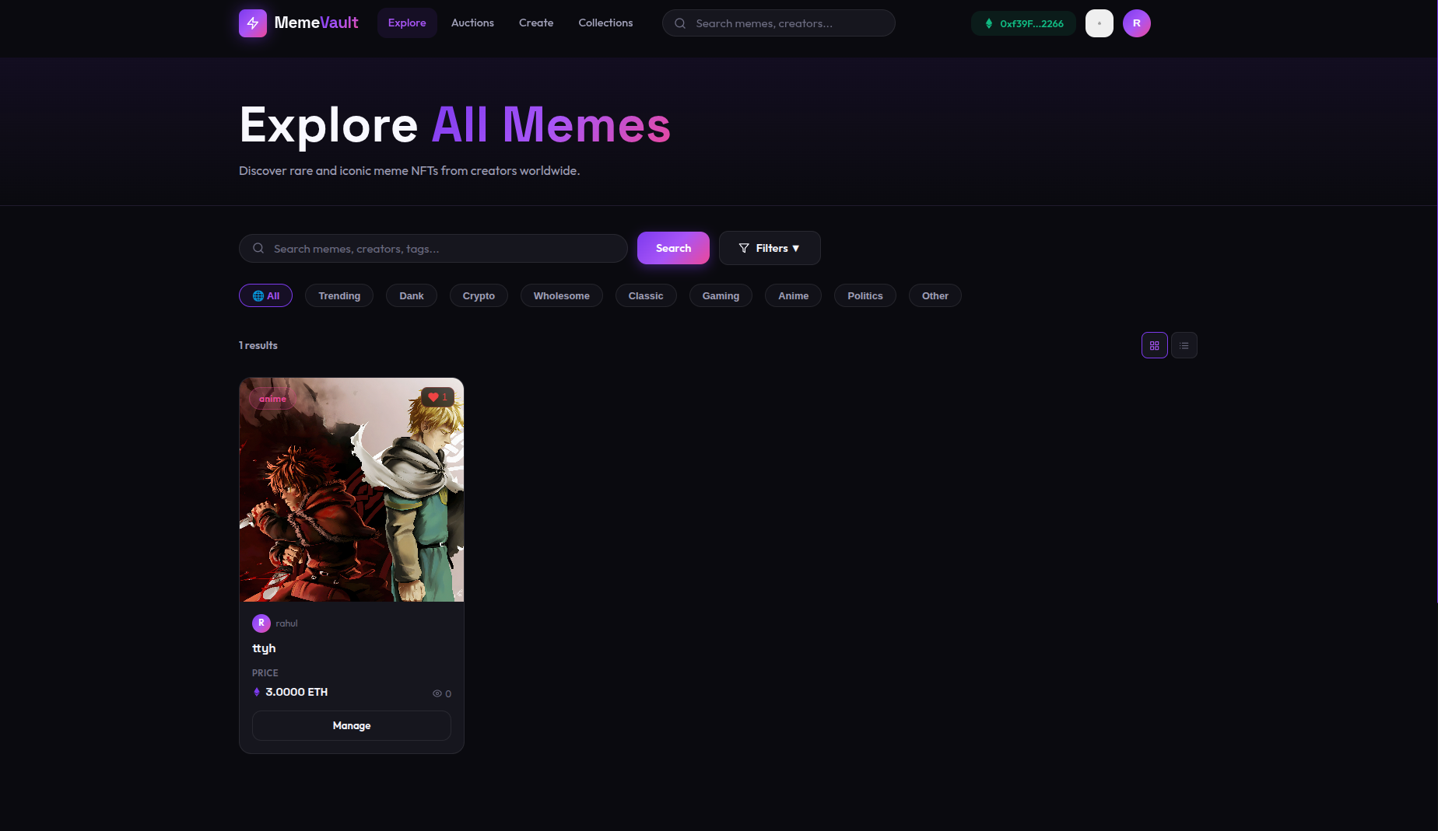
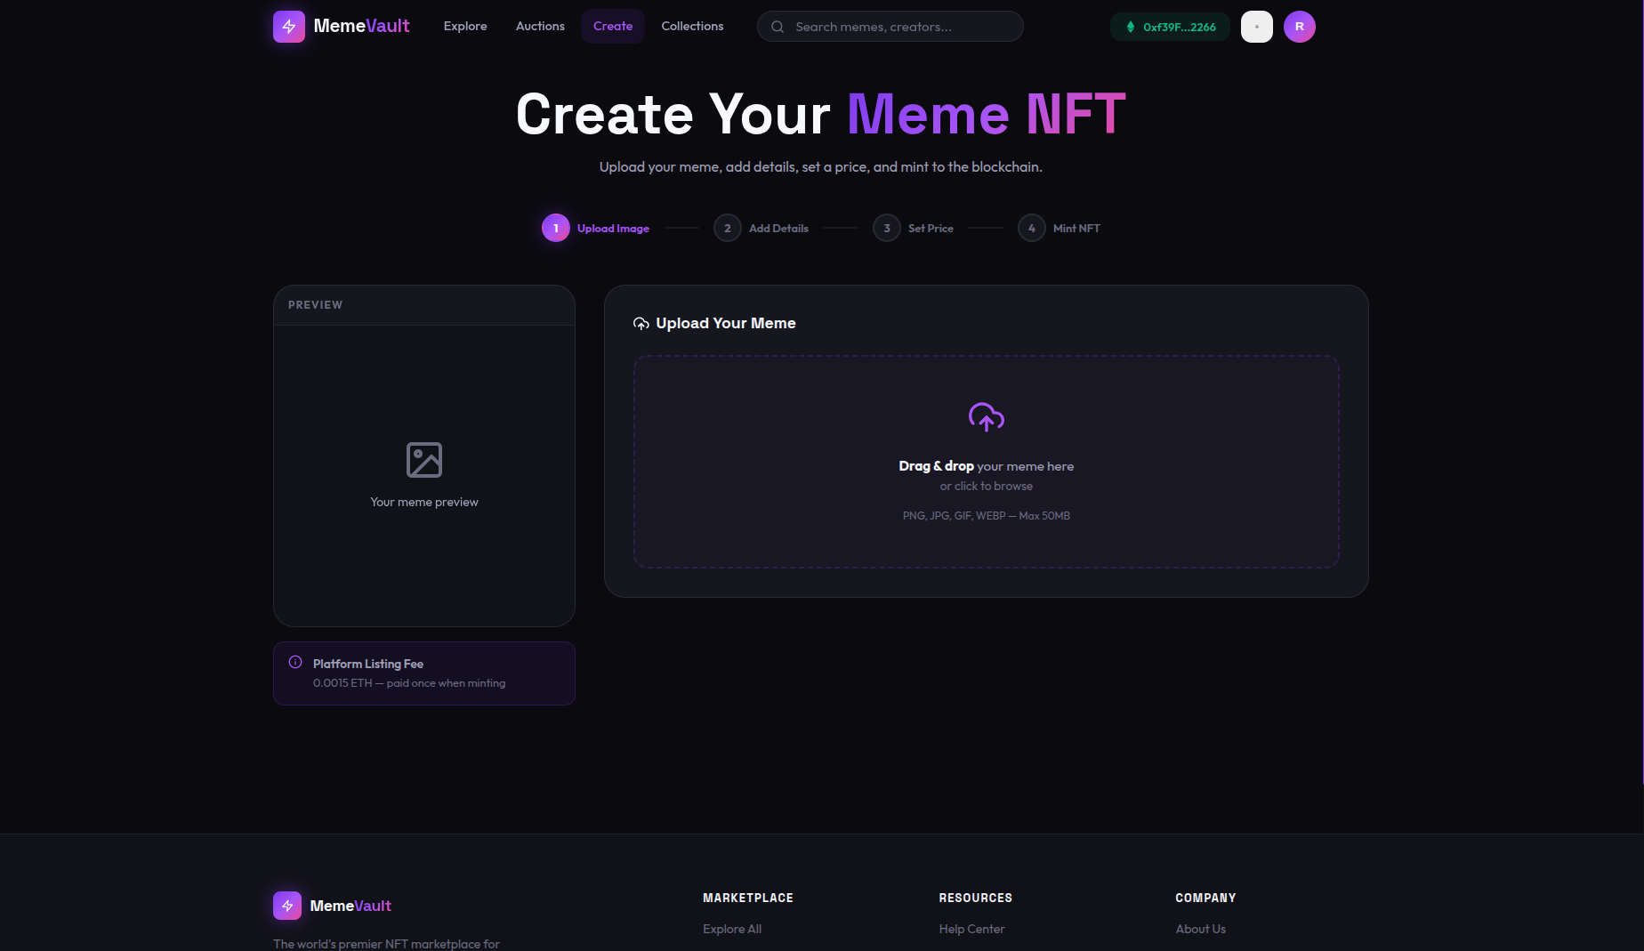

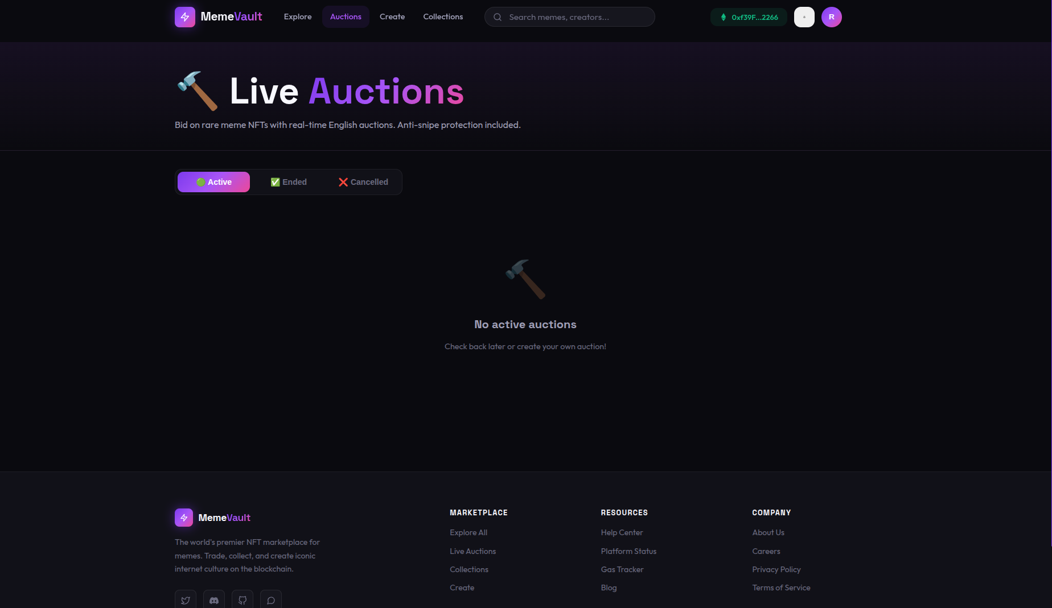

3. Backend Logic
The backend service routes complex off-chain logic, significantly reducing gas costs and RPC (Remote Procedure Call) spam that would occur if the frontend solely relied on the blockchain for queries.
Key Backend Logic Segments: * Authentication Service (/api/auth): Uses JSON Web Tokens (JWT) and bcrypt for secure hashing. It provides clients with short-lived access tokens stored in LocalStorage to access protected REST routes. * Decentralized Storage Abstraction (/api/upload): For NFT creation, raw images are captured via multipart/form-data using the multer middleware. The backend temporarily buffers the files and streams them securely via API keys to Pinata’s decentralized IPFS network, returning an immutable CID hash mapped to the NFT metadata URI. * Caching Layer (/api/nfts, /api/auctions): Functions as an accelerated caching layer serving the marketplace grid. Off-chain MongoDB syncing allows instantaneous sorting and filtering without querying the smart contract directly. * Follower System (/api/users/follow): Implements a relational networking feature allowing creators to gather followers and build an audience natively within the platform.

4. Database
Our NoSQL Database is tightly coupled with the application’s states. Using Mongoose ODM, it bridges generic data (like bios) and indices of blockchain events ensuring lightning-fast lookup times.
Primary Database Schemas:
Schema/Model | Application Layer Scope | Key Database Fields
User | Off-chain auth, networking, wallet associations | username, email, password, walletAddress, followers, bio, nftsCreated
NFT | Secondary indexing of minted blockchain NFTs | name, creator, price, tokenId, royaltyPercent, category, image
Auction | Live auction caching & state mapping | seller, startingPrice, highestBidder, endTime, isActive
Offer | Off-market asynchronous bidding states | buyer, amount, expirationTime, status

5. Integration Workflow
The final piece of the architecture is the Integration phase, which securely binds the React components, Express API, MongoDB, and Ethereum ecosystem into a cohesive unit.
1. Authentication Integration: Standard POST /api/auth/login requests set the MongoDB user context. Concurrently, a custom Web3Context actively listens to the window.ethereum object injection from MetaMask to detect the active Web3 account (0x...). The application pairs the JWT session with the actively connected wallet.
2. Smart Contract Transacting: When a user initiates the minting process, the integration flow is: 1. React uploads the image to the Backend using axios. 2. The Backend proxies the image to IPFS and returns the generated Metadata URI. 3. React passes the URI into an ethers.BrowserProvider execution function targeting MemeVault.sol. 4. MetaMask requests user signature. 5. The transaction is validated natively by the EVM and mined. Both the user’s dashboard and the database immediately reflect the new token.
3. Secondary Markets (Auctions & Direct Buys): * Quick Buy: Clicking “Buy” invokes the payable buyNFT() method, directly moving msg.value (ETH) from the buyer to the seller, with smart contracts managing state checks (e.g., verifying msg.value == price). * Auctions Integration: Real-time English Auctions run strictly on-chain to prevent manipulation. The UI queries block-timestamps against the endTime variable set in the MemeVaultAuction.sol contract to dynamically render countdowns securely without centralized server reliance.

