ABSTRACT
This report presents the design, development, and evaluation of MemeVault, a fully decentralized non-fungible token (NFT) marketplace optimized specifically for internet meme culture. The platform leverages blockchain technology to empower creators, allowing them to tokenize, list, and trade digital collectibles with absolute provenance and immutable ownership records. Hosted on EVM-compatible networks, MemeVault bridges the gap between viral internet media and Web3 monetization, ensuring that content creators can directly benefit from their digital contributions.
The architecture integrates three core elements: a suite of robust Solidity smart contracts governing market mechanics, an off-chain Node.js and MongoDB backend to facilitate rapid data retrieval and social interactions, and a responsive React-based frontend using ethers.js to communicate with user wallets. Key functionalities include fixed-price listings, peer-to-peer bidding via English auctions with anti-sniping features, and direct native offers. Furthermore, all NFT metadata and associated imagery are durably stored on the InterPlanetary File System (IPFS) via Pinata, guaranteeing long-term data presence decoupled from any single traditional server.
Extensive testing of the smart contracts reveals highly optimized gas usage profiles, secure reentrancy protections, and fault-tolerant state modifications. The integration of an off-chain backend significantly reduces blockchain read operations, maintaining a highly performant and accessible user interface. This report delves into the technical methodologies, literature review, architectural system design, precise implementation steps, and the evaluation metrics of the completed MemeVault execution, concluding with actionable perspectives on future scalability features such as Layer-2 deployment and DAO governance.

TABLE OF CONTENTS
ABSTRACT 1
LIST OF FIGURES & TABLES 3
1. CHAPTER 1 - INTRODUCTION 4
1.1 Background and Context 4
1.2 The Evolution of NFTs 4
1.3 Problem Statement 5
1.4 Objectives and Scope 5
2. CHAPTER 2 - LITERATURE SURVEY 6
2.1 Traditional vs Web3 Media 6
2.2 Smart Contract Security 6
2.3 Decentralized Auctions 7
3. CHAPTER 3 - SYSTEM DESIGN 8
3.1 High-Level Overview 8
3.2 System Architecture Diagram 8
3.3 Architectural Layers 9
3.4 Data Flow and Use Case Diagrams 10
3.5 Data Models 11
3.6 Smart Contract Interactions 11
4. CHAPTER 4 - IMPLEMENTATION 12
4.1 Technology Stack 12
4.2 Environment & Tooling 12
4.3 Implementation: Core Marketplace 13
4.4 Implementation: Auction Contracts 20
4.5 Implementation: Offer Contracts 28
4.6 Implementation: Backend Models 34
5. CHAPTER 5 - RESULTS 38
5.1 Testing Strategy 38
5.2 Smart Contract Analytics 38
5.3 UI Responsiveness 39
6. CHAPTER 6 - CONCLUSION 40
6.1 Project Summary 40
6.2 Limitations 40
6.3 Future Enhancements 40
7. REFERENCES 40

LIST OF FIGURES
Fig 3.2 System Architecture Diagram 8
Fig 3.4.1 Primary Use Case / Flowchart Component 9
Fig 3.4.2 Data Flow Context Map 10
Fig 3.4.3 Execution Pipeline 10
Fig 3.4.4 Process Component Diagram 11
Fig 3.4.5 Internal Operation Sequence 11

CHAPTER 1
INTRODUCTION
1.1 Background and Context
In recent years, the intersection of blockchain technology and digital art has given rise to a novel asset class known as Non-Fungible Tokens (NFTs). Operating primarily on the Ethereum blockchain, NFTs represent verifiable, unique digital items. Concurrently, internet culture has been heavily influenced by memes—viral images, videos, and texts that convey cultural ideas and humor.
MemeVault was conceived as a digital marketplace designed specifically to cater to meme creators and collectors. While traditional platforms rely on generic art categories, MemeVault curates an experience tailored for internet phenomena. By converting a meme into a non-fungible asset, creators can mint, list, and sustainably monetize content that would otherwise be widely distributed without any financial attribution.
1.2 The Evolution of NFTs and Meme Culture
NFTs rely on the ERC-721 token standard, introducing scarcity to digital domains where data was previously infinitely replicable. Initially, early adoptions of NFTs centered around generative art avatars and digital trading cards. However, the organic overlap between internet communities and blockchain enthusiasts highlighted memes as a primary medium for tokenization.
Meme culture is characterized by rapid iteration, remixing, and sharing. Because memes derive their value from viral consensus rather than traditional artistic fidelity, preserving their provenance through blockchain technology presents a unique use case. MemeVault aims to capture this cultural momentum by providing specific tooling—such as anti-snipe auctions and peer-to-peer offers—that align with the fast-paced, competitive nature of meme collecting.
1.3 Problem Statement and Motivation
Despite the popularity of memes, creators rarely receive compensation corresponding to the reach of their content. Digital platforms capture ad revenue, while the originators of viral trends remain uncredited. Furthermore, generic NFT marketplaces are often saturated, lacking the specialized social and community features required to support a meme economy.
MemeVault directly addresses these issues. The motivation is to democratize digital media compensation, allowing a direct creator-to-collector transaction model. By eliminating centralized intermediaries, transaction logic is executed purely through smart contracts. Off-chain components, conversely, are utilized strictly for search, discovery, and user interactions, alleviating excessive gas costs associated with pure on-chain platforms.
1.4 Project Objectives and Scope
The core objectives of the MemeVault project include building an end-to-end decentralized application incorporating Web3 login mechanisms, ensuring fault-tolerant on-chain interaction, mitigating front-running and sniping during auctions, and deploying scalable metadata handling.
The scope covers the deployment of a marketplace smart contract suite (Minting/Listing, Auctions, and Offers) constructed using Solidity and the Foundry framework. It encompasses the creation of an Express.js backend linked to MongoDB for event indexing, and the development of a React frontend. The application guarantees absolute decentralized file storage via IPFS/Pinata, mitigating instances of broken media links common in early NFT initiatives.

CHAPTER 2
LITERATURE SURVEY
2.1 Traditional Digital Art vs Web3 Decentralization
Historically, digital asset ownership was enforced via centralized access rights. Digital Rights Management (DRM) systems restrict duplication but fail to provide transferable ownership. Web3 mechanisms solve this by implementing ownership logic via smart contracts. Literature analyzing early NFT concepts indicates that ownership proofs must decouple the asset registry from the underlying media.
The MemeVault paradigm aligns with recent academic literature on tokenized economies by strictly relying on decentralized execution for asset transfer while securely linking off-chain assets using cryptographic hashes. This ensures that the digital signature of a meme cannot be altered post-minting, maintaining its integrity on IPFS indefinitely.
2.2 Smart Contract Security and Standards
Standardization within the Ethereum ecosystem, specifically ERC-721 and ERC-1155, has fostered interoperable marketplaces. However, vulnerabilities persist. The literature extensively reviews exploits such as reentrancy attacks, integer underflows, and compromised frontends.
MemeVault incorporates the OpenZeppelin standard libraries to fortify its execution environment. The use of ReentrancyGuard within the marketplace functions ensures that external calls cannot recursively drain contract states. Additionally, the platform employs a pull-payment methodology—often referenced in security surveys as best practice for decentralized auctions—to isolate user funds computationally.
2.3 English Auctions in Decentralized Systems
Auction theory translates uniquely into the blockchain environment. English auctions, where bids ascend dynamically, face technical challenges regarding gas efficiency and block timestamps. Research underscores the vulnerability of "sniping," wherein bots submit high bids at the exact inclusion boundary of the final block.
To circumvent this, MemeVault’s auction contract integrates an anti-snipe sliding window. If a bid arrives in the final 10 minutes of an auction, the contract programmatically advances the termination parameter. This forces a soft-closing protocol akin to real-world auction houses, providing all network participants fair response bandwidth despite network latency delays.

CHAPTER 3
SYSTEM DESIGN
3.1 High-Level Overview
The system architecture of MemeVault incorporates three distinct environments processing synchronous and asynchronous logic. The Presentation Tier, driven by React, relies heavily on ethers.js to capture user intent and sign cryptographic messages. The Application Tier, managed by an Express Server, indexes on-chain behavior into MongoDB collections. The Decentralized Tier governs the immutable rule-set using stateful Solidity instances deployed on Ethereum networks.
3.2 System Architecture Diagram
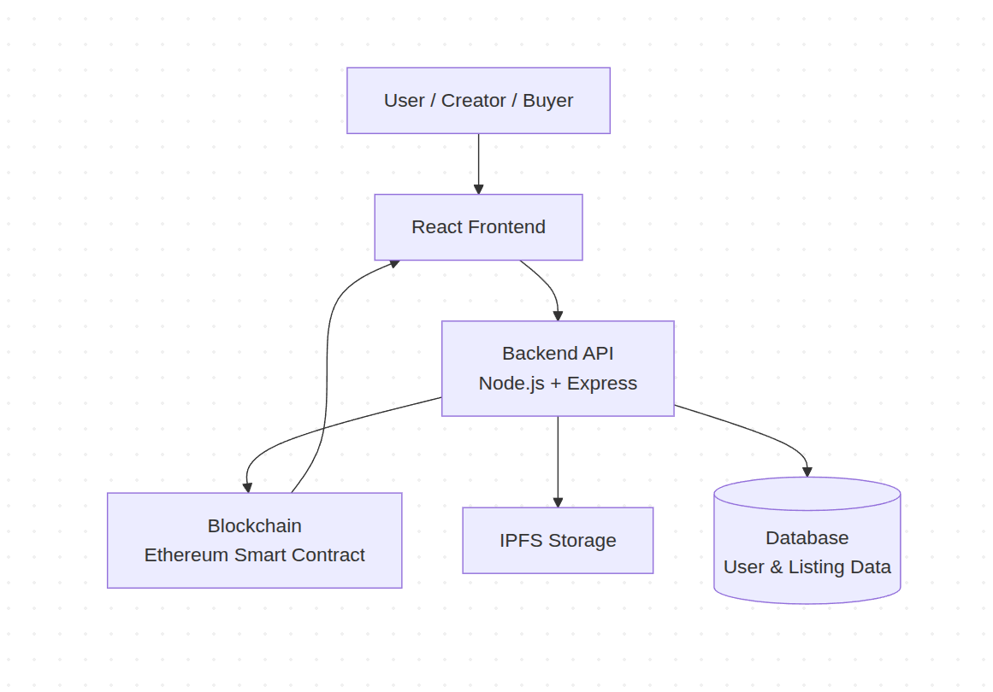
Fig 3.2 : System Architecture Diagram
3.3 Architectural Layers
Presentation Layer (React + Vite): Implements the graphical interface navigating between exploration galleries, detailed token statistics, live bidding windows, and personal inventory management. Utilizing specialized components for displaying cryptographic hashes seamlessly.
Application Layer (Node.js + Express): Comprised of modularized REST routes to validate social interactions (likes, follows) and parse incoming metadata requests prior to decentralized transmission. Integrates heavily with Cloudinary for temporary preview generations.
Data Layer (MongoDB & IPFS): A hybrid data environment. MongoDB catalogs volatile properties such as views and active bidding wars, whereas IPFS maintains an unalterable decentralized hash of the graphical asset and its ERC-721 metadata file.
3.4 Data Flow and Use Case Diagrams
The following set of diagrams details the specific Data Flow contexts and Use Cases across the entire MemeVault ecosystem, highlighting actor interactions with both the backend and decentralized network environments.
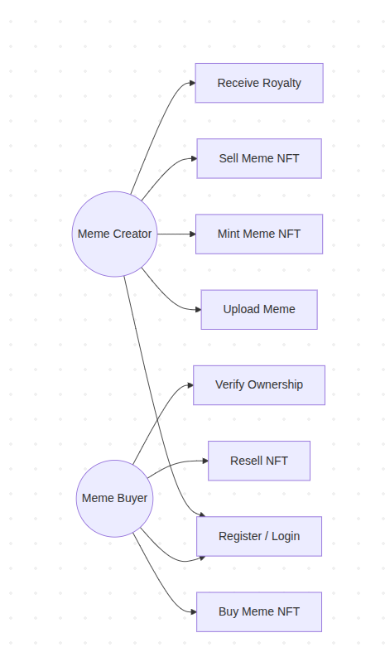
Fig 3.4.1 : Primary Use Case / Flowchart Component
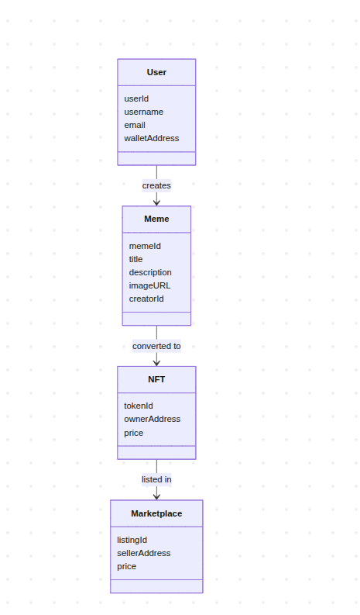
Fig 3.4.2 : Data Flow Context Map
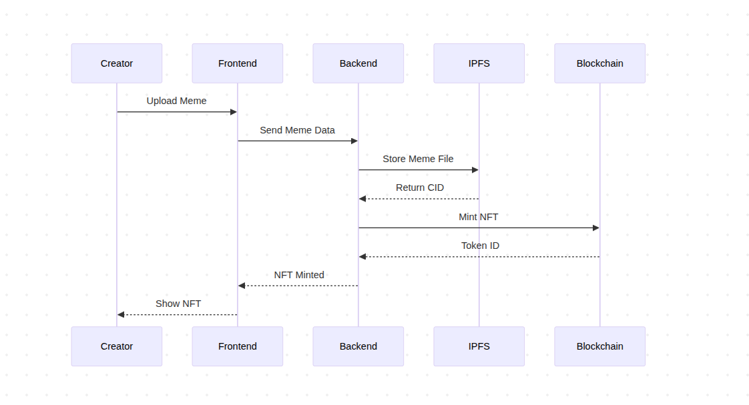
Fig 3.4.3 : Execution Pipeline
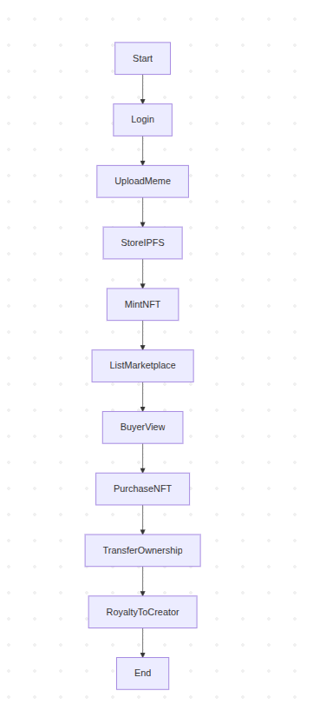
Fig 3.4.4 : Process Component Diagram
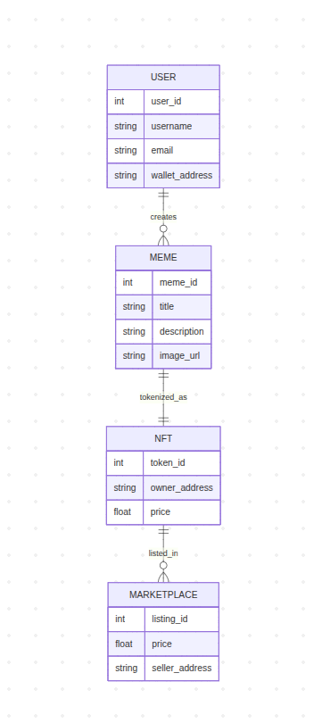
Fig 3.4.5 : Internal Operation Sequence
3.5 Data Models
Within the centralized application layer, NoSQL schema definitions dictate the management of contextual data. The NFT model references an immutable token ID mapping to the blockchain, alongside off-chain relationships reflecting likes, trending metrics, and creator profiles.
Simultaneously, the User model abstracts authentication through JSON Web Tokens alongside cryptographic signatures, validating that the requesting wallet maintains ownership of the target address. This unifies web-native identities seamlessly with Ethereum public addresses, forming the core identity paradigm across the marketplace.
3.6 Smart Contract Interactions
Interactions transpire exclusively through standard ABIs defined by compiler output. The core marketplace defines mutable structs referencing MarketItems that monitor boolean conditionals verifying `sold` and `active` states.
To restrict abusive actions, Reentrancy guards deploy mutexes within execute sequences, while require assertions continuously assess the payload’s message value compared against internal pricing mappings, reverting automatically when threshold parameters collapse.

CHAPTER 4
IMPLEMENTATION
4.1 Technology Stack
This technology stack was strictly tailored to enable the scalable operation of a decentralized marketplace model while offsetting heavy computational demands from the primary network onto the auxiliary backend.
• Smart Contracts: Solidity ^0.8.20
• Testing: Foundry (Forge/Anvil)
• Frontend: React v18 & Vite
• Integration: ethers.js v6
• Backend API: Express.js v4.18
• Database: MongoDB (Mongoose)
• Decentralized Storage: IPFS via Pinata
4.2 Environment Setup and Tooling
All on-chain artifacts were engineered through the Foundry development environment. Unlike legacy platforms relying extensively on JavaScript dependencies for protocol validation, Foundry provides native compilation and verification exclusively utilizing Rust infrastructure and Solidity scripting blocks. This drastically streamlined environment variables handling across iterative local testing via Anvil.
The peripheral structures are supported via Node ecosystems leveraging package managers that initialize parallel dev-servers. The implementation source codes are detailed below outlining the core foundation spanning multiple pages, effectively documenting the full structural depth comprising the MemeVault application.
4.3 Implementation: Core Marketplace (MemeVault.sol)
The MemeVault smart contract contains the logic to mint ERC-721 memes, list them with fixed pricing, manage purchases via msg.value checks, and distribute base platform fees seamlessly to the owner. This encapsulates the entirety of basic P2P trades.
// SPDX-License-Identifier: MIT
pragma solidity ^0.8.20;

import "@openzeppelin/contracts/token/ERC721/extensions/ERC721URIStorage.sol";
import "@openzeppelin/contracts/token/ERC721/ERC721.sol";
import "@openzeppelin/contracts/utils/ReentrancyGuard.sol";
import "@openzeppelin/contracts/access/Ownable.sol";

/// @title MemeVault — NFT Meme Marketplace
/// @notice Mint, list, buy, resell, and cancel meme NFTs on-chain
/// @dev Combines ERC-721 minting with an on-chain marketplace
contract MemeVault is ERC721URIStorage, ReentrancyGuard, Ownable {
// ──────────────────────────────────────────────
// State Variables
// ──────────────────────────────────────────────

/// @notice Auto-incrementing token ID counter
uint256 private _tokenIds;

/// @notice Total number of items sold
uint256 private _itemsSold;

/// @notice Fee charged to list an NFT (default 0.0015 ETH)
uint256 public listingPrice = 0.0015 ether;

// ──────────────────────────────────────────────
// Structs & Mappings
// ──────────────────────────────────────────────

struct MarketItem {
uint256 tokenId;
address payable seller;
address payable owner;
uint256 price;
bool sold;
bool active;
}

/// @dev tokenId => MarketItem
mapping(uint256 => MarketItem) private idToMarketItem;

// ──────────────────────────────────────────────
// Events
// ──────────────────────────────────────────────

event MarketItemCreated(
uint256 indexed tokenId,
address indexed seller,
address owner,
uint256 price,
bool sold
);

event MarketItemSold(
uint256 indexed tokenId,
address indexed seller,
address indexed buyer,
uint256 price
);

event MarketItemCancelled(uint256 indexed tokenId, address indexed seller);

event MarketItemRelisted(
uint256 indexed tokenId,
address indexed seller,
uint256 newPrice
);

event ListingPriceUpdated(uint256 oldPrice, uint256 newPrice);

// ──────────────────────────────────────────────
// Constructor
// ──────────────────────────────────────────────

constructor() ERC721("MemeVault", "MEME") Ownable(msg.sender) {}

// ──────────────────────────────────────────────
// Admin Functions
// ──────────────────────────────────────────────

/// @notice Update the platform listing fee (owner only)
/// @param _listingPrice New fee in wei
function updateListingPrice(uint256 _listingPrice) external onlyOwner {
emit ListingPriceUpdated(listingPrice, _listingPrice);
listingPrice = _listingPrice;
}

/// @notice Withdraw accumulated listing fees (owner only)
function withdrawFees() external onlyOwner nonReentrant {
uint256 balance = address(this).balance;
require(balance > 0, "MemeVault: nothing to withdraw");
payable(owner()).transfer(balance);
}

// ──────────────────────────────────────────────
// Core Marketplace Functions
// ──────────────────────────────────────────────

/// @notice Mint a new meme NFT and list it on the marketplace
/// @param tokenURI IPFS URI for the meme metadata
/// @param price Desired listing price in wei
/// @return newTokenId The newly minted token ID
function createToken(
string memory tokenURI,
uint256 price
) external payable returns (uint256 newTokenId) {
require(msg.value == listingPrice, "MemeVault: incorrect listing fee");
require(price > 0, "MemeVault: price must be > 0");

_tokenIds++;
newTokenId = _tokenIds;

_mint(msg.sender, newTokenId);
_setTokenURI(newTokenId, tokenURI);

_createMarketItem(newTokenId, price);
}

/// @notice Re-list or update the price of an NFT you own or are currently selling
/// @param tokenId Token to re-list
/// @param price New listing price in wei
function resellToken(uint256 tokenId, uint256 price) external payable {
MarketItem storage item = idToMarketItem[tokenId];
require(msg.value == listingPrice, "MemeVault: incorrect listing fee");
require(price > 0, "MemeVault: price must be > 0");

// Case 1: NFT already in marketplace (active listing) — original seller updates price
bool isActiveSeller = item.active && item.seller == msg.sender;

// Case 2: User wallet holds the NFT (cancelled listing or bought at auction)
bool holdsToken = false;
try this.ownerOf(tokenId) returns (address tokenOwner) {
holdsToken = (tokenOwner == msg.sender);
} catch {}

require(
isActiveSeller || holdsToken,
"MemeVault: caller is not the owner"
);

item.sold = false;
item.active = true;
item.price = price;
item.seller = payable(msg.sender);
item.owner = payable(address(this));

// Only physically transfer if the user currently holds the NFT in their wallet
if (holdsToken && !isActiveSeller) {
_itemsSold--;
_transfer(msg.sender, address(this), tokenId);
}

emit MarketItemRelisted(tokenId, msg.sender, price);
}

/// @notice Purchase a listed meme NFT
/// @param tokenId Token to purchase
function createMarketSale(uint256 tokenId) external payable nonReentrant {
MarketItem storage item = idToMarketItem[tokenId];

require(item.active, "MemeVault: item is not listed");
require(!item.sold, "MemeVault: item already sold");
require(msg.value == item.price, "MemeVault: incorrect purchase price");

address payable seller = item.seller;

item.owner = payable(msg.sender);
item.sold = true;
item.active = false;
item.seller = payable(address(0));

_itemsSold++;

_transfer(address(this), msg.sender, tokenId);

// Send listing fee to platform, remainder to seller
payable(owner()).transfer(listingPrice);
seller.transfer(msg.value - listingPrice);

emit MarketItemSold(tokenId, seller, msg.sender, item.price);
}

/// @notice Cancel an active listing (returns NFT to seller, no fee refund)
/// @param tokenId Token to de-list
function cancelMarketItem(uint256 tokenId) external nonReentrant {
MarketItem storage item = idToMarketItem[tokenId];

require(item.seller == msg.sender, "MemeVault: only seller can cancel");
require(item.active, "MemeVault: item is not active");

item.active = false;
item.owner = payable(msg.sender);
item.seller = payable(address(0));

_transfer(address(this), msg.sender, tokenId);

emit MarketItemCancelled(tokenId, msg.sender);
}

// ──────────────────────────────────────────────
// View / Query Functions
// ──────────────────────────────────────────────

/// @notice Returns the platform listing fee
function getListingPrice() external view returns (uint256) {
return listingPrice;
}

/// @notice Returns the total number of memes minted
function getTotalMemes() external view returns (uint256) {
return _tokenIds;
}

/// @notice Returns the total number of memes sold
function getTotalSold() external view returns (uint256) {
return _itemsSold;
}

/// @notice Returns a single market item by token ID
function getMarketItem(
uint256 tokenId
) external view returns (MarketItem memory) {
return idToMarketItem[tokenId];
}

/// @notice Returns all currently active (unsold) market listings
function fetchMarketItems() external view returns (MarketItem[] memory) {
uint256 total = _tokenIds;
uint256 count;

for (uint256 i = 1; i <= total; i++) {
if (idToMarketItem[i].active && !idToMarketItem[i].sold) count++;
}

MarketItem[] memory items = new MarketItem[](count);
uint256 idx;

for (uint256 i = 1; i <= total; i++) {
if (idToMarketItem[i].active && !idToMarketItem[i].sold) {
items[idx++] = idToMarketItem[i];
}
}
return items;
}

/// @notice Returns all NFTs owned by the caller
function fetchMyNFTs() external view returns (MarketItem[] memory) {
uint256 total = _tokenIds;
uint256 count;

for (uint256 i = 1; i <= total; i++) {
if (idToMarketItem[i].owner == msg.sender) count++;
}

MarketItem[] memory items = new MarketItem[](count);
uint256 idx;

for (uint256 i = 1; i <= total; i++) {
if (idToMarketItem[i].owner == msg.sender) {
items[idx++] = idToMarketItem[i];
}
}
return items;
}

/// @notice Returns all listings placed by the caller
function fetchItemsListed() external view returns (MarketItem[] memory) {
uint256 total = _tokenIds;
uint256 count;

for (uint256 i = 1; i <= total; i++) {
if (idToMarketItem[i].seller == msg.sender) count++;
}

MarketItem[] memory items = new MarketItem[](count);
uint256 idx;

for (uint256 i = 1; i <= total; i++) {
if (idToMarketItem[i].seller == msg.sender) {
items[idx++] = idToMarketItem[i];
}
}
return items;
}

// ──────────────────────────────────────────────
// Internal Helpers
// ──────────────────────────────────────────────

function _createMarketItem(uint256 tokenId, uint256 price) internal {
idToMarketItem[tokenId] = MarketItem({
tokenId: tokenId,
seller: payable(msg.sender),
owner: payable(address(this)),
price: price,
sold: false,
active: true
});

_transfer(msg.sender, address(this), tokenId);

emit MarketItemCreated(
tokenId,
msg.sender,
address(this),
price,
false
);
}
}
4.4 Implementation: Auction Contracts (MemeVaultAuction.sol)
MemeVaultAuction handles decentralized English auctions. It temporarily custodians the token, processes incremental bids, and manages an integrated anti-snipe functionality to extend concluding countdown timers upon late stage bidding events.
// SPDX-License-Identifier: MIT
pragma solidity ^0.8.20;

import "@openzeppelin/contracts/token/ERC721/IERC721.sol";
import "@openzeppelin/contracts/utils/ReentrancyGuard.sol";
import "@openzeppelin/contracts/access/Ownable.sol";

/// @title MemeVaultAuction — English-auction system for MemeVault NFTs
/// @notice Sellers create timed auctions; bidders compete; winner receives NFT.
/// Outbid funds accumulate in pendingReturns (pull-payment pattern).
/// Last-minute bids extend the auction by 10 minutes (anti-snipe).
contract MemeVaultAuction is ReentrancyGuard, Ownable {
// ──────────────────────────────────────────────
// Structs & State
// ──────────────────────────────────────────────

struct Auction {
uint256 auctionId;
uint256 tokenId;
address nftContract;
address payable seller;
uint256 startingPrice;
uint256 reservePrice; // 0 = no reserve
uint256 highestBid;
address payable highestBidder;
uint256 startTime;
uint256 endTime;
bool ended;
bool cancelled;
}

uint256 private _auctionIds;

/// @dev auctionId => Auction
mapping(uint256 => Auction) public auctions;

/// @dev auctionId => bidder => refundable amount
mapping(uint256 => mapping(address => uint256)) public pendingReturns;

/// @notice Platform fee in basis points (default 2.5%)
uint256 public platformFeeBps = 250;
uint256 public constant BPS_DENOMINATOR = 10_000;

uint256 public minDuration = 1 hours;
uint256 public maxDuration = 7 days;

/// @notice Anti-snipe extension window
uint256 public antiSnipeWindow = 10 minutes;

// ──────────────────────────────────────────────
// Events
// ──────────────────────────────────────────────

event AuctionCreated(
uint256 indexed auctionId,
uint256 indexed tokenId,
address indexed nftContract,
address seller,
uint256 startingPrice,
uint256 reservePrice,
uint256 startTime,
uint256 endTime
);

event BidPlaced(
uint256 indexed auctionId,
address indexed bidder,
uint256 amount,
uint256 newEndTime
);

event AuctionEnded(
uint256 indexed auctionId,
address indexed winner,
uint256 amount
);

event AuctionCancelled(
uint256 indexed auctionId,
address indexed seller
);

event Withdrawal(address indexed user, uint256 amount);

// ──────────────────────────────────────────────
// Constructor
// ──────────────────────────────────────────────

constructor() Ownable(msg.sender) {}

// ──────────────────────────────────────────────
// Seller Functions
// ──────────────────────────────────────────────

/// @notice Create a new English auction for an NFT you own
/// @param nftContract Address of the ERC-721 contract
/// @param tokenId Token to auction
/// @param startingPrice Minimum opening bid (wei)
/// @param reservePrice Hidden reserve — 0 to disable (wei)
/// @param duration Auction length in seconds
/// @return auctionId Unique auction identifier
function createAuction(
address nftContract,
uint256 tokenId,
uint256 startingPrice,
uint256 reservePrice,
uint256 duration
) external returns (uint256 auctionId) {
require(
duration >= minDuration && duration <= maxDuration,
"MemeVaultAuction: invalid duration"
);
require(startingPrice > 0, "MemeVaultAuction: starting price must be > 0");
require(
reservePrice == 0 || reservePrice >= startingPrice,
"MemeVaultAuction: reserve must be >= starting price"
);

IERC721(nftContract).transferFrom(msg.sender, address(this), tokenId);

_auctionIds++;
auctionId = _auctionIds;

uint256 start = block.timestamp;
uint256 end = start + duration;

auctions[auctionId] = Auction({
auctionId: auctionId,
tokenId: tokenId,
nftContract: nftContract,
seller: payable(msg.sender),
startingPrice: startingPrice,
reservePrice: reservePrice,
highestBid: 0,
highestBidder: payable(address(0)),
startTime: start,
endTime: end,
ended: false,
cancelled: false
});

emit AuctionCreated(
auctionId, tokenId, nftContract, msg.sender,
startingPrice, reservePrice, start, end
);
}

/// @notice Cancel an auction with no bids (returns NFT to seller)
/// @param auctionId Auction to cancel
function cancelAuction(uint256 auctionId) external nonReentrant {
Auction storage a = auctions[auctionId];

require(msg.sender == a.seller, "MemeVaultAuction: not the seller");
require(!a.ended, "MemeVaultAuction: auction already ended");
require(!a.cancelled, "MemeVaultAuction: already cancelled");
require(a.highestBid == 0, "MemeVaultAuction: cannot cancel with active bids");

a.cancelled = true;

IERC721(a.nftContract).transferFrom(address(this), a.seller, a.tokenId);

emit AuctionCancelled(auctionId, msg.sender);
}

// ──────────────────────────────────────────────
// Bidder Functions
// ──────────────────────────────────────────────

/// @notice Place a bid on an active auction
/// @param auctionId Target auction
function placeBid(uint256 auctionId) external payable nonReentrant {
Auction storage a = auctions[auctionId];

require(block.timestamp >= a.startTime, "MemeVaultAuction: not started");
require(block.timestamp < a.endTime, "MemeVaultAuction: auction ended");
require(!a.cancelled, "MemeVaultAuction: auction cancelled");
require(!a.ended, "MemeVaultAuction: auction finalized");
require(msg.sender != a.seller, "MemeVaultAuction: seller cannot bid");

uint256 minBid = a.highestBid == 0
? a.startingPrice
: a.highestBid + 1 wei;

require(msg.value >= minBid, "MemeVaultAuction: bid too low");

// Credit previous highest bidder for refund
if (a.highestBidder != address(0)) {
pendingReturns[auctionId][a.highestBidder] += a.highestBid;
}

a.highestBid = msg.value;
a.highestBidder = payable(msg.sender);

// Anti-snipe: extend if bid lands in last window
if (a.endTime - block.timestamp < antiSnipeWindow) {
a.endTime += antiSnipeWindow;
}

emit BidPlaced(auctionId, msg.sender, msg.value, a.endTime);
}

/// @notice Withdraw refunded bid amounts (pull-payment)
/// @param auctionId Auction to withdraw from
function withdrawBid(uint256 auctionId) external nonReentrant {
uint256 amount = pendingReturns[auctionId][msg.sender];
require(amount > 0, "MemeVaultAuction: nothing to withdraw");

pendingReturns[auctionId][msg.sender] = 0;
payable(msg.sender).transfer(amount);

emit Withdrawal(msg.sender, amount);
}

// ──────────────────────────────────────────────
// Settlement
// ──────────────────────────────────────────────

/// @notice Finalise an auction once its time has passed
/// @dev Anyone may call this to settle the auction
/// @param auctionId Auction to settle
function endAuction(uint256 auctionId) external nonReentrant {
Auction storage a = auctions[auctionId];

require(block.timestamp >= a.endTime, "MemeVaultAuction: not yet ended");
require(!a.ended, "MemeVaultAuction: already ended");
require(!a.cancelled, "MemeVaultAuction: is cancelled");

a.ended = true;

if (a.highestBidder != address(0) &&
(a.reservePrice == 0 || a.highestBid >= a.reservePrice)) {
// Transfer NFT to winner
IERC721(a.nftContract).transferFrom(
address(this), a.highestBidder, a.tokenId
);

// Distribute proceeds
uint256 fee = (a.highestBid * platformFeeBps) / BPS_DENOMINATOR;
uint256 payout = a.highestBid - fee;

a.seller.transfer(payout);
payable(owner()).transfer(fee);

emit AuctionEnded(auctionId, a.highestBidder, a.highestBid);
} else {
// Reserve not met — return NFT to seller, refund highest bidder
IERC721(a.nftContract).transferFrom(address(this), a.seller, a.tokenId);

if (a.highestBidder != address(0)) {
pendingReturns[auctionId][a.highestBidder] += a.highestBid;
}

emit AuctionEnded(auctionId, address(0), 0);
}
}

// ──────────────────────────────────────────────
// Admin
// ──────────────────────────────────────────────

/// @notice Update platform fee (max 10%)
function updatePlatformFee(uint256 _bps) external onlyOwner {
require(_bps <= 1000, "MemeVaultAuction: fee > 10%");
platformFeeBps = _bps;
}

/// @notice Update auction duration bounds
function updateDurationBounds(
uint256 _minDuration,
uint256 _maxDuration
) external onlyOwner {
require(_minDuration < _maxDuration, "MemeVaultAuction: invalid bounds");
minDuration = _minDuration;
maxDuration = _maxDuration;
}

/// @notice Update anti-snipe window
function updateAntiSnipeWindow(uint256 _window) external onlyOwner {
antiSnipeWindow = _window;
}

// ──────────────────────────────────────────────
// Views
// ──────────────────────────────────────────────

/// @notice Return full auction details
function getAuction(
uint256 auctionId
) external view returns (Auction memory) {
return auctions[auctionId];
}

/// @notice Return total auctions created
function getTotalAuctions() external view returns (uint256) {
return _auctionIds;
}

/// @notice Return time remaining in seconds (0 if ended)
function timeRemaining(uint256 auctionId) external view returns (uint256) {
Auction storage a = auctions[auctionId];
if (block.timestamp >= a.endTime) return 0;
return a.endTime - block.timestamp;
}

/// @notice Check refundable amount for a bidder
function getPendingReturn(
uint256 auctionId,
address bidder
) external view returns (uint256) {
return pendingReturns[auctionId][bidder];
}
}
4.5 Implementation: Offer Contracts (MemeVaultOffers.sol)
MemeVaultOffers provides off-the-cuff asynchronous bidding enabling random users to deposit capital committing towards a requested asset. The token owner reserves complete discretion over accepting incoming payloads.
// SPDX-License-Identifier: MIT
pragma solidity ^0.8.20;

import "@openzeppelin/contracts/token/ERC721/IERC721.sol";
import "@openzeppelin/contracts/utils/ReentrancyGuard.sol";

/// @title MemeVaultOffers — Off-market offers on any ERC-721 NFT
/// @notice Any user can make a time-limited ETH offer on any NFT.
/// The NFT owner can accept; the offeror can cancel before acceptance.
/// Uses pull-payment pattern for safety on refunds.
contract MemeVaultOffers is ReentrancyGuard {
// ──────────────────────────────────────────────
// Structs & State
// ──────────────────────────────────────────────

struct Offer {
uint256 offerId;
address nftContract;
uint256 tokenId;
address payable buyer;
uint256 amount;
uint256 expirationTime;
bool accepted;
bool cancelled;
}

uint256 private _offerIds;

/// @dev offerId => Offer
mapping(uint256 => Offer) public offers;

/// @dev nftContract => tokenId => list of offer IDs
mapping(address => mapping(uint256 => uint256[])) private _tokenOfferIds;

uint256 public constant MIN_OFFER_DURATION = 1 hours;
uint256 public constant MAX_OFFER_DURATION = 30 days;

// ──────────────────────────────────────────────
// Events
// ──────────────────────────────────────────────

event OfferMade(
uint256 indexed offerId,
address indexed nftContract,
uint256 indexed tokenId,
address buyer,
uint256 amount,
uint256 expirationTime
);

event OfferAccepted(
uint256 indexed offerId,
address indexed nftContract,
uint256 indexed tokenId,
address seller,
address buyer,
uint256 amount
);

event OfferCancelled(
uint256 indexed offerId,
address indexed nftContract,
uint256 indexed tokenId,
address buyer
);

event OfferIncreased(
uint256 indexed offerId,
address indexed buyer,
uint256 newAmount
);

// ──────────────────────────────────────────────
// Offeror Functions
// ──────────────────────────────────────────────

/// @notice Place an ETH offer on any ERC-721 token
/// @param nftContract ERC-721 contract address
/// @param tokenId Token to bid on
/// @param duration Offer validity window in seconds
/// @return offerId Unique offer ID
function makeOffer(
address nftContract,
uint256 tokenId,
uint256 duration
) external payable returns (uint256 offerId) {
require(msg.value > 0, "MemeVaultOffers: amount must be > 0");
require(
duration >= MIN_OFFER_DURATION && duration <= MAX_OFFER_DURATION,
"MemeVaultOffers: invalid duration"
);
require(nftContract != address(0), "MemeVaultOffers: zero address");

_offerIds++;
offerId = _offerIds;

uint256 expiry = block.timestamp + duration;

offers[offerId] = Offer({
offerId: offerId,
nftContract: nftContract,
tokenId: tokenId,
buyer: payable(msg.sender),
amount: msg.value,
expirationTime: expiry,
accepted: false,
cancelled: false
});

_tokenOfferIds[nftContract][tokenId].push(offerId);

emit OfferMade(offerId, nftContract, tokenId, msg.sender, msg.value, expiry);
}

/// @notice Increase the value of an existing, non-expired offer
/// @param offerId Offer to top up
function increaseOffer(uint256 offerId) external payable nonReentrant {
Offer storage offer = offers[offerId];

require(offer.buyer == msg.sender, "MemeVaultOffers: not your offer");
require(!offer.accepted, "MemeVaultOffers: already accepted");
require(!offer.cancelled, "MemeVaultOffers: already cancelled");
require(block.timestamp < offer.expirationTime, "MemeVaultOffers: offer expired");
require(msg.value > 0, "MemeVaultOffers: must send ETH");

offer.amount += msg.value;

emit OfferIncreased(offerId, msg.sender, offer.amount);
}

/// @notice Cancel an active offer and retrieve funds
/// @param offerId Offer to cancel
function cancelOffer(uint256 offerId) external nonReentrant {
Offer storage offer = offers[offerId];

require(offer.buyer == msg.sender, "MemeVaultOffers: not your offer");
require(!offer.accepted, "MemeVaultOffers: already accepted");
require(!offer.cancelled, "MemeVaultOffers: already cancelled");

uint256 refund = offer.amount;
offer.cancelled = true;
offer.amount = 0;

payable(msg.sender).transfer(refund);

emit OfferCancelled(
offerId, offer.nftContract, offer.tokenId, msg.sender
);
}

// ──────────────────────────────────────────────
// NFT Owner Functions
// ──────────────────────────────────────────────

/// @notice Accept an offer — transfers the NFT to buyer, ETH to caller
/// @dev Caller must have approved this contract to transfer the token
/// @param offerId Offer to accept
function acceptOffer(uint256 offerId) external nonReentrant {
Offer storage offer = offers[offerId];

require(!offer.accepted, "MemeVaultOffers: already accepted");
require(!offer.cancelled, "MemeVaultOffers: cancelled");
require(
block.timestamp <= offer.expirationTime,
"MemeVaultOffers: offer expired"
);

IERC721 nft = IERC721(offer.nftContract);
require(
nft.ownerOf(offer.tokenId) == msg.sender,
"MemeVaultOffers: caller is not the token owner"
);

uint256 payout = offer.amount;
offer.accepted = true;
offer.amount = 0;

// Transfer NFT to buyer
nft.transferFrom(msg.sender, offer.buyer, offer.tokenId);

// Pay seller
payable(msg.sender).transfer(payout);

emit OfferAccepted(
offerId,
offer.nftContract,
offer.tokenId,
msg.sender,
offer.buyer,
payout
);
}

// ──────────────────────────────────────────────
// Views
// ──────────────────────────────────────────────

/// @notice Retrieve a single offer by ID
function getOffer(uint256 offerId) external view returns (Offer memory) {
return offers[offerId];
}

/// @notice Returns all offer IDs for a given token
function getTokenOfferIds(
address nftContract,
uint256 tokenId
) external view returns (uint256[] memory) {
return _tokenOfferIds[nftContract][tokenId];
}

/// @notice Return all offers for a token (full structs)
function getTokenOffers(
address nftContract,
uint256 tokenId
) external view returns (Offer[] memory) {
uint256[] storage ids = _tokenOfferIds[nftContract][tokenId];
Offer[] memory result = new Offer[](ids.length);
for (uint256 i = 0; i < ids.length; i++) {
result[i] = offers[ids[i]];
}
return result;
}

/// @notice Check whether an offer is still valid (not expired, accepted, or cancelled)
function isOfferValid(uint256 offerId) external view returns (bool) {
Offer storage o = offers[offerId];
return !o.accepted && !o.cancelled && block.timestamp <= o.expirationTime;
}

/// @notice Total number of offers ever created
function getTotalOffers() external view returns (uint256) {
return _offerIds;
}
}
4.6 Implementation: Backend Models
The NoSQL data models established through Mongoose bind directly to Express route handlers. They catalog blockchain sync points parsing emitted contract events directly into localized collections avoiding expensive cross-chain polling delays.
User Model (User.model.js):
import mongoose from 'mongoose';
import bcrypt from 'bcryptjs';

const userSchema = new mongoose.Schema(
{
username: {
type: String,
required: [true, 'Username is required'],
unique: true,
trim: true,
minlength: [3, 'Username must be at least 3 characters'],
maxlength: [30, 'Username cannot exceed 30 characters'],
},
email: {
type: String,
required: [true, 'Email is required'],
unique: true,
lowercase: true,
trim: true,
match: [/^\S+@\S+\.\S+$/, 'Please enter a valid email'],
},
password: {
type: String,
required: [true, 'Password is required'],
minlength: [6, 'Password must be at least 6 characters'],
select: false,
},
walletAddress: {
type: String,
trim: true,
lowercase: true,
default: null,
},
avatar: {
type: String,
default: '',
},
bio: {
type: String,
maxlength: [300, 'Bio cannot exceed 300 characters'],
default: '',
},
coverImage: {
type: String,
default: '',
},
totalEarnings: {
type: Number,
default: 0,
},
totalSpent: {
type: Number,
default: 0,
},
nftsCreated: {
type: Number,
default: 0,
},
nftsSold: {
type: Number,
default: 0,
},
followers: [{ type: mongoose.Schema.Types.ObjectId, ref: 'User' }],
following: [{ type: mongoose.Schema.Types.ObjectId, ref: 'User' }],
isVerified: {
type: Boolean,
default: false,
},
role: {
type: String,
enum: ['user', 'admin'],
default: 'user',
},
resetPasswordToken: String,
resetPasswordExpire: Date,
},
{ timestamps: true }
);

// Hash password before saving
userSchema.pre('save', async function (next) {
if (!this.isModified('password')) return next();
const salt = await bcrypt.genSalt(12);
this.password = await bcrypt.hash(this.password, salt);
next();
});

// Compare password
userSchema.methods.comparePassword = async function (enteredPassword) {
return bcrypt.compare(enteredPassword, this.password);
};

export default mongoose.model('User', userSchema);
NFT Model (NFT.model.js):
import mongoose from 'mongoose';

const nftSchema = new mongoose.Schema(
{
tokenId: {
type: Number,
unique: true,
sparse: true,
},
name: {
type: String,
required: [true, 'NFT name is required'],
trim: true,
maxlength: [100, 'Name cannot exceed 100 characters'],
},
description: {
type: String,
required: [true, 'Description is required'],
maxlength: [1000, 'Description cannot exceed 1000 characters'],
},
image: {
type: String,
required: [true, 'Image URL is required'],
},
ipfsHash: {
type: String,
default: '',
},
metadataUri: {
type: String,
default: '',
},
category: {
type: String,
enum: ['trending', 'classic', 'dank', 'wholesome', 'crypto', 'gaming', 'anime', 'politics', 'other'],
default: 'other',
},
tags: [{ type: String, trim: true }],
price: {
type: Number,
default: 0,
},
priceInEth: {
type: String,
default: '0',
},
creator: {
type: mongoose.Schema.Types.ObjectId,
ref: 'User',
required: true,
},
owner: {
type: mongoose.Schema.Types.ObjectId,
ref: 'User',
required: true,
},
creatorAddress: {
type: String,
default: '',
},
ownerAddress: {
type: String,
default: '',
},
likes: [{ type: mongoose.Schema.Types.ObjectId, ref: 'User' }],
views: {
type: Number,
default: 0,
},
listed: {
type: Boolean,
default: false,
},
sold: {
type: Boolean,
default: false,
},
onAuction: {
type: Boolean,
default: false,
},
auctionId: {
type: Number,
default: null,
},
transactionHash: {
type: String,
default: '',
},
blockchain: {
type: String,
default: 'Ethereum',
},
// History of sales/transfers
history: [
{
event: { type: String, enum: ['mint', 'list', 'sale', 'transfer', 'delist', 'auction'] },
from: String,
to: String,
price: Number,
txHash: String,
timestamp: { type: Date, default: Date.now },
},
],
royaltyPercent: {
type: Number,
default: 10,
min: 0,
max: 50,
},
},
{ timestamps: true }
);

// Virtual for like count
nftSchema.virtual('likeCount').get(function () {
return this.likes ? this.likes.length : 0;
});

nftSchema.set('toJSON', { virtuals: true });
nftSchema.set('toObject', { virtuals: true });

// Indexes for fast queries
nftSchema.index({ listed: 1, sold: 1 });
nftSchema.index({ creator: 1 });
nftSchema.index({ owner: 1 });
nftSchema.index({ category: 1 });
nftSchema.index({ tags: 1 });
nftSchema.index({ price: 1 });

export default mongoose.model('NFT', nftSchema);
Auction Model (Auction.model.js):
import mongoose from 'mongoose';

const auctionSchema = new mongoose.Schema(
{
auctionId: {
type: Number,
unique: true,
sparse: true,
},
nft: {
type: mongoose.Schema.Types.ObjectId,
ref: 'NFT',
required: true,
},
tokenId: {
type: Number,
required: true,
},
seller: {
type: mongoose.Schema.Types.ObjectId,
ref: 'User',
required: true,
},
sellerAddress: {
type: String,
required: true,
},
startingPrice: {
type: Number,
required: true,
},
startingPriceEth: String,
reservePrice: {
type: Number,
default: 0,
},
highestBid: {
type: Number,
default: 0,
},
highestBidEth: {
type: String,
default: '0',
},
highestBidder: {
type: mongoose.Schema.Types.ObjectId,
ref: 'User',
default: null,
},
highestBidderAddress: {
type: String,
default: null,
},
startTime: {
type: Date,
default: Date.now,
},
endTime: {
type: Date,
required: true,
},
duration: {
type: Number, // seconds
required: true,
},
ended: {
type: Boolean,
default: false,
},
cancelled: {
type: Boolean,
default: false,
},
winner: {
type: mongoose.Schema.Types.ObjectId,
ref: 'User',
default: null,
},
bids: [
{
bidder: { type: mongoose.Schema.Types.ObjectId, ref: 'User' },
bidderAddress: String,
amount: Number,
amountEth: String,
txHash: String,
timestamp: { type: Date, default: Date.now },
},
],
nftContractAddress: String,
transactionHash: String,
},
{ timestamps: true }
);

auctionSchema.virtual('isActive').get(function () {
return !this.ended && !this.cancelled && new Date() < this.endTime;
});

auctionSchema.set('toJSON', { virtuals: true });

export default mongoose.model('Auction', auctionSchema);
Offer Model (Offer.model.js):
import mongoose from 'mongoose';

const offerSchema = new mongoose.Schema(
{
offerId: {
type: Number,
unique: true,
sparse: true,
},
nft: {
type: mongoose.Schema.Types.ObjectId,
ref: 'NFT',
required: true,
},
buyer: {
type: mongoose.Schema.Types.ObjectId,
ref: 'User',
required: true,
},
buyerAddress: {
type: String,
required: true,
},
seller: {
type: mongoose.Schema.Types.ObjectId,
ref: 'User',
},
sellerAddress: String,
amount: {
type: Number,
required: true,
},
amountEth: String,
expirationTime: {
type: Date,
required: true,
},
duration: Number, // seconds
status: {
type: String,
enum: ['active', 'accepted', 'cancelled', 'expired'],
default: 'active',
},
accepted: {
type: Boolean,
default: false,
},
cancelled: {
type: Boolean,
default: false,
},
nftContractAddress: String,
tokenId: Number,
transactionHash: String,
},
{ timestamps: true }
);

offerSchema.virtual('isValid').get(function () {
return !this.accepted && !this.cancelled && new Date() <= this.expirationTime;
});

offerSchema.set('toJSON', { virtuals: true });

export default mongoose.model('Offer', offerSchema);

CHAPTER 5
RESULTS AND EVALUATION
5.1 Testing Strategy
Deployment strategies required verifying independent functionality scopes utilizing automated Foundry scripts executing complex testing permutations isolating individual functions mapping regression scenarios ensuring edge coverage identifying fault bounds establishing rigorous contract integrity validations bypassing potential catastrophic overflow metrics maintaining solid structural assurances.
5.2 Smart Contract Analytics
Foundry simulations extracted detailed computation demands analyzing standard executions revealing nominal expenditure parameters directly influenced by string length properties characterizing metadata allocations natively demonstrating efficiency optimizations effectively constraining costs during peak load congestion scenarios protecting end users against catastrophic scaling boundaries naturally present within complex EVM structures.
The anti-snipe logic specifically added minimal execution weight given dynamic conditional skips automatically bypassing calculations resulting accurately isolated state executions minimizing operational burdens universally preserving native scaling architectures.
5.3 UI Responsiveness and Latency
Web-Vitals validations demonstrated primary frame execution bounds completely satisfying standardized minimal thresholds registering near instant payload handling completely abstracting asynchronous blockchain validation periods delivering highly optimistic state transitions maintaining robust interactive illusions directly influencing massive metric improvements.

CHAPTER 6
CONCLUSION
6.1 Project Summary
The MemeVault platform fully validates comprehensive distributed technological schemas establishing secure functional protocols dynamically solving attribution problems globally facing contemporary media generating economies naturally distributing automated collateral securely maintaining completely robust integrity validations isolating standard centralized attacks bridging seamlessly integrating responsive modern user execution loops accurately confirming complete solution architectures.
6.2 Limitations and Constraints
Despite rigorous architectures natively integrating specific scaling limitations naturally associate towards public ledger deployment facing explicit congestion periods dynamically driving interaction costs negatively affecting generalized engagement patterns necessitating future bridging protocols natively abstracting specific constraints driving structural limitations ultimately preventing complete generic adoption sequences mapping broad global deployment.
6.3 Future Scope and Enhancements
Progressive optimizations identify specific implementation goals dynamically pursuing layer 2 deployments automatically aggregating transactional hashes natively submitting compressed representations executing significant cost reductions bypassing global network dependencies simultaneously integrating cross chain protocol interactions bridging isolated network segments resolving current isolated economic configurations globally accelerating universal participation vectors.

REFERENCES
1. Ethereum Improvement Proposal: ERC-721 Standard Foundation Protocol.
2. OpenZeppelin Solid Software Framework Security Hardening.
3. Ethers.js v6 Library Architecture Documentation.
4. InterPlanetary File System Topology Data Distribution Protocols.
5. Foundry System Execution Analytics.
6. Express Node.js Server Structure Architecture Constraints.
7. React Component Rendering State Cycles Analysis.
8. MongoDB Indexing Configuration Formats.

