**About Dataset**

**Endometrial cancer** (also called endometrial carcinoma) starts in the cells of the inner lining of the uterus (the endometrium). This is the most common type of cancer in the uterus. Endometrial carcinomas can be divided into different types based on how the cells look under the microscope.

**What causes uterine cancer?**

* Researchers aren’t sure of the exact cause of uterine cancer. Something happens to create changes in cells in your uterus. The mutated cells grow and multiply out of control, which can form a mass called a tumor.

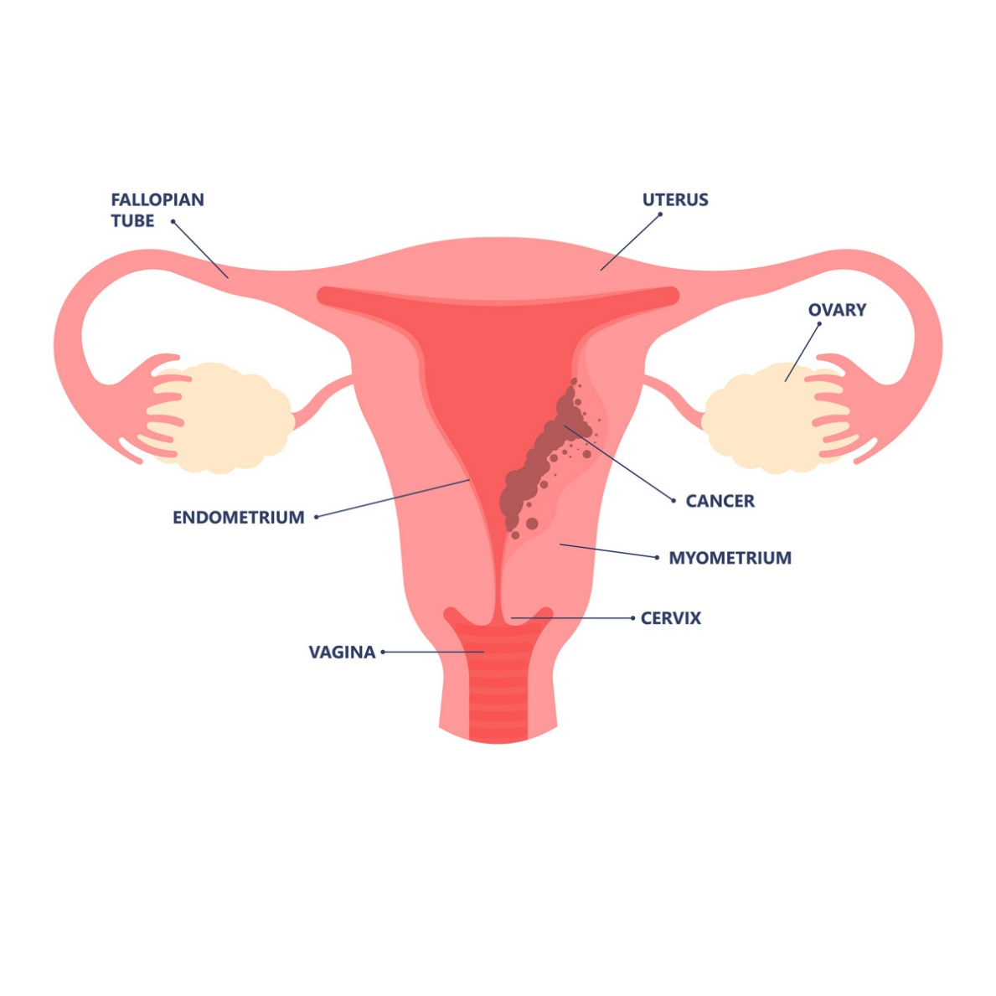**Let's take a brief look at the image of Cancerous uterus**

**What is MSI Mantis score?**

* The MANTIS score is a score that predicts a patient's MSI status . The higher the MANTIS score is, the more likely a patient is to have the MSI-H status.

**What is MSI sensor?**

* MSIsensor: microsatellite instability detection using paired tumor-normal sequence data.
* The resulting MSIsensor score is a value between 0 and 100 that corresponds to the percentage of mutated microsatellite loci.