# Name : Rahul Patil

# Analysis

As per the problem statement, we have built a dashboard with multiple visualizations through which we can get lots of insights present in the dataset.

# Complete Dashboard

1. **Overview**

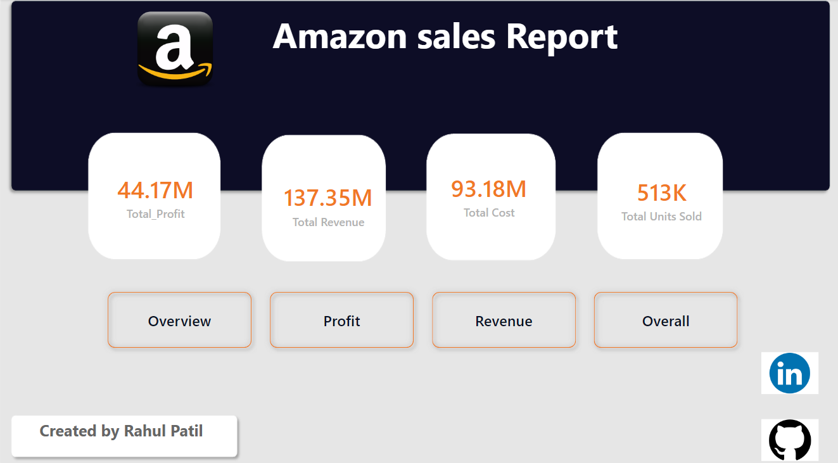

•

1. **Profit**

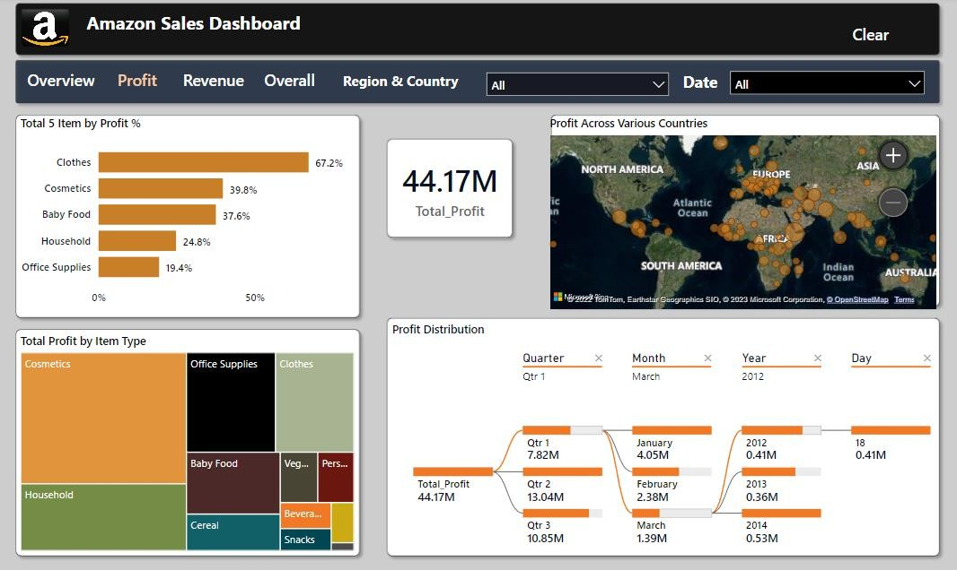

1. **Revenue**

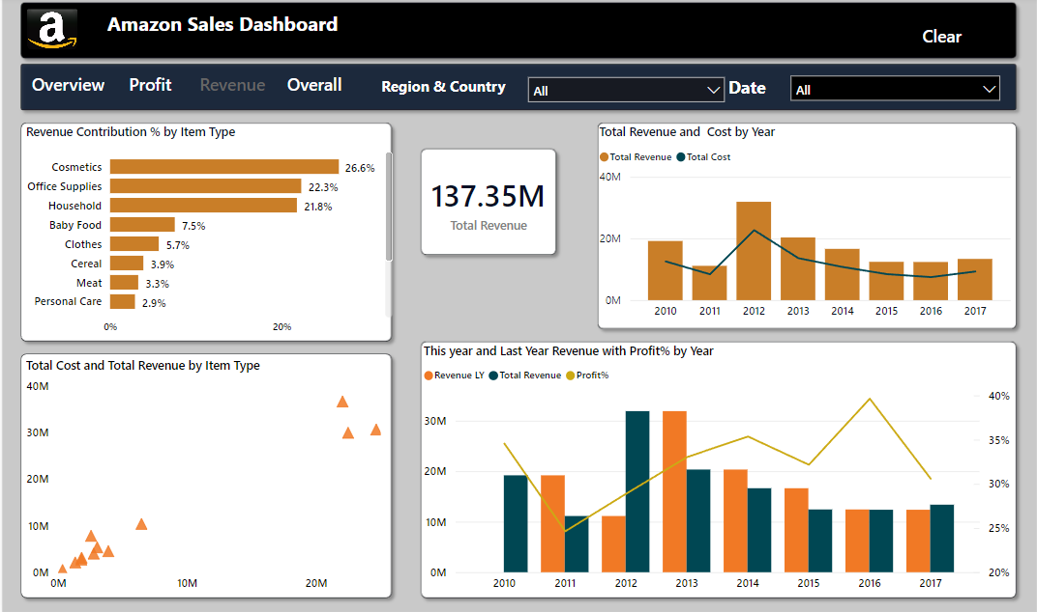

1. **Overall**

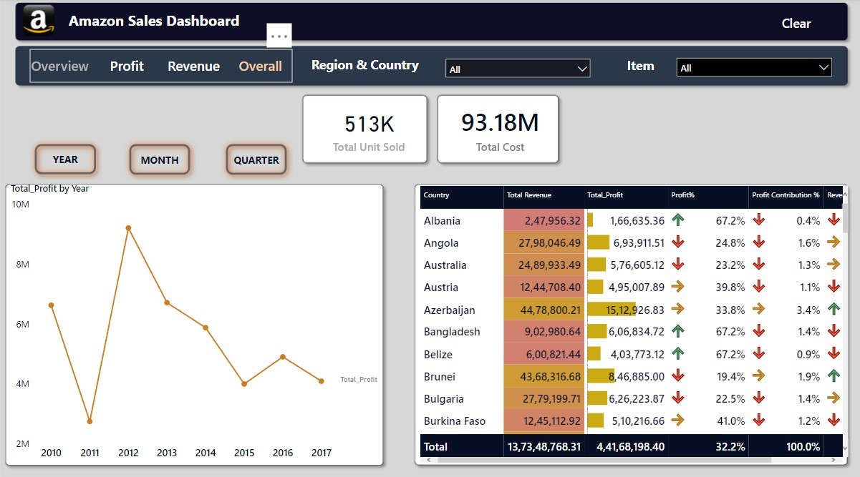

# Components of Dashboard

## Top 5 Item by Profit%

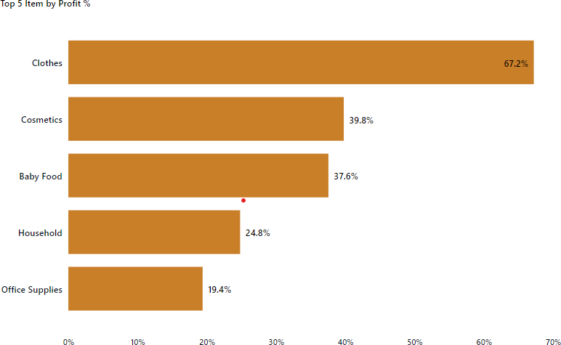

## Total Profit By Item Type

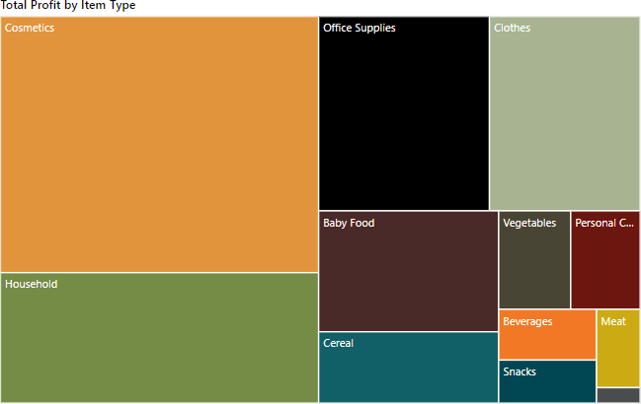

## Profit Distribution Year,Month,Quarter and Day wise

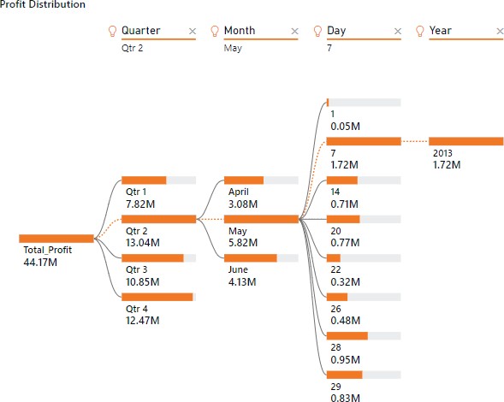

## Profit Across Various Countries

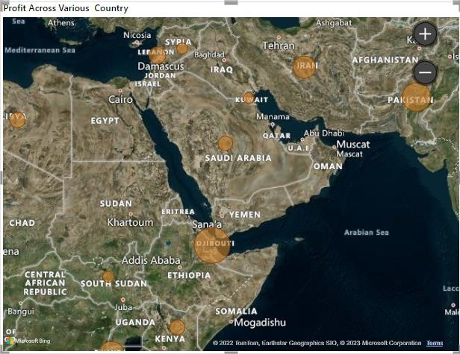

* Revenue Contribution% by Item Type

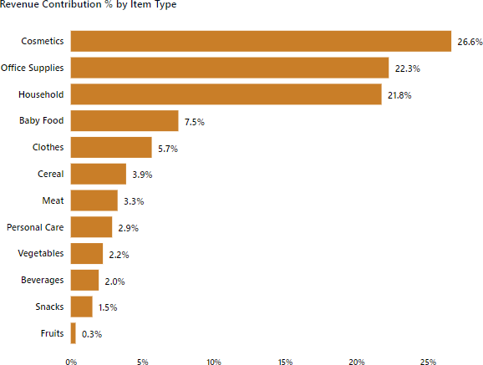

•

## Total Cost and Total Revenue by Item Type

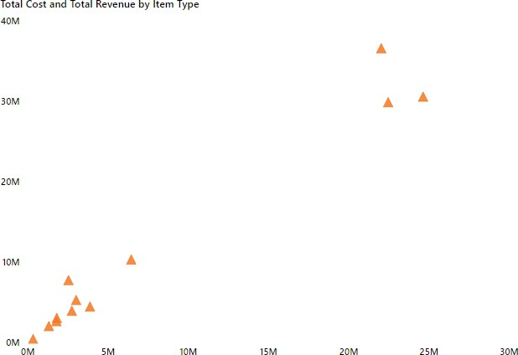

* This Year and Last Year Revenue with Profit% by Year

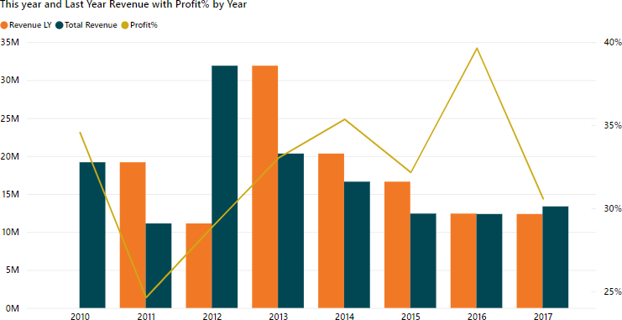

## Total Cost and Total Revenue by Year

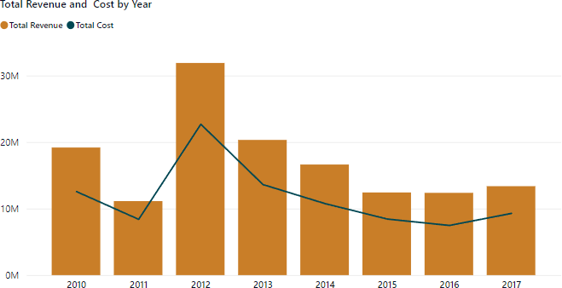

* Total Profi by Year

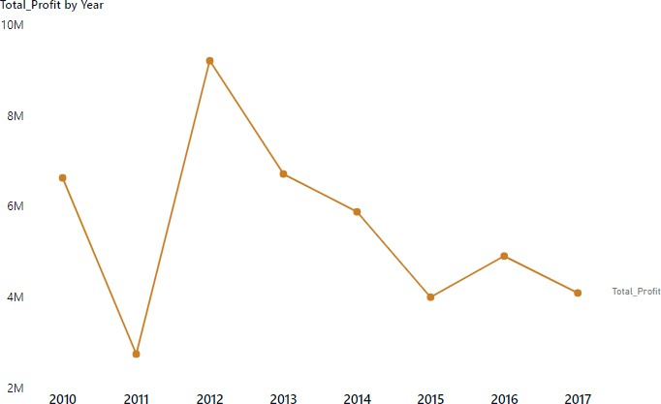

## Table Metrics

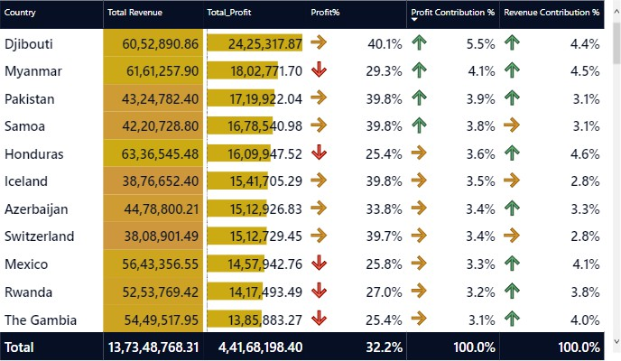

**Insights**

1. Djibouti Country has the Highest Total Profit and Kuwait has the least Total Profit.
2. Across all year 2013 has the highest Total Profit in Second Quarter in the month of may on day 7.
3. Clothes, Cosmetics, Baby Food, Household, Office Supplies are the top 5 Items. In which Clothes having Highest Profit% of 67.2% and Office Supplies has lowest Profit% of 19.4%.
4. Across All the Items Cosmetics Has the Highest Total Profit of

14.56M and Fruits has the Lowest Total Profit of 120.50k.

1. In terms of Revenue Contribution%, Cosmetics has the highest and Fruits has the Lowest.
2. Across all the Items Office Supplies Has the highest Total Cost and Cosmetics has the Highest Total Revenue.
3. Across All the Year 2012 has the Highest Total Revenue with 28.9% of Profit whereas 2016 has the highest Profit% which is 39.6%
4. Belize, Bangladesh, Cape Verde, Fiji, Lebanon, Macedonia, Madagascar, Albania, Cote d’Ivoire, Libya, Mali are the Countries having Highest Profit% of 67.2%.
5. The Total Profit Earned Across Various Countries. Djibouti has the highest profit Contribution of 5.5%
6. Kuwait, New Zealand, Kyrgyzstan, Syria, Slovakia, Kiribati, Malaysia are the Countries which has lowest Profit of 0%.
7. The Total Revenue Earned Across Various Countries, Honduras has the highest Revenue Contribution% of 4.6%.
8. Kuwait, New Zealand, Kyrgyzstan, Syria, Slovakia, Kiribati, Malaysia are the Countries which has the lowest Revenue Contribution% of 0%.