# ONLINE Music App

**A PROJECT REPORT**

***Submitted by***

**RINKI KANJANI [19BECE30162] RAHUL PRANAMI [19BECE30159] SHAH VIDHYESH [19BECE30203]**

***In fulfillment for the award of the degree Of***

**BACHELOR OF ENGINEERING**

**In**

**COMPUTER ENGINEERING**



## LDRP INSTITUTE OF TECHNOLOGY AND RESEARCH,

***LDRP Institute of Technology and Research***

***Gandhinagar***

**CE-IT Department**



CERTIFICATE

This is to certify that the Project Work entitled **“ONLINE Music App”** has been carried out by **RINKI KANJANI (19BECE30162)** under my guidance in fulfilment of the degree of Bachelor of Engineering in COMPUTER ENGINEERING Semester-7 of Kadi Sarva Vishwavidyalaya University during the academic year 2022-23.

RASHMIKA PATEL DR.SANDIP MODHA

**Internal Guide** **Head of the Department**

**LDRP ITR LDRP ITR**

***LDRP Institute of Technology and Research***

***Gandhinagar***

**CE-IT Department**



CERTIFICATE

This is to certify that the Project Work entitled **“ONLINE Music App”** has been carried out by **RAHUL PRANAMI [19BECE30159]** under my guidance in fulfilment of the degree of Bachelor of Engineering in COMPUTER ENGINEERING Semester-7 of Kadi Sarva Vishwavidyalaya University during the academic year 2022-23.

RASHMIKA PATEL DR.SANDIP MODHA

**Internal Guide** **Head of the Department**

**LDRP ITR LDRP ITR**

***LDRP Institute of Technology and Research***

***Gandhinagar***

**CE-IT Department**



CERTIFICATE

This is to certify that the Project Work entitled **“ONLINE Music App”** has been carried out by **SHAH VIDHYESH [19BECE30203]**under my guidance in fulfilment of the degree of Bachelor of Engineering in COMPUTER ENGINEERING Semester-7 of Kadi Sarva Vishwavidyalaya University during the academic year 2022-23.

RASHMIKA PATEL DR.SANDIP MODHA

**Internal Guide** **Head of the Department**

**LDRP ITR LDRP ITR**

**ACKNOWLEDGEMENT**

**RINKI KANJANI**

**(19BECE30162)**

**Rahul Pranami (19BECE3-159)**

**Shah Vidhyesh (19BECE30203)**

**ABSTRACT**

This project is about the mp3 music player application development using React Js. The biggest difference between the music player and existing applications is that it is completely free for users to use. It will integrate the advantages of existing music players on the market, as far as possible to mining out the existing music players' function, and then do the filtering in order to eliminate function that not practical or low cost-effective. Also, it will be keep improved based on user feedback.

In addition, depending on the user's usage scenario, the music player will also add some modes, such as driving mode and night mode, to allow users to use the application in any situation or environment. Moreover, the music player will have audio trim features, allowing users to trim the best part of their favorite song into phone ringtone or alarm. On the other hand, the existing music players pay less attention to the control of gestures. Therefore, the music player will solve the limitation by adding more gestures and shake the phone feature for media control to make it more user-friendly and humanity.

The agile development cycle consists of six phases, which is requirements analysis, planning, design, implementation or development, testing, and deployment. Due to the iterative and flexible nature of this approach, it is able to effectively adapt to users with changing requirements.

**TABLE OF CONTENTS**

|  |  |  |
| --- | --- | --- |
| **NO** | **CHAPTER NAME** | **PAGE NO** |
|  | **Acknowledgement** | i |
|  | **Abstract** | ii |
| 1 | **Introduction** | 1 |
|  | 1.1 Introduction | 2 |
|  | 1.2 Scope | 2 |
|  | 1.2.1Current Scope | 2 |
|  | 1.2.2 Future Scope | 2 |
|  | 1.3 Project Summary and purpose | 3 |
|  | 1.3.1Project Summary | 3 |
|  | 1.3.2Purpose | 3 |
|  | 1.4 Objectives | 3 |
| 2 | **System Requirement Study** | 15 |
|  | 2.1 User Characteristics | 16 |
|  | 2.2 Software and Hardware Requirements | 16 |
|  | 2.2.1 Software Requirements | 16 |
|  | 2.2.2 Hardware Requirements | 17 |
|  | 2.2.3 Functional Requirements | 17 |
|  | 2.2.4 Non Functional Requirements | 18 |
|  | 2.3 Constraints | 19 |
|  | 2.3.1 Parallel Operations | 19 |
|  | 2.3.2 Reliability Requirements | 19 |
|  | 2.3.3 Criticality of the application | 19 |
|  | 2.3.4 Safety and security considerations | 19 |
|  | 2.3.5 Hardware limitations | 19 |

|  |  |  |
| --- | --- | --- |
|  | * + 1. Regulatory Policies     2. General Constraint   1. Assumptions and Dependencies      1. Assumptions      2. Dependencies | 20  20  20  20  20 |
| 3 | **System Analysis**   * 1. Study of current system   2. Modules and Functionality of proposed system   3. Feasibility Study      1. Technical feasibility      2. Operational feasibility      3. Economic feasibility   4. Requirement Validation   5. Class Diagram   6. Use Case Diagrams      1. Use Case Diagram of system      2. Use Case Scenarios and Diagram of XXX      3. Use Case Scenarios and Diagram of YYY | 21  22  22  26  26  27  27  28  28  30  31 |
| 4 | **Project Planning - Estimation and scheduling**   * 1. Project Scheduling   2. Estimation      1. Effort Estimation      2. Cost Estimation |  |
| 5 | **System Design**   * 1. Database Design   2. Entity Relationship Diagram   3. Data Flow Diagram      1. Context level      2. First level DFD of Admin      3. Second level DFD of Admin      4. First level DFD of consultant      5. First level DFD of client      6. First level DFD of Accountant   4. Activity Diagram      1. Activity diagram of admin      2. Activity diagram of consultant      3. Activity diagram of client      4. Activity diagram of accountant   5. Sequence Diagram | 33  34  39  40  40  41  42  43  44  45  46  46  47  48  49 |

|  |  |  |
| --- | --- | --- |
| 6 | **Testing**   * 1. Testing Plan      1. Planning Steps   2. Testing Strategies   3. Test Cases | 73  74  74  79  81 |
| 7 | **Experience, Limitations And Future Enhancement**   * 1. Experience during project development   2. Limitations   8.2 Future Enhancement | 84  85  85 |
| 8 | **Bibliography**   * 1. Conclusion   2. Bibliography | 86  87  87 |
|  | **Appendix A** |  |
|  | **Appendix B** |  |

# INTRODUCTION

* + **INTRODUCTION**
  + **SCOPE**
  + **PROJECT SUMMARY AND PURPOSE**
  + **OBJECTIVES**

## Introduction

Music player in this project is web based application using React JS. Music is one of the best ways to relieve pressure in stressful modern society life. The purpose of this project is to develop a player which can play the mainstream file format. To browse and query the storage space as well as operation of playing can be realised. Meanwhile, this software can play, pause and select songs with latest button and next button according to sets requirement as well as set up songs.

## Project summary and Purpose

### Project Summary

This section describes requirements of the system based on basic control functions of players, and system setup function of the player according to research results of the project demand.

According to the research results of project demand, the basic requirements of project system and its function structure are presented. And describe the demand of the system through the different angles. The project is divided into the following parts by using diagram: the basic control functions of the player, the playlist management function of the player and system setting function of the player. The player interface requires rational layout, comfortable color, friendly control buttons and concise and beautiful images. According to the Android system requires, the non- response time is 5 seconds.

The following is requirements in the music player development application: Application response time shall not exceed 5 seconds in music playing.

Application response time shall not exceed 5 seconds as the music is suspended. Application response time shall not exceed 5 seconds as the music is stopped.

Application response time shall not exceed 5 seconds as Move Next/Move Previous music.

Application response time shall not exceed 5 seconds as system listing is required

### Purpose

This project is about the mp3 music player application development using React Js. The biggest difference between the music player and existing applications is that it is completely free for users to use. It will integrate the advantages of existing music players on the market, as far as possible to mining out the existing music players' function, and then do the filtering in order to eliminate function that not practical or low cost-effective. Also, it will be keep improved based on user feedback

## Objective

## The objective of this thesis is to propose development of android that:

### Make it with a simple feature and run smoothly

By using this mp3 music player will make users fell comfortable and relaxed because it will pay more attention to the features commonly used by users, excluding some rarely used features that occupy a large of system processors, making the music player lightweight, simple, but also has powerful basic features.

### Support gesture control

The MP3 music player will add features triggered by gestures to make it easier for users to use as well as less dependent on touch buttons. For example, a user can skip next or previous songs by simply swiping left and right on the anywhere of the screen in the playing interface.

### Support quick search

The lack of a search bar in the music list is unacceptable. Therefore, the mp3 music player will use the search bar as well as fast scroll using alphabets on the right side of the screen, allowing users to quickly filter through hundreds of songs to find the ones users want to play.

# TECHNOLOGY AND LITERATURE REVIEW

* + **TOOLS AND TECHNOLOGY**
  + **PROJECT PLANNING**
  + **PROJECT SCHEDULING**
  + **COST ESTIMATION**

## Tools and Technology

### React JS:

**React Js** is it painless to create interactive UIs. Design simple views for each state in your application, and React will efficiently update and render just the right components when your data changes. Declarative views make your code more predictable and easier to debug.

### JavaScript:

JavaScript is among the most powerful and flexible programming languages of the web.It powers the dynamic behaviour on most websites. JavaScript was invented by Brendan Eich in 1995. It was developed for Netscape 2, and became the ECMA-262 standard in 1997. After Netscape handed JavaScript over to ECMA, the Mozilla foundation continued to develop JavaScript for the Firefox browser.

**API:**

An application programming interface (API) is a way for two or more computer programs to communicate with each other. It is a type of software interface, offering a service to other pieces of software.[1] A document or standard that describes how to build or use such a connection or interface is called an API specification. A computer system that meets this standard is said to implement or expose an API. The term API may refer either to the specification or to the implementation.

## Project Planning

* + 1. **Project Development Approach:**

The model that is referred for the development of the project is INCREMENTAL model. It combines elements of the waterfall model applied in an iterative fashion. In this process the phases are same as waterfall but the advantage is that when first phase is done it is incremented and then the other phases are carried with the same cycle. Here in this add ons on each phase can be added according to the need of the client and the project.

Phases are as follows:

1. Communication
2. Planning
3. .Modeling: Includes Designing
4. Construction
5. Deployment: Feedback,Delivery

Each phases are iteratively carried out. Main reason for using this then any other is waterfall has the drawback of iterations, if there is any other requirement added later on then this is not possible to add up in it, Spiral model has disadvantage that it need more manpower and even it is for multiple transactions or multiple tasks handling projects and so does the time consumption is more in it for those projects.

Planning is essential cause multiple software teams works in parallel on different system functions. Scalability should be obtained in any of the project selected but it is not available in waterfall cause of few drawbacks.

**2.1.3 Group Dependencies**

The team structure depends on the management style of the organization, number of people in the team, their skill levels and the problem difficulty. Our team organization is *democratic decentralized* which doesn’t have a team leader. Decision is made by all of us and the problems were discussed and solved by all of us after consulting and discussing with our external guide and project guides.

## Project Scheduling

Project scheduling involves separating the total work in a project into separate activities and judging the time required to complete these activities. Usually, some of these activities are carried out in parallel.

### Work Breakdown Structure

Work Breakdown Structure is used to decompose a given task set recursively into small activity [Fig (2.3)].

### Activity Network Representation

An activity network shows the different activities making of a project, their estimated duration and interdependencies [Fig (2.4)].

### Gantt Chart

Gantt chart is mainly used to allocate resources to activities. Gantt Charts are useful for resource planning [Fig (2.5)]

### Work Breakdown Structure

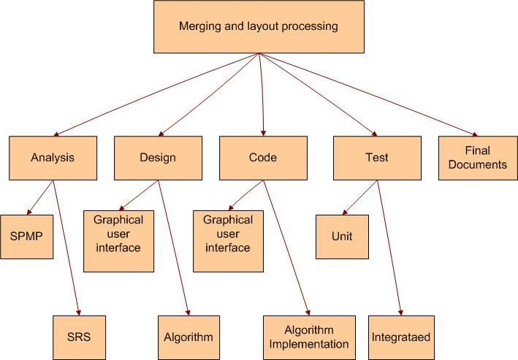

Fig 2.1 Work Breakdown Structure

### Activity Network Representation

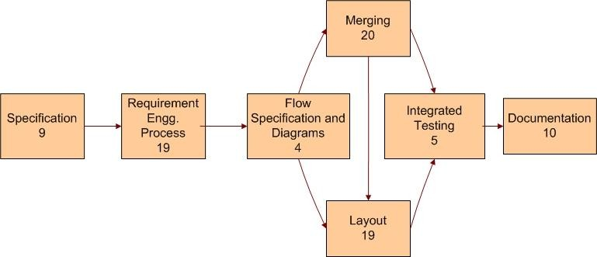

Fig 2.2 Activity Network Representation

## Estimation

### Effort Estimation

Effort Estimation includes the time required i.e. the dedication for developing the project successfully. Gantt chart includes that each phases or each modules divided so that is according to the plan.

Even effort estimation includes the labor power included in it. But that is not in Client Support System as man power does not include the cost.

### Cost Estimation

There are two types of models that have been used to estimate cost: *cost models* and *constraint models*. Cost models provide direct estimates of effort. These models typically have a primary cost factor such as size and the number of secondary adjustment factors or *cost drivers*. Cost drivers are characteristics of the project, process, products, or resources that influence effort. Cost drivers are used to adjust the preliminary estimate provided by the primary cost factor.

# SYSTEM REQUIREMENTS STUDY

* + **USER CHARACTERISTICS**
  + **HARDWARE AND SOFTWARE REQUIREMENTS**
  + **CONSTRAINTS**
  + **ASSUMPTIONS AND DEPENDENCIES**

## User Characteristics

Analyzing user characteristics is an important aspect of any project. It allows us to clearly define and focus on who the end users are for the project. Also, it allows checking the progress of the project to ensure that we are still developing the system for the end users. The user must have following characteristics:

* + - User must have basic knowledge of Computers.
    - User should understand the use of all modules.
    - User can easily interact with the proposed system.
    - User must know the technical terms used in the company for performing different tasks specially related to call logs, payment details, transportation details and report retrieval.
    - User should be also being aware about the running process of the system.

## Software and Hardware Requirements

Software and Hardware Requirements are used to describe the minimum hardware and software requirements to run the Software. These requirements are described below.

### Software Requirements

* + - * **Client:**
        + Operating System: Windows or Linux
        + Web Browser: Any React JS compiler

### Server:

* + - * + Operating System: WINDOWS or LINUX SERVER OS
        + Database Server: Oracle
        + Technologies: ASP.NET with C#, AJAX

### Hardware Requirements

* + - * **Client:**
        + 1.6 GHZ CPU
        + 256 MB of RAM
        + Internet Connection
        + Monitor
        + Keyboard/Mouse
        + Printer

### Server:

* + - * + 1.6 GHZ CPU
        + 1 GB of RAM
        + Internet Connection
        + Monitor
        + Keyboard/Mouse
        + Printer

### Functional Requirements

The basic features available in the system are as follows:

* + - * Admin can search any details of consultant easily.
      * Admin can view various reports based on different criteria’s.
      * Manages the payment details, enable consultants to view their payment log at any point of time.
      * Consultants can refer to the log details of their own recorded logs as well as all the logs of the companies to which they provide services for future problem assessment of other problems when required.
      * Accountant gets a clear log of client and company payment details there by ESS alerts the employees on their screens about their daily work and tasks that they have to complete.
      * ESS provides facility to its users to greet people on their special days via emails automatically.

### Non Functional Requirements

Following is a list of non functional requirements:

### Performance:

This system should remain accessible 24x7. At least 100 users should be able to access the system altogether at any given time.

### Security:

The database of system should not store any password in plain text rather the ceaser cipher text has to be stored.

### Reliability:

It can be accessed by the end users 24*7 as an when needed hence is highly reliable for end users.

### Availability:

Internet connection for the nodes with the database server is ensured and hence the application will be available any time for access.

### Portability:

The developed web application is portable as it can be accessed from any operation system regardless Windows, Mac, Linux provided they have a browser to access Internet.

## Constraints

### Parallel Operations

The project is on basis of multi-user. This is used for carrying out updating as well as entry by preventing the redundancy of the data.

### Reliability Requirements

Reliability requirements of the system are one of the prime ones in the list. The system is needed to be highly reliable in terms of performance and capable of delivering robust performance. If the reports are generated within 5 seconds then the system is said to be reliable.

### Criticality of the Application

The system can stop working on computers with very low internet connection. Other than that there won’t be any issues. Apart from these the system should be able to make updates at regular time intervals.

### Safety and Security Consideration

Safety and security too are other major concerns of any system. It is necessary to provide safety and security as the system is web application and might be intrude by security threats from the internet. Thus, the code needs to be encrypted and any transaction needs to be done securely.

### Hardware Limitations

Hardware Limitations are other constraint of the system. Hardware Limitations should be overcome for better performance of the system. This can be achieved by using minimum and only necessary hardwares.

### Regulatory Policies

Regulatory policy is about achieving organization’s objectives through the use of regulations, laws, and other instruments to deliver better economic and social outcomes and thus enhance the life of business. Thus the system should be developed by using these regulations to provide better outcome to the company.

### General Constraints

The service provided by consultants of google is 24*7 to its client companies. Hence the oracle database server as well as the web application needs to be up 24*7. Internet availability is the major requirement for all the end users to successfully access the application. As well as being a live application security enforcement needs to be tight else there are chances of hacking or intrusion.

## Assumptions and Dependencies

### Assumptions

* + - * Database transactions are assumed to be secure and reliable.
      * User is the person having enough knowledge for the traversing operation.
      * We will provide a user friendly interface so that any user can easily navigate through the system, but he/she should be capable of providing valid credentials for successful login.
      * The server used for data storing is always secured.

### Dependencies

* + - * The system is dependent upon the user’s valid credentials. If user inputs wrong username or password, he/she will not be allowed to login to the system.
      * This application depends on the server and internet as all the information is collected and then stored in the server through secure internet connection.
      * All the users of the system will be assigned a specific role. According to these roles each and every user will be allowed to access predefined set of features.

# SYSTEM ANALYSIS

* + **STUDY OF CURRENT SYSTEM**
  + **MODULES AND FUNCTIONALITY OF PROPOSED SYSTEM**
  + **FEASIBILITY STUDY**
  + **REQUIREMENTS VALIDATION**
  + **CLASS DIAGRAM**
  + **SYSTEM ACTIVITY(USECASE DIAGRAM)**
  + **SEQUENCE DIAGRAM**

## Study of current system

* + - Manual systems are tedious to manage.
    - It is time consuming.
    - It is most difficult for report generation.

## Modules and functionality of proposed system

* + - Search
    - Now Playing
    - View lyrics
    - Autoplay
    - Equalizer

## Feasibility Study

An important outcome of the preliminary investigation is the determination that the system requested is feasible. The feasibility study is carried out to examine the likelihood that the system will be useful to the organization.

There are four aspects in the feasibility study namely.

* Operational Feasibility
* Technical Feasibility
* Economic Feasibility

### Technical Feasibility:

The main purpose of checking Technical Feasibility is to examine whether the current technology is sufficient for the development of the system.

The outcomes of the technical feasibility are as follows:

* + - * React JS, Tailwind uses as frontend and backend respectively that is provides all API’s that are required for the application.
      * The application developed in javascript can run on any of the web browser like Opera, Fire- Fox, Chrome, IE, Safari etc.
      * Back end we can use Shazam Core API
      * It provides faster response to the user. It is accurate, reliable and easy to use on [WWW.](http://WWW/)

So, this application is Technically Feasible.

### Operational Feasibility:

The main purpose of checking Operational Feasibility is to find out whether the system will be functional after its development and installation or not.

The outcomes of the operational feasibility are as follows:

* + - * This application provides all the data of call log services provided to client companies along with the payment and transportation details.
      * They can be administered from remote locations using mail, email or telephone.
      * So, it is supposed to improve the working efficiency of user.

So, this application is operationally feasible.

### Economic Feasibility:

The main purpose of checking Economical Feasibility is to examine whether the financial investment in the system will meet the organization’s requirements or not.

The outcomes of the technical feasibility are as follows:

* + - * Proposed System is developed as web application which is freely available on [WWW.](http://WWW/)
      * It uses React JS as a front end that is also freely available.
      * The advantages of the system nullify its development cost as the scope and effect of the system are very large.

So, this application is economically feasible.

## Requirements Validation

The Basic validation from user side is to detect wrong information or blank information:

* + - When the user has entered correct username and password, then he/she is allowed to enter information or to see the information either into the database or from the database.
    - If anyone field from username or password remains blank, then user will not be allowed to enter into the system.
    - If a consultant leaves some fields blank in call log form then he/she does not allowed submitting his/her information.
    - If user has entered wrong data then accordingly message will generate automatically.

## Class Diagram

A class diagram is a graph of classified elements connected by their various static relationships. It is shown here for Client Support System. This includes the System and the End-users as its main classes. Here are three different fields: Class, Attributes, and Operations.

Class shows the class name, i.e., System, End-user, Data and Sign Clip. They are connected with each other through links and their relation with each other is shown through the numbers represented on the link; here **\*** indicates zero or more multiplicity. Here Data class is connected to System through a Composition link which is the collaboration of all participants are part of one composite class.

Attributes provide the details of the Class while Operations show all possible operations respective class can do in the system.

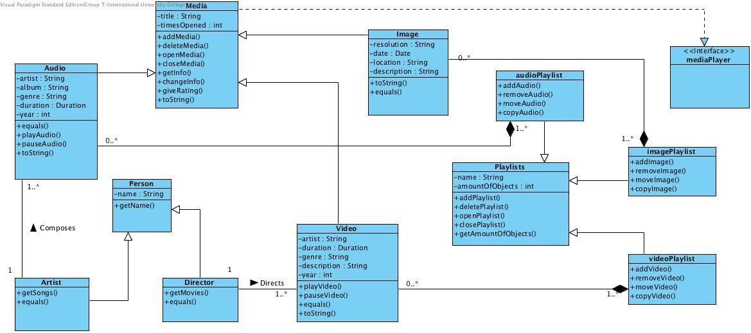

## System Activity

A use case diagram shows the relationship among actors and use cases within a system. Hence it provides the characteristics of the actors whose behavior and relationships can be well understood using the diagrams elaborated here.

An end-user can perform various tasks on the application; he may use signs or upload a new sign o his own. On the other hand, the system would respond to the operations done by the user. It would display the sign clips and store the uploaded sign to the defined category. Also it would provide a message whenever needed for confirmation.

Here the rectangle indicates system boundary, out of which there are actors found who perform various operations on the system which are the end-user and the system here. An elliptical shape shows the use-case while the connecting links between an actor and a use case are said to be communicates.

## Use case diagram:-

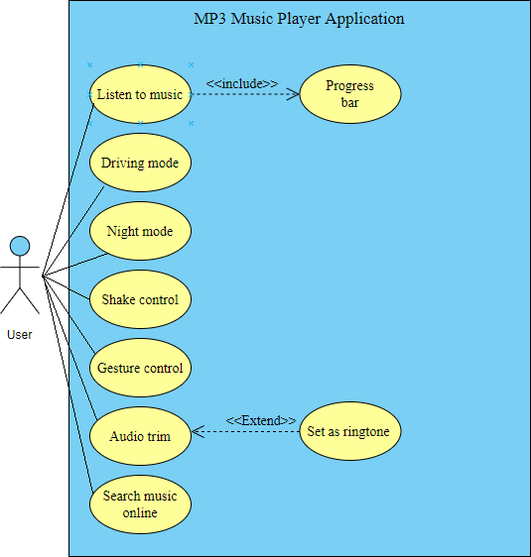

* 1. **Sequence Diagram**

A sequence diagram represents an Interaction, which is a set of messages exchanged among objects within collaboration to effect a desired operation or result. Here are the sequence diagrams for various interactions among the user, system and the data storage. It must be noted that the rectangle box on the top of the diagram indicates the object or actor and dashed lines beneath to it shows an object’s lifeline. Another rectangles following and followed by the dashed lines in a vertical manner show the activation period of the object or actor when it performs some actions. A solid arrow conveys a message while the dashed arrow gives return message. These message names are written along with their respective arrows as shown further in the diagram.

## 4.8. Activity Diagram:

* **Listen to music:**

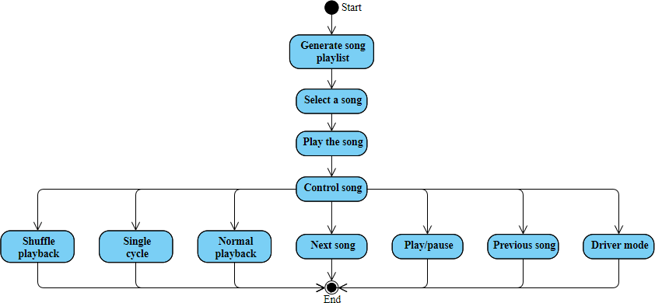

# SYSTEM DESIGN

* + **ENTITY RELATIONSHIP DIAGRAM**
  + **DATA FLOW DIAGRAM**
  + **ACTIVITY DIAGRAM**

## Online Music Portal System ER Diagram | FreeProjectzEntity Relationship Diagram

* 1. **Data Flow Diagram**

### Context Level

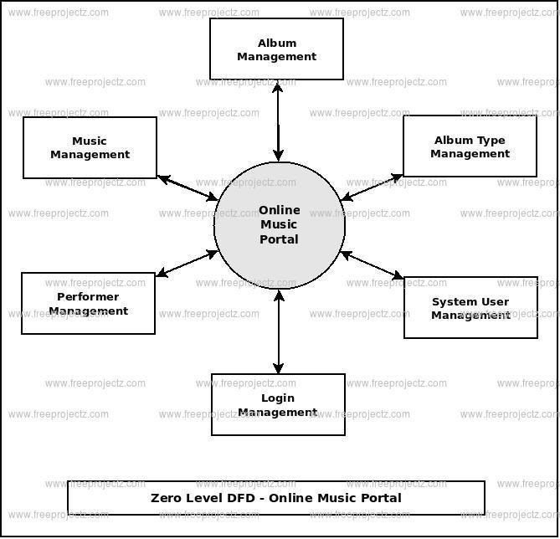

* + 1. **First Level DFD for Admin**

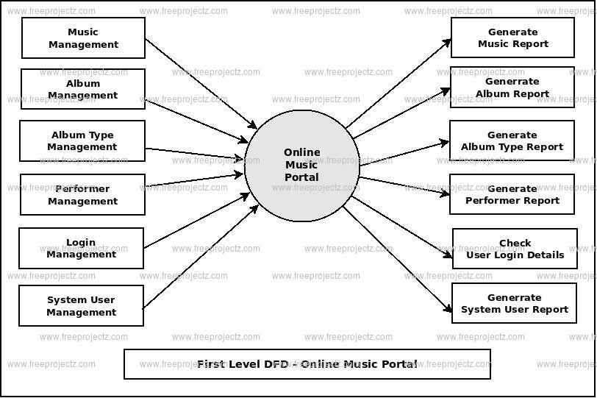

# IMPLEMENTATION STANDARDS

* + **IMPLEMENTATION ENVIRONMENT**
  + **SECURITY FEATURES**

## Implementation Environment

Challenges identified for successful design and implementation of this project are dominated by: complexity, reliability/availability, transparent data access while respecting security, a high experiment data rate and data volume, scientific exploitation from multiple sites. All the systems have a GUI interface to interact with the user.

### Multi User

This Software is a multi-user Application. This must be uploading on the server and start through internet on which you want to work. Multiple instances of the Application can be run at a time.

### GUI Based

This Software consists of GUI that is user friendly but the background process consists of much center of attraction. That is written in such a way that manipulation of multiple images can be easily done.

## Security Features

Any infrastructure/application development for the web should adhere to the Security Policy detailed by the organization. It is assumed that Organization has a detailed Security policy for protecting its resources and information. What follows is a “common” approach for protecting the resources and information when a web application is published in the web.

### Security Layers:

* Application Security
* Database Security
* Network - Data Transfer Security
* External Security: Firewall and Antivirus

### Application Security

Single sign-on provides users with a ***single point of entry*** to all authorized applications with a

***single authentication*** or login process. Application Server Security includes

**Authentication:** System supports strong user Authentication. Server Password-based authentication will support Password-based schemes, to be secure, must facilitate change of passwords regularly, sufficient complexity and cannot be easily guessed.

* Only Authenticated users can login in the System by entering their own Login Id and Password.
* We are storing Passwords in Encrypted form so only authenticated user can use that.

**Authorization:** User Authorization in the system is implemented as access control. Access control deals with the concept of who has access to what information and what type of operations can be accessed. System provides a strong set of access control security mechanisms through privileges.

**Data Confidentiality:** Encryption is the mechanism that is used to provide data confidentiality. The required data can be sent in encrypted form through SSL (Secure Socket Layer). SSL can be enabled for accessing the applications through Internet.

# TESTING

* + **TESTING PLANS**
  + **TESTING STRATEGIES**
  + **TEST CASES**

## Testing Plan

* + 1. **Planning Steps**
       1. Functionality Testing
       2. Usability testing
       3. Interface testing
       4. Performance testing
       5. Security testing

### Functionality Testing:

Test for – all the links in web pages, database connection, forms used in the web pages for submitting or getting information from user, Cookie testing.

### Check all the links:

* Test the outgoing links from all the pages from specific domain under test.
* Test all internal links.
* Test links jumping on the same pages.
* Test links used to send the email to admin or other users from web pages.
* Test to check if there are any orphan pages.
* Lastly in link checking, check for broken links in all above-mentioned links.

### Test forms in all pages:

Forms are the integral part of any web site. Forms are used to get information from users and to keep interaction with them. So what should be checked on these forms?

* First check all the validations on each field.
* Check for the default values of fields.
* Wrong inputs to the fields in the forms.
* Options to create forms if any, form delete, view or modify the forms.

Let’s take example of the search engine project currently I am working on, In this project we have advertiser and affiliate signup steps. Each sign up step is different but dependent on other steps. So sign up flow should get executed correctly. There are different field validations like email Ids, User financial info validations. All these validations should get checked in manual or automated web testing.

### Cookies testing:

Cookies are small files stored on user machine. These are basically used to maintain the session mainly login sessions. Test the application by enabling or disabling the cookies in your browser options. Test if the cookies are encrypted before writing to user machine. If you are testing the session cookies (i.e. cookies expire after the sessions ends) check for login sessions and user stats after session end. Check effect on application security by deleting the cookies. (I will soon write separate article on cookie testing)

### Validate your HTML/CSS:

If you are optimizing your site for Search engines then HTML/CSS validation is very important. Mainly validate the site for HTML syntax errors. Check if site is crawlable to different search engines.

### Usability Testing:

* + **Test for navigation:**

Navigation means how the user surfs the web pages, different controls like buttons, boxes or how user using the links on the pages to surf different pages. Usability testing includes: Web site should be easy to use. Instructions should be provided clearly. Check if the provided instructions are correct means whether they satisfy purpose. Main menu should be provided on each page. It should be consistent.

### Content:

Content should be logical and easy to understand. Check for spelling errors. Use of dark colours annoys users and should not be used in site theme. You can follow some standards that are used for web page and content building. These are common accepted standards like as I mentioned above about annoying colors, fonts, frames etc. Content should be meaningful. All the anchor text links should be working properly. Images should be placed properly with proper sizes. These are some basic standards that should be followed in web development. Your task is to validate all for UI testing.

### Other user information for user help:

Like search option, sitemap, help files etc. Sitemap should be present with all the links in web sites with proper tree view of navigation. Check for all links on the sitemap. “Search in the site” option will help users to find content pages they are looking for easily and quickly. These are all optional items and if present should be validated.

### Interface Testing:

The main interfaces are:

* Web server and application server interface
* Application server and Database server interface.

Check if all the interactions between these servers are executed properly. Errors are handled properly. If database or web server returns any error message for any query by application server then application server should catch and display these error messages appropriately to users. Check what happens if user interrupts any transaction in-between? Check what happens if connection to web server is reset in between?

### Performance Testing

Web application should sustain to heavy load. Web performance testing should include:

* Web Load Testing
* Web Stress Testing

Test application performance on different internet connection speed.In **web load testing** test if many users are accessing or requesting the same page. Can system sustain in peak load times? Site should handle many simultaneous user requests, large input data from users, Simultaneous connection to DB, heavy load on specific pages etc.

**Stress testing:** Generally stress means stretching the system beyond its specification limits. Web stress testing is performed to break the site by giving stress and checked how system reacts to stress and how system recovers from crashes. Stress is generally given on input fields, login and sign up areas.

In web performance testing web site functionality on different operating systems, different hardware platforms is checked for software, hardware memory leakage errors.

### Security Testing:

Following are some test cases for web security testing:

* Test by pasting internal url directly into browser address bar without login. Internal pages should not open.
* If you are logged in using username and password and browsing internal pages then try changing url options directly. I.e. If you are checking some publisher site statistics with publisher site ID= 123. Try directly changing the url site ID parameter to different site ID which is not related to logged in user. Access should denied for this user to view others stats.
* Try some invalid inputs in input fields like login username, password, input text boxes. Check the system reaction on all invalid inputs.
* Web directories or files should not be accessible directly unless given download option.
* Test if SSL is used for security measures. If used proper message should get displayed when user switch from non-secure http:// pages to secure https:// pages and vice versa.
* All transactions, error messages, security breach attempts should get logged in log files somewhere on web server.

## Testing Strategies

### White Box Testing:

White box testing (WBT) is also called **Structural or Glass box testing**. White box testing involves looking at the structure of the code. When you know the internal structure of a product, tests can be conducted to ensure that the internal operations performed according to the specification. And all internal components have been adequately exercised.

### Why we do White Box Testing? To ensure:

* + That all independent paths within a module have been exercised at least once.
  + All logical decisions verified on their true and false values.
  + All loops executed at their boundaries and within their operational bounds internal data structures validity.

### Need of White Box Testing?

**To discover the following types of bugs:**

* + Logical error tend to creep into our work when we design and implement functions, conditions or controls that are out of the program
  + The design errors due to difference between logical flow of the program and the actual implementation
  + Typographical errors and syntax checking

### Limitation Of WBT:

Not possible for testing each and every path of the loops in program. This means exhaustive testing is impossible for large systems.This does not mean that WBT is not effective. By selecting important logical paths and data structure for testing is practically possible and effective.

### Black Box Testing:

* + Black box testing treats the system as a **“black-box”**, so it doesn’t explicitly use Knowledge of the internal structure or code. Or in other words the Test engineer need not know the internal working of the “Black box” or application.
  + **Main focus in black box testing is on functionality of the system as a whole.** The term **‘behavioural testing’** is also used for black box testing and white box testing is also sometimes called **’structural testing’**. Behavioural test design is slightly different from black-box test design because the use of internal knowledge isn’t strictly forbidden, but it’s still discouraged.
  + Each testing method has its own advantages and disadvantages. There are some bugs that cannot be found using only black box or only white box. Majority of the application are tested by black box testing method. We need to cover majority of test cases so that most of the bugs will get discovered by black box testing.
  + Black box testing occurs throughout the software development and Testing life cycle i.e. in Unit, Integration, System, Acceptance and regression testing stages.

### Advantages of Black Box Testing

* + - Tester can be non-technical.
    - Used to verify contradictions in actual system and the specifications.
    - Test cases can be designed as soon as the functional specifications are complete

### Disadvantages of Black Box Testing

* + - The test inputs needs to be from large sample space.
    - It is difficult to identify all possible inputs in limited testing time. So writing test cases is slow and difficult. Chances of having unidentified paths during this testing.

# 8 LIMITATIONS AND FUTURE ENHANCEMENT

* + **LIMITATIONS**
  + **FUTURE ENHANCEMENT**

## Limitations

Following are the limitations of Client Support System application:

* + - There needs to be an internet connectivity to access the application without internet connectivity the application cannot be accessed.
    - A few details such as client and call log details cannot be deleted because they may lead to inconsistency of data.

## Future Enhancement

Following can be enhancements to Client Support System application:

* + - In future the environment details of client companies can also be added to give more information about the company.
    - Health check report can be generated of the database.
    - Database connectivity to main client companies can be detected and if not responding can be directly conveyed to appropriate consultant.

# BIBLIOGRAPHY

* 1. **CONCLUSION**
  2. **BIBLIOGRAPHY**

## Conclusion

MusicApp web application helps the end users of to get rid off their manual system of keeping track of all the log services of client companies through this application.

It allows the Admin to manage all end users and view all the reports. Helps consultants to enter their log records online at any time along with their transportation details and view their own reports. Allows accountant to manage payment services log and helps clients to register their issues.

Hence it helps each user to keep track of just their records and also bifurcates the work load amongst the end users which is currently not deployed.

## Bibliography

### Web Resources

* + - * https://reactjs.org/docs/create-react-app.html
      * <https://rapidapi.com/tipsters/api/shazam-core>
      * <https://tailwindcss.com/docs/installation>

