**Pizza Sales Analysis**

**KPI’S**

**1. Total Revenue:**

Select SUM(total_price) AS Total_Revenue from pizza_sales;

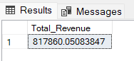

**2. Average Order Value:**

Select Sum(total_price) / Count(DISTINCT order_id) AS Avg_order_Value

from pizza_sales;

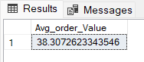

**3. Total Pizza Sold:**

Select Sum(quantity) AS Total_Pizzas_Sold from pizza_sales;

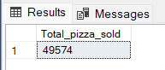

**4. Total Orders:**

Select COUNT(DISTINCT order_id) AS Total_Orders from pizza_sales;

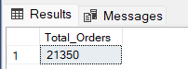

**5. Average Pizzas Per Order:**

Select CAST(CAST(Sum(quantity) AS Decimal(10,2)) /

CAST(COUNT(Distinct order_id) AS Decimal(10,2)) AS Decimal(10,2)) AS Avg_Pizzas_Per_Order from pizza_sales;

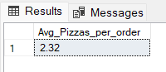

**Business Requirements**

**1.Daily Trend for Total Orders:**

Select DATENAME(DW, order_date) AS order_day, COUNT(DISTINCT order_id)

AS total_orders FROM pizza_sales

GROUP BY DATENAME(DW, order_date);

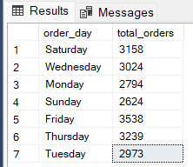

**2. Hourly Trend for Total Orders:**

Select DATEPART(HOUR, order_time) AS order_hours, COUNT(DISTINCT order_id) AS total_orders FROM pizza_sales

GROUP BY DATEPART(HOUR, order_time)

ORDER BY DATEPART(HOUR, order_time);

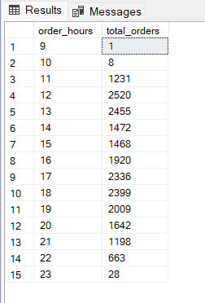

**3.Percentage of Sales by Pizza Category:**

Select pizza_category, CAST(SUM(total_price) AS DECIMAL(10,2))

as total_revenue,

CAST(SUM(total_price) * 100 / (SELECT SUM(total_price) from pizza_sales) AS DECIMAL(10,2)) AS PCT

FROM pizza_sales

GROUP BY pizza_category;

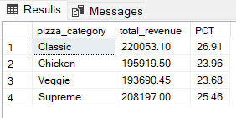

**4.Percentage of Sales of Pizza Size:**

Select pizza_size, CAST(SUM(total_price) AS DECIMAL(10,2))

as total_revenue,

CAST(SUM(total_price) * 100 / (SELECT SUM(total_price) from pizza_sales) AS DECIMAL(10,2)) AS PCT

FROM pizza_sales

GROUP BY pizza_size

ORDER BY pizza_size;

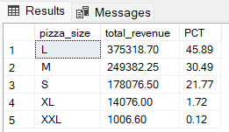

**5.Total Pizza Sold BY Pizza Category:**

Select pizza_category, SUM(quantity) as Total_Quantity_Sold

FROM pizza_sales

GROUP BY pizza_category

ORDER BY Total_Quantity_Sold DESC;

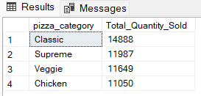

**6.Top 5 Best Sellers by Total Pizzas Sold:**

SELECT Top 5 pizza_name, SUM(quantity) AS Total_Pizza_Sold

FROM pizza_sales

GROUP BY pizza_name

ORDER BY Total_Pizza_Sold DESC

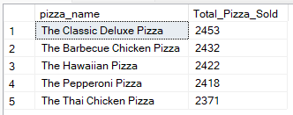

**7.Bottom 5 Worst Sellers by Total Pizza Sold:**

SELECT TOP 5 pizza_name, SUM(quantity) AS Total_Pizza_Sold

FROM pizza_sales

GROUP BY pizza_name

ORDER BY Total_Pizza_Sold ASC

