**MOOD Website V2.0 (1st Part)**

**ALL LINKS MENTIONED ON THE UPCOMING PAGES ARE AVAILABLE IN ITS MAIN FOLDER SENT TO YOU BEFORE AND PROPERLY NAMED AS SUBFOLDER (HERE):** [**https://www.dropbox.com/sh/281umj1gpadf6xg/AADYUXRezyr3R1OK1p5E4YGya?dl=0**](https://www.dropbox.com/sh/281umj1gpadf6xg/AADYUXRezyr3R1OK1p5E4YGya?dl=0)

* Menu Hover Button: Please make 4 horizontal lines  
  
* Homepage Opening Texts “must be same” of the template (<https://aliothwp-light.pethemes.com/>) with scrolling strikeouts animation linking to Main Menu links (please see screenshots below)  
    
    
    
    
    
    
  on our website, please underlined the following words then link to the following menu and/or section:  
  **emotions (Team)  
  and moods, (Portfolio)  
  minds now and (Contact)  
  consider (Showcase)  
  ahead (“Trustful Partner” on Homepage)**
* What’s Your Mood? Image at the beginning before the homepage loads with 100% counter. Program it as Full Responsive in MOOD Red background. (**dropbox link:** [**https://www.dropbox.com/s/lf1ppxwjj1ncng8/WHATS_YOUR_MOOD.png?dl=0**](https://www.dropbox.com/s/lf1ppxwjj1ncng8/WHATS_YOUR_MOOD.png?dl=0))
* Trustful Partners on Homepage (**logos dropbox link:** [**https://www.dropbox.com/sh/vq2n6j292lsu9ut/AAAMjZ163HT_cPoGp4YXCoVEa?dl=0**](https://www.dropbox.com/sh/vq2n6j292lsu9ut/AAAMjZ163HT_cPoGp4YXCoVEa?dl=0))

**(insert copy)**As we build trust with our clients, we are also making a footprint that is long-standing and can be relished by both parties. Below are the some of our partners that we worked with.  
 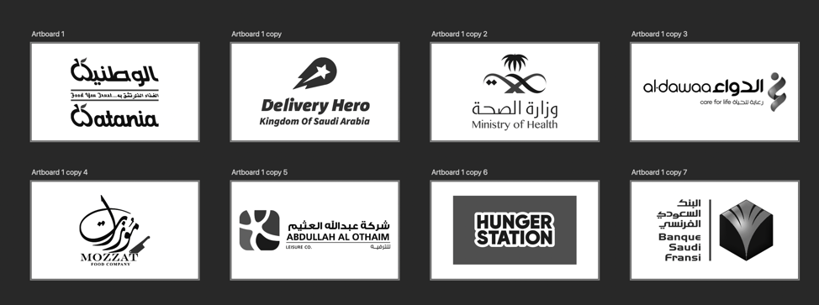  
***\*these are the arrangements of the logos***

* SERVICES Icons (replaced) (**dropbox link:** [**https://www.dropbox.com/sh/an59qoemlltlz38/AAB7UgXcA4RcYanX1iXcSrzva?dl=0**](https://www.dropbox.com/sh/an59qoemlltlz38/AAB7UgXcA4RcYanX1iXcSrzva?dl=0))

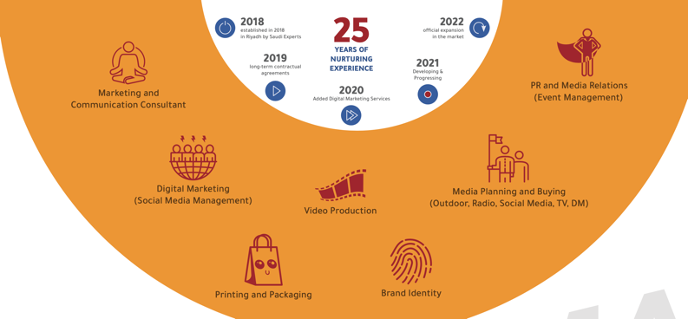 ***\*these are the reference of the icons***

* TEAM Menu Scrolling Words (add 3 spacing in between words, so it looks like continuous and infinite:  
  WORK HARD  
  PLAY HARD  
  NEVER GIVE UP  
  GIVE YOUR 101%  
  GO EXTRA MILE  
  BELIEVE YOU CAN  
  ALWAYS SMILE ☺
* Timeline Icons (replaced) (**dropbox link:** [**https://www.dropbox.com/sh/sgdnsky1qp9kz76/AABeT9a7fOcvREbRbtoy7eMTa?dl=0**](https://www.dropbox.com/sh/sgdnsky1qp9kz76/AABeT9a7fOcvREbRbtoy7eMTa?dl=0))
* Replaced **ALL** contact numbers to: **+966 55 469 9550  
  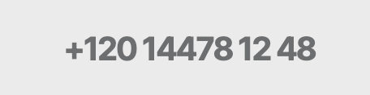  
    
  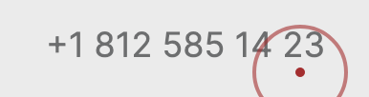**
* 8 MOOD Words on Homepage (please replaced with these, delete commas and add 3 spacing in between words, so it looks like continuous and infinite):  
  ANGER  
  FEAR  
  SADNESS  
  DISGUST  
  ANTICIPATION  
  TRUST  
  JOY  
  SURPRISE  
  NO MORE DRAMA
* Mood Emojis and names to be replaced in “CONTACT” Main Menu (**dropbox link:** [**https://www.dropbox.com/sh/78cfyl1ulkkpcvx/AADmGSO66k6FSf52SY9y0Gdqa?dl=0**](https://www.dropbox.com/sh/78cfyl1ulkkpcvx/AADmGSO66k6FSf52SY9y0Gdqa?dl=0)) **It was 7 emojis before NOW we have 8.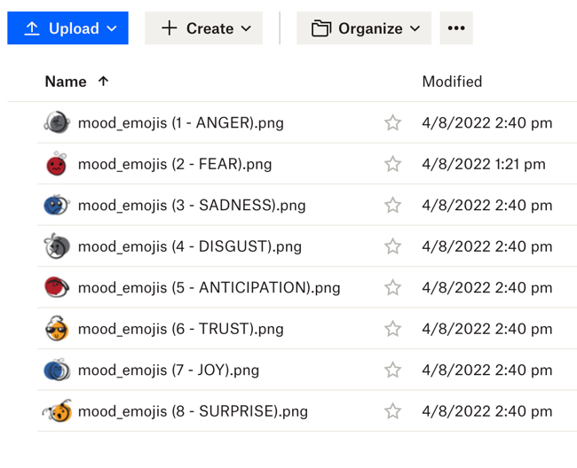 *names of emojis are accordingly synchronized on the filename of the PNG files.**
* Change right side image on “CONTACT” Main Menu (**dropbox link:** [**https://www.dropbox.com/s/9mhhqergxqzurh9/MOOD_Contact_Us%20V2.jpg?dl=0**](https://www.dropbox.com/s/9mhhqergxqzurh9/MOOD_Contact_Us%20V2.jpg?dl=0))
* Portfolio Menu: add PDF download buttons for English and Arabic Version of MOOD Credential that can be updated on the back-end (*here is the temporary PDF to be used replicate the PDF first so you can make the PDF download buttons respectively,* **dropbox link:** <https://www.dropbox.com/sh/aqf4vxurrcirr0j/AADuLXOIR7r0FQBvWjGVK8XVa?dl=0>)
* **Page errors that needed to be fixed:**  

