Student Details

Name USN Roll No

Rahul R C 01FE20BEC210 426

**DSP COURSE PROJECT**

ECG Signal Analysis and Arrhythmia Detection

on IoT wearable medical devices

* DATA IDENTIFICATION :

The MIT-BIH Arrhythmia Database contains 48 half-hour excerpts of two-channel ambulatory ECG recordings, obtained from 47 subjects studied by the BIH Arrhythmia Laboratory between 1975 and 1979. Twenty-three recordings were chosen at random from a set of 4000 24-hour ambulatory ECG recordings collected from a mixed population of inpatients (about 60%) and outpatients (about 40%) at Boston's Beth Israel Hospital; the remaining 25 recordings were selected from the same set to include less common but clinically significant arrhythmias that would not be well-represented in a small random sample.  
  
The recordings were digitized at 360 samples per second per channel with 11-bit resolution over a 10 mV range. Two or more cardiologists independently annotated each record; disagreements were resolved to obtain the computer-readable reference annotations for each beat (approximately 110,000 annotations in all) included with the database.

This directory contains the entire MIT-BIH Arrhythmia Database. About half (25 of 48 complete records, and reference annotation files for all 48 records) of this database has been freely available here since PhysioNet's inception in September 1999. The 23 remaining signal files, which had been available only on the MIT-BIH Arrhythmia Database CD-ROM, were posted here in February 2005.

MODULE IMPLEMENTATION

Convolution is the first layer to extract features from an input image. Convolution preserves the relationship between pixels by learning image features using small squares of input data. It is a mathematical operation that takes two inputs such as image matrix and a filter or kernel.

**Strides**

Stride is the number of pixels shifts over the input matrix. When the stride is 1 then we move the filters to 1 pixel at a time. When the stride is 2 then we move the filters to 2 pixels at a time and so on.

**Padding**

Sometimes filter does not fit perfectly fit the input image. We have two options:

* Pad the picture with zeros (zero-padding) so that it fits
* Drop the part of the image where the filter did not fit. This is called valid padding which keeps only valid part of the image.

**Non Linearity (ReLU)**

* ReLU stands for Rectified Linear Unit for a non-linear operation. The output is ***ƒ(x) = max(0,x).***
* Why ReLU is important : ReLU’s purpose is to introduce non-linearity in our ConvNet. Since, the real world data would want our ConvNet to learn would be non-negative linear values.

**Pooling Layer**

Pooling layers section would reduce the number of parameters when the images are too large. Spatial pooling also called subsampling or downsampling which reduces the dimensionality of each map but retains important information. Spatial pooling can be of different types:

* Max Pooling
* Average Pooling
* Sum Pooling

Max pooling takes the largest element from the rectified feature map. Taking the largest element could also take the average pooling. Sum of all elements in the feature map call as sum pooling.

**Fully Connected Layer**

The layer we call as FC layer, we flattened our matrix into vector and feed it into a fully connected layer like a neural network.

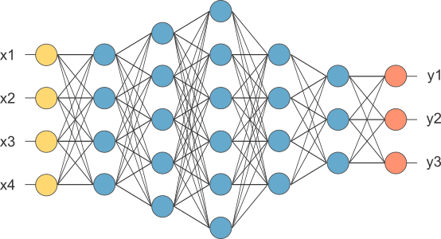

Figure below : Complete CNN Architecture

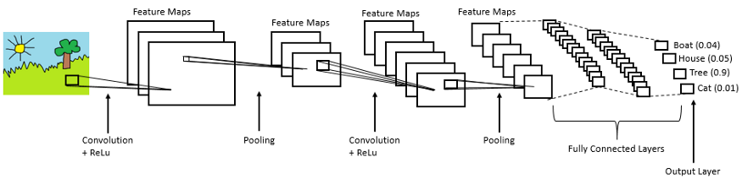

LSTM : LSTM stands for long short-term memory networks, used in the field of Deep Learning. It is a variety of recurrent neural networks (RNNs) that are capable of learning long-term dependencies, especially in sequence prediction problems. LSTM has feedback connections, i.e., it is capable of processing the entire sequence of data, apart from single data points such as images. This finds application in speech recognition, machine translation, etc. LSTM is a special kind of RNN, which shows outstanding performance on a large variety of problems.

The central role of an LSTM model is held by a memory cell known as a ‘cell state’ that maintains its state over time. The cell state is the horizontal line that runs through the top of the below diagram. It can be visualized as a conveyor belt through which information just flows, unchanged.

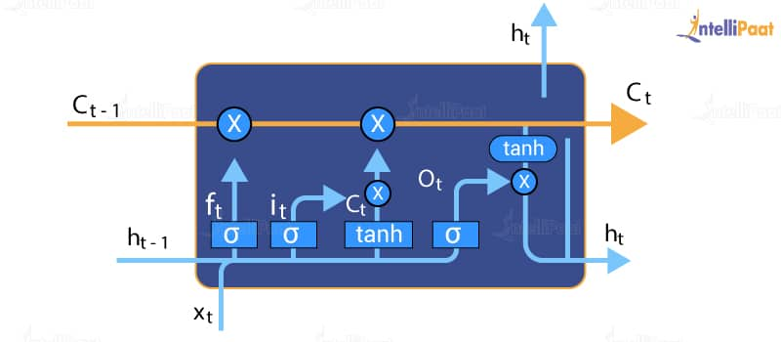

Information can be added to or removed from the cell state in LSTM and is regulated by gates. These gates optionally let the information flow in and out of the cell. It contains a pointwise multiplication operation and a sigmoid neural net layer that assist the mechanism.

LSTM neural networks are capable of solving numerous tasks that are not solvable by previous learning algorithms like RNNs. Long-term temporal dependencies can be captured effectively by LSTM, without suffering much optimization hurdles. This is used to address the high-end problems.

**Bidirectional LSTMs**

These are like an upgrade over LSTMs. In bidirectional LSTMs, each training sequence is presented forward and backward so as to separate recurrent nets. Both sequences are connected to the same output layer. Bidirectional LSTMs have complete information about every point in a given sequence, everything before and after it.

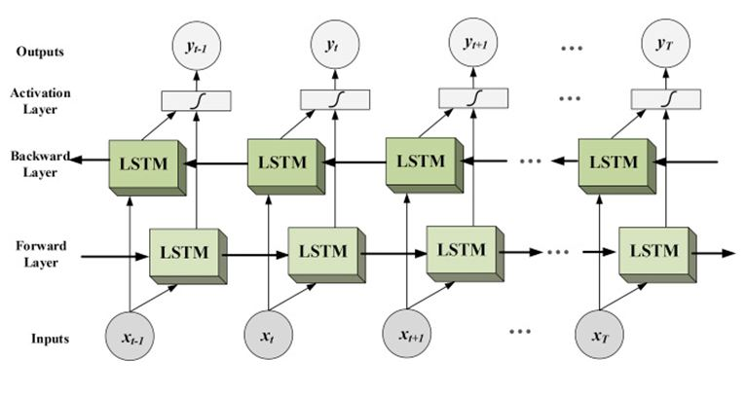

NEURAL NET ARCHITECTURES :

