LAB Logbook

Lab 1 (Week -1)

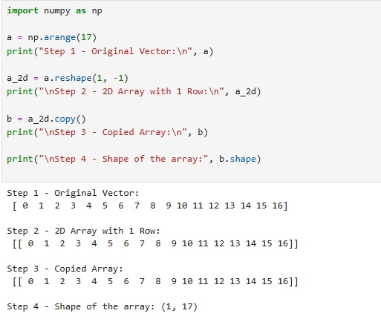

Lab 2 (Week-2)

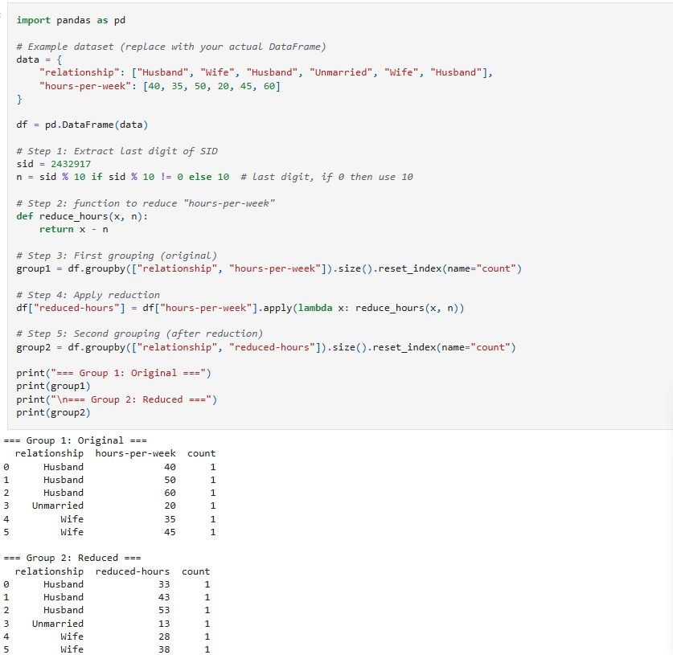

Lab 3(Week-3)

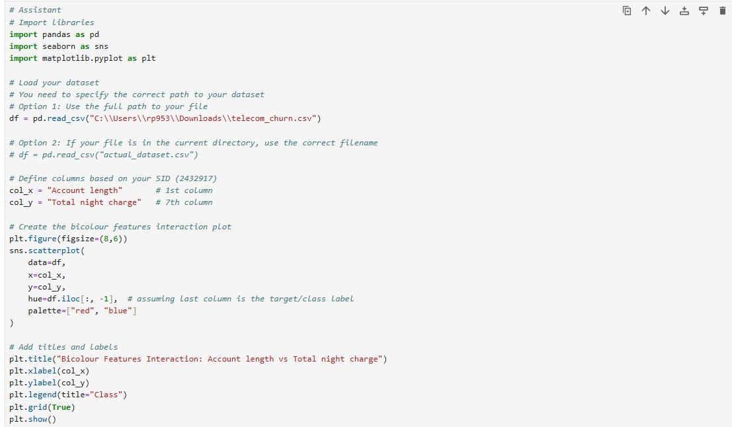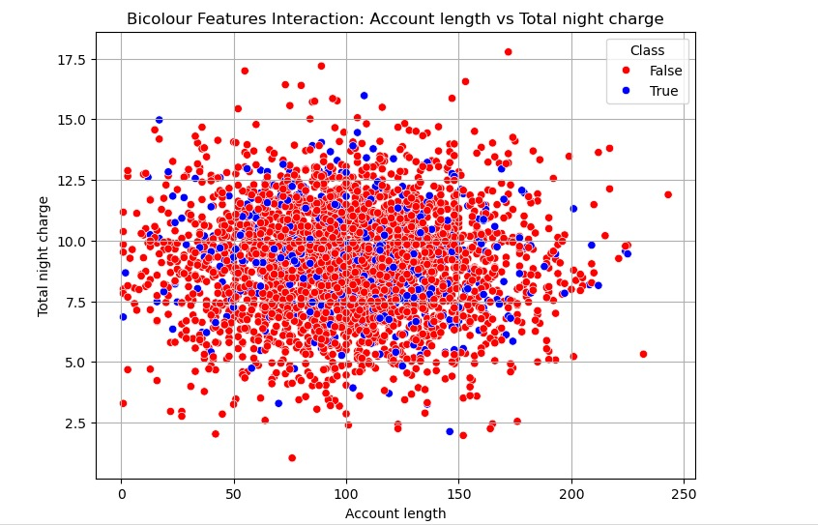

Lab 4

Lab 5

Lab 6

Lab 7

Lab 8

Lab 9

Lab 10

Lab 11

Lab 12