**UCS1412 – Database Lab**

**Assignment – 8**

**NAME:** Rahul Ram M

**ROLL NO:** 185001121

**TABLE CREATION:**

create table emp_payroll(eid varchar2(4) constraint eid_pkey primary key,

ename char(15),

dob date,

sex char(7),

designation varchar2(20),

basic number(7),

da number(11,2),

hra number(11,2),

pf number(11,2),

mc number(11,2),

gross number(11,2),

tot_deduc number(11,2),

net_pay number(11,2));

**PROCEDURE TO CALCULATE NET PAY:**

create or replace procedure cal_netpay(eid1 emp_payroll.eid%type, basic1 emp_payroll.basic%type) as

da1 emp_payroll.da%type;

hra1 emp_payroll.hra%type;

pf1 emp_payroll.pf%type;

mc1 emp_payroll.mc%type;

gross1 emp_payroll.gross%type;

tot_deduc1 emp_payroll.tot_deduc%type;

net_pay1 emp_payroll.net_pay%type;

begin

da1 :=0.60*basic1;

hra1 :=0.11*basic1;

pf1 :=0.04*basic1;

mc1 :=0.03*basic1;

gross1:=basic1+da1+hra1;

tot_deduc1:=pf1+mc1;

net_pay1:=gross1-tot_deduc1;

update emp_payroll set da=da1,hra=hra1,pf=pf1,mc=mc1,gross=gross1,tot_deduc=tot_deduc1,net_pay=net_pay1 where eid=eid1;

end;

/

**INITIAL TABLE EMP_PAYROLL WITH 3 ROWS INSERTED:**

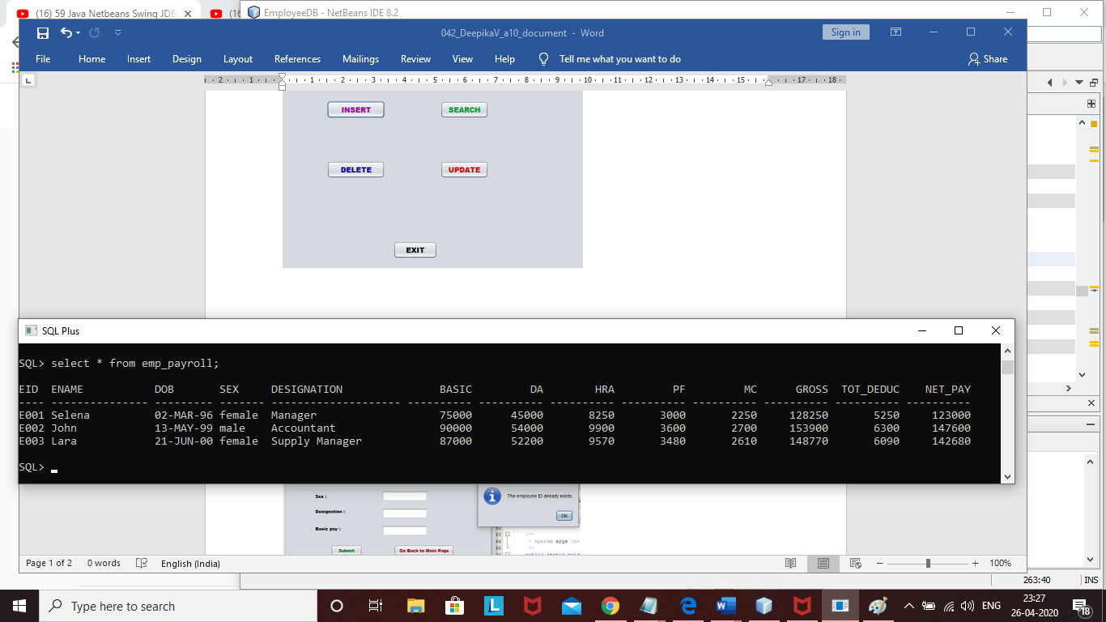

**Main Frame:**

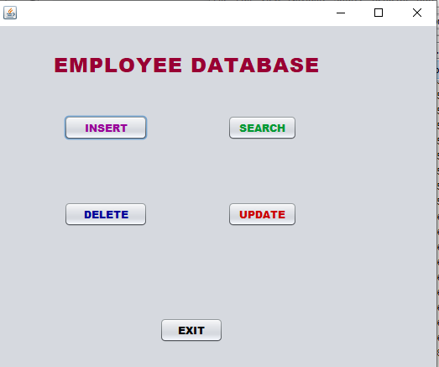

**MAIN FRAME CODE**

package employeedb;

import java.sql.*;

public class MainFrame extends javax.swing.JFrame {

Connection con;

Statement st;

PreparedStatement ps;

/**

* Creates new form MainFrame

*/

public MainFrame() {

initComponents();

try {

Class.forName("oracle.jdbc.driver.OracleDriver");

con=DriverManager.getConnection("jdbc:oracle:thin:@localhost:1521:orcl","hr","hr");

} catch (Exception ex) {

ex.printStackTrace();

}

}

@SuppressWarnings("unchecked")

private void msearchActionPerformed(java.awt.event.ActionEvent evt) {

// TODO add your handling code here:

SearchFrame ef=new SearchFrame();

ef.setVisible(true);

}

private void minsertActionPerformed(java.awt.event.ActionEvent evt) {

// TODO add your handling code here:

InsertFrame i=new InsertFrame();

i.setVisible(true);

}

private void jButton2ActionPerformed(java.awt.event.ActionEvent evt) {

// TODO add your handling code here:

DeleteFrame df=new DeleteFrame();

df.setVisible(true);

}

private void jButton3ActionPerformed(java.awt.event.ActionEvent evt) {

// TODO add your handling code here:

UpdateFrame uf=new UpdateFrame();

uf.setVisible(true);

}

private void jButton4ActionPerformed(java.awt.event.ActionEvent evt) {

// TODO add your handling code here:

System.exit(0);

}

/**

* @param args the command line arguments

*/

public static void main(String args[]) {

/* Set the Nimbus look and feel */

/* Create and display the form */

java.awt.EventQueue.invokeLater(new Runnable() {

public void run() {

new MainFrame().setVisible(true);

}

});

}

// Variables declaration - do not modify

javax.swing.JButton jButton1;

javax.swing.JButton jButton2;

javax.swing.JButton jButton3;

javax.swing.JButton jButton4;

javax.swing.JLabel jLabel1;

javax.swing.JButton minsert;

javax.swing.JButton msearch;

}

**INSERT:**

**Checking whether the entered employee ID already exists:**

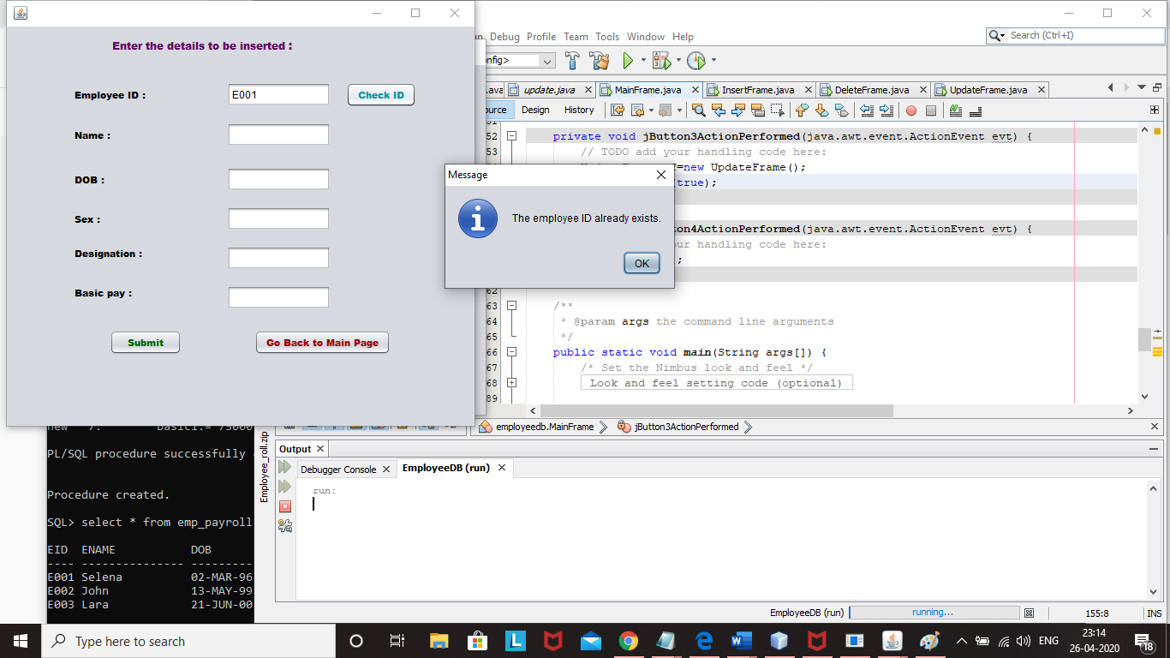

**After insertion:**

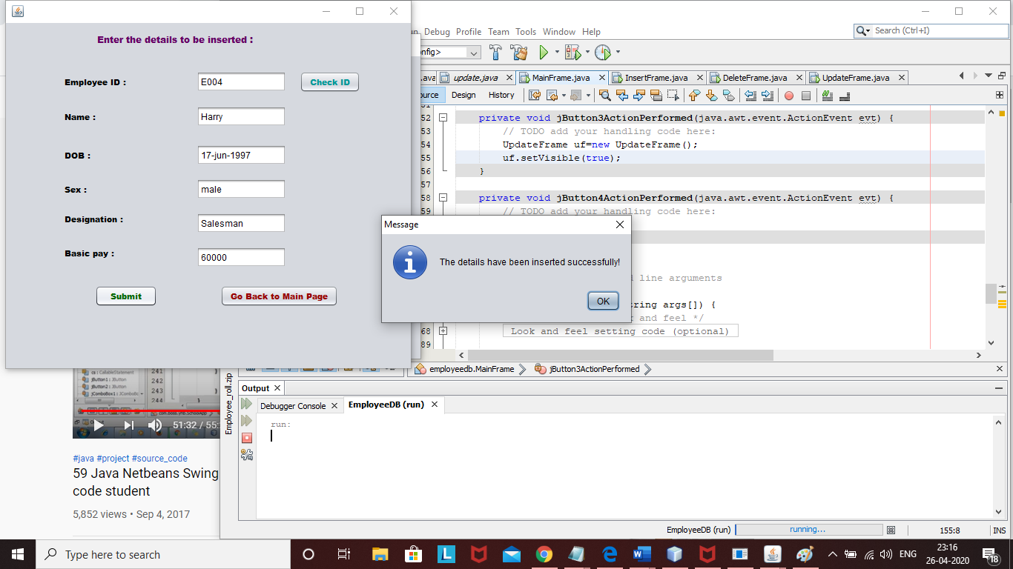

**TABLE AFTER INSERTION :**

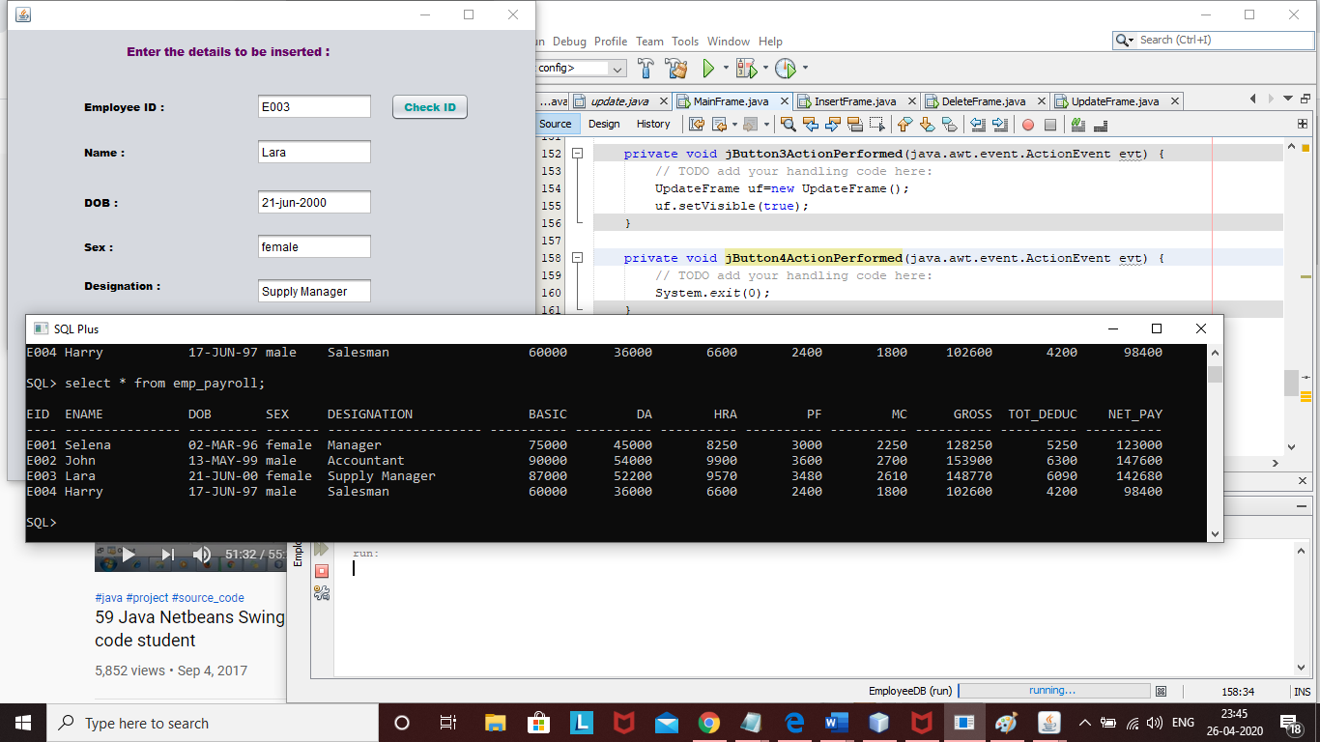

**INSERT FRAME CODE**

package employeedb;

import com.sun.istack.internal.logging.Logger;

import java.sql.*;

import java.util.logging.Level;

import javax.swing.JOptionPane;

public class InsertFrame extends javax.swing.JFrame {

Connection con;

Statement st;

PreparedStatement ps,ps1,ps2;

CallableStatement cs;

ResultSet rs1,rs2,rs3;

/**

* Creates new form InsertFrame

*/

public InsertFrame() {

initComponents();

insert1();

}

public void insert1(){

try {

Class.forName("oracle.jdbc.driver.OracleDriver");

con=DriverManager.getConnection("jdbc:oracle:thin:@localhost:1521:orcl","hr","hr");

st=con.createStatement();

}

catch (Exception se) {

se.printStackTrace();

}

}

private void jButton2ActionPerformed(java.awt.event.ActionEvent evt) {

// TODO add your handling code here:

try{

ps1=con.prepareStatement("select eid from emp_payroll where eid=?");

String i2=jTextField2.getText();

ps1.setString(1, i2);

rs1=ps1.executeQuery();

if(rs1.next()){

JOptionPane.showMessageDialog(null, "The employee ID already exists.");

}

else{

JOptionPane.showMessageDialog(null, "Valid ID.");

}

}

catch(Exception e1){

}

}

private void ibackActionPerformed(java.awt.event.ActionEvent evt) {

// TODO add your handling code here:

MainFrame mf=new MainFrame();

mf.setVisible(true);

}

public static void main(String args[]) {

/* Create and display the form */

java.awt.EventQueue.invokeLater(new Runnable() {

public void run() {

new InsertFrame().setVisible(true);

}

});

}

// Variables declaration - do not modify

private javax.swing.JTextField basicField;

private javax.swing.JTextField designField;

private javax.swing.JTextField dobField;

private javax.swing.JTextField enameField;

private javax.swing.JTextField idField;

private javax.swing.JTextField idSearch;

private javax.swing.JButton jButton1;

private javax.swing.JColorChooser jColorChooser1;

private javax.swing.JLabel jLabel1;

private javax.swing.JLabel jLabel10;

private javax.swing.JLabel jLabel2;

private javax.swing.JLabel jLabel3;

private javax.swing.JLabel jLabel4;

private javax.swing.JLabel jLabel5;

private javax.swing.JLabel jLabel6;

private javax.swing.JLabel jLabel7;

private javax.swing.JLabel jLabel8;

private javax.swing.JLabel jLabel9;

private javax.swing.JTextField jTextField1;

private javax.swing.JTextField sexField;

private javax.swing.JButton submit1;

}

**SEARCH:**

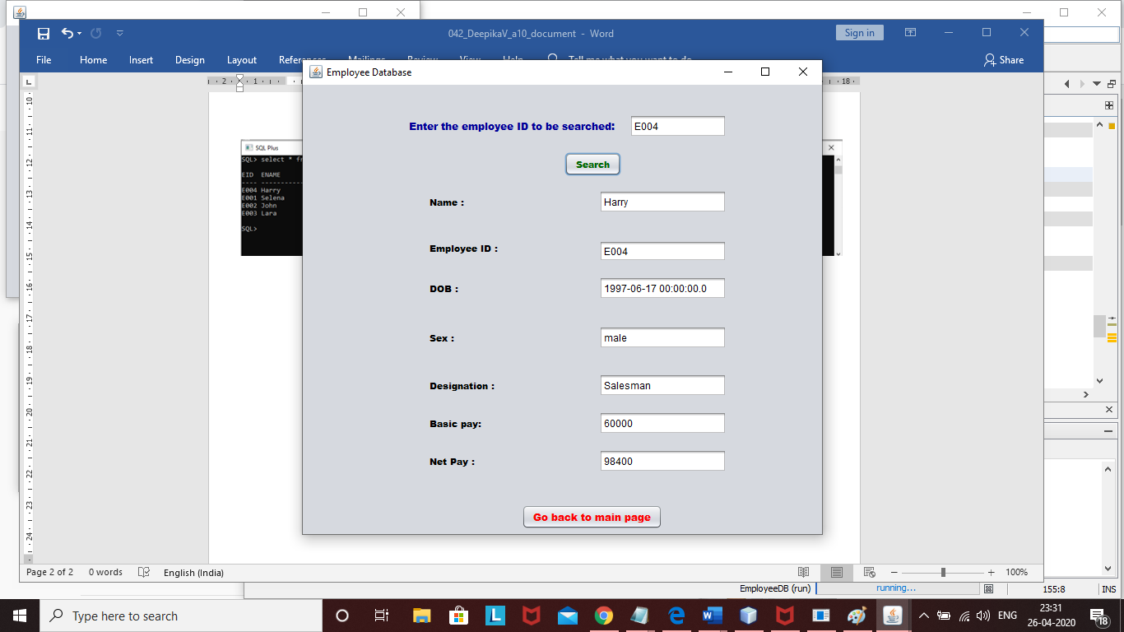

**SEARCH FRAME CODE**

package employeedb;

import java.sql.Connection;

import java.sql.Statement;

import java.sql.PreparedStatement;

import java.sql.CallableStatement;

import java.sql.DriverManager;

import java.sql.ResultSet;

import javax.swing.JOptionPane;

public class SearchFrame extends javax.swing.JFrame {

Connection con;

Statement st;

PreparedStatement ps;

CallableStatement cs;

ResultSet rs1,rs2;

/**

* Creates new form EmployeeFrame

*/

public SearchFrame() {

initComponents();

myInit();

}

public void myInit(){

try {

Class.forName("oracle.jdbc.driver.OracleDriver");

con=DriverManager.getConnection("jdbc:oracle:thin:@localhost:1521:orcl","hr","hr");

st=con.createStatement();

rs1=st.executeQuery("select eid from emp_payroll”);

ps=con.prepareStatement("select * from emp_payroll where eid=?");

}

catch (Exception se) {

se.printStackTrace();

}

}

private void submit1ActionPerformed(java.awt.event.ActionEvent evt) {

try {

String tno=(String)idSearch.getText();

ps.setString(1, tno);

rs2=ps.executeQuery();

if(rs2.next()){

enameField.setText((String)rs2.getString(2));

sexField.setText((String)rs2.getString(4));

designField.setText((String)rs2.getString(5));

idField.setText((String)rs2.getString(1));

dobField.setText((String)rs2.getString(3));

basicField.setText(rs2.getString(6));

jTextField1.setText((String)rs2.getString(13));

}

else{

JOptionPane.showMessageDialog(null,"Employee ID not found!");

}

}

catch(Exception e){

e.printStackTrace();

}

}

private void jButton1ActionPerformed(java.awt.event.ActionEvent evt) {

// TODO add your handling code here:

MainFrame mf=new MainFrame();

mf.setVisible(true);

}

/**

* @param args the command line arguments

*/

public static void main(String args[]) {

/* Set the Nimbus look and feel */

//<editor-fold defaultstate="collapsed" desc=" Look and feel setting code (optional) ">

java.awt.EventQueue.invokeLater(new Runnable() {

public void run() {

new SearchFrame().setVisible(true);

}

});

//</editor-fold>

/* Create and display the form */

}

// Variables declaration - do not modify

private javax.swing.JTextField basicField;

private javax.swing.JTextField designField;

private javax.swing.JTextField dobField;

private javax.swing.JTextField enameField;

private javax.swing.JTextField idField;

private javax.swing.JTextField idSearch;

private javax.swing.JButton jButton1;

private javax.swing.JLabel jLabel1;

private javax.swing.JLabel jLabel10;

private javax.swing.JLabel jLabel2;

private javax.swing.JLabel jLabel3;

private javax.swing.JLabel jLabel4;

private javax.swing.JLabel jLabel5;

private javax.swing.JLabel jLabel6;

private javax.swing.JLabel jLabel7;

private javax.swing.JLabel jLabel8;

private javax.swing.JLabel jLabel9;

private javax.swing.JTextField jTextField1;

private javax.swing.JTextField sexField;

private javax.swing.JButton submit1;

// End of variables declaration

}

**DELETE :**

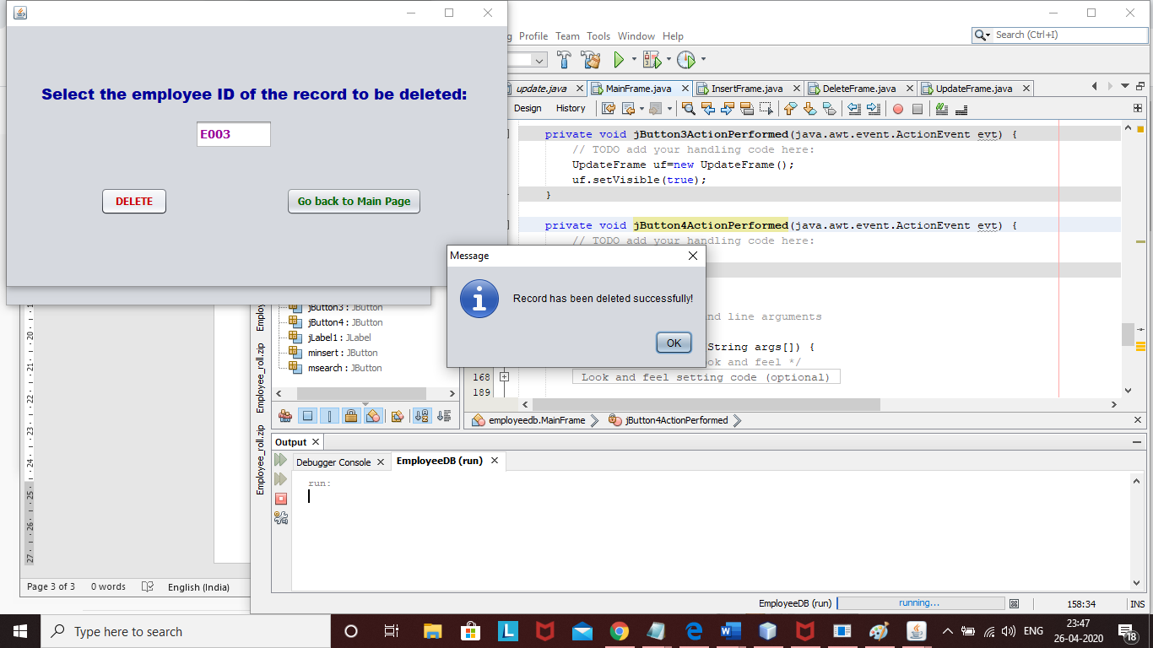

**TABLE AFTER DELETION :**

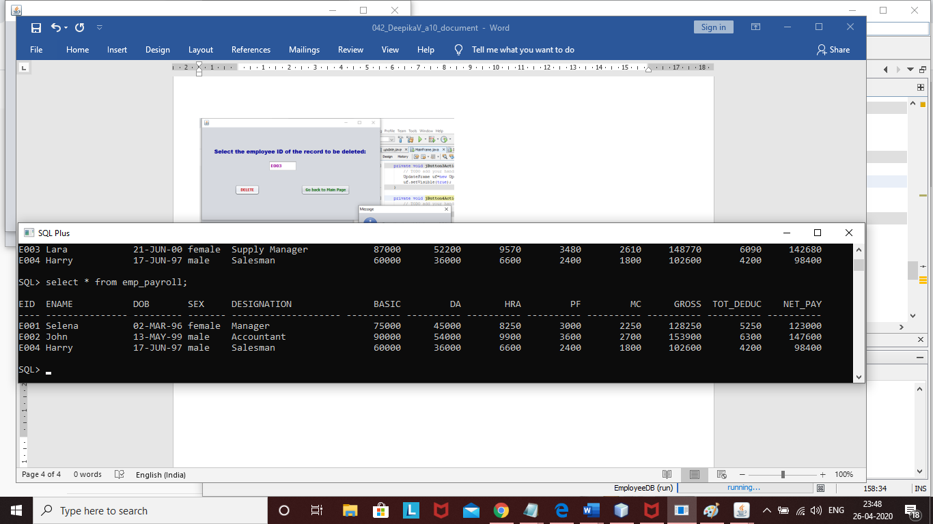

**DELETE FRAME CODE**

package employeedb;

import java.sql.CallableStatement;

import java.sql.Connection;

import java.sql.DriverManager;

import java.sql.PreparedStatement;

import java.sql.ResultSet;

import java.sql.Statement;

import javax.swing.JOptionPane;

public class DeleteFrame extends javax.swing.JFrame {

Connection con;

Statement st;

PreparedStatement ps;

CallableStatement cs;

ResultSet rs1,rs2;

/**

* Creates new form DeleteFrame

*/

public DeleteFrame() {

initComponents();

delete1();

}

public void delete1(){

try {

Class.forName("oracle.jdbc.driver.OracleDriver");

con=DriverManager.getConnection("jdbc:oracle:thin:@localhost:1521:orcl","hr","hr");

st=con.createStatement();

// rs1=st.executeQuery("select eid from emp_payroll");

ps=con.prepareStatement("delete from emp_payroll where eid=?");

}

catch (Exception se) {

se.printStackTrace();

}

}

private void jButton1ActionPerformed(java.awt.event.ActionEvent evt) {

// TODO add your handling code here:

try{

String d1=(String)jTextField1.getText();

ps.setString(1, d1);

rs1=ps.executeQuery();

JOptionPane.showMessageDialog(null,"Record has been deleted successfully!");

}

catch(Exception e2){

e2.printStackTrace();

}

}

private void jButton2ActionPerformed(java.awt.event.ActionEvent evt) {

// TODO add your handling code here:

MainFrame mf=new MainFrame();

mf.setVisible(true);

}

/**

* @param args the command line arguments

*/

public static void main(String args[]) {

/* Create and display the form */

java.awt.EventQueue.invokeLater(new Runnable() {

public void run() {

new DeleteFrame().setVisible(true);

}

});

}

// Variables declaration - do not modify

javax.swing.JButton jButton1;

javax.swing.JButton jButton2;

javax.swing.JLabel jLabel1;

javax.swing.JTextField jTextField1;

// End of variables declaration

}

**UPDATE :**

**Displaying the details of the entered employee ID:**

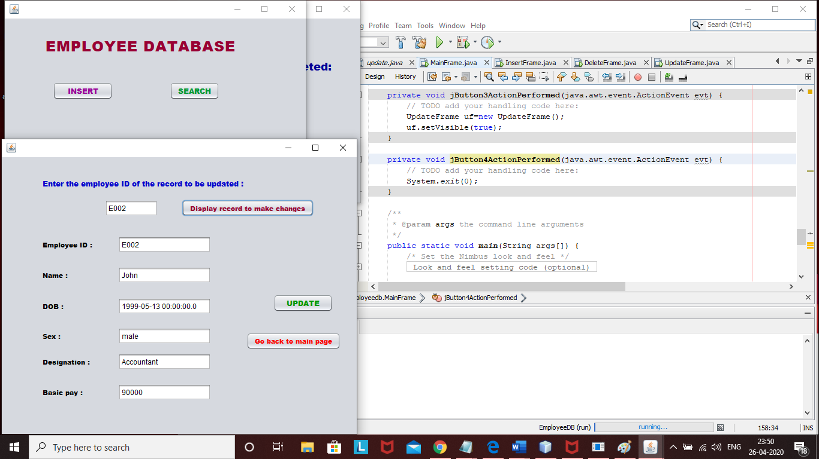

**Updating the necessary values :**

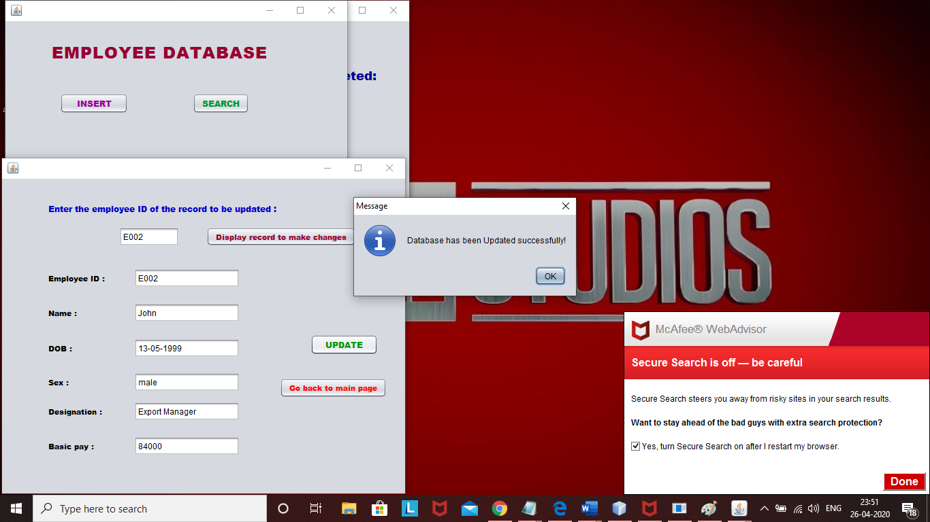

**TABLE AFTER UPDATION:**

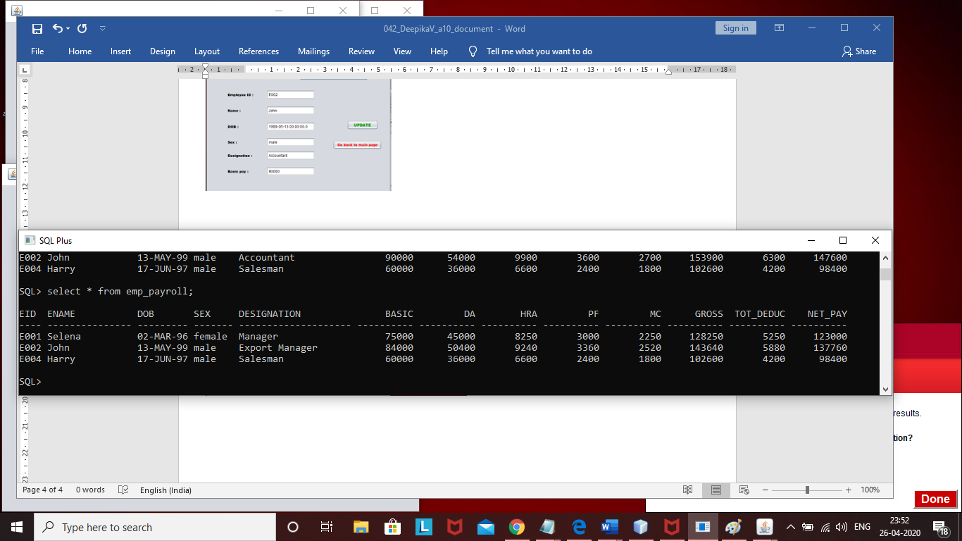

**UPDATE FRAME CODE**

package employeedb;

import java.sql.CallableStatement;

import java.sql.Connection;

import java.sql.DriverManager;

import java.sql.PreparedStatement;

import java.sql.ResultSet;

import java.sql.SQLException;

import java.sql.Statement;

import java.util.logging.Level;

import java.util.logging.Logger;

import javax.swing.JOptionPane;

public class UpdateFrame extends javax.swing.JFrame {

Connection con;

Statement st;

PreparedStatement ps,ps1,ps2,ps3,ps4,ps5,ps6;

CallableStatement cs;

ResultSet rs1,rs2,rs3;

/**

* Creates new form UpdateFrame

*/

public UpdateFrame() {

initComponents();

update1();

}

public void update1(){

try {

Class.forName("oracle.jdbc.driver.OracleDriver");

con=DriverManager.getConnection("jdbc:oracle:thin:@localhost:1521:orcl","hr","hr");

st=con.createStatement();

ps=con.prepareStatement("select * from emp_payroll where eid=?");

}

catch (Exception se) {

se.printStackTrace();

}

}

private void change1ActionPerformed(java.awt.event.ActionEvent evt) {

// TODO add your handling code here:

try {

String tno=(String)updateidField.getText();

// int no=Integer.parseInt(tno);

ps.setString(1, tno);

rs2=ps.executeQuery();

if(rs2.next()){

jTextField2.setText((String)rs2.getString(2));

jTextField4.setText((String)rs2.getString(4));

jTextField5.setText((String)rs2.getString(5));

jTextField1.setText((String)rs2.getString(1));

jTextField3.setText((String)rs2.getString(3));

jTextField6.setText(rs2.getString(6));

}

else{

JOptionPane.showMessageDialog(null,"Employee ID not found!");

}

}

catch(Exception e){

e.printStackTrace();

}

}

private void jButton2ActionPerformed(java.awt.event.ActionEvent evt) {

// TODO add your handling code here:

MainFrame mf=new MainFrame();

mf.setVisible(true);

}

private void jButton1ActionPerformed(java.awt.event.ActionEvent evt) {

// TODO add your handling code here:

try {

if(!jTextField2.getText().isEmpty()){

ps1=con.prepareStatement("update emp_payroll set ename=? where eid=?");

ps1.setString(1,jTextField2.getText());

ps1.setString(2,jTextField1.getText());

rs1=ps1.executeQuery();

}

if(!jTextField3.getText().isEmpty()){

ps2=con.prepareStatement("update emp_payroll set dob=? where eid=?");

ps2.setString(1,jTextField3.getText());

ps2.setString(2,jTextField1.getText());

rs1=ps2.executeQuery();

}

if(!jTextField4.getText().isEmpty()){

ps3=con.prepareStatement("update emp_payroll set sex=? where eid=?");

ps3.setString(1,jTextField4.getText());

ps3.setString(2,jTextField1.getText());

rs1=ps3.executeQuery();

}

if(!jTextField5.getText().isEmpty()){

ps4=con.prepareStatement("update emp_payroll set designation=? where eid=?");

ps4.setString(1,jTextField5.getText());

ps4.setString(2,jTextField1.getText());

rs1=ps4.executeQuery();

}

if(!jTextField6.getText().isEmpty()){

ps5=con.prepareStatement("update emp_payroll set basic=? where eid=?");

ps5.setInt(1,Integer.parseInt(jTextField6.getText()));

ps5.setString(2,jTextField1.getText());

rs1=ps5.executeQuery();

int bp=Integer.parseInt(jTextField6.getText());

ps6=con.prepareStatement("call cal_netpay(?,?)");

ps6.setString(1, jTextField1.getText());

ps6.setInt(2, bp);

rs3=ps6.executeQuery();

}

JOptionPane.showMessageDialog(null, "Database has been Updated successfully!");

} catch (SQLException ex) {

Logger.getLogger(UpdateFrame.class.getName()).log(Level.SEVERE, null, ex);

}

}

/**

* @param args the command line arguments

*/

public static void main(String args[]) {

/* Create and display the form */

java.awt.EventQueue.invokeLater(new Runnable() {

public void run() {

new UpdateFrame().setVisible(true);

}

});

}

// Variables declaration - do not modify

javax.swing.JLabel basicLabel;

javax.swing.JButton change1;

javax.swing.JLabel desLabel;

javax.swing.JLabel dobLabel;

javax.swing.JLabel idLabel;

javax.swing.JButton jButton1;

javax.swing.JButton jButton2;

javax.swing.JLabel jLabel1;

javax.swing.JLabel jLabel4;

javax.swing.JLabel jLabel6;

javax.swing.JTextField jTextField1;

javax.swing.JTextField jTextField2;

javax.swing.JTextField jTextField3;

javax.swing.JTextField jTextField4;

javax.swing.JTextField jTextField5;

javax.swing.JTextField jTextField6;

javax.swing.JLabel nameLabel;

javax.swing.JLabel sexLabel;

javax.swing.JTextField updateidField;

// End of variables declaration

}