**SSN College of Engineering Department of Computer Science and Engineering**

**III year - UCS1512 – Microprocessors Lab**

**8-bit arithmetic operations using 8051**

**Exp No:** 12

**Name:** Rahul Ram M

**Register Number:** 185001121

**Date:** 20/10/2020

**12a) Addition:**

**Aim:**

To design 8051-program for 8-bit addition.

**Algorithm:**

1. Move 00H to R0.
2. Move the value in R1 to register A.
3. Add register A and the value in the R2. The result is stored in register A.
4. Jump to LABEL if there is no carry.
5. Else increment value in R0.
6. LABEL: Move the register A’s value to R4 and move the value in R0 to R3.
7. HERE: Infinite loop to HERE using SJMP HERE.

**Program:**

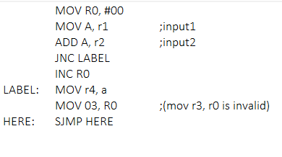

|  |  |  |
| --- | --- | --- |
|  | **Program** | **Comments** |
| START: | MOV R0, #00 | R0 <- 00H |
| MOV A, r1 | A <- R1 |
| ADD A, r2 | A <- A + R2 |
| JNC LABEL | Jump to LABEL, if no carry. |
| INC R0 | R0++ |
| LABEL: | MOV r4, a | R4 <- A |
| MOV 03, R0 | R3 <- R0 |
| HERE: | SJMP HERE | Transfers execution to HERE. |

**Snapshot of sample output:**

**R1 = 6F, R2 = EE.**

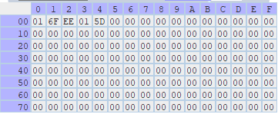

**Result:**

Thus the 8051-program for 8-bit addition is executed successfully.

**12a) Subtraction:**

**Aim:**

To design 8051-program for 8-bit subtraction.

**Algorithm:**

1. Move 00H to R0.
2. Clear the carry flag using CLR C.
3. Move the value in R1 to register A.
4. Sub register A with the value in the R2 using SUBB A, R2. The result is stored in register A.
5. Jump to LABEL if there is no carry.
6. Else increment value in R0 for carry. Take 2’s compliment of register A by using the instructions CPL A and INC A.
7. LABEL: Move the register A’s value to R4 and move the value in R0 to R3.
8. HERE: Infinite loop to HERE using SJMP HERE.

**Program:**

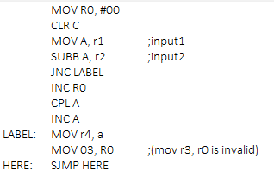

|  |  |  |
| --- | --- | --- |
|  | **Program** | **Comments** |
| START: | MOV R0, #00 | R0 <- 00H |
| CLR C | Clear the carry flag. |
| MOV A, r1 | A <- R1 |
| ADD A, r2 | A <- A + R2 |
| JNC LABEL | Jump to LABEL, if no carry. |
| INC R0 | R0++ |
| CPL A | Complient the value in Register A. |
| INC A | Increment A to get 2’s compliment. |
| LABEL: | MOV r4, a | R4 <- A |
| MOV 03, R0 | R3 <- R0 |
| HERE: | SJMP HERE | Transfers execution to HERE. |

**Snapshot of sample output:**

**R1 = 6F, R2 = EE.**

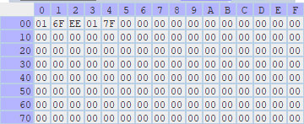

**Result:**

Thus the 8051-program for 8-bit subtraction is executed successfully.

**12a) Multiplication:**

**Aim:**

To design 8051-program for 8-bit multiplication.

**Algorithm:**

1. Move the value in R0 to register A.
2. Move the value in R1 to register B.
3. Multiply A and B using MUL AB (BA <- A x B).
4. Move the register A’s value to R3 and move the Register B's value to R2.
5. HERE: Infinite loop to HERE using SJMP HERE.

**Program:**

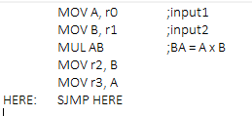

|  |  |  |
| --- | --- | --- |
|  | **Program** | **Comments** |
| START: | MOV A, R0 | A <- R0 |
| MOV B, R1 | B <- R1 |
| MUL AB | BA = A x B |
| MOV R2, B | R2 <- B |
| MOV R3, A | R3 <- A |
| HERE: | SJMP HERE | Transfers execution to HERE. |

**Snapshot of sample output:**

**R0 = 6F, R1 = EE.**

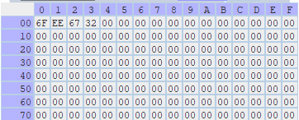

**Result:**

Thus the 8051-program for 8-bit multiplication is executed successfully.

**12a) Division:**

**Aim:**

To design 8051-program for 8-bit division.

**Algorithm:**

1. Move the value in R0 to register A.
2. Move the value in R1 to register B.
3. Divide A by B using DIV AB with Quotient in A and Remainder in B.
4. Move the register A’s value to R3 and move the Register B's value to R2.
5. HERE: Infinite loop to HERE using SJMP HERE.

**Program:**

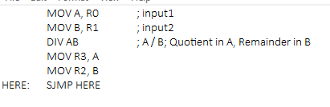

|  |  |  |
| --- | --- | --- |
|  | **Program** | **Comments** |
| START: | MOV A, R0 | A <- R0 |
| MOV B, R1 | B <- R1 |
| DIV AB | A / B; Quotient in A, Remainder in B |
| MOV R3, A | R3 <- A |
| MOV R2, B | R2 <- B |
| HERE: | SJMP HERE | Transfers execution to HERE. |

**Snapshot of sample output:**

**R1 = EE, R2 = 15.**

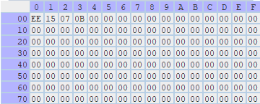

**Result:**

Thus the 8051-program for 8-bit division is executed successfully.