**SSN College of Engineering Department of Computer Science and Engineering**

**III year - UCS1512 – Microprocessors Lab**

**Display a string**

**Exp No:** 10

**Name:** Rahul Ram M

**Register Number:** 185001121

**Date:** 13/10/2020

**Aim:**

To design 8086-program for displaying a string.

**Procedure for executing MASM:**

1. Run Dosbox and mount your masm folder to a drive in dosbox.
2. Goto the mounted drive.
3. Save the 8086 program with extension .asm in the same folder using command “edit”
4. After creating the file, assemble it using the command “masm filename.asm”
5. Link the file using the command “link filename.obj;”
6. Use debug command with filename.exe to execute and analyse the memory contents, “debug filename.exe”.
7. In debug, command “u” will display the unassembled code.
8. Use command “d segment:offset” to see the content of memory locations starting from segment:offset address.
9. To change the value in memory, use the command “e segment:offset”
10. Verify the memory contents to ensure the updates (using command “d”).
11. . Execute using the command “g” and check the outputs.
12. “q” to exit from debug and “exit” to exit from command prompt and to close the Dosbox.

**Algorithm:**

1. START: Move the starting address of data segment to AX register and move the data from AX register to DS register.
2. Move 9H to AH register.
3. Calling int 21H with AH == 9 will display the contents from the offset stored in DX register.
4. Move the hexadecimal value 4C into AH register. INT 21H means invoke the interrupt identified by the hexadecimal number 21. In MS-DOS, invoking interrupt 21h while AH = 4Ch causes the current process to terminate and uses the value of register AL as the exit code of the process.

**Program:**

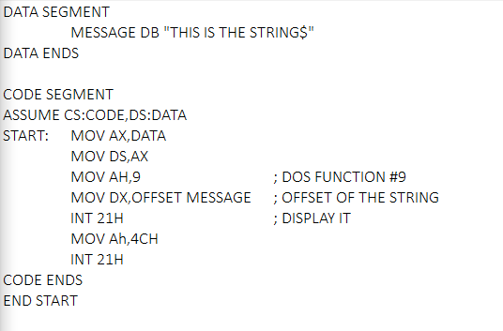

|  |  |  |
| --- | --- | --- |
|  | **Program** | **Comments** |
| START: | MOV AX, DATA  MOV DS, AX | Transferring the data from DATA to AX register and  from AX register to DS register. |
| MOV AH,9 | DOS FUNCTION #9 |
| MOV DX, OFFSET MESSAGE | OFFSET OF THE STRING. |
| MOV AH,4CH | Setup function-4C of the int21. |
| INT 21H | Call BIOS int21 to return to DOS. |

**Unassembled Code:**

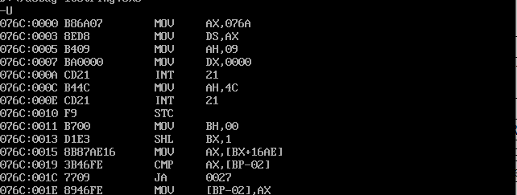

**Snapshot of sample input and output:**



**Result:**

ShapeThus the 8086 program for displaying a string is executed successfully in DOS-BOX