**SSN College of Engineering Department of Computer Science and Engineering**

**III year - UCS1512 – Microprocessors Lab**

**Cube of a number using 8051**

**Exp No:** 13

**Name:** Rahul Ram M

**Register Number:** 185001121

**Date:** 20/10/2020

**Aim:**

To design 8051-program for finding cube of a number (0 – F).

**Algorithm:**

1. Move the value in R0 to register A and B.
2. Multiply A and B using MUL AB with higher order bits in A and lower order bits in A.
3. Since the number is from 0 to F, higher order bits will be 00H.
4. Move the value in R0 to register B.
5. Multiply A and B using MUL AB with higher order bits in A and lower order bits in A.
6. Move the register B’s value to R1 and register A’s value to R2.
7. HERE: Infinite loop to HERE using SJMP HERE.

**Program:**

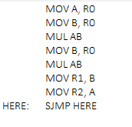

|  |  |  |
| --- | --- | --- |
|  | **Program** | **Comments** |
|  | MOV A, R0 | A <- R0 |
| MOV B, R0 | B <- R0 |
| MUL AB | BA <- A x B |
| MOV B, R0 | B <- R0 |
| MUL AB | BA <- A x B |
| MOV R1, B | R1 <- B |
| MOV R2, A | R2 <- A |
| HERE: | SJMP HERE | Transfers execution to HERE. |

**Snapshot of sample output:**

**R0 – 0FH.**

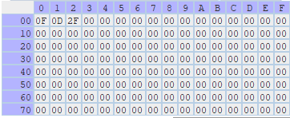

**Result:**

Thus the 8051-program for finding cube of a number (0 – F) is executed successfully.