**SSN College of Engineering Department of Computer Science and Engineering**

**III year - UCS1512 – Microprocessors Lab**

**BCD to ASCII conversion using 8051**

**Exp No:** 14

**Name:** Rahul Ram M

**Register Number:** 185001121

**Date:** 20/10/2020

**Aim:**

To design 8051-program to covert BCD to ASCII.

**Algorithm:**

1. Move the value in R0 to register A.
2. Extract the first digit of the given number by performing AND on A and F0H. Only the first digit will be present in the register A.
3. Swap A interchanges the lower order and higher order nibbles of register A.
4. Now add 30H to A to get the ASCII value and move the value to R1.
5. Now extract the second digit of the given number by performing AND on A and 0FH. Only the second digit will be present in the register A.
6. Now add 30H to A to get the ASCII value and move the value to R2.
7. HERE: Infinite loop to HERE using SJMP HERE.

**Program:**

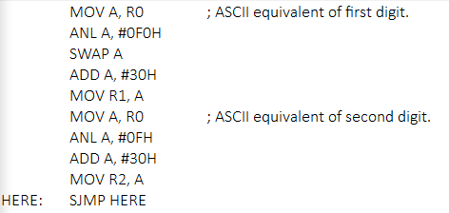

|  |  |  |
| --- | --- | --- |
|  | **Program** | **Comments** |
|  | MOV A, R0 | A <- R0 |
| ANL A, #0F0H | A <- A ^ F0H |
| SWAP A | Swap higher and lower order nibbles of A. |
| ADD A, #30H | A <- A + 30H |
| MOV R1, A | R1 <- A |
| MOV A, R0 | A <- R0 |
| ANL A, #0FH | A <- A ^ 0FH |
| ADD A, #30H | A <- A + 30H |
| MOV R2, A | R2 <- A |
| HERE: | SJMP HERE | Transfers execution to HERE. |

**Snapshot of sample output:**

**R0 – 0FH.**

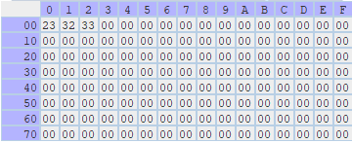

**Result:**

Thus the 8051-program to covert BCD to ASCII is executed successfully.