**SSN College of Engineering**

**Department of Computer Science and Engineering**

**Compiler Lab – UCS 1602**

**EX – 7: Three Address Code Generation**

------------------------------------------------------------------------------------------------

Name: **Rahul Ram M**

Register Number: **185001121**

Semester: VI

Batch: 2018-2022

**AIM:**

To generate Three Address Code.

**PROGRAM CODE:**

**tac.l**

%{

#include<stdio.h>

#include<string.h>

#include "y.tab.h"

%}

term ([a-zA-Z\_][a-zA-Z\_0-9]*|[0-9]+)

relop ("<"|"<="|">"|">="|"=="|"!=")

op ("+"|"-"|"*"|"/"|"%")

%%

"while" { return WHILE; }

"do" { return DO; }

"switch" { return SWITCH; }

"case" { return CASE; }

"default" { return DEFAULT; }

"break" { return BREAK; }

{term} { yylval.str = strdup(yytext); return TERM; }

{relop} { yylval.str = strdup(yytext); return RELOP; }

{op} { yylval.str = strdup(yytext); return OP; }

[ \t\n]+ { }

. { return *yytext; }

%%

int main(int argc,char **argv)

{

FILE *fp;

fp = fopen(argv[1],"r");

if (fp == NULL)

{

printf("FILE NOT FOUND!!\n");

exit(1);

}

fp = fopen(argv[1],"r");

yyin = fp;

yyparse();

return 0;

}

------------------------------------------------------------------------------------------------

**tac.y**

%{

#include<stdio.h>

#include<stdlib.h>

#include<math.h>

int yylex(void);

#include "y.tab.h"

int cc = 1, tc = 1, nc = 1, sc = 0;

%}

%token TERM RELOP OP WHILE DO SWITCH CASE DEFAULT BREAK

%union

{

int intval; float floatval; char *str;

}

%type<str> TERM RELOP OP

%%

line: /* empty */

| TERM '=' TERM OP TERM ';' { printf("t%d := %s %s %s\n%s := t%d\n", tc, $3, $4, $5, $1, tc); tc++; } line

| TERM '=' TERM RELOP TERM ';' { printf("t%d := %s %s %s\n%s := t%d\n", tc, $3, $4, $5,

$1, tc); tc++; } line

| TERM '=' TERM ';' { printf("%s := %s\n", $1, $3); } line

| WHILE TERM RELOP TERM DO '{' { printf("LABEL%d: if not %s %s %s then goto FALSE%d\nTRUE%d: ", cc, $2, $3, $4, cc, cc); } line '}' { printf("FALSE%d: ", cc); cc++; } line

| WHILE TERM OP TERM DO '{' { printf("LABEL%d: if not %s %s %s then goto FALSE%d\nTRUE%d: ", cc, $2, $3, $4, cc, cc); } line '}' { printf("FALSE%d: ", cc); cc++; } line

| WHILE TERM DO '{' { printf("LABEL%d: if not %s then goto FALSE%d\nTRUE%d: ", cc, $2, cc, cc); } line '}' { printf("FALSE%d: ", cc); cc++; } line

| SWITCH '(' TERM RELOP TERM ')' '{' { printf("t%d := %s %s %s\n", tc, $3, $4, $5); sc = tc; tc++; } cases '}' { printf("NEXT%d: ", cc); cc++; } line

| SWITCH '(' TERM OP TERM ')' '{' { printf("t%d := %s %s %s\n", tc, $3, $4, $5); sc = tc; tc++;

} cases '}' { printf("NEXT%d: ", cc); cc++; } line

| SWITCH '(' TERM ')' '{' { printf("t%d := %s\n", tc, $3); sc = tc; tc++; } cases '}' { printf("NEXT%d: ", cc); cc++; } line

| BREAK ';' line { printf("goto NEXT%d\n", cc); } cases: /* empty */

| CASE TERM ':' { printf("CASE%d: if not t%d == %s goto CASE%d\n", nc, sc, $2, nc + 1); nc++; } line cases

| DEFAULT { printf("CASE%d: ", nc); nc++; } ':' line { printf("goto NEXT%d\n", cc); } cases

%%

int yyerror(char* s)

{

fprintf(stderr, "%s\n", s); return 0;

}

int yywrap()

{

return 1;

}

------------------------------------------------------------------------------------------------

**INPUT FILE:**

while i < 10 do { a = 0;

i = i + 1;

}

switch(i + j) {

case 1: x = y + z; break;

case 2: u = v + w; break;

default: p = q + r;

}

a = 5;

------------------------------------------------------------------------------------------------

**OUTPUT:**

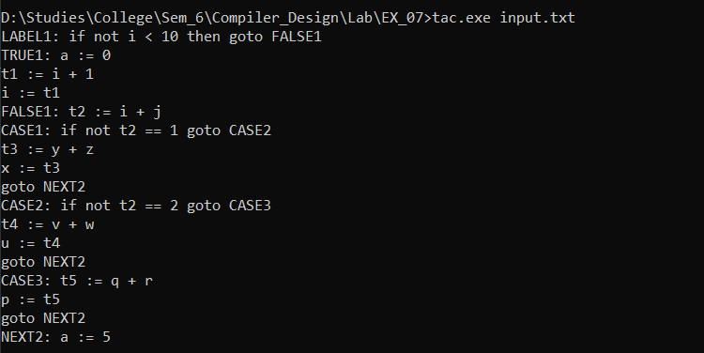

------------------------------------------------------------------------------------------------

**Learning Outcomes:**

* Learnt to generate three address code for a code.
* Learnt to implement the same using lex and yacc tool.

------------------------------------------------------------------------------------------------