SSN College of Engineering, Kalavakkam
Department of Computer Science and Engineering
V Semester - CSE 'B'
UCS1511 NETWORKS LAB

Date :08/10/2020 Name : Rahul Ram M
Exercise : 05 Reg No : 185001121

DOMAIN NAME SERVER USING UDP

Learning Objective:
To simulate the concept of Domain Name Server using UDP.

Algorithm for Server:
- Creating a socket using the function socket(domain, type, protocol) which the returns an integer as the status of the socket creation. Here the domain is AF_INET(iPv4 protocol), type is SOCK_DGRAM for UDP protocol .
- Using bzero(&server_addr, sizeof(server_addr)) function setting values of all the socket structures to null.
- Using bind() to binf the socket to the address and port number specified in addr(custom data structure). Here, we bind the server to the localhost, hence we use INADDR_ANY to specify the IP address.
- Using addEntry() function in “dns.h” adding the Entry to the table.
- Using printTable() printing the table.
- Reading the option for modification of the table from the user.
- IF yes, read the correct values of IP from the user and modify the table.
- If correct value is not given, repeat asking for correct value.
- Define a while loop that runs till ctrl+z is given
- Recieve the request from the user using recvfrom() function.
- Using the getAddress() function in “dns.h” get the correct address for the domain name.
- Copy the result to result.
- Send the result to the client using sendto() function.

Algorithm for Client:
- Creating a socket using the function socket(domain, type, protocol) which the returns an integer as the status of the socket creation. Here the domain is AF_INET(iPv4 protocol), type is SOCK_DGRAM for UDP protocol and value as 0.
- Using bzero(&server_addr, sizeof(server_addr)) function setting values of all the socket structures to null.
- The above two steps are same as the server.
- Setting a while loop which runs till ‘exit’ is given as message.
  - Clearing the buffer using bzero().
  - Reading the domain name from the user using scanf().
  - If the message is ‘exit’, close the descriptor using close() and break the loop.
  - Else send the domain name to the server using sendto() function.
  - Using the recvfrom() function read the IP addresses sent by the server to the client.
  - If the buffer is empty, means domain is not found.
  - Else, Print the IP address of the domain in the correct format.

Program for Server:
#include <stdio.h>
#include <netdb.h>
#include <fcntl.h>
#include <unistd.h>
#include <netinet/in.h>
#include <stdlib.h>
#include <string.h>
#include <sys/socket.h>
#include <sys/types.h>
#include "dns.h"

#define PORT 8080

int main()
{

char result[100], opt[10], domain[20], address[20], buffer[1024];
int sockfd;
socklen_t len;
struct sockaddr_in server_addr, client_addr;
struct Entry* table = NULL;

// SOCK_DGRAM -UDP
if ((sockfd = socket(AF_INET, SOCK_DGRAM, 0)) < 0)
{
perror("Socker error");
exit(1);
}

bzero(&server_addr, sizeof(server_addr));
// assign IP, PORT
server_addr.sin_family = AF_INET;
server_addr.sin_addr.s_addr = htonl(INADDR_ANY);
server_addr.sin_port = htons(PORT);

// Binding newly created socket to given IP and verification
if ((bind(sockfd, (struct sockaddr *)&server_addr, sizeof(server_addr))) < 0)
{
perror("Bind error: ");
exit(1);
}

len = sizeof(client_addr);

addEntry(&table, "www.yahoo.com", "10.2.45.67");
addEntry(&table, "www.annauniv.edu", "197.34.53.122");
addEntry(&table, "www.google.com", "142.89.78.66");

printTable(table);

int flag = 0;
printf("Do you want to modify (yes/no): ");
scanf("%s", opt);
if (strcmp(opt, "yes") == 0)
{
printf("Enter domain: ");
scanf("%s", domain);
do
{
printf("Enter IP address: ");
scanf("%s", address);
flag = addEntry(&table, domain, address);

} while (flag != 1);

printf("\nUpdated table\n");
printTable(table);
}

while (1)
{
bzero(buffer, 1024);
recvfrom(sockfd, buffer, sizeof(buffer), MSG_WAITALL, (struct sockaddr*)&client_addr, &len);
printf("Checking and sending IP address for %s\n", buffer);
strcpy(result,getAddress(table, buffer));
sendto(sockfd, &result, sizeof(result), MSG_CONFIRM, (struct sockaddr*)&client_addr, len);
}

close(sockfd);
}
Program for Client:
#include <stdio.h>
#include <string.h>
#include <unistd.h>
#include <sys/types.h>
#include <sys/socket.h>
#include <netinet/in.h>
#include <arpa/inet.h>

#define PORT 8080

int main()
{
int client_fd, count;
struct sockaddr_in server_addr;
socklen_t len;
char buffer[1024], domain[30], address[10][20], temp[20];

if((client_fd = socket(AF_INET, SOCK_DGRAM, 0)) < 0)
{
perror("Socket error");
}

bzero(&server_addr,sizeof(server_addr));

server_addr.sin_family = AF_INET;
server_addr.sin_addr.s_addr = inet_addr("127.0.0.1");
server_addr.sin_port = htons(PORT);

while(1)
{
bzero(buffer, 1024);
printf("Enter the server name : ");
scanf("%s", domain);

if(strcmp(domain, "exit") == 0){
close(client_fd);
printf("Disconnected from server...\n");
break;
}
else
{
sendto(client_fd, domain, sizeof(domain), MSG_CONFIRM, (struct sockaddr *)&server_addr, sizeof(server_addr));
}

recvfrom(client_fd, &buffer, sizeof(buffer), MSG_WAITALL, (struct sockaddr*)&server_addr, &len);

if(strcmp(buffer, "") == 0)
{
printf("Domain not found!\n");
}
else
{
count = 0;
strcpy(temp, "");
for(int i = 0; i < strlen(buffer); i++)
{
if(buffer[i] == ' ')
{
strcpy(address[count++], temp);
strcpy(temp, "");
}
else
{
strncat(temp, &buffer[i], 1);
}
}
strcpy(address[count++], temp);
printf("The IP address is : ");
for(int i = 0; i < count; i++)
{
printf("%s\n", address[i]);
if((count - i) != 1)
{
printf("\t\t ");
}
}
printf("\n");
}
}

return 0;
}
dns.h:
“performs all the functions related to dns”
struct Entry
{
char domain[20];
char address[10][16];
int count;
struct Entry* next;
};

int searchDomain(struct Entry* head, char *domain)
{
struct Entry *temp = head;
if (head == NULL)
{
return 0;
}
while (temp != NULL)
{
if(strcmp(temp->domain, domain) == 0)
{
return 1;
}
temp = temp->next;
}
return 0;
}

int searchAddress(struct Entry* head, char *address)
{
struct Entry *temp = head;
if (head == NULL)
{
return 0;
}
while (temp != NULL)
{
for(int i = 0; i < temp->count; i++)
{
if(strcmp(temp->address[i], address) == 0)
{
return 1;
}
}
temp = temp->next;
}
return 0;
}

int checkIP(char *address)
{
int count = 0;
int num[5];
for(int i = 0; i < strlen(address); i++)
{
if(address[i] == '.')
{
count++;
}
}

if(count != 3)
{
return 1;
}
count = 0;
char value[10];
strcpy(value, "");

for(int i = 0; i < strlen(address); i++)
{
if(address[i] == '.')
{
num[count++] = atoi(value);
strcpy(value, "");
}
else
{
strncat(value, &address[i], 1);
}
}

num[count++] = atoi(value);

for(int i = 0; i < count; i++)
{
if(num[i] < 0 || num[i] > 255)
{
return 1;
}
}
return 0;
}

void modifyEntry(struct Entry** head, char *domain, char* address)
{
struct Entry* current = *head; // Initialize current
if(searchAddress(*head, address) == 1)
{
printf("Address already present!\n");
return;
}
while (current != NULL)
{
if (strcmp(current->domain, domain) == 0)
{
strcpy(current->address[current->count++], address);
return;
}
current = current->next;
}
}

int addEntry(struct Entry** head, char *domain, char *address)
{

if(checkIP(address) == 1)
{
printf("Invalid IP address!\n");
return 0;
}
if(searchAddress(*head, address) == 1)
{
printf("Address already present!\n");
return 0;
}
if(searchDomain(*head, domain) == 1)
{
modifyEntry(head, domain, address);
return 1;
}

struct Entry* new_Entry = (struct Entry*) malloc(sizeof(struct Entry));
struct Entry *last = *head;

strcpy(new_Entry->domain, domain);
new_Entry->count = 0;
strcpy(new_Entry->address[new_Entry->count++], address);

new_Entry->next = NULL;

if (*head == NULL)
{
*head = new_Entry;
return 1;
}

while (last->next != NULL)
last = last->next;

last->next = new_Entry;
return 1;
}

char* getAddress(struct Entry* head, char *domain)
{
static char address[100];
strcpy(address, "");;

if (head == NULL)
{
printf("List is empty.\n");
return NULL;
}
struct Entry *temp = head;
while (temp != NULL)
{
if(strcmp(temp->domain, domain) == 0)
{
for(int i = 0; i < temp->count; i++)
{
strcat(address, temp->address[i]);

if((temp->count - i) != 1)
{
strcat(address, " ");
}
}
break;
}
temp = temp->next;
}
return address;
}

void printTable(struct Entry *head) {
struct Entry *temp;
if (head == NULL) {
printf("List is empty.\n");
return;
}
//printf("Server domain\t\tIP address\n");
printf("+-------------------+----------------------+\n");
printf("| Server Domain | IP Address |\n");
printf("+-------------------+----------------------+\n");
temp = head;
while (temp != NULL) {
printf("| %-17s ", temp->domain);
for(int i = 0; i < temp->count; i++)
{
printf("| %-20s |\n", temp->address[i]);
if((temp->count - i) != 1)
{
printf("|\t\t ");
}
}
printf("+-------------------+----------------------+\n");
temp = temp->next;
}
printf("\n");
}
Screenshot for Server:
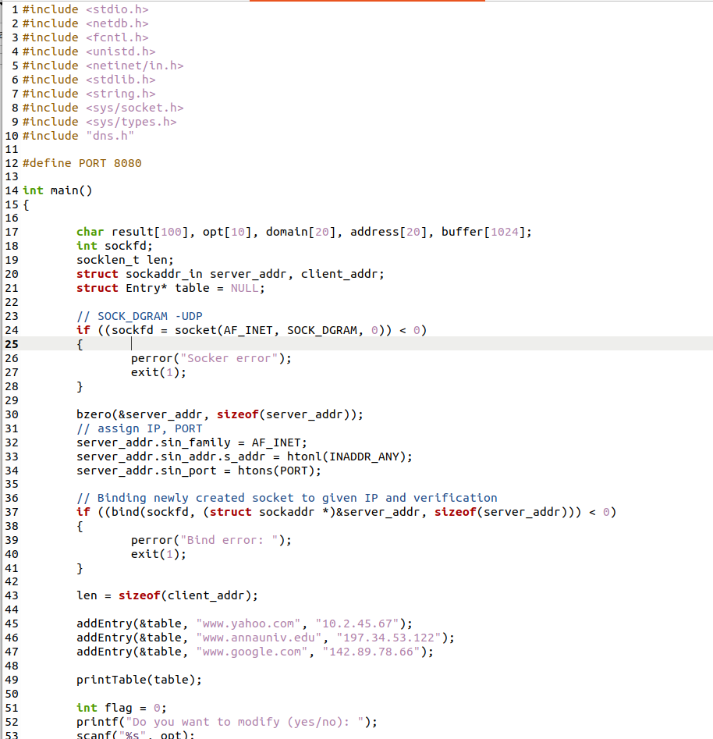
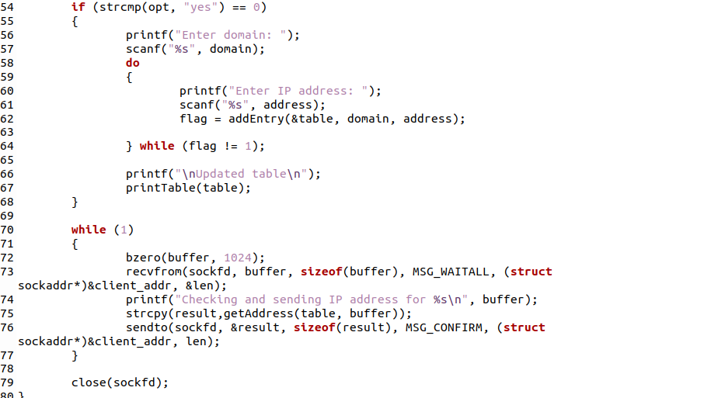

Screenshot for Client:

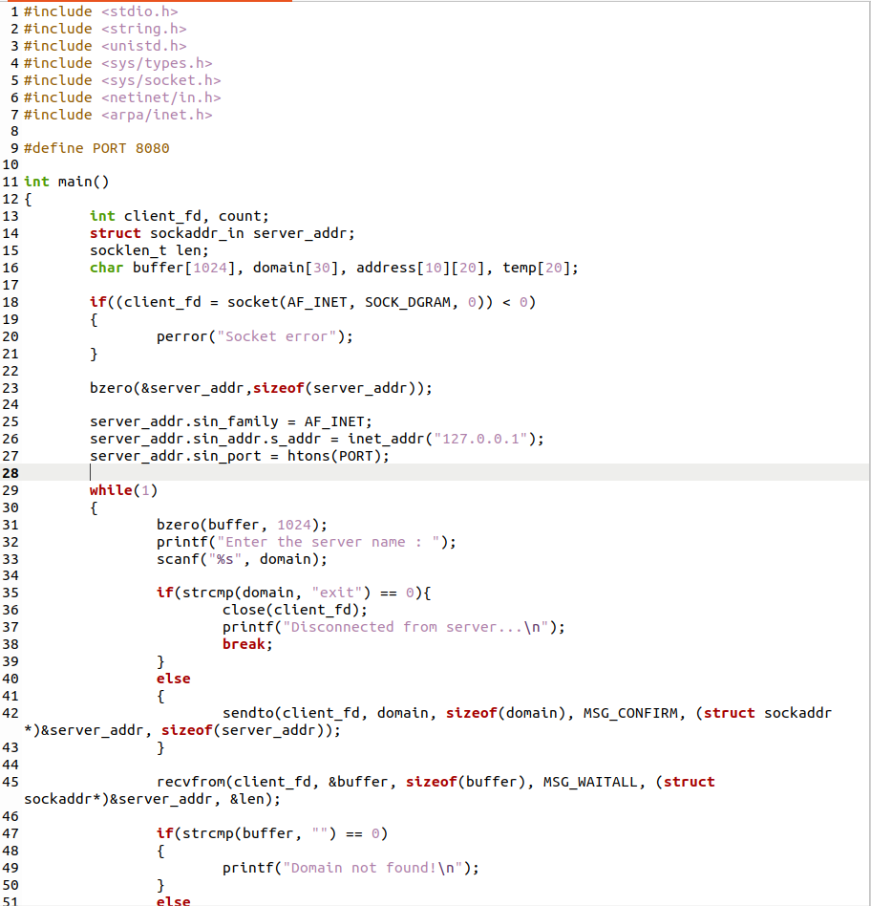
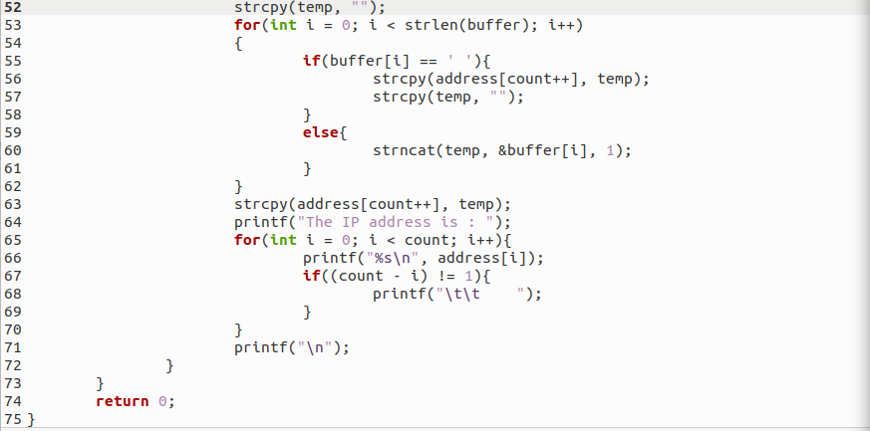

Server Output:
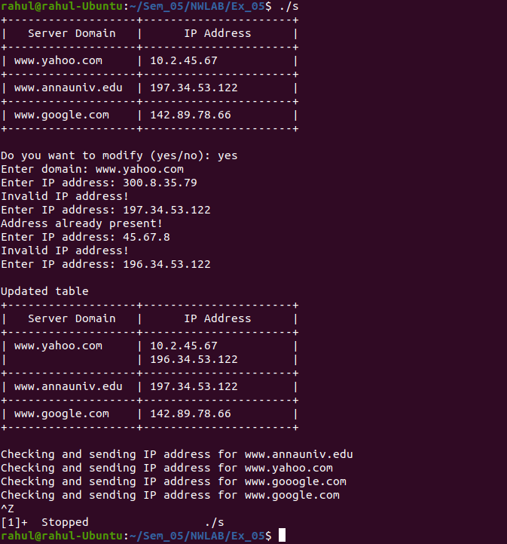

Client1 Output:
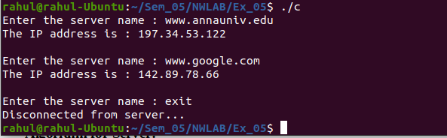

Client2 Output:

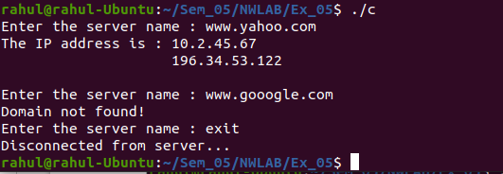

Learning Outcomes:
This assignment helped me to
- Write program for server and client with socket programming using UDP protocol.
- Understand various functions invloved in creating, estabilishing, maintaining, Sending, recieving and termininating the connection between the server and client.
- Write code to make server and client communicate with each other using readfrom() and sendto() functions.

