SSN College of Engineering, Kalavakkam
Department of Computer Science and Engineering
V Semester - CSE 'B'
UCS1511 NETWORKS LAB

Date :08/10/2020 Name : Rahul Ram M
Exercise : 06 Reg No : 185001121

ADDRESS RESOLUTION PROTOCOL

Learning Objective:
To simulate ARP using socket programming.

Algorithm for Server:
- Reading the value of source IP, destination IP, Source MAC and data from the user.
- Concatenating all these to form an ARP request packet.
- Creating a socket using the function socket(domain, type, protocol) which the returns an integer as the status of the socket creation. Here the domain is AF_INET(iPv4 protocol), type is SOCK_STEAM and protocol as 0.
- Using bzero(&server_addr, sizeof(server_addr)) function setting values of all the socket structures to null.
- Using bind() to binf the socket to the address and port number specified in addr(custom data structure). Here, we bind the server to the localhost, hence we use INADDR_ANY to specify the IP address.
- listen() function is used to set the server socket in the passive mode, where it waits for the client to approach the server to make a connection, with maximum number of connection in this case is 5.
- Intitialize all the values of the client_socket array to 0(means we don’t have to listen to them).
- Setting a while loop which runs till we terminate using ctrl+z.
- Clear the list of socket descriptors to monitor using FD_ZERO(&read_fds).
- Add the descriptor of the server to the list using FD_SET(sockfd, &read_fds).
- Assign max_sd as server_socket.
- Using for loop over client_socket array to select valid descriptors , add them to the list of descriptors to monitor and assign the higher number to max_fd.
- Using select() wait for the activity on one of the sockets in the read_fds indefinetely(timeout is NULL).
- Using FD_ISSET(server_socket, &read_fds) tests for an incoming connection.
  - If it detects any incoming connection, accept the connection using accept() which creates a socket and assign the new socket any free space in client_socket array.
  - It also sends the ARP packet request to the client using send().
- Now loop over all the valid fds in the client_socket array
  - Using FD_ISSET(sd, &read_fds) tests for any message from the descriptor.
  - If the received buffer is empty means the connection is terminated by client with server. We then close the descriptor for that client and make the cleint_sockets[i] to be zero for reuse.
  - Else the buffer contains the ARP packet sent by the client to the server.
  - Extract the MAC address of the client and print it.
  - Now add the Dara to the ARP packet using strcat and send to the client using send().

Algorithm for Client(same for all the clients):
- Reading the IP address and MAC of the client from the user.
- Creating a socket using the function socket(domain, type, protocol) which the returns an integer as the status of the socket creation. Here the domain is AF_INET(iPv4 protocol), type is SOCK_STEAM and protocol as 0.
- Using bzero(&server_addr, sizeof(server_addr)) function setting values of all the socket structures to null.
- The above two steps are same as the server.
- The connect() system call connects the socket referred to by the file descriptor socket_fd to the address specified by server_addr. Server’s address and port is specified in server_addr.
- Recieve the ARP request packet from the server using recv().
- Extract the source MAC, source IP address, destination IP address from the ARP request packet sent by the server using for loop.
- Check if the destination IP sent by the server match with IP of this client.
- If not, print the message and exit.
- Else, concatenate the MAC address of this client to the ARP packet and send it to the client using send().
- Recieve the packet from the server that contains the data from the server.

Program for Server:
#include <stdio.h>
#include <stdlib.h>
#include <string.h>
#include <unistd.h>
#include <netinet/in.h>
#include <sys/socket.h>

#define PORT 8080

int main()
{
struct sockaddr_in server_addr, client_addr;
char buffer[1024];
char SRC_IP[100], DEST_IP[100], SRC_MAC[100], DEST_MAC[100], DATA[100], PKT[600];
int client_sockets[10], max_sd, fd, sockfd, newfd, ping;
int k, i, count;
socklen_t len;
fd_set newfds;

printf("\nEnter the details of packet received.\n");
printf("Destination IP\t: ");
scanf("%s", DEST_IP);
printf("Source IP\t: ");
scanf("%s", SRC_IP);
printf("Source MAC\t: ");
scanf("%s", SRC_MAC);
printf("16 bit data\t: ");
scanf("%s", DATA);

printf("\nDeveloping ARP Request packet\n");
strcpy(PKT, "");
strcat(PKT, SRC_MAC);
strcat(PKT, "|");
strcat(PKT, SRC_IP);
strcat(PKT, "|");
strcat(PKT, "00-00-00-00-00-00");
strcat(PKT, "|");
strcat(PKT, DEST_IP);

printf("\t%s\n", PKT);
printf("\tThe ARP Request packet is broacasted.\n");
printf("Waiting for ARP Reply...\n");

sockfd = socket(AF_INET, SOCK_STREAM, 0);

if(sockfd < 0)
{
perror("Unable to open socket.\n");
}

bzero(&server_addr, sizeof(server_addr));

server_addr.sin_family = AF_INET;
server_addr.sin_addr.s_addr = INADDR_ANY;
server_addr.sin_port = htons(PORT);

if(bind(sockfd, (struct sockaddr*)&server_addr, sizeof(server_addr)) < 0)
{
perror("Bind error occurred.\n");
}

listen(sockfd, 5);

for(i = 0; i < 10; i++)
{
client_sockets[i] = 0;
}

len = sizeof(client_addr);

while(1)
{
FD_ZERO(&newfds); //Clears socket set.
FD_SET(sockfd, &newfds); //Add sockfd to socket set.

max_sd = sockfd;

for(i = 0; i < 10; i++){
fd = client_sockets[i];

if(fd > 0){
FD_SET(fd, &newfds);
}

if(fd > max_sd){ //Store the max valued FD.
max_sd = fd;
}
}

//Wait indefinitely till any client pings.
ping = select(max_sd+1, &newfds, NULL, NULL, NULL);

if(ping < 0){
perror("Select error occurred.\n");
}

//if sockfd change => new connection request.
if(FD_ISSET(sockfd, &newfds)){
newfd = accept(sockfd, (struct sockaddr*)&client_addr, &len);

if(newfd < 0){
perror("Unable to accept the new connection.\n");
}

strcpy(buffer, PKT);
send(newfd, buffer, sizeof(buffer), 0);

//Add the new client on an empty slot.
for(i = 0; i < 10; i++){
if(client_sockets[i] == 0){
client_sockets[i] = newfd;
break;
}
}
}

// checking for any response from any connected clients.
for(i = 0; i < 10; i++)
{
fd = client_sockets[i];
bzero(buffer, sizeof(buffer));

//Check for change in FD
if(FD_ISSET(fd, &newfds))
{
recv(fd, buffer, sizeof(buffer), 0);

//Check ARP response
if(buffer[0])
{
printf("\nARP Reply received: %s\n", buffer);
count = 0;
k = 0;
for(i = 0; buffer[i]; i++)
{
if(count == 0)
{
DEST_MAC[k++] = buffer[i];
}
if(buffer[i] == '|')
{
break;
}
}
DEST_MAC[k] = '\0';

printf("\nSending the packet to: %s\n", DEST_MAC);
bzero(buffer, sizeof(buffer));

strcat(buffer, SRC_MAC);
strcat(buffer, "|");
strcat(buffer, SRC_IP);
strcat(buffer, "|");
strcat(buffer, DEST_IP);
strcat(buffer, "|");
strcat(buffer, DEST_MAC);
strcat(buffer, "|");
strcat(buffer, DATA);

send(newfd, buffer, sizeof(buffer), 0);
printf("\nPacket Sent: %s\n", buffer);
}
else
{
close(fd);
client_sockets[i] = 0;
}
}
}
}

return 0;
}
Program for Client(same for all the clients):
#include <stdio.h>
#include <stdlib.h>
#include <string.h>
#include <unistd.h>
#include <netinet/in.h>
#include <sys/socket.h>
#include <arpa/inet.h>

#define PORT 8080

int main()
{
struct sockaddr_in server_addr;
char buffer[1024], dest[100], SRC_IP[100], DEST_IP[100], SRC_MAC[100], DEST_MAC[100];
int sockfd;
int i, count, k;

printf("\nEnter the IP Address\t: ");
scanf("%s", dest);
printf("\nEnter the MAC Address\t: ");
scanf("%s", DEST_MAC);

sockfd = socket(AF_INET, SOCK_STREAM, 0);

if(sockfd < 0)
{
perror("Unable to open socket.\n");
}

bzero(&server_addr, sizeof(server_addr));

server_addr.sin_family = AF_INET;
server_addr.sin_addr.s_addr = inet_addr("127.0.0.1");
server_addr.sin_port = htons(PORT);

connect(sockfd, (struct sockaddr*)&server_addr, sizeof(server_addr));

bzero(buffer, sizeof(buffer));
recv(sockfd, buffer, sizeof(buffer), 0);
printf("\nARP Request Received: %s\n", buffer);

count = 0;
k = 0;
for(i = 0; buffer[i]; i++)
{
if(buffer[i] == '|')
{
if(count == 0)
{
SRC_MAC[k] = '\0';
}
else if(count == 1)
{
SRC_IP[k] = '\0';
}
else if(count == 3)
{
DEST_IP[k] = '\0';
}
count++;
k = 0;
}
else if(count == 0)
{
SRC_MAC[k++] = buffer[i];
}
else if(count == 1)
{
SRC_IP[k++] = buffer[i];
}
else if(count == 3)
{
DEST_IP[k++] = buffer[i];
}

}

if(strcmp(dest, DEST_IP) == 0)
{
bzero(buffer, sizeof(buffer));
printf("\nIP Address matches.\n");

strcat(buffer, DEST_MAC);
strcat(buffer, "|");
strcat(buffer, DEST_IP);
strcat(buffer, "|");
strcat(buffer, SRC_IP);
strcat(buffer, "|");
strcat(buffer, SRC_MAC);
send(sockfd, buffer, sizeof(buffer), 0);
printf("\nARP Reply Sent: %s\n", buffer);

bzero(buffer, sizeof(buffer));
recv(sockfd, buffer, sizeof(buffer), 0);
printf("\nReceived Packet is: %s\n", buffer);
}

else{
printf("\nIP Address does not match.\n");
}

close(sockfd);

return 0;
}

Screenshot for Server:

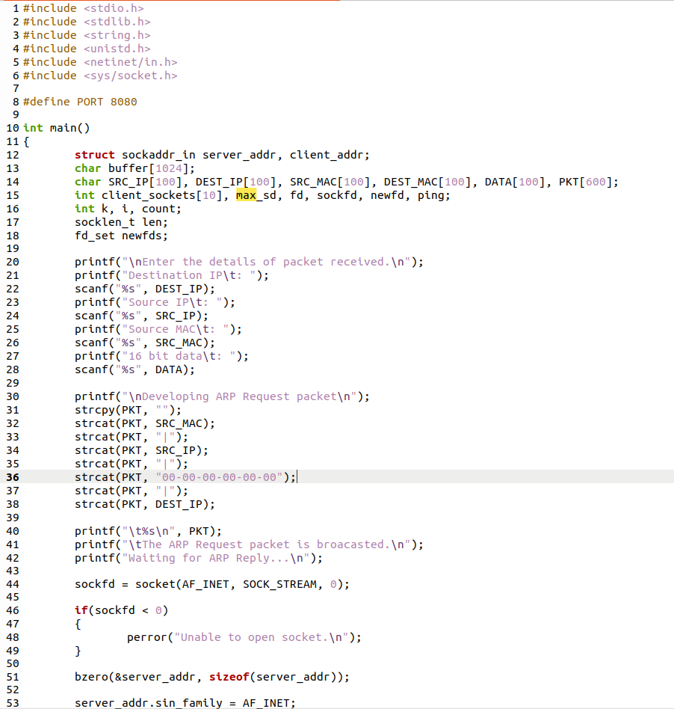

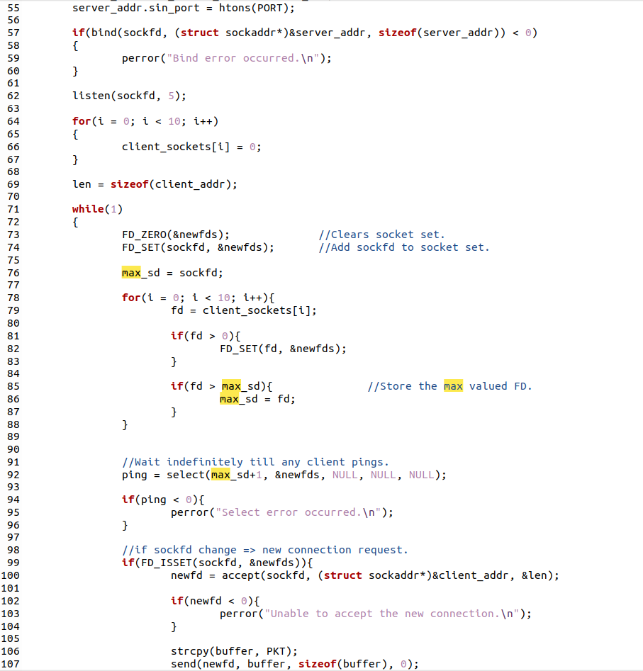

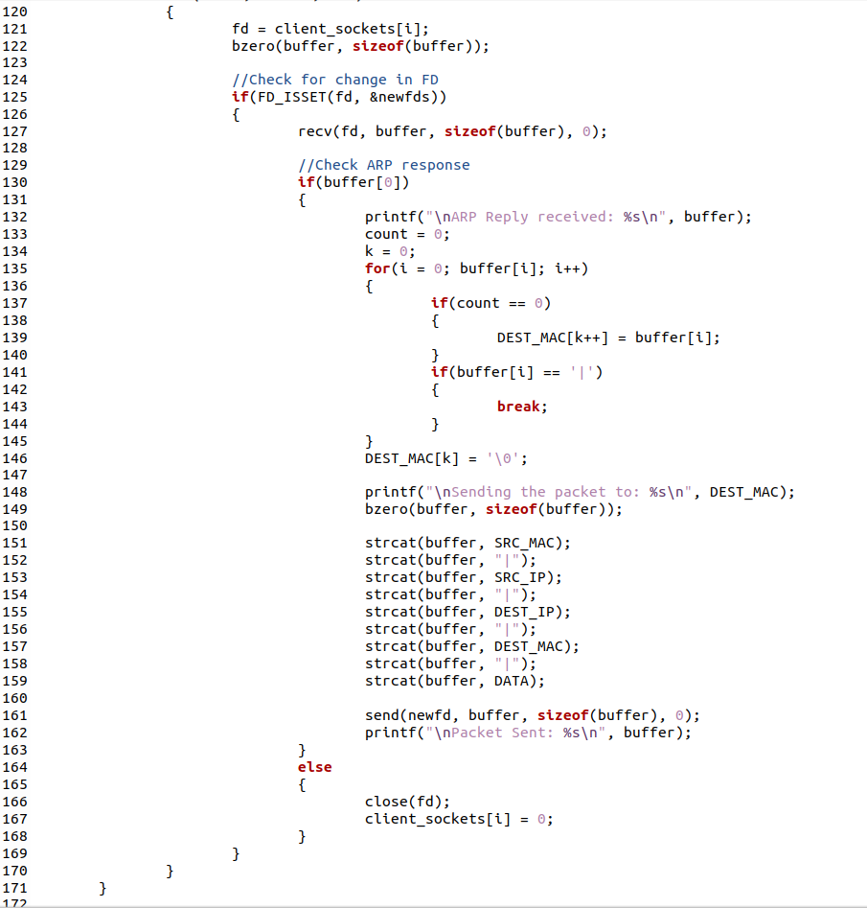

Screenshot for Client:

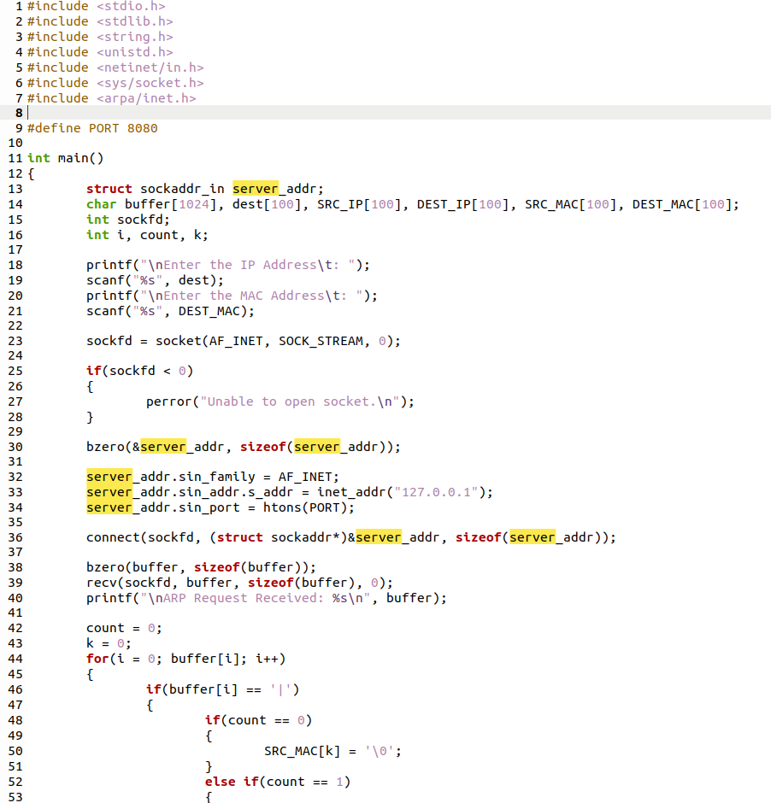

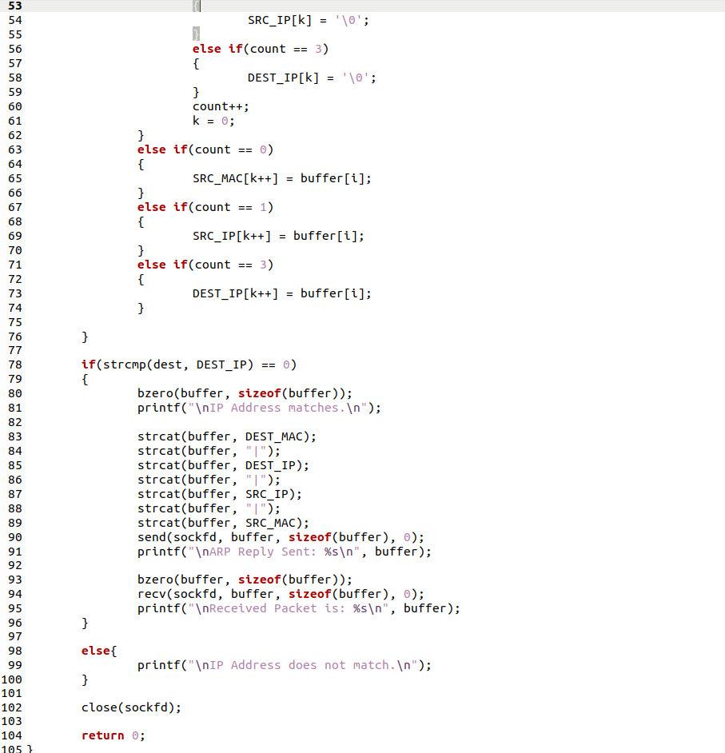

Server Output:

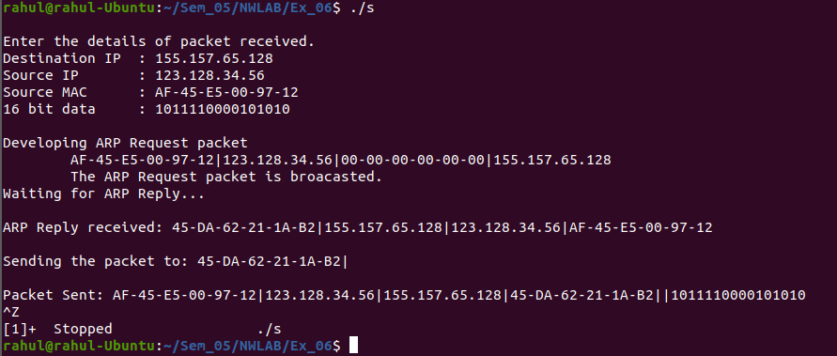

Client1 Output:
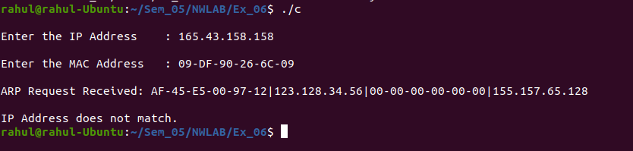

Client2 Output:
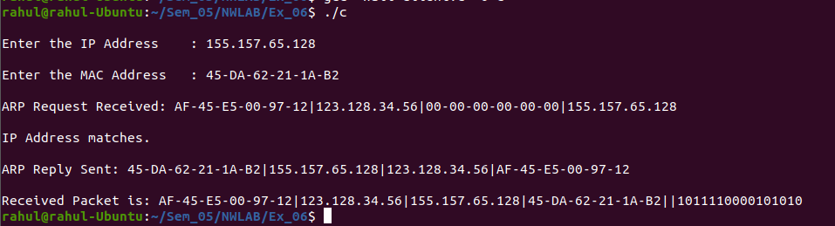
Client3 Output:

Learning Outcomes:
This assignment helped me to
- Write program for server and client with socket programming.
- Understand various functions invloved in creating, estabilishing, maintaining, Sending, recieving and termininating the connection between the server and client.
- Connect multiple clients to the server using select() system call.
- Understand various functions of ARP protocol.
- Simulate the functions of ARP using socket programming.

