SSN College of Engineering, Kalavakkam
Department of Computer Science and Engineering
V Semester - CSE 'B'
UCS1511 NETWORKS LAB

Date : 26/08/2020 Name : Rahul Ram M
Exercise : 1 Reg No : 185001121
Network Commands

Command : tcpdump

Syntax : tcpdump [option] [interface]

Description : tcpdump is a command line utiltiy that allows the user to capture and analyze network traffic going through the system.

Screenshots :
-D --list-interfaces Print the list of the network interfaces available on the system and on which tcpdump can capture packets.

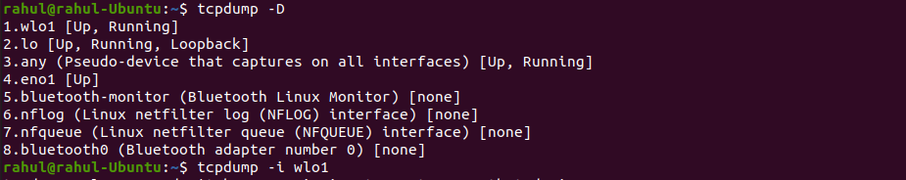
-i interface Listen on interface.
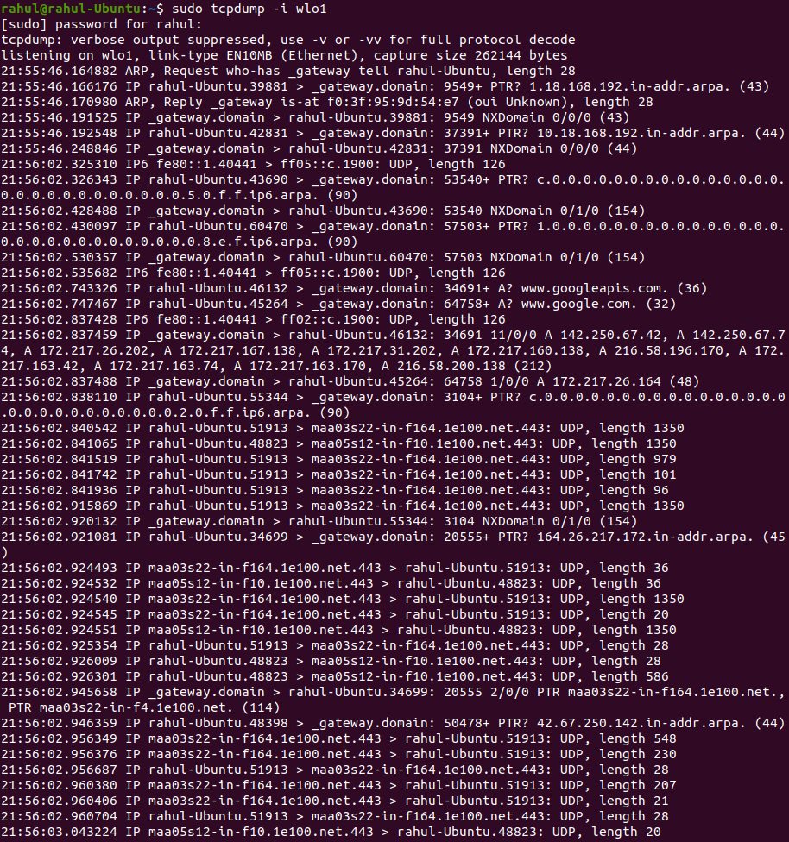
-c count Exit after receiving count packets.
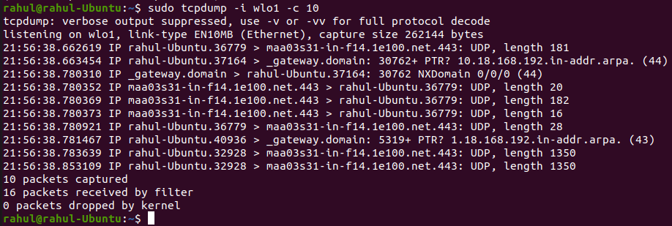

Command : netstat

Syntax : netstat [option]

Description :
Netstat prints information about the Linux networking subsystem.

Screenshots :
(none)By default, netstat displays a list of open sockets. If you don't specify any address families, then the active sockets of all configured address families will be printed.
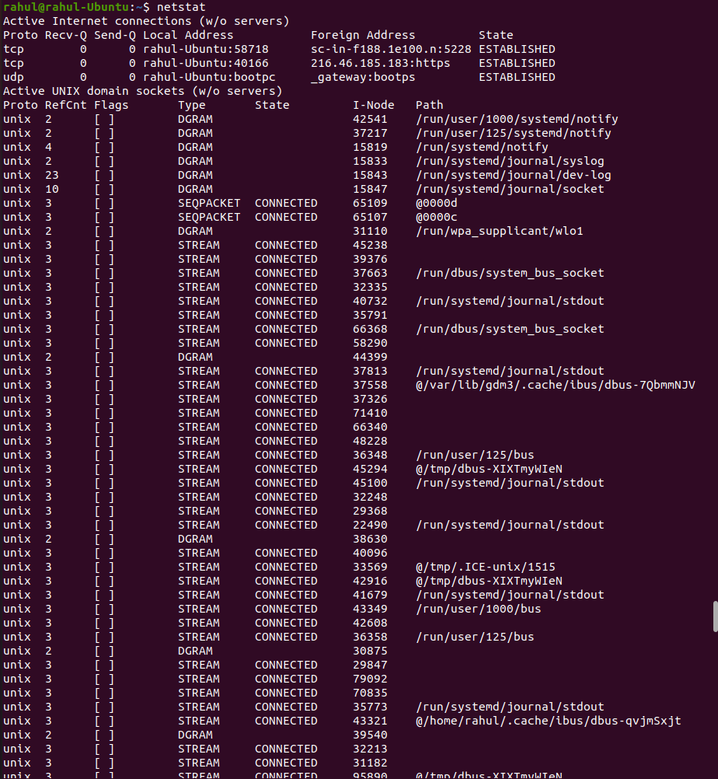
-a, --all Show both listening and non-listening sockets. With the --interfaces option, show interfaces that are not up
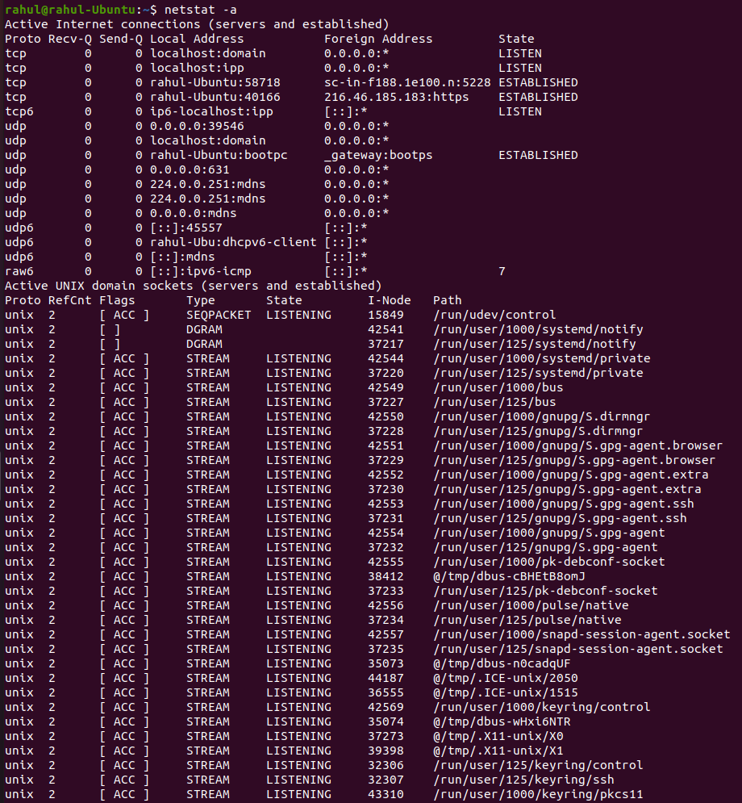

--statistics, -s Display summary statistics for each protocol.
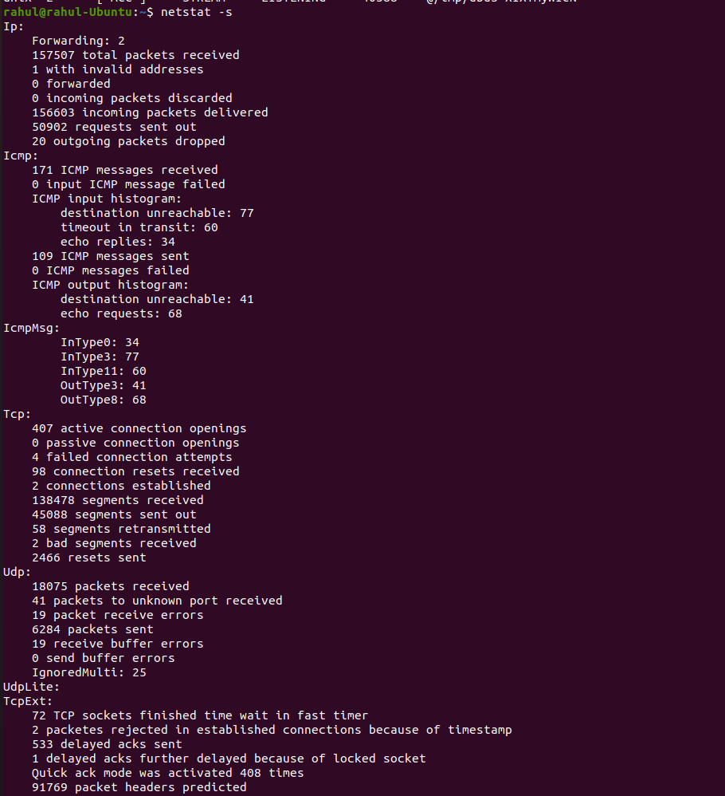
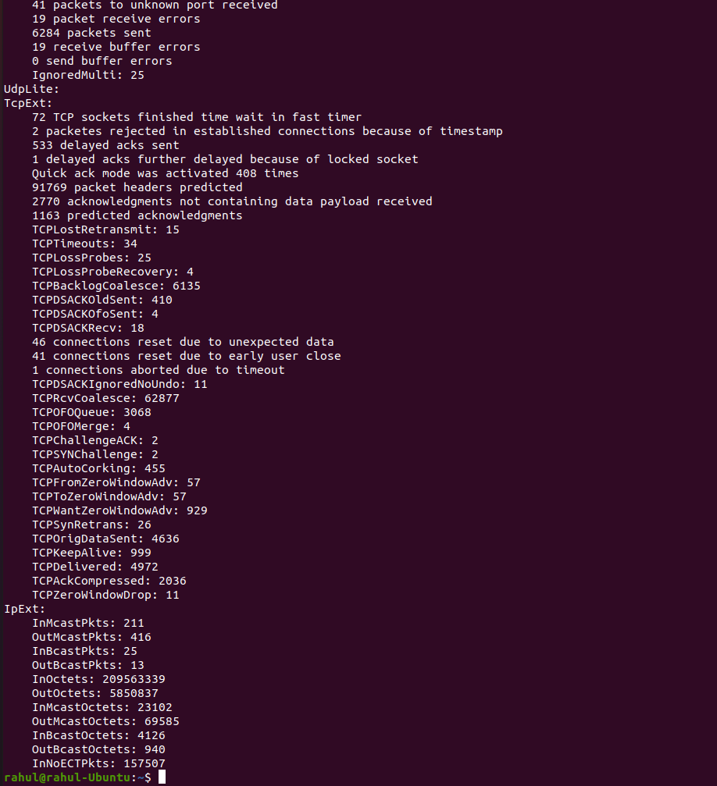

-at Display statistics for all the tcp ports.
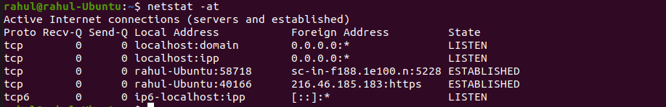
-au Displays statistics for all the udp ports.
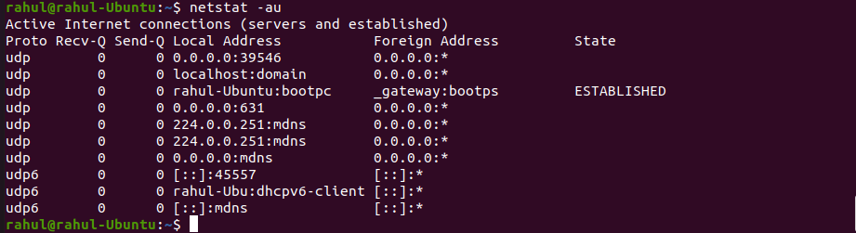
-l Displays statistics for all the listening ports.
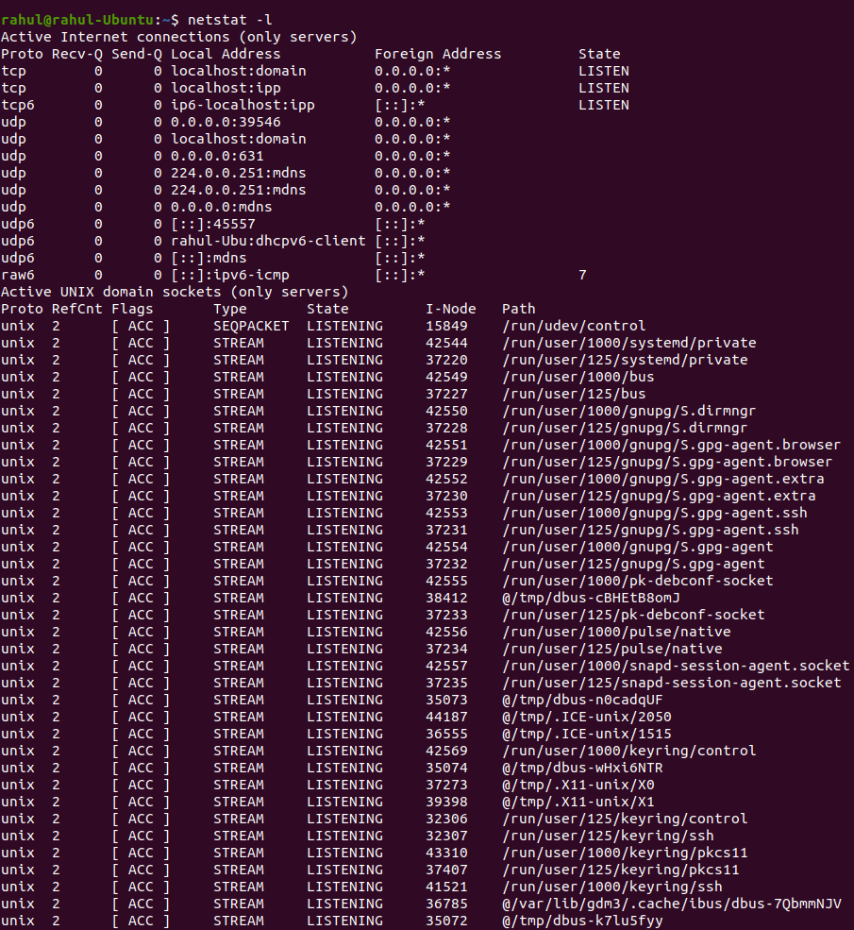
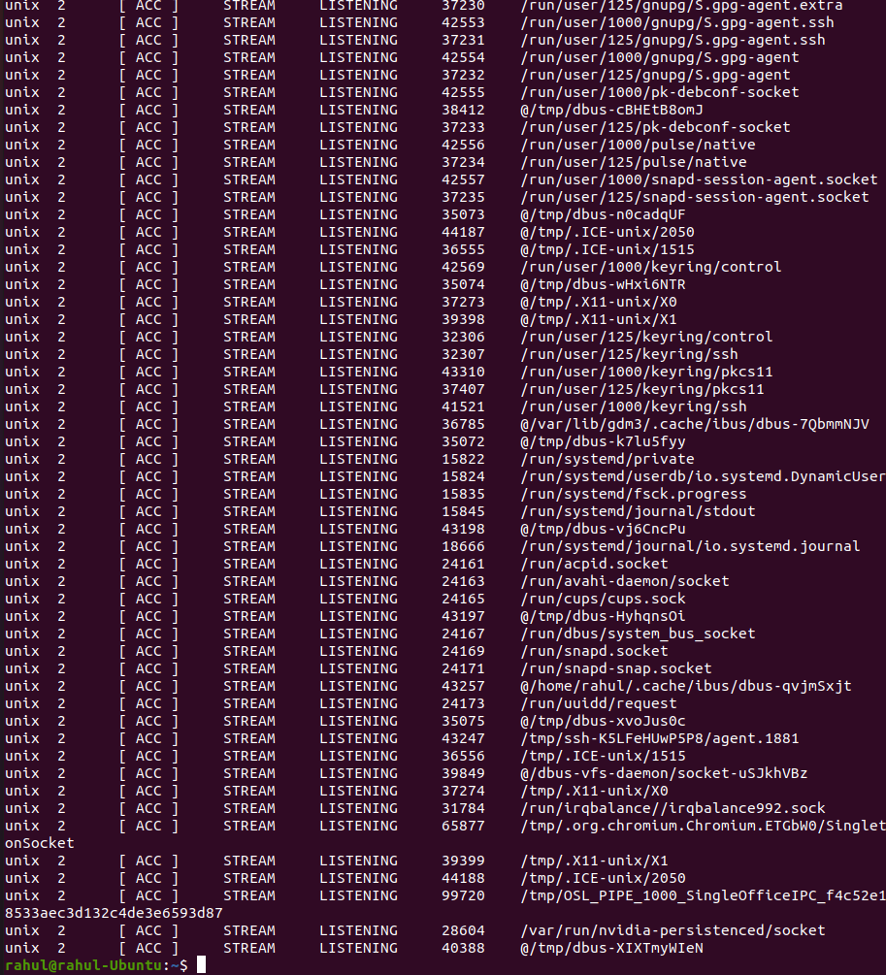

-lt Displays statistics for all the listening tcp ports.
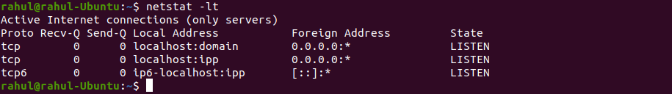
-lu Displays statistics for all the listening udp ports.
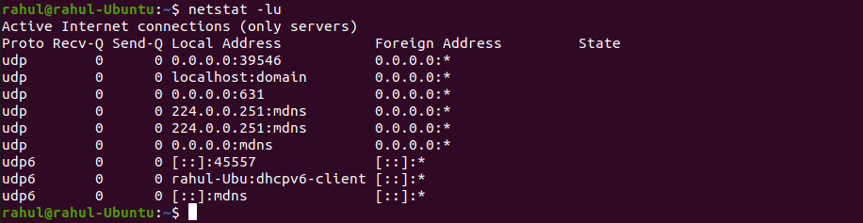

Command : ifconfig

Syntax : ifconfig [options] [interface]

Description : Ifconfig is used to configure the kernel-resident network interfaces.

Screenshots :
(none) If no arguments are given, ifconfig displays the status of the currently active interfaces
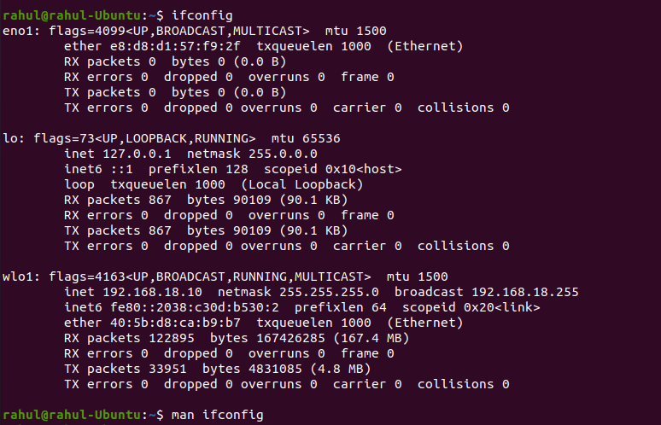
-a display all interfaces which are currently available, even if down
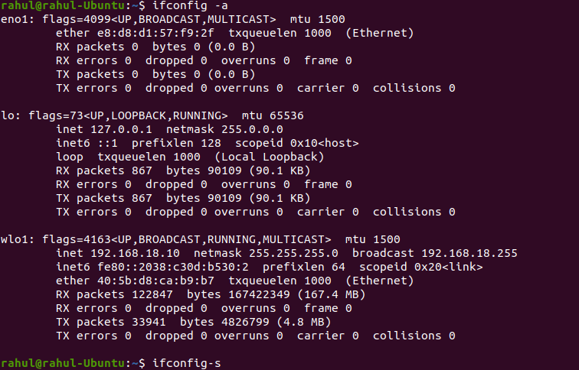
-s display a short list (like netstat -i)
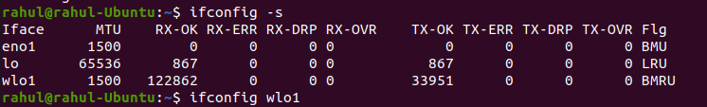
ifconfig with network interface ‘wlo1’
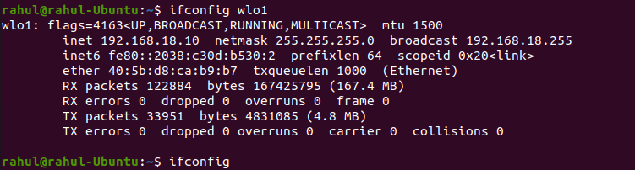

Command : nslookup

Syntax : nslookup [-option] [name | -] [server]

Description : Nslookup is a program to query Internet domain name servers. Nslookup has two modes: interactive and non-interactive. Interactive mode allows the user to query name servers for information about various hosts and domains or to print a list of hosts in a domain. Non-interactive mode is used to print just the name and requested information for a host or domain.

Screenshots :
www.google.com
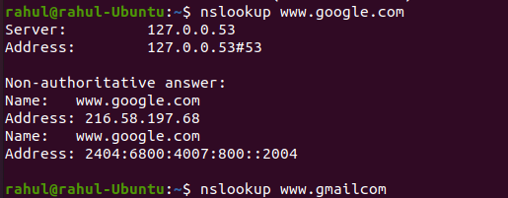
www.gmail.com
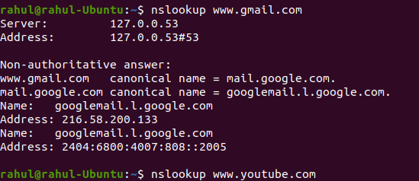
www.youtube.com
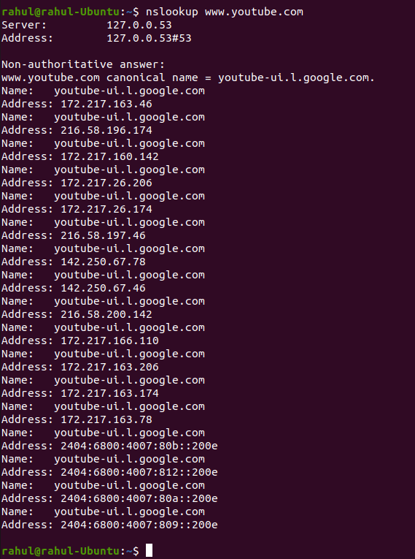

Command : traceroute

Syntax : traceroute [options]

Description : traceroute tracks the route packets taken from an IP network on their way to a given host.

Screenshots :
www.google.com
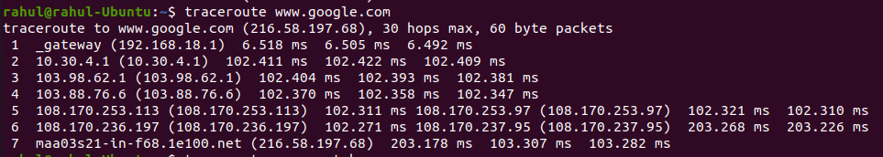
www.gmail.com
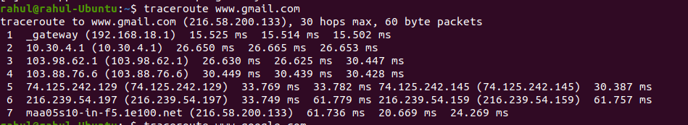
www.youtube.com
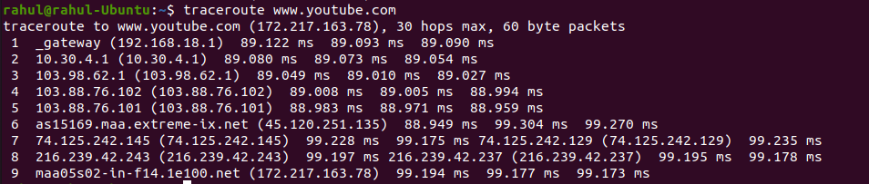

Command : ping

Syntax : ping [options]

Description : ping uses the ICMP protocol's mandatory ECHO_REQUEST datagram to elicit an ICMP ECHO_RESPONSE from a host or gateway.

Screenshots :
www.google.com
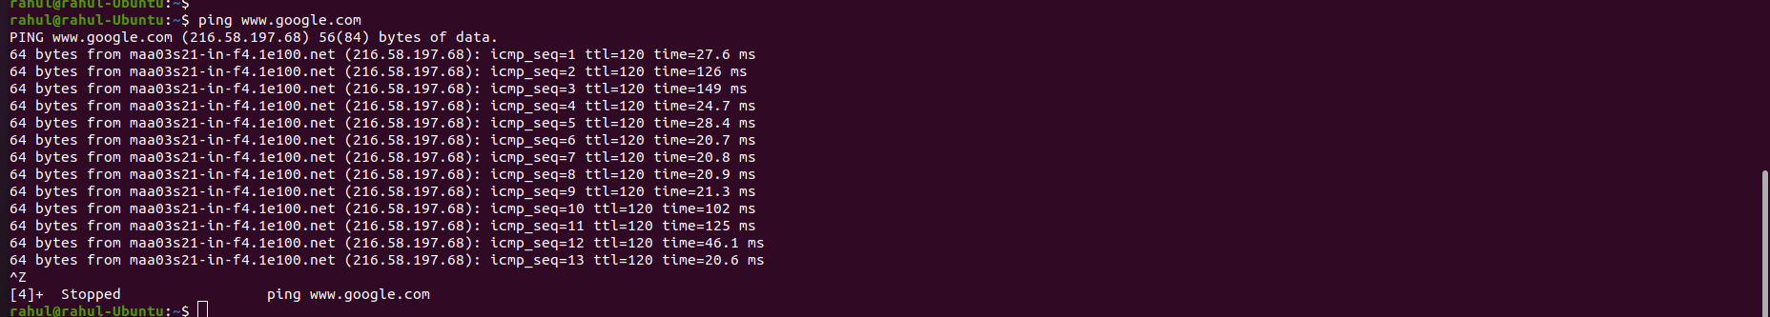
www.gmail.com
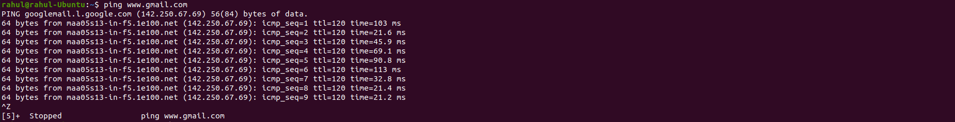
www.youtube.com
