SSN College of Engineering, Kalavakkam
Department of Computer Science and Engineering
V Semester - CSE 'B'
UCS1511 NETWORKS LAB

Date :13/08/2020 Name : Rahul Ram M
Exercise : 04 Reg No : 185001121

FILE TRANSFER USING TCP

Learning Objective:
To transfer a file from server to client using TCP socket programming.

Algorithm for Server:
- Creating a socket using the function socket(domain, type, protocol) which the returns an integer as the status of the socket creation. Here the domain is AF_INET(iPv4 protocol), type is SOCK_STEAM and protocol as 0.
- Using bzero(&server_addr, sizeof(server_addr)) function setting values of all the socket structures to null.
- Using bind() to binf the socket to the address and port number specified in addr(custom data structure). Here, we bind the server to the localhost, hence we use INADDR_ANY to specify the IP address.
- listen() function is used to set the server socket in the passive mode, where it waits for the client to approach the server to make a connection, with maximum number of connection in this case is 2.
- accept() creates a new connected socket and returns a new file descriptor reffering to the socket. After this the connection between server and client is established.
- read(new_socket, filename, sizeof(filename)) - reads the filename sent by the client in the variable filename specified in the parameter along with its size preceded by the new socket descriptor.
- Printing the filename received from the client using printf().
- Open the file with Read mode using fopen(filename, “r”) and assign the file descriptor to fp.
- Get the number of bytes of the file using fseek(fp, 0L, SEEK_END) and ftell(fp) and assgin the value in numbytes.
- Now reset the file position indicator to the beginning of the file using fseek(fp, 0L, SEEK_SET).
- Copy all the text from the file into the buffer using fread(buffer, sizeof(char), numbytes, fp).
- Close the file using fclose().
- write(new_socket, buffer, sizeof(buffer)) - is used to write the contents of the file stored in buffer to be read by the client.
- close() function shuts down the socket associated with socket descriptor’s, and frees resources allocated to the socket.

Algorithm for Client:
- Creating a socket using the function socket(domain, type, protocol) which the returns an integer as the status of the socket creation. Here the domain is AF_INET(iPv4 protocol), type is SOCK_STEAM and protocol as 0.
- Using bzero(&server_addr, sizeof(server_addr)) function setting values of all the socket structures to null.
- The above two steps are same as the server.
- The connect() system call connects the socket referred to by the file descriptor socket_fd to the address specified by server_addr. Server’s address and port is specified in server_addr.
- Read the filename from the user using scanf().
- write(socket_fd, filename, sizeof(filename)) – sends the filename given by the cient to the server.
- read(new_socket, buffer, sizeof(buffer)) - reads the contents of the file sent by the server in the buffer specified in the parameter along with its size preceded by the socket_fd.
- Read the path of the file from user where the new file to be stored.
- Open the file using fopen() with write persmission.
- Using fprintf(fp, “%s”, buffer) to write the contents of the buffer to the file specified by the filename along with the path given by the user.
- close() function shuts down the socket associated with socket descriptor’s, and frees resources allocated to the socket.

Program for Server:

#include <stdio.h>
#include <string.h>
#include <unistd.h>
#include <stdlib.h>
#include <sys/types.h>
#include <sys/socket.h>
#include <netinet/in.h>

#define PORT 8080

int main()
{
int server_fd, new_socket, value;
struct sockaddr_in server_addr, client_addr;
char buffer[1024], filename[100];
socklen_t len;
long numbytes;
FILE *fp;

if((server_fd = socket(AF_INET, SOCK_STREAM, 0)) < 0)
{
perror("Socker error");
}

bzero(&server_addr,sizeof(server_addr));

server_addr.sin_family = AF_INET;
server_addr.sin_addr.s_addr = INADDR_ANY;
server_addr.sin_port = htons(PORT);

if(bind(server_fd, (struct sockaddr*)&server_addr, sizeof(server_addr)) < 0)
{
perror("Bind error: ");
}

if(listen(server_fd,2) < 0)
{
perror("Listen error");
}

len = sizeof(client_addr);

printf("Waiting for client...\n");

if((new_socket = accept(server_fd, (struct sockaddr*)&client_addr, &len)) < 0)
{
perror("Accept error");
}

value = read(new_socket, filename, sizeof(filename));
printf("File to be transferred is %s\n", filename);

fp = fopen(filename, "r");
fseek(fp, 0L, SEEK_END);
numbytes = ftell(fp);
fseek(fp, 0L, SEEK_SET);
fread(buffer, sizeof(char), numbytes, fp);
fclose(fp);

value = write(new_socket, buffer, sizeof(buffer));
printf("File Transferred!\n");

close(server_fd);
close(new_socket);
return 0;
}
Program for Client:
#include <stdio.h>
#include <string.h>
#include <unistd.h>
#include <arpa/inet.h>
#include <sys/types.h>
#include <sys/socket.h>

#define PORT 8080

int main()
{
int socket_fd, value;
struct sockaddr_in server_addr;
FILE *fp;
char buffer[1024], filename[100];

if((socket_fd=socket(AF_INET, SOCK_STREAM, 0)) < 0)
{
perror("Socket error");
}

bzero(&server_addr,sizeof(server_addr));

server_addr.sin_family = AF_INET;
server_addr.sin_addr.s_addr = inet_addr("127.0.0.1");
server_addr.sin_port = htons(PORT);

if(connect(socket_fd,(struct sockaddr*)&server_addr, sizeof(server_addr)) < 0)
{
perror("Connect error");
}

printf("Enter the path of file : ");
scanf("%s", filename);
value = write(socket_fd, filename, sizeof(filename));

value = read(socket_fd, buffer, sizeof(buffer));
printf("FIle Transferred!\n");

printf("Save the file in path : ");
scanf("%s", filename);

fp = fopen(filename, "w");
fprintf(fp, "%s", buffer);
fclose(fp);

close(socket_fd);
return 0;
}

Server Screenshot:

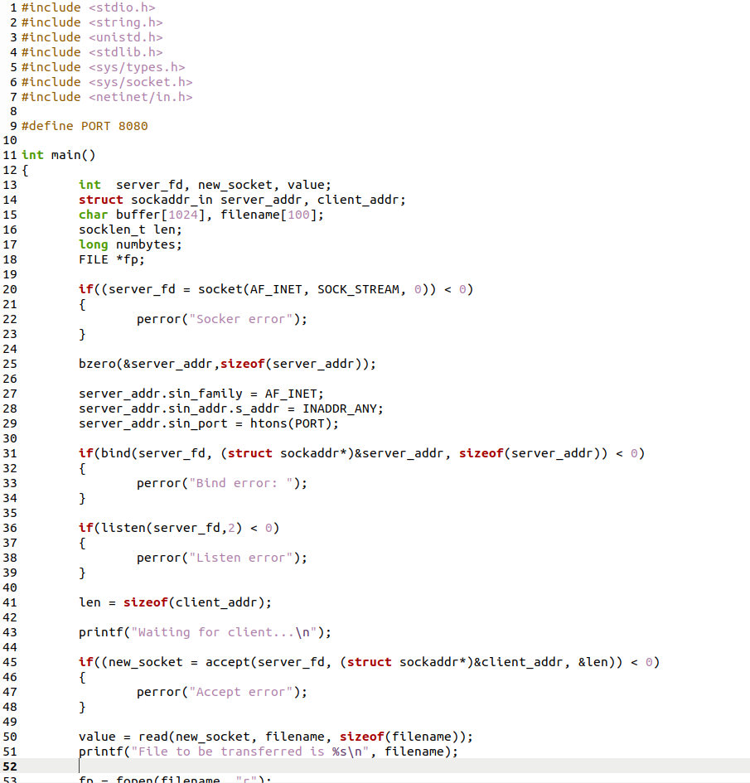
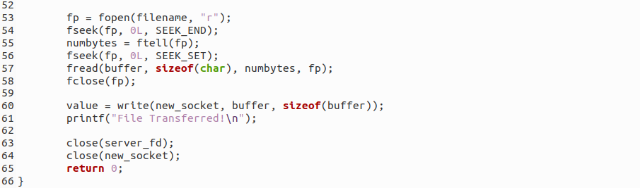

Client Screenshot:
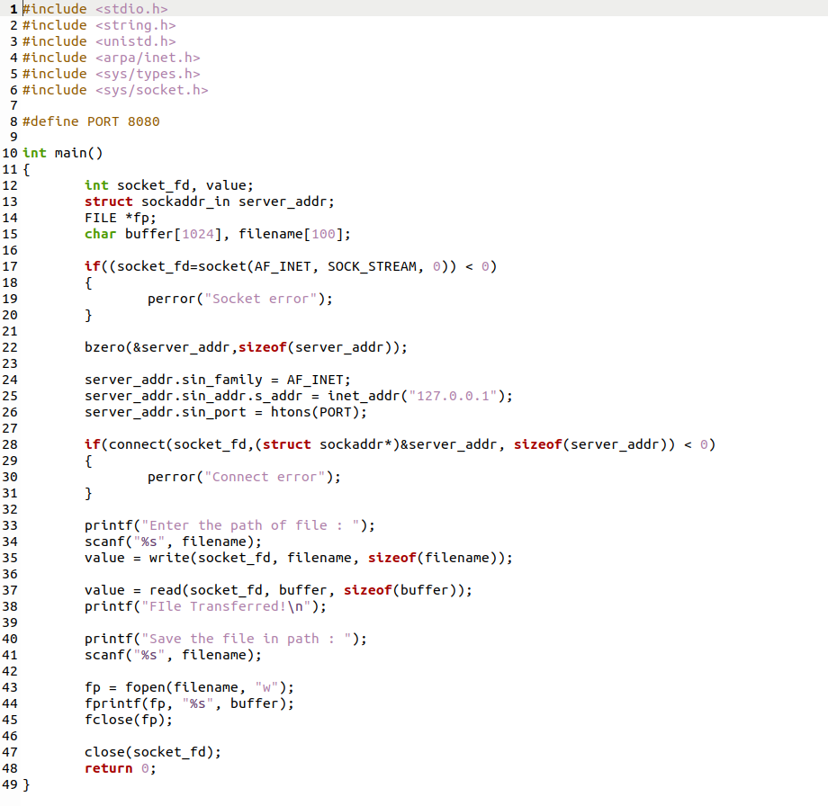
Server Output:
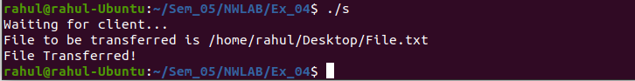
Client Output:
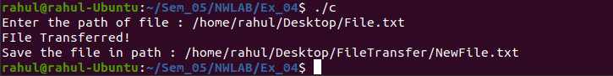

File at Server:
/home/rahul/Desktop/File.txt:
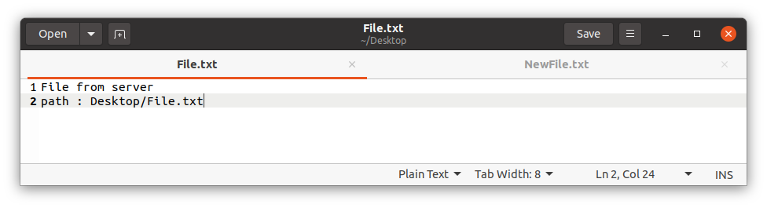
File at Client:
/home/rahul/Desktop/FileTransfer/NewFile.txt:

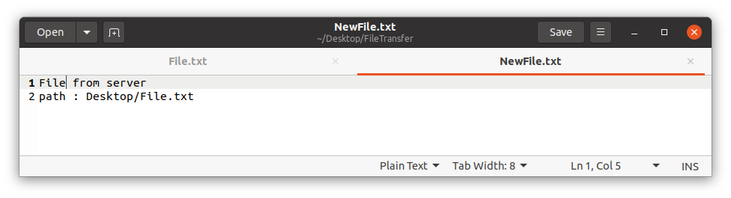

Learning Outcomes:

This assignment helped me to
- Write program for server and client with socket programming.
- Understand various functions invloved in creating, estabilishing, maintaining, Sending, recieving and termininating the connection between the server and client.
- Write code to make server and client communicate with each other using read() and write() functions.
- Modify the code to transfer a file between client and server.

