SSN College of Engineering, Kalavakkam
Department of Computer Science and Engineering
V Semester - CSE 'B'
UCS1511 NETWORKS LAB

Date : 15/10/2020 Name : Rahul Ram M
Exercise : 07 Reg No : 185001121

HAMMING CODE ERROR DETECTION AND CORRECTION

Learning Objective:
To develop a socket program to establish a client server communication in which the server and client uses hamming code for error detection and correction.

Algorithm for Server:
- Read the input from the user(0’s and 1’s).
- Fill the message bits in the new array in reverse order leaving appropriate places for redundant bits.
- Find the number of reduntant bits needed by using the equation 2^r ≥ m + r + 1 where, r = redundant bit, m = data bit.
- Calculate the value of the redundant bit based on the even priority and insert the reduntant bits in the position 2^i where i range from 0 to r.
- Again reverse the bits in the final array and convert this integer array to a string array.
- Creating a socket using the function socket(domain, type, protocol) which the returns an integer as the status of the socket creation. Here the domain is AF_INET(iPv4 protocol), type is SOCK_STEAM and protocol as 0.
- Using bzero(&server_addr, sizeof(server_addr)) function setting values of all the socket structures to null.
- Using bind() to binf the socket to the address and port number specified in addr(custom data structure). Here, we bind the server to the localhost, hence we use INADDR_ANY to specify the IP address.
- listen() function is used to set the server socket in the passive mode, where it waits for the client to approach the server to make a connection, with maximum number of connection in this case is 2.
- accept() creates a new connected socket and returns a new file descriptor reffering to the socket. After this the connection between server and client is established.
- Copy the string array to the buffer.
- write(new_socket, buffer, sizeof(buffer)) - is used to write the message in the buffer to be sent to client.
- close() function shuts down the socket associated with socket descriptor’s, and frees resources allocated to the socket.

Algorithm for Client:
- Creating a socket using the function socket(domain, type, protocol) which the returns an integer as the status of the socket creation. Here the domain is AF_INET(iPv4 protocol), type is SOCK_STEAM and protocol as 0.
- Using bzero(&server_addr, sizeof(server_addr)) function setting values of all the socket structures to null.
- The above two steps are same as the server.
- The connect() system call connects the socket referred to by the file descriptor socket_fd to the address specified by server_addr. Server’s address and port is specified in server_addr.
- read(new_socket, buffer, sizeof(buffer)) - reads the message sent by the client in the buffer specified in the parameter along with its size preceded by the new socket descriptor.
- The string in the buffer contains the message by the server along with the redundant bits by the hamming codes.
- The string from the server may contains error in any bit.
- First the string is converted into an integer array and this array is reversed.
- Now the redundant bits are calculated by ham_calc() function for positions 2^i where i is from 0 to r.
- Now the decimal value for the obtained redundant bits is calculated.
- If the decimal value is greater than length of the string then there is no error.
- Else there is error at the index specified by the decimal value.
- Flip the bit in that index and extract the message bit leaving all the redundant bits at position 2^i.
- Printing the corrected message from the server using printf().
- close() function shuts down the socket associated with socket descriptor’s, and frees resources allocated to the socket.

Program for Server:
#include <stdio.h>
#include <string.h>
#include <stdlib.h>
#include <math.h>
#include <unistd.h>
#include <sys/types.h>
#include <sys/socket.h>
#include <netinet/in.h>

#define max_r 20

int ham_calc(int position,int len, int data[])
{
int count=0, i, j;
i = position - 1;
while(i < len)
{
for(j = i; j < i+position; j++)
{
if(data[j] == 1)
count++;
}
i = i + 2*position;
}
if(count%2 == 0)
return 0;
else
return 1;
}

char* convertToString(int n_len, int e_data[])
{
char *code = malloc(n_len + 1);
for(int i = 0; i < n_len; i++)
{
code[i] = e_data[i] + '0';
}
return code;
}

void printBinary(int len, int data[])
{
for(int i = 0; i < len; i++)
{
printf("%d", data[i]);
}
printf("\n");
}

int main()
{
int data[100], n_data[200];
int n_len, r, i, count, position, e_index = 4;
char tmp_data[100], code[200];

int len, server_fd, new_socket, n;
struct sockaddr_in server_addr, client_addr;
char buffer[1024];

printf("Input data: ");
scanf("%s", tmp_data);

// convert string to integer array.
for(i = 0; i < strlen(tmp_data); i++)
{
data[i] = tmp_data[i] - 48;
}

// find the number of reduntant bits.
for(i = 1; i < max_r; i++)
{
if((int)pow(2, i) >= (strlen(tmp_data) + i + 1))
{
r = i;
break;
}
}

printf("Number of redundant bits needed is: %d\n", r);

// length of new data array.
n_len = strlen(tmp_data) + r;

// filling the reduntant bits as -1.
for(i = 0; i < r; i++)
{
n_data[(int)pow(2, i) - 1] = -1;
}

// filling the message bits in the reverse order.
count = 0;
for(i = n_len-1; i >= 0; i--)
{
if(n_data[i] != -1)
{
n_data[i] = data[count++];
}
}

// filling the reduntant bits with correct parity.
for(i = 0; i < r; i++)
{
position = (int)pow(2, i);
n_data[position - 1] = ham_calc(position, n_len, n_data);
}

// reversing the data bits.
for(i = 0; i < n_len/2; i++)
{
int temp = n_data[i];
n_data[i] = n_data[(n_len-1) - i];
n_data[(n_len-1) - i] = temp;
}

strcpy(code, convertToString(n_len, n_data));

printf("Data with redundant bits: %s\n", code);

// introducing error in the code.
if(n_data[e_index] == 1)
n_data[e_index] = 0;
else
n_data[e_index] = 1;

strcpy(code, convertToString(n_len, n_data));

printf("Introduce error in data: %s\n", code);

//----------------------------------------------------------------------
if((server_fd = socket(AF_INET, SOCK_STREAM, 0)) < 0)
{
perror("Socker error");
}

bzero(&server_addr,sizeof(server_addr));

server_addr.sin_family = AF_INET;
server_addr.sin_addr.s_addr = INADDR_ANY;
server_addr.sin_port = htons(8080);

if(bind(server_fd, (struct sockaddr*)&server_addr, sizeof(server_addr)) < 0)
{
perror("Bind error");
}

if(listen(server_fd,2) < 0)
{
perror("Listen error");
}

len = sizeof(client_addr);

if((new_socket = accept(server_fd, (struct sockaddr*)&client_addr, &len)) < 0)
{
perror("Accept error");
}

strcpy(buffer, code);

write(new_socket, buffer, sizeof(buffer));

close(server_fd);
close(new_socket);
//----------------------------------------------------------------------

return 0;
}

Program for Client:
#include <stdio.h>
#include <string.h>
#include <stdlib.h>
#include <math.h>
#include <unistd.h>
#include <sys/types.h>
#include <sys/socket.h>
#include <netinet/in.h>
#include <arpa/inet.h>

int ham_calc(int position,int len, int data[])
{
int count=0, i, j;
i = position - 1;
while(i < len)
{
for(j = i; j < i+position && j < len; j++)
{
if(data[j] == 1)
{
count++;
}
}
i = i + 2*position;
}
if(count%2 == 0)
{
return 0;
}
else
{
return 1;
}
}

void printBinary(int len, int data[])
{
for(int i = 0; i < len; i++)
{
printf("%d", data[i]);
}
printf("\n");
}

int main()
{
int data[200], c_data[100], rbits[20];
int len, r, i, count, position, e_index;
char code[200];

//--------------------------------------------------------------------------------
int socket_fd;
struct sockaddr_in server_addr;
char buffer[1024];

if((socket_fd=socket(AF_INET, SOCK_STREAM, 0)) < 0)
{
perror("Socket error");
}

bzero(&server_addr,sizeof(server_addr));

server_addr.sin_family = AF_INET;
server_addr.sin_addr.s_addr = inet_addr("127.0.0.1");
server_addr.sin_port = htons(8080);

if(connect(socket_fd,(struct sockaddr*)&server_addr, sizeof(server_addr)) < 0)
{
perror("Connect error");
}

read(socket_fd, buffer, sizeof(buffer));

close(socket_fd);
//--------------------------------------------------------------------------------

strcpy(code, buffer);

len = strlen(code);

// convert string to integer array.
for(i = 0; i < len; i++)
{
data[i] = code[i] - 48;
}

printf("Data received: ");
printBinary(len, data);

// reversing the data array.
for(i = 0; i < len/2; i++)
{
int temp = data[i];
data[i] = data[(len-1) - i];
data[(len-1) - i] = temp;
}

// find the number of redundant bits.
i = 0;
while((int)pow(2, i) < (len + i + 1))
{
i++;
}
r = i;

// extracting the redundant bits and placing it in separate array.
for(i = 0; i < r; i++)
{
position = (int)pow(2, i);
rbits[i] = ham_calc(position, len, data);
}

// calculating the value of the rbits array.
// binary to decimal conversion.
e_index = 0;
for(i = 0; i < r; i++)
{
if(rbits[i] == 1)
{
e_index += (int)pow(2, i);
}
}

// reversing the rbits array.
for(i = 0; i < r/2; i++)
{
int temp = rbits[i];
rbits[i] = rbits[(r-1) - i];
rbits[(r-1) - i] = temp;
}

printf("Calculated redundant bits: ");
printBinary(r, rbits);

// correcting the data.
e_index--;
if(e_index >= 0)
{
if(data[e_index] == 1)
data[e_index] = 0;
else
data[e_index] = 1;
}

// assigning the rbits as -1.
for(i = 0; i < r; i++)
{
position = (int)pow(2, i);
data[position-1] = -1;
}

count = 0;
for(i = 0; i < len; i++)
{
if(data[i] != -1)
{
c_data[count++] = data[i];
}
}

printf("Corrected data: ");
printBinary(len - r, c_data);

return 0;
}
Screenshot for Server:

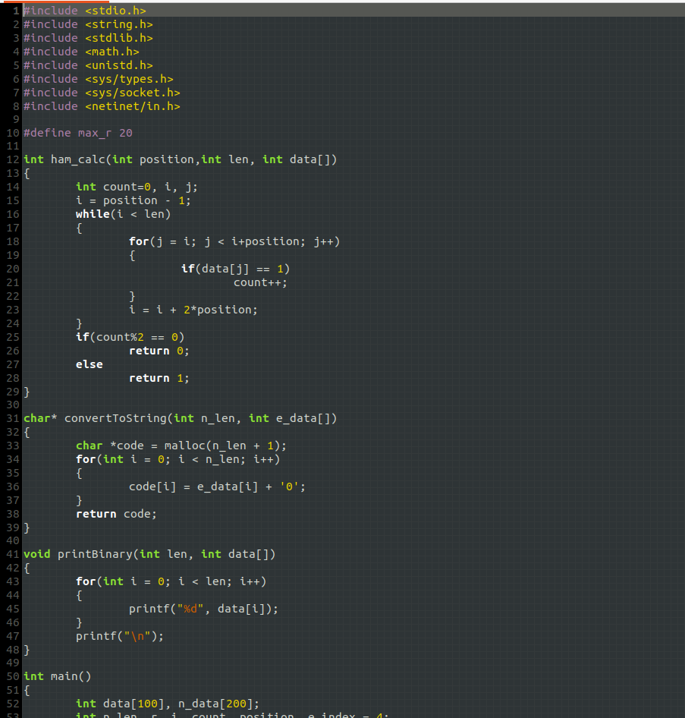

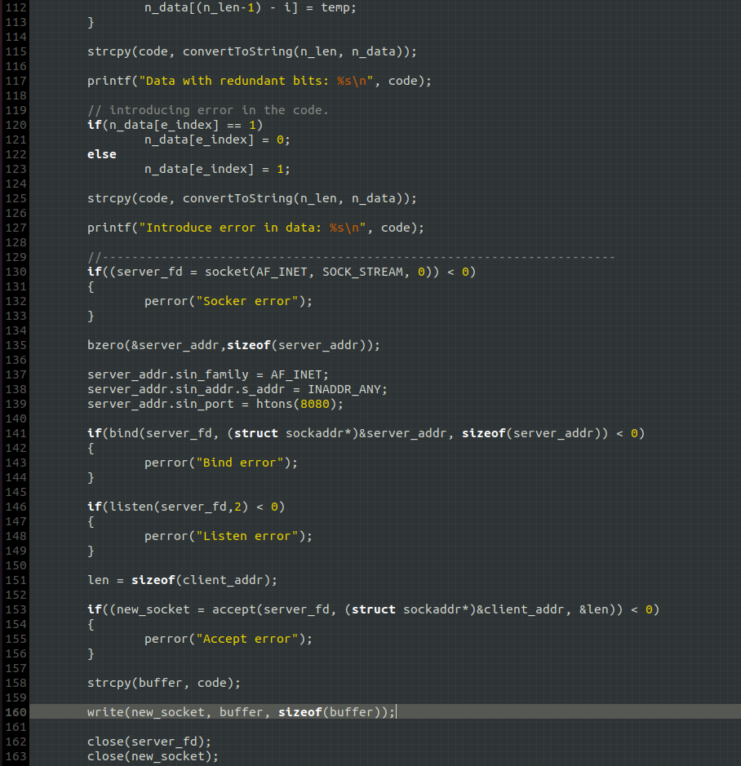

Screenshot for Client:

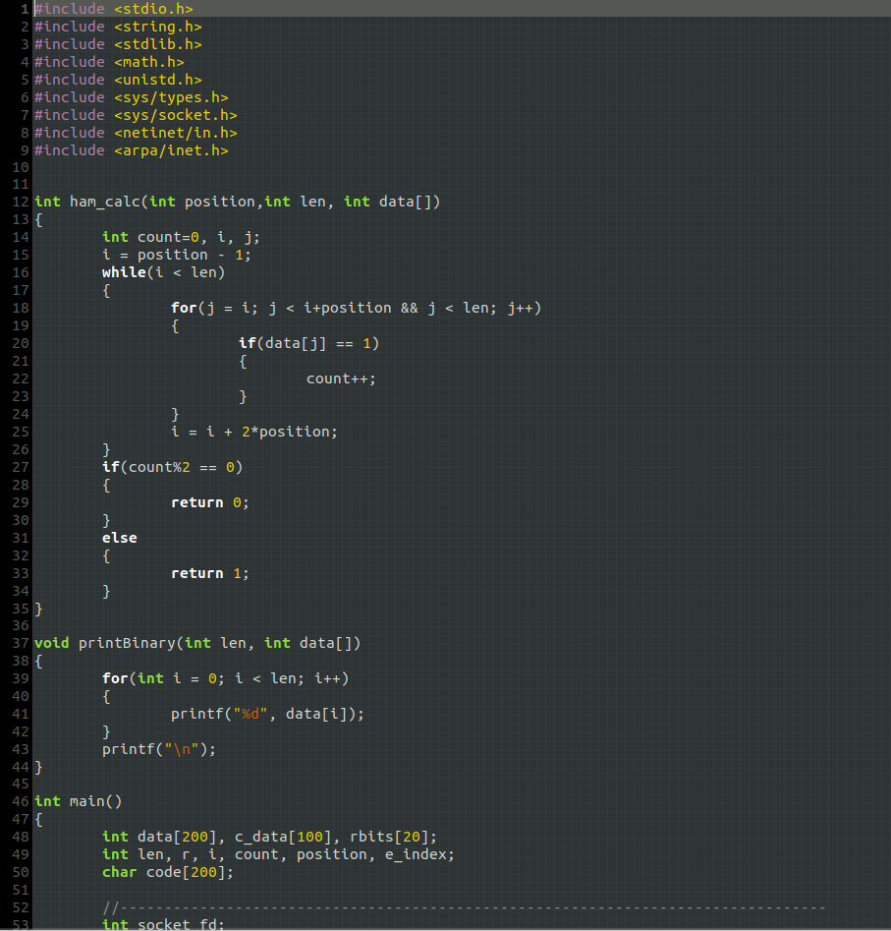

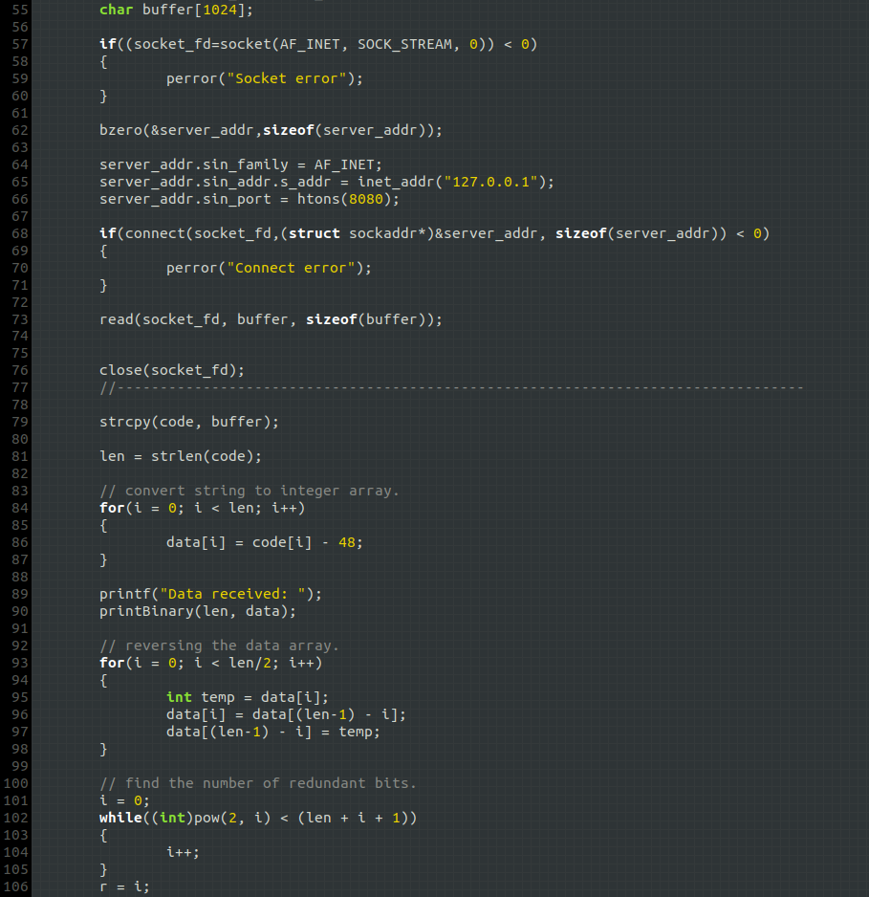

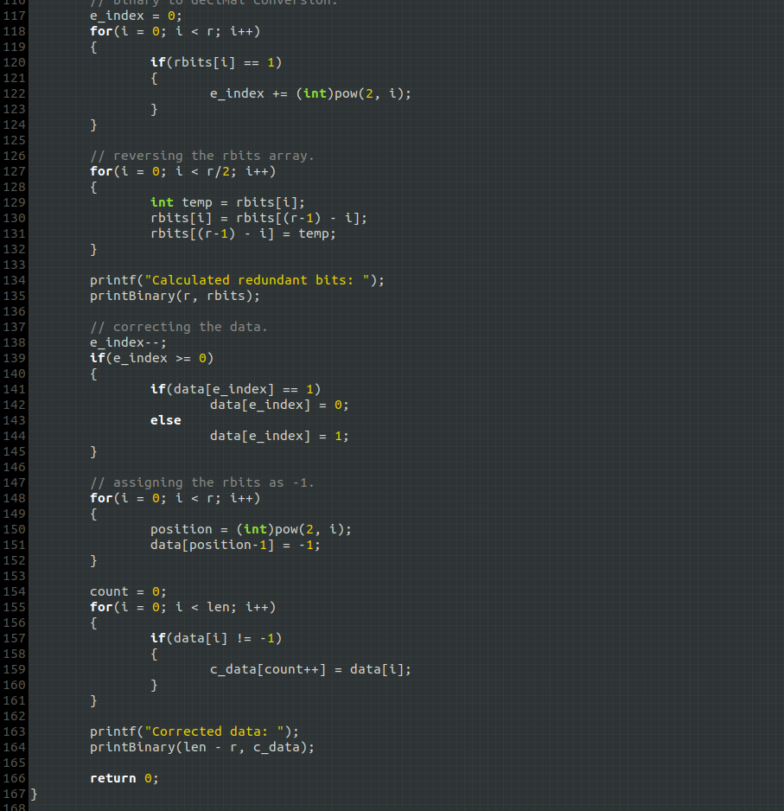

Server Output:

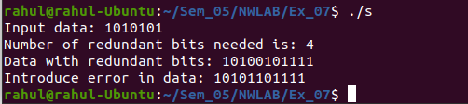

Client Output:

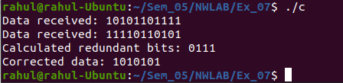

Learning Outcomes:
This assignment helped me to
- Write program for server and client with socket programming.
- Understand various functions invloved in creating, estabilishing, maintaining, Sending, recieving and termininating the connection between the server and client.
- Write code to make server and client communicate with each other using read() and write() functions.
- Understand the concepts of hamming codes and how it is used for error detection and correction.
- Implement hamming codes in c along with Socket programming.

