**USER MANUAL DOCUMENTATION - GENIE**

The Genie Plugin documentation contains the following modules, providing a brief description of the entire Genie (VS code extension) Plugin:

1. Installation of .vsix file  
 2. The GENIE icon

3. URL submission

4. Registration Form

5. Login Form

6. Genie Commands Category - Assistant Features

7. Genie Commands Category - Review Features

8. Git Commit Feature  
 9. Login/Register Category

10.Uninstall the extension

**1. Installation of .vsix file:**

**Steps to install .vsix file and access the extension:**  
 **1. Download the .vsix** **File :** Ensure you have the .vsix extension file on your local   
 machine.

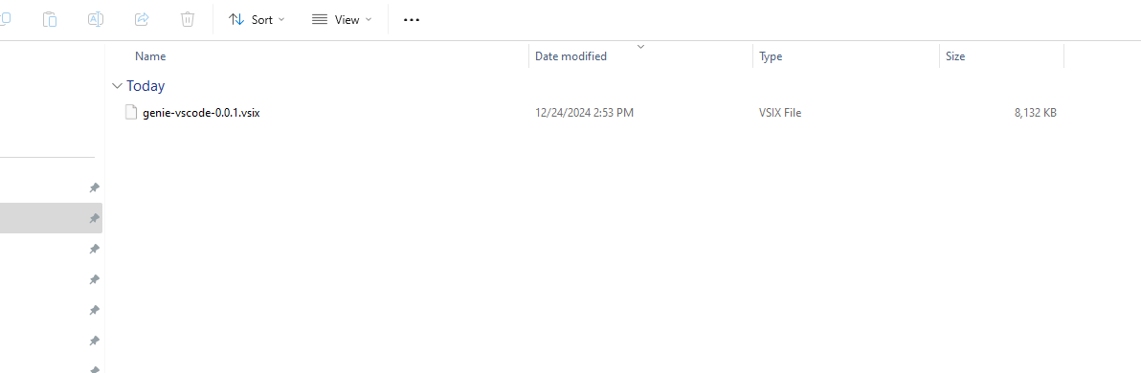   
  
  **2. Open Visual Studio Code:** Launch Visual Studio Code from your desktop or start   
 menu.  
  **3. Access the Extensions View:**

a. In Visual Studio Code, click on the **Extensions** icon in the **Activity Bar** on the  
 left sidebar.

b. Alternatively, you can open the Extensions view by using the shortcut:

* + 1. Ctrl+Shift+X on **Windows/Linux**
    2. Cmd+Shift+X on **macOS**

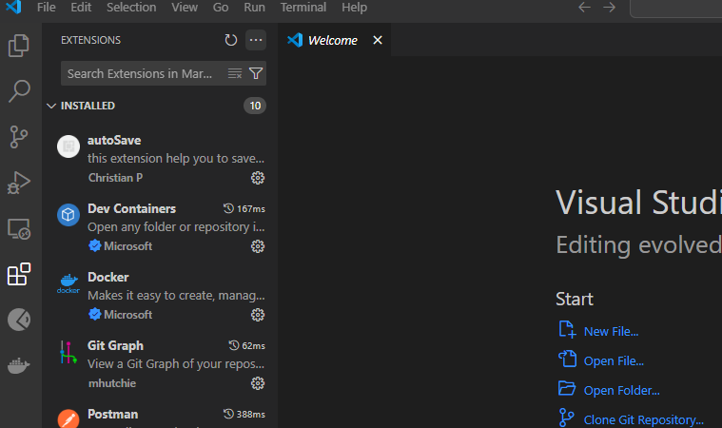

**4. Open the Extension Installation** **Menu :**

a. In the Extensions view, click on the three-dot menu (**More Actions**) at the   
 right corner of the Extensions pane in the sidebar.

b. From the dropdown menu, select **Install from VSIX...**.

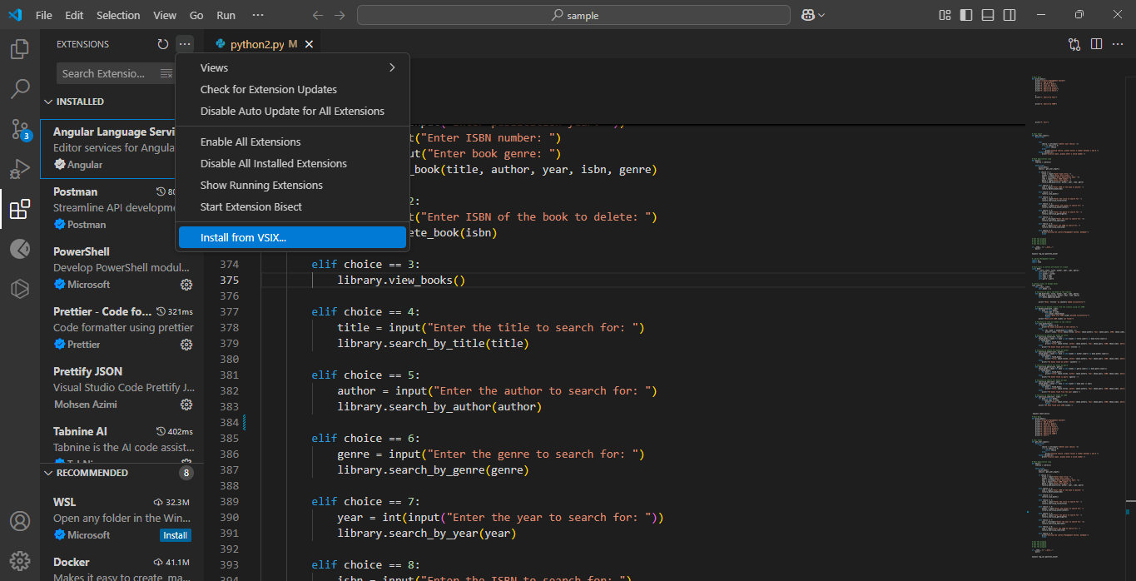

**5. Select the .vsix** **File :**

a. A file picker dialog will open. Navigate to the location where the .vsix file is   
 saved.

b. Select the file and click **Open** to begin the installation process.

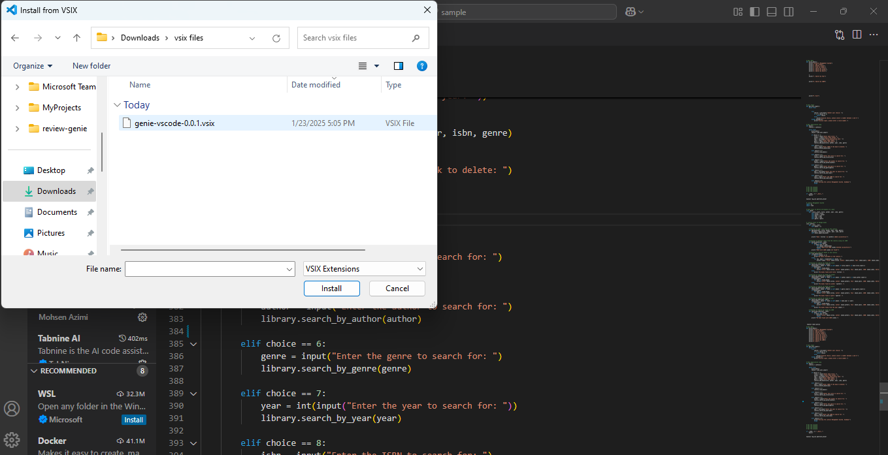

**6. Wait for** **Installation :**

a. Visual Studio Code will process the .vsix file and install the extension.

b. Once installed, it may prompt you to reload VS Code to complete the   
 installation.

**7. Verify Installation:** After installation, the extension should appear in the **Installed**   
 section of the Extensions view. (Basically, the GENIE icon in the sidenav )   
 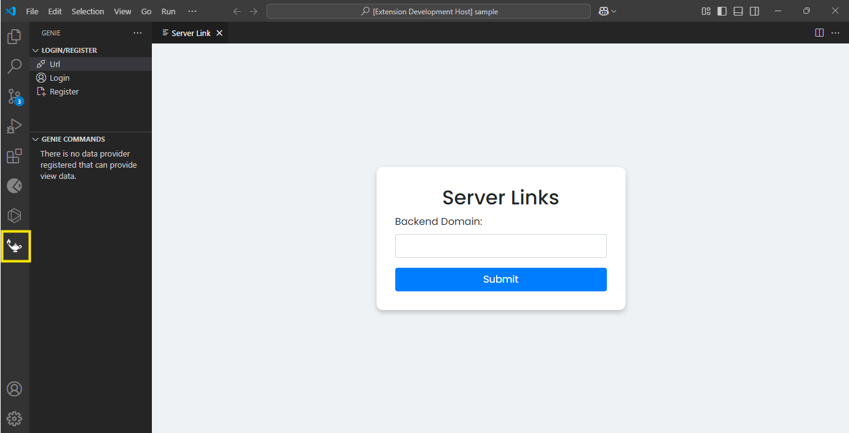   
  
**2. The GENIE icon :**  
After the successful installation of the extension through the **.vsix** file, the respective icon will be displayed in the sidenav of **VS Code**, and in this case, it is the **GENIE** icon.   
  
   
  
**3. URL submission :**  
Along with getting the icon in the sidenav, a webview will open simultaneously. This webview will display the input field for URL: **Backend Domain**  
  
  
  
  
   
   
  
  
Once the required information is entered and submitted,a popup window will open effortlessly consisting of Login and Register.  
  
 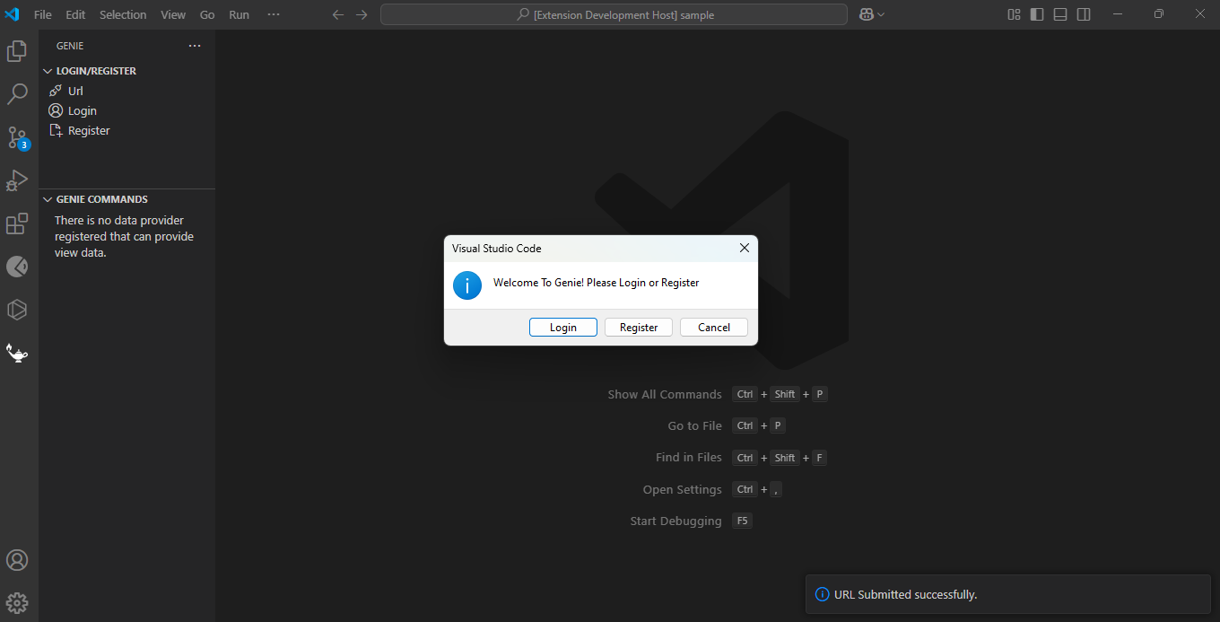  
**4. Registration Form:**  
 If you do not have an account previously, then all required fields must be filled out to complete the registration process. Once registered, login using the same credentials.

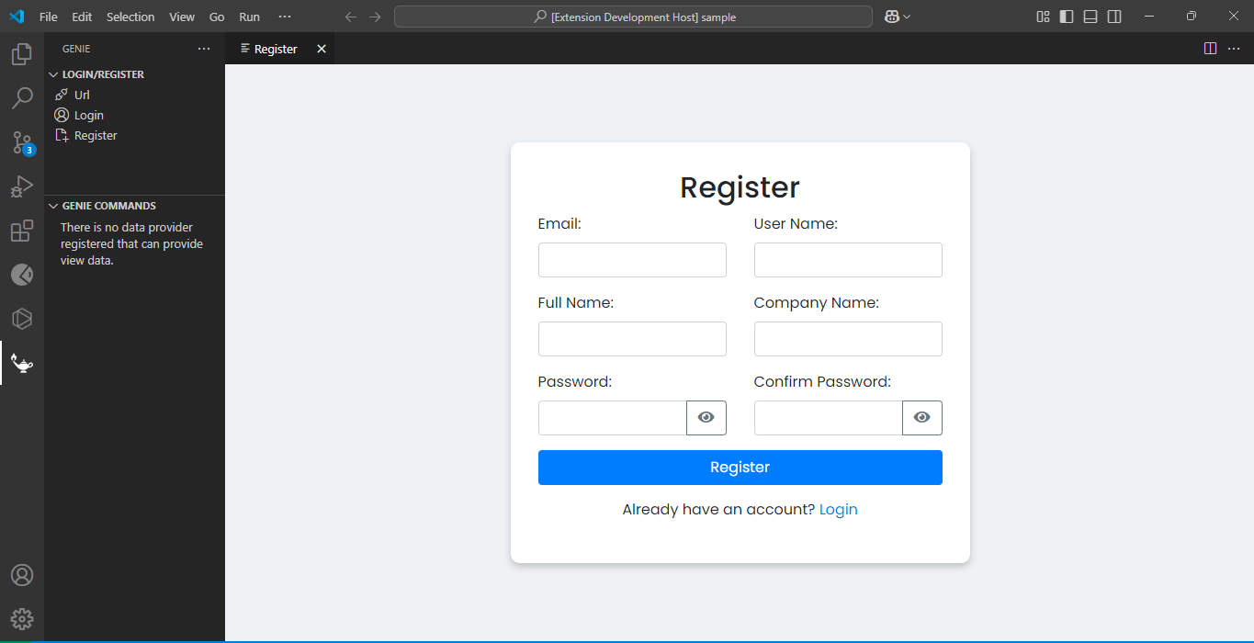

**5. Login :**  
If you already have an account, proceed to log in. Otherwise, click on **Register**, fill in the required details, submit the registration form, and then log in.

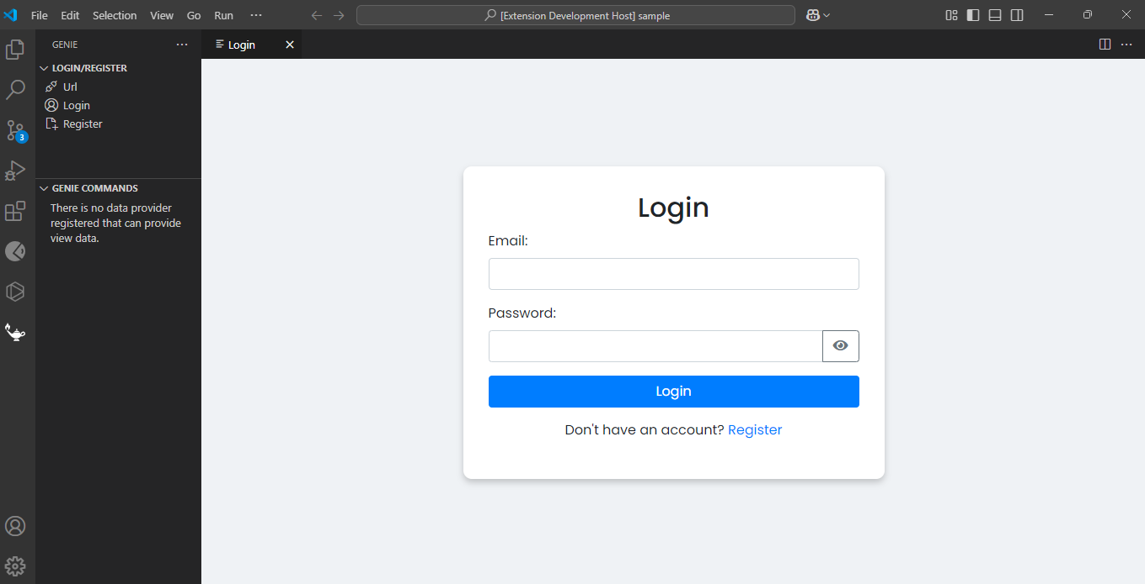  
  
After a successful login, the Login/Register and Genie Commands categories will appear when the Genie icon is clicked.  
  
 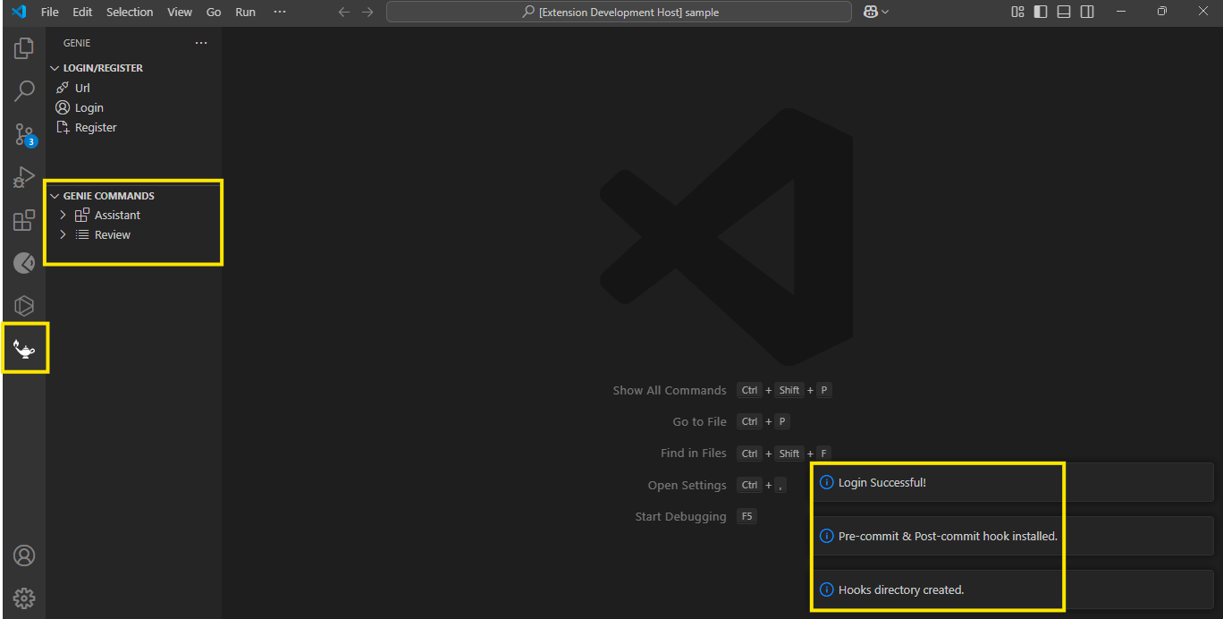

**6. Genie Commands Category - Assistant Features :**  
  
The following are the different types of Assistants features available in the GENIE extension:  
**1.** **Add Docstrings**: Adds docstrings to the selected code.   
**2.** **Add Error Handling**: Adds error handling to the selected code.  
**3.** **Add Logging**: Adds logging functionality to the selected code.  
**4. Code Generation**: Write a question, select it, and choose this command to generate the corresponding code.  
**5**. **Comment Code**: Adds comment descriptions to each section of the selected code.   
**6. Explain Code**: Provides an explanation of the selected code.  
**7.** **Refactor Code**: Refactors the selected code to improve its structure or readability.  
**8. Unit Test Code**: Generates unit tests for the selected code.  
  
 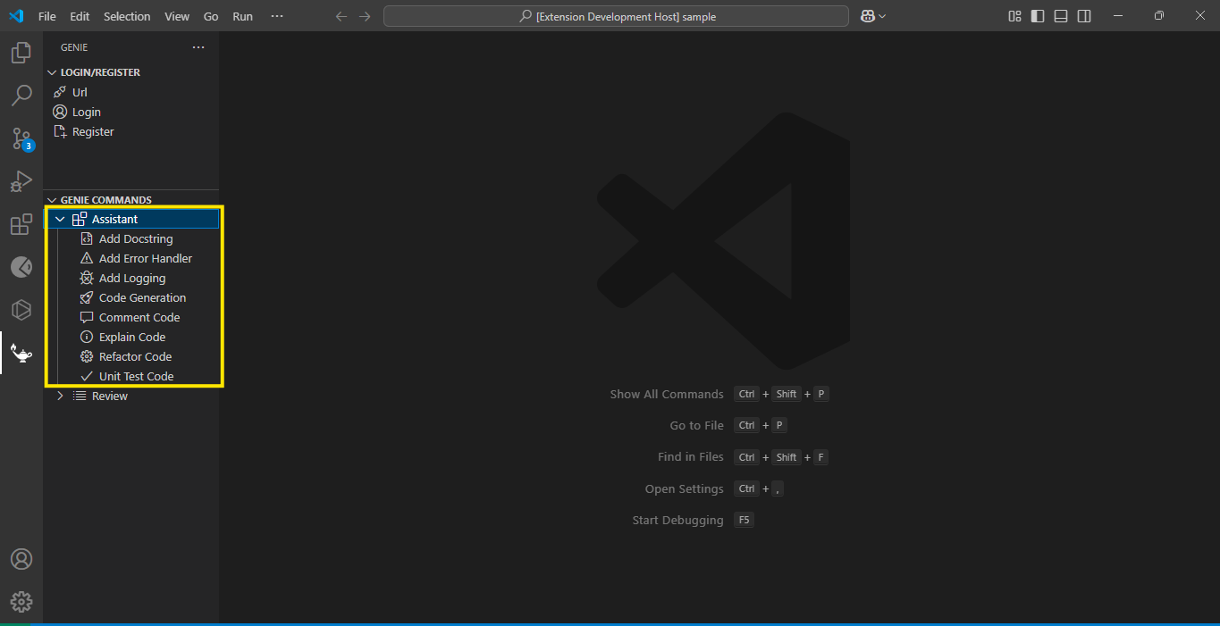  
  
  
  
  
 To use any of these commands, simply select the code snippet and then choose the desired command from the **GENIE Commands Assistant**  
  
 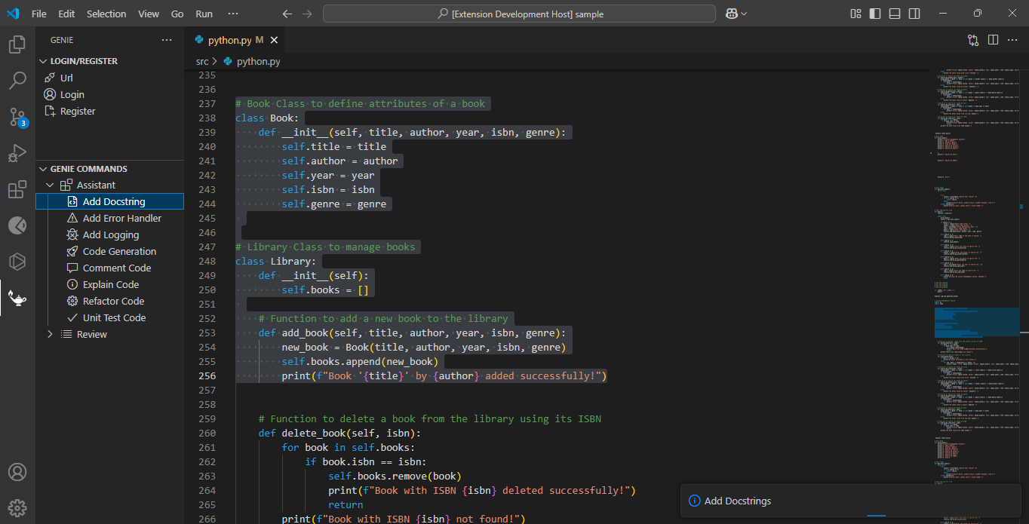  
  
  
  
After executing, you'll see options to **ACCEPT** or **REJECT** the result at the bottom of result container, allowing you to select as per your requirement.  
  
  
  
 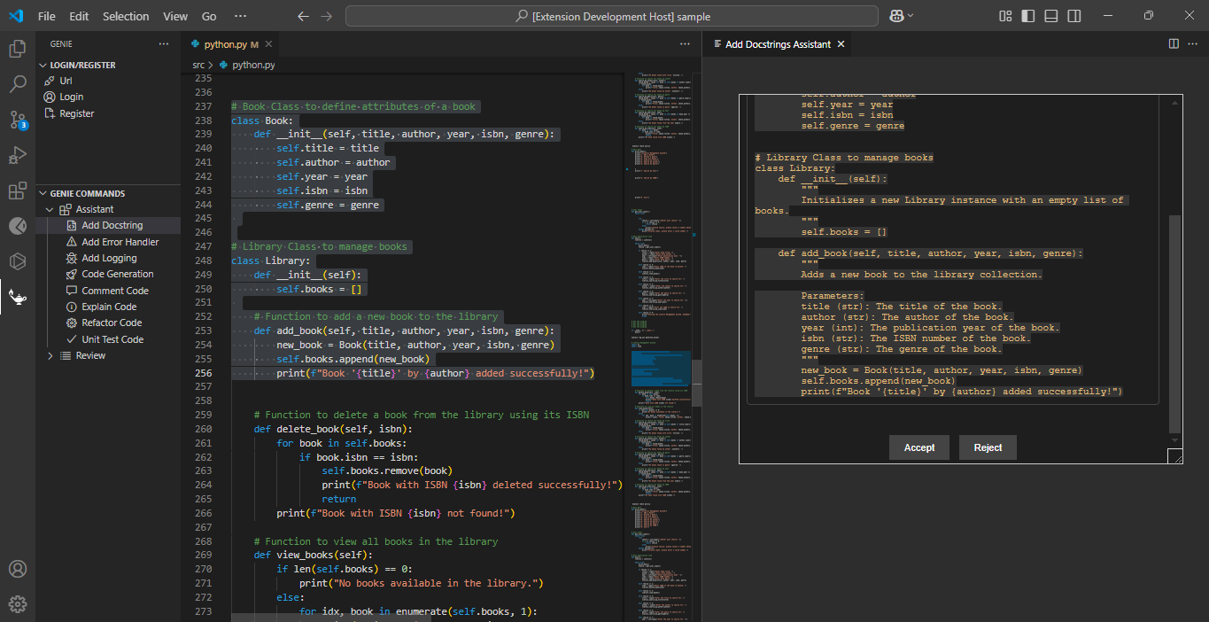  
  
  
  
  
  
  
On clicking ACCEPT, the existing code will be replaced with the resulting code and rejects the code on clicking REJECT.  
  
   
 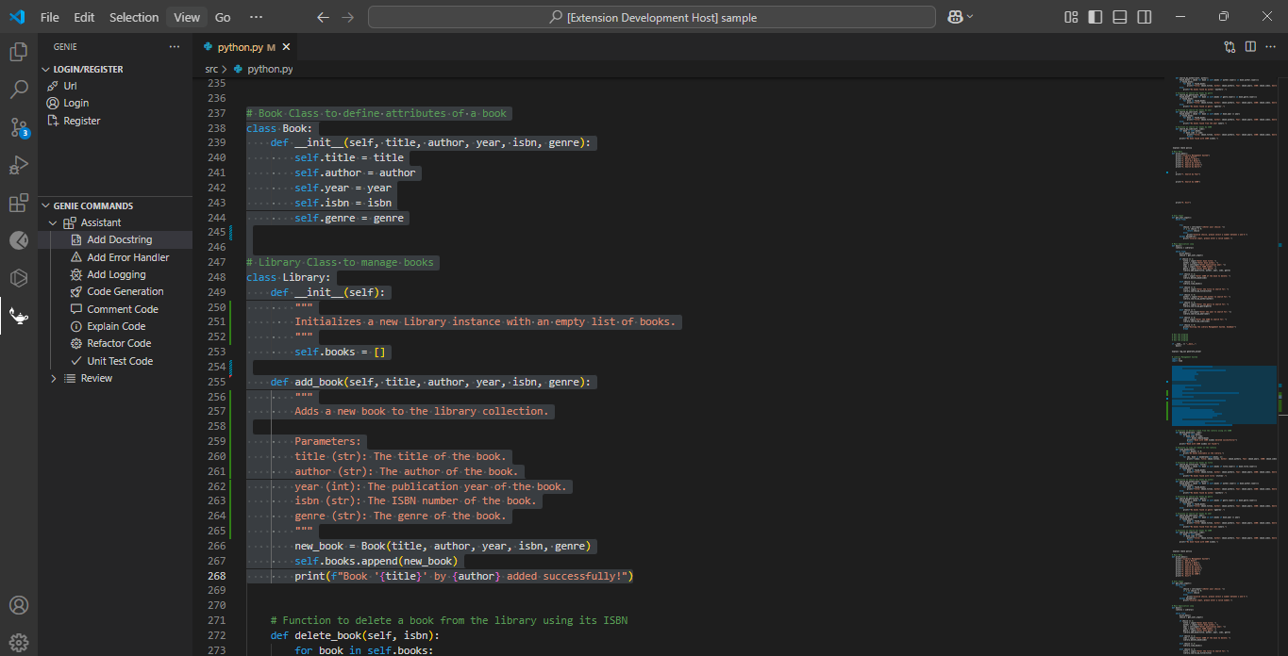  
  
**7. Genie Commands Category - Review Features :**  
  
The following are the different types of Review features available in the GENIE extension:  
1.**CK Review:** Evaluates the quality of the object-oriented code.  
2. **Code Overall Review**: Provides a comprehensive review of the entire code base.  
3. **Code Review**: Performs a focused review of the selected code snippet.  
4. **Tech Debt Review**: Identifies and highlights technical debt within the code.  
5. **Org Std Review**: Ensures the code adheres to organizational standards.  
6. **OWASP Review**: Evaluates the code for vulnerabilities based on OWASP security standards.  
7.**Performance Review**: Analyzes the code for performance bottlenecks and optimization opportunities.  
8. **Security Review**: Checks for potential security vulnerabilities in the code.  
9. **Syntax Review**: Validates the syntax of the code and ensures it meets standard conventions.  
 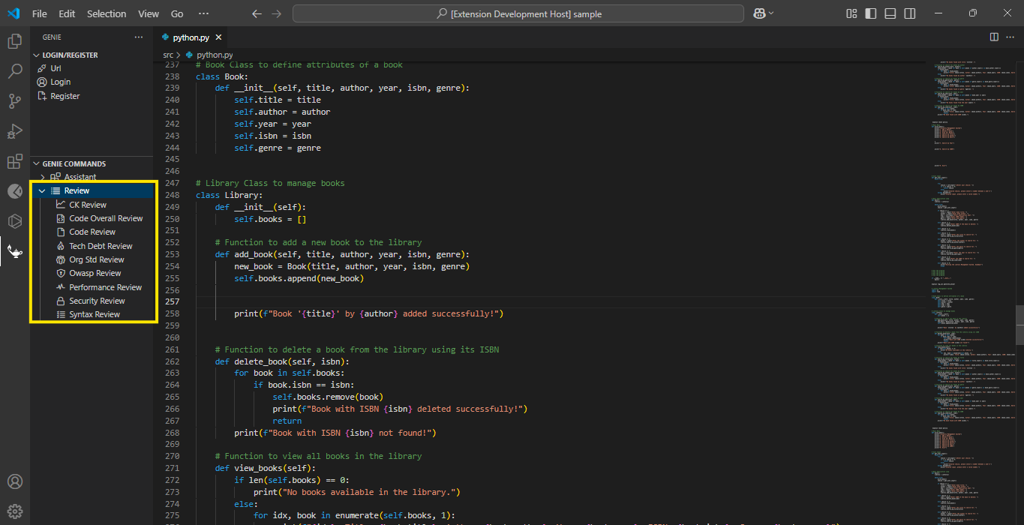  
  
To use any of these features:

* **Select the code snippet or file** you want to review.
* Choose the desired command from the **GENIE Review** section.
* The **review results** will be displayed in a **dedicated webview**, presenting details in a structured format, including:
  + **Summary:** Overall quality, remarks, and severity level.
  + **Issues:** Detailed breakdown with identification, suggested fixes, explanations, severity, and status.

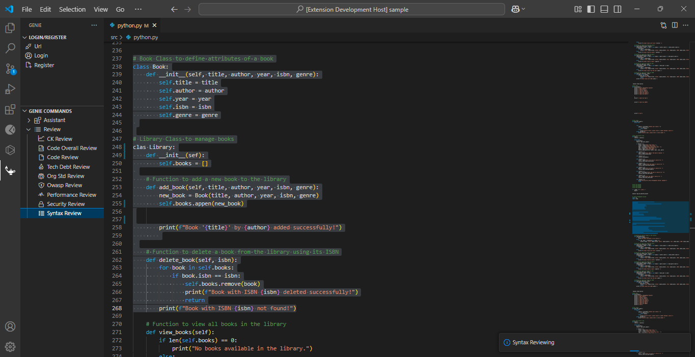  
  
  
  
This structured approach in the **webview** makes it easier to review, understand, and act on the findings efficiently.  
  
  
 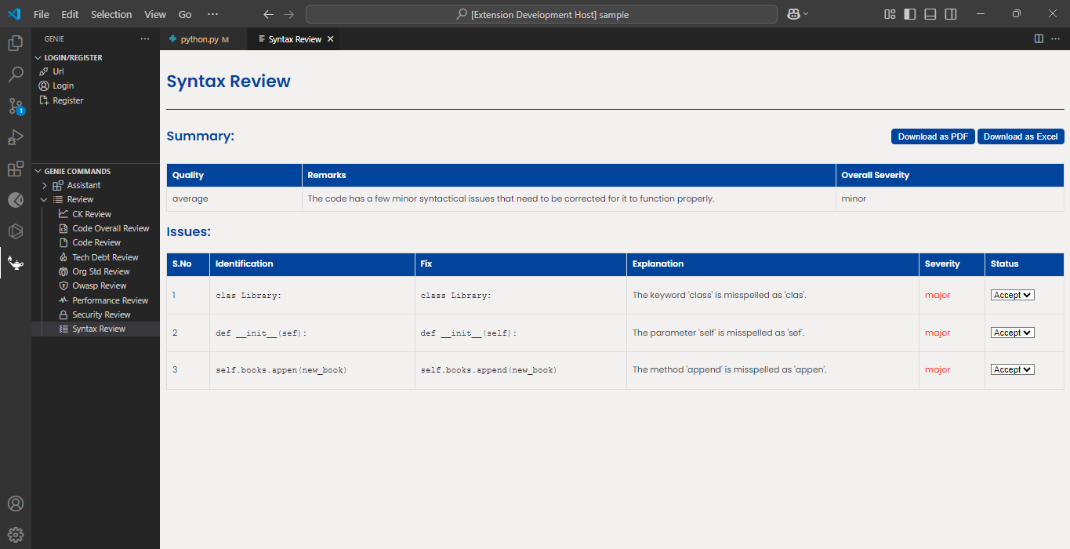

**8. Git Commit Feature :**  
  
The **Git Commit Feature** in the GENIE extension automates the setup and configuration of **Git hooks** to enable commit review functionalities. It focuses on **pre-commit** and **post-commit hooks** to ensure enhanced code quality. In brief, **pre-commit** and **post-commit** are Git hooks used to automate checks and actions before and after a commit.  
  
**Pre-commit Hook**:  
  
The pre-commit hook runs before a commit is finalized. It performs the following tasks:  
  
1. Checks for Python Installation: Ensures that Python or Python3 is installed in the system. If not installed, then it warns for installation.  
2. Get staged files: Retrieves the files that are staged for commit.  
3. Prepare JSON payload: Converts the staged files and their diff content into a JSON payload.  
4. Send to API: Sends the JSON payload to an API endpoint for review.  
  
5. Handle Response: Checks the response for any secrets or disallowed files. If any disallowed files are found then it aborts the commit immediately and if any secrets are found, it prompts the user to confirm whether to proceed with the commit.   
  
  
  
  
  
  
  
**Post-Commit Hook**:  
  
The post commit hook runs after a commit is finalized. It performs the following tasks:  
  
1. Get Commit details: Retrieves details about the commit, such as commit ID, branch and diff content.  
2. Prepare JSON payload: Converts the commit details into a JSON payload.  
3. Send to API: Sends the JSON payload to an API endpoint for review.  
4. Handle Response: Checks the response for the quality, remarks and severity of the commit. It also lists any issues identified in the commit.

**NOTE:**   
1. Please ensure that either Python or Python 3 is pre-installed on your system for the git   
commit feature to function as expected.  
  
2.If you encounter an error such as Internal server error followed by Argument list too long when attempting to commit code, please commit only one file at a time to avoid any issues and ensure a smooth process.  
  
 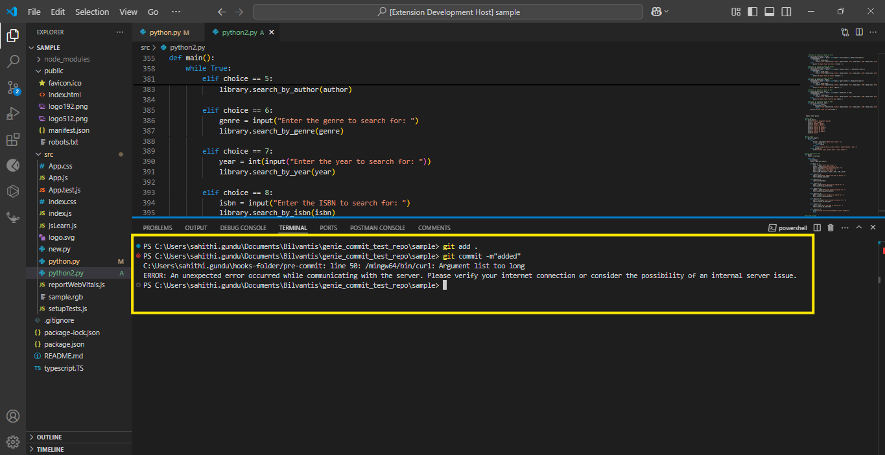

**11. Login/Register Category :**  
  
Unfortunately, if not authenticated at the beginning or start of the extension, access to Genie Commands will be restricted. Users will need to go to the Login/Register category, authenticate, and then they can access Genie Commands.  
  
  
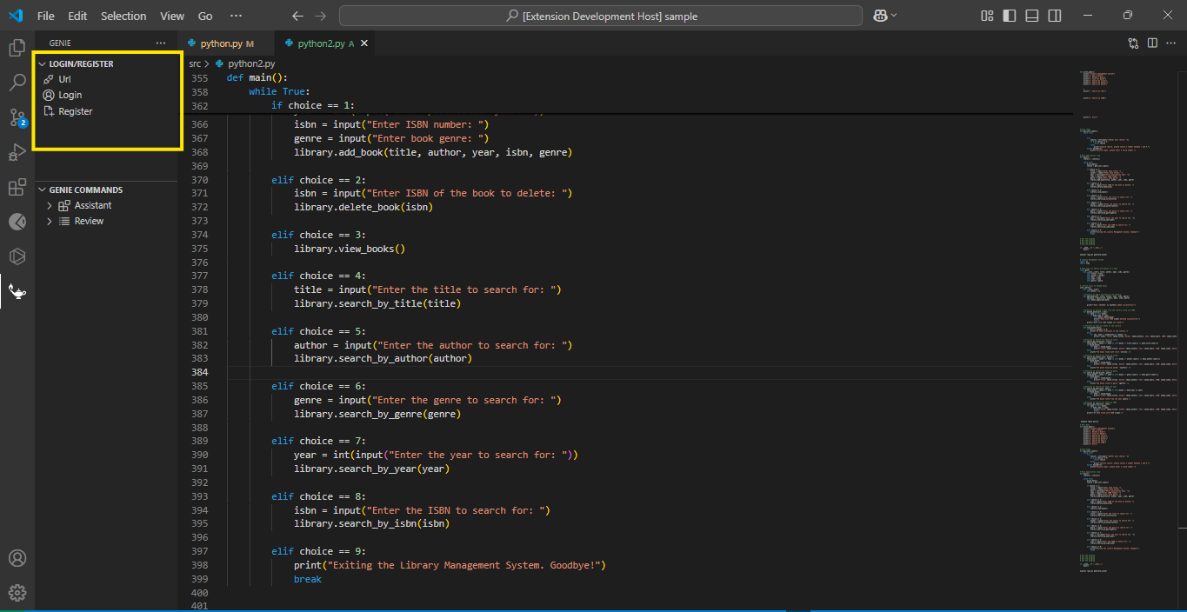  
  
  
  
  
  
**12. Uninstall the extension:**   
  
 Select the **GENIE** extension from the Extensions View and click on the **Uninstall** button and **Restart Extension** button to remove the extension from the VS Code environment.

After the uninstallation is complete, the GENIE extension will no longer appear in the Extensions view or the sidebar.

