C++
______________________________________________________________________________

Q. What is C++?
_____________________________________________________________
C++ is object-oriented programming language or C++ is a semi object-oriented programming language.

Q. What is object oriented?
________________________________________________________________________
Object oriented is a concept of programming or it is standard methodology in programming
based on four pillar and seven features.

Q. What is the Pillar of OOP?
______________________________________________________________
Pillar of OOP
1. Inheritance 2. Polymorphism 3. Database Abstraction 4. Encapsulation
Feature of OOP
1. class 2. object 3. inheritance 4. polymorphism 5. data abstraction and encapsulation
6. dynamic binding 7. message passing.

How to create Application by using C++
__________________________________________________________________
Steps to develop the using C++
1. Add iostream.h header file in code.
______________________________________________________________
#include<iostream.h>
iostream stands for input output stream and this file contain two types of classes name as
istream and ostream which help us to accept the input from keyboard and display output on output screen
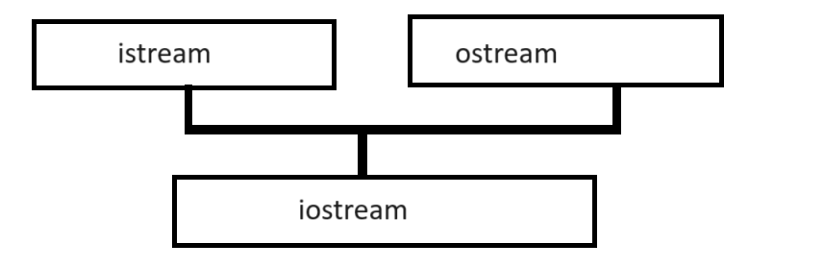

2. Write main function and its logic
_______________________________________________________________
void main()
{
}
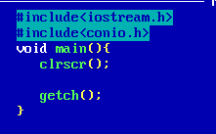

Example: WAP C++ to display good morning message
Note: if we want to display anything on output using C++ we have cout object of ostream class which help us to display output on output on output screen like as printf() in c

Syntax: cout<<”message”;
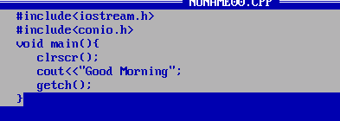

How to accept input from keyboard using C++
______________________________________________________________________________
If we want to accept input from keyboard using C++ we have cin object of istream class
this object help us to accept the input from keyboard like as scanf() in c

Syntax: cin>>variable1>>variable2>>……variable…n;

Example: we want to accept two values from keyboard and calculate its addition and display it on output screen.
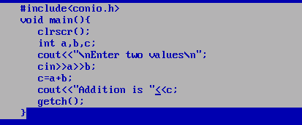

Example: WAP to input two values consider first as base and second as index and calculate its power.
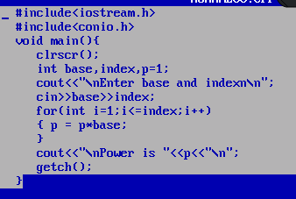

Example: WAP to input number and calculate its factorial using C++
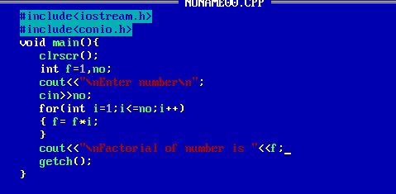
Example: we want to create array of size 5 store values in it and display it.
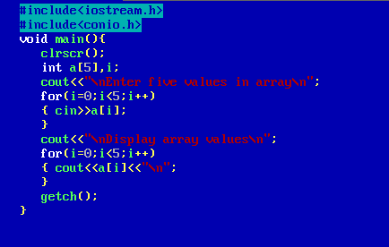

Polymorphism
__________________________________________________________________________

Q. what is polymorphism?
_________________________________________________________________
Polymorphism means if same thing performs different behavior in different situation as per the requirement called as polymorphism.

Example: Suppose if we think about mobile we can use it as calculator, as camera as map as tv etc
Means we single device can work different in different situation so we can say mobile is best example of polymorphism

Suppose consider if we think about person a single person can behave differently in different situation suppose if he is in office work as employee or boss if he is in friend behave like as friend if in house behave like as parent or child etc

How we can implement polymorphism in programming
______________________________________________________________________________
or how to achieve polymorphism by programming
________________________________________________________________________________
If we want to achieve polymorphism by programming, we have two ways

1. Compile time polymorphism: compile time polymorphism means if functionality bounded with object at program compile time called as compile time polymorphism.

There are two types of compile time polymorphism
_________________________________________________________________________
a. Function overloading.
b. Operator Overloading.
2. Runtime polymorphism: runtime polymorphism means if functionality bounded with object at program run time called as runtime polymorphism.
a) Function overriding.

Now we want to discuss about the function overloading
________________________________________________________________________________

Q. what is function overloading?
________________________________________________________________________
Function overloading means if we define multiple functions with same name with different data type with different parameter list with different parameter sequence called as function overloading.

Example of function overloading
______________________________________________________________________
void add(int x,int y);
void add(float x,float y)
void add(float x,int y)
etc void add(int x,float y)

If we want to work with function overloading, we have some important rules.

1. Function name must be same
2. Return type is not considered in function overloading
Note: In C++ in the case function overloading return type may be different with different function definition.
There is no compulsion return type of function overloading must be same.
3. Parameter type or number of parameter or parameter sequence may be different in every function overloading.
4. Function calling is dependent on parameter type or sequence of parameter or number of parameters in function.
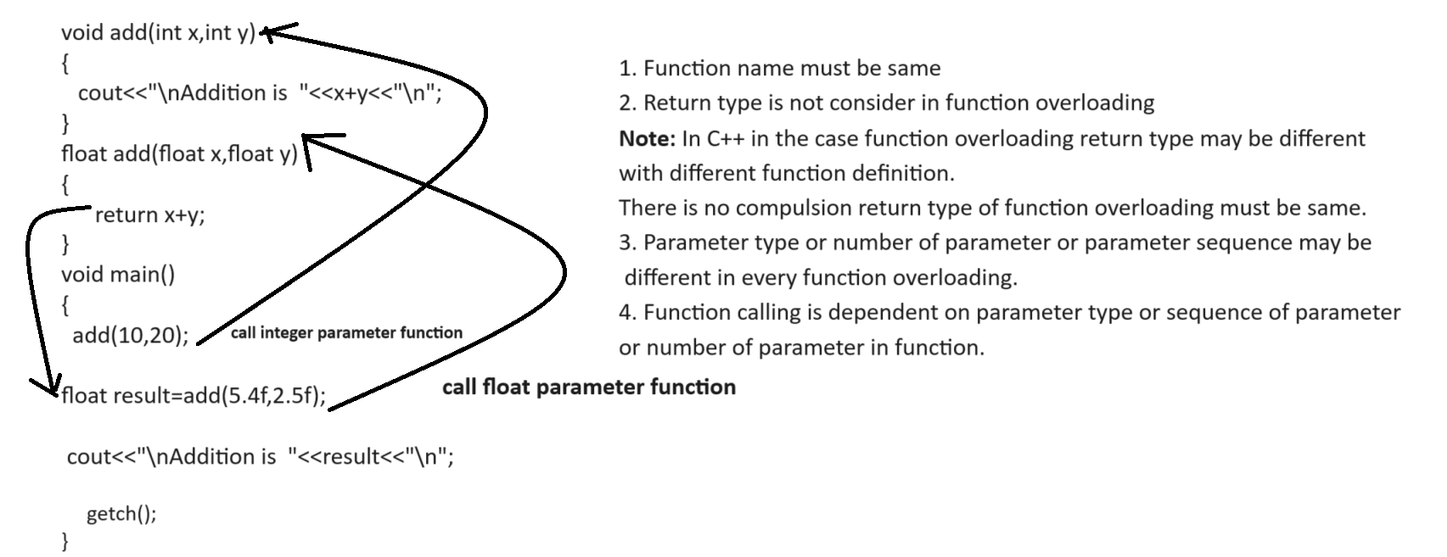

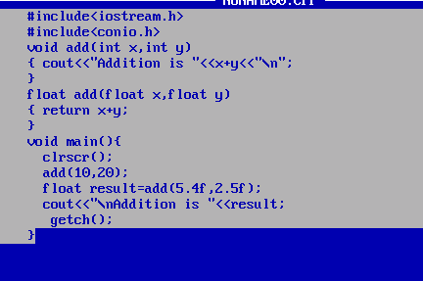

Example: Write a program using function overloading
void sort(int a[]): this function accept integer array and sort it.
void sort(char[]): this function accept character array and sort it.

#include<iostream.h>
#include<conio.h>
#include<string.h>
void sort(int a[])
{
for(int i=0; i<5;i++)
{
for(int j=(i+1);j<5;j++)
{
if(a[i]>a[j])
{ int temp=a[i];
a[i]=a[j];
a[j]=temp;
}
}
}
}
void sort(char ch[])
{
int len=strlen(ch);
for(int i=0;i<len;i++)
{
for(int j=(i+1);j<len; j++)
{
if(ch[i]>ch[j])
{
char temp=ch[i];
ch[i]=ch[j];
ch[j]=temp;
}
}
}
}
void main(){
clrscr();
int a[5];
char ch[90];
cout<<"\nEnter values in integer array\n";
for(int i=0;i<5;i++)
{ cin>>a[i];
}
cout<<"\nEnter data in character array\n";
cin>>ch;
cout<<"\nBefore sorting integer data\n";
for(i=0;i<5;i++)
{ cout<<a[i]<<"\t";
}
cout<<"\nBefore sorting character data\n";
cout<<ch<<"\n";
sort(a);//call integer array function
sort(ch);//call character array function
cout<<"\nAfter sorting integer data\n";
for(i=0;i<5;i++)
{ cout<<a[i]<<"\t";
}
cout<<"\nAfter sorint character data\n";
cout<<ch;
getch();
}

Q. Why use function overloading or what is benefit of function overloading?
____________________________________________________________________
The major benefit of function overloading if we have multiple logics using particular domain or we have some application under same domain with different logic then we required to write different function for every logic using different function name then the problem is it is very tedious task to remember every function name and its parameter so better way you can write different logic in different function but give function name same to all logics so the benefit is not need to remember different function name.

Example: Suppose consider we are working on billing application and the customer required different types of bill.

void bill(int qty,int rate,int gstRate)
void bill(int qty,int rate)

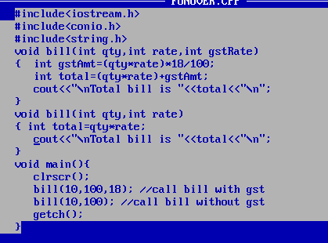

Assignment:
Q. WAP to create function name as search()
int search(int a[],int key): this function accept integer array and one search key and search value in array and if value found return its index and if value not found return -1
int search(char ch[],char key): this function accept character array and one search character key and if value found in array return its index otherwise return -1

Q. WAP create function name void reverse() using overloading
void reverse(int a[]): this function is used for reverse the array
void reverse(char[]): this function is used for reverse character array

