Inheritance
_______________________________________________________________
Inheritance means transfer the properties of one class to another class called as inheritance. Property sender class known as parent class and property receiver class known as child class.
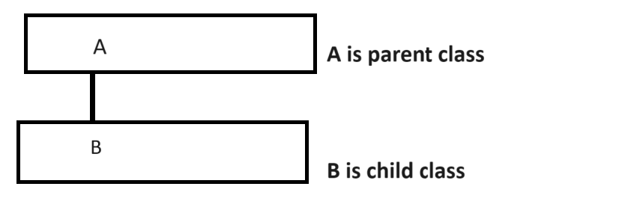
Q. Why use inheritance or what is benefit of inheritance?
______________________________________________________________
There are two benefits of inheritance
1. Reusability: Reusability means we can declare the class only once and we can reuse it more than one time without creating its object.
Means normally if we think about inheritance if we have some common logics and if we use required logic in multiple places then we can mention the logic in parent class and we can reuse in multiple child classes.
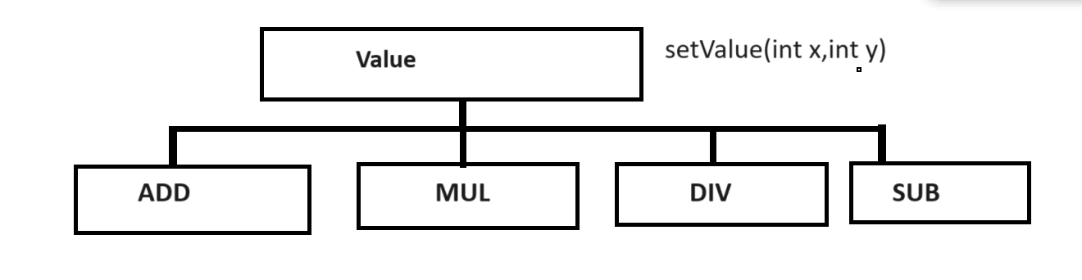
If we think about above diagram we have Value class and it is parent class of Add , Mul , Div , Sub and Value class contain method name as setValue() which is common method present in all child classes.
Means we can say we reuse setValue() function in four different classes.

2. Extensibility: Extensibility means acquire the properties from parent class and some own properties called as extensibility.
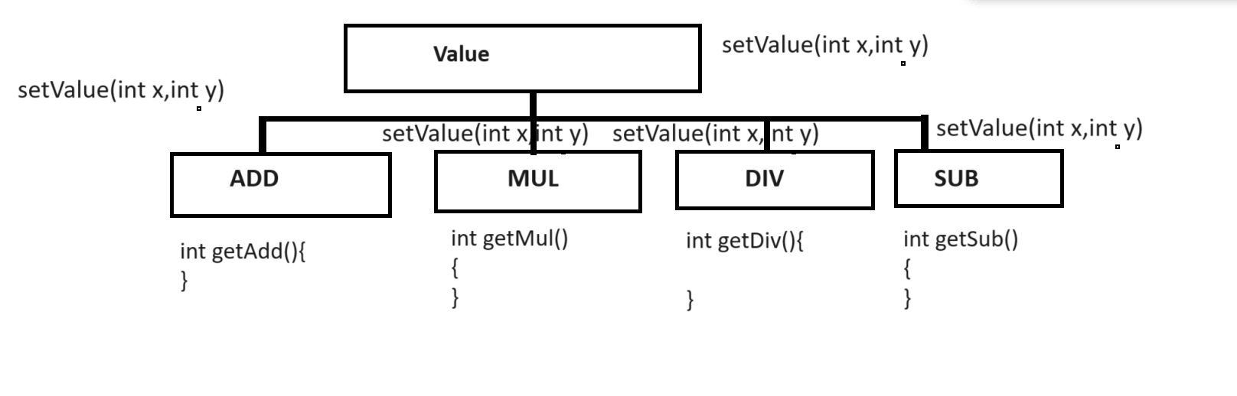
Note: if we think about above diagram we have Value class which is parent of all child classes name as Add Mul Div Sub means all contain one common method name as setValue() but every class has own function like int getAdd(), int getMul(), int getDiv() and getSub() means every child class acquire the some properties from parent and add own properties so this behavior known as extensibility.

How to perform inheritance practically
_________________________________________________________
class parentclassname
{
};
class childclassname: access specifier parentclassname{
};
Example:
class Add
{ protected:
int a,b;
public:
void setValue(int x,int y)
{ a=x;
b=y;
}
};
class Mul:public Add
{ public:
int getMul(){
return a+b;
}
};
If we want to work with inheritance we have some types of inheritance.

Types of inheritance
1. Single level inheritance: Single level inheritance means there is only one base class and only one child class called as single level inheritance.
A – Parent class
|
B – Child class
2. Multi level inheritance: Multi level inheritance means one class is parent of another and child of another and there is one pure base class and one pure child class called as multilevel inheritance.

A -- Pure parent or main parent
|
B
|
C
|
D ----- pure child class

3. Multiple Inheritances: Multiple inheritance means there is more than one parent classes and single child class called as multiple inheritances.
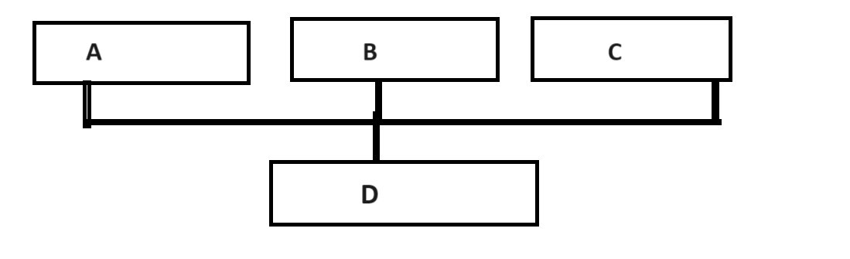

4. Hierarchical Inheritance: Hierarchical inheritance means there is only one parent class and more than one child classes called as hierarchical inheritance.
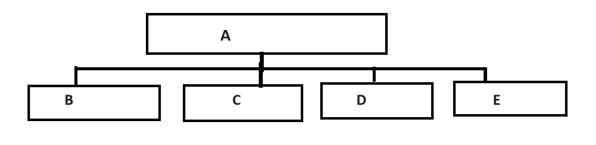
5. Hybrid inheritance: Hybrid inheritance is combination of all types of inheritance or all kind of inheritance.
The major limitation of hybrid inheritance is main parent class content may be duplicated in last child class through the intermediate classes and if we try to create object of last child class and to call parent method by using last child class compiler may be get confused and if we want to solve this problem we have new concept called as virtual class.
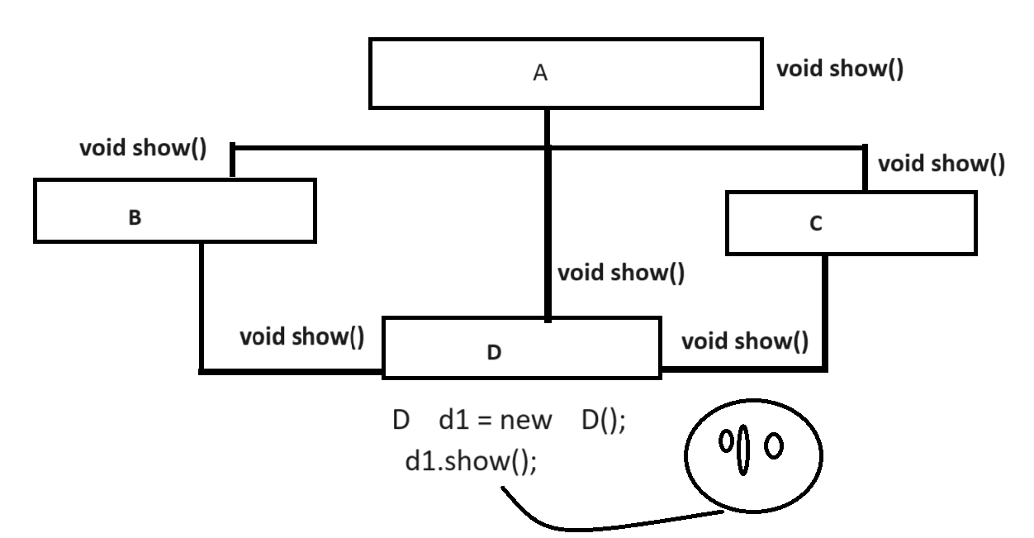

Note: if we think about above diagram we have four classes name as A, B, C and D and we inherit class A in class B and class A in class C and we inherit class B and class C in class D as well as we direct inherit class A in class D so the class A contain void show() so this method present in class B because B is child of A and show() method present in class C because A is parent of C and show method present three times in class D because first time D use show() from B class , 2nd B use show from A and third B use show() from C means D contain three times show method and when we create object of class D and try to call show() method then compiler cannot predicate which show should call means call show() from ,or C or A so it is called as ambiguity problem and compiler will generate compile time error to us so we can resolve this problem by using virtual class concept.

Note: In the case of inheritance we not need to create object of parent class we can use the parent member or parent content by using child class object.

Example of hierarchical inheritance
__________________________________________________________________
We want to design Calculator with two operations Add and Mul
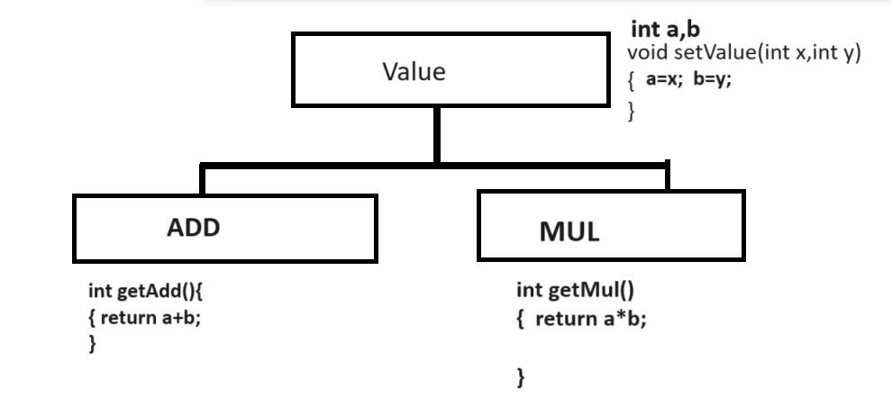

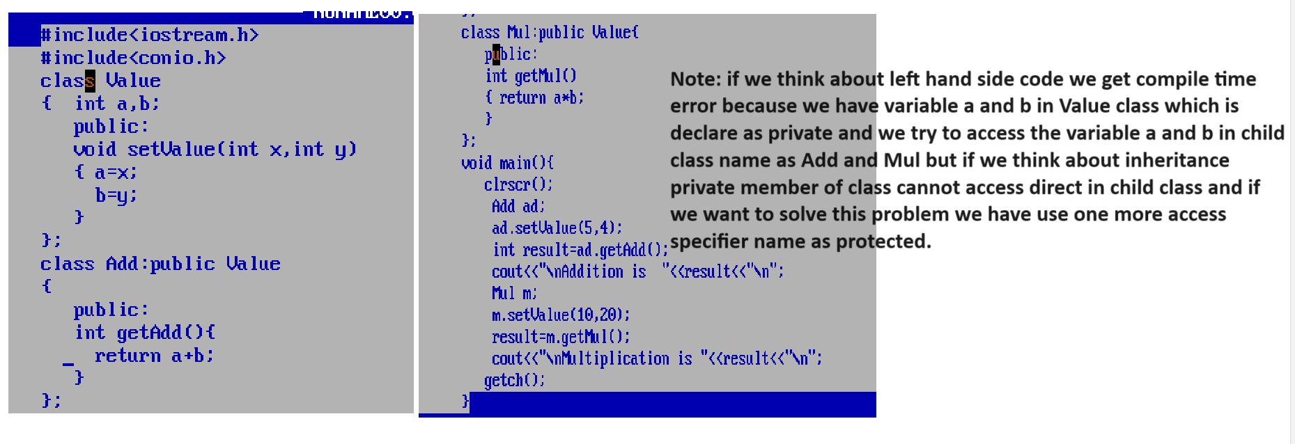

Use of Protected access specifier shown in following code
#include<iostream.h>
#include<conio.h>
class Value
{ protected:
int a,b;
public:
void setValue(int x,int y)
{ a=x;
b=y;
}
};
class Add:public Value
{
public:
int getAdd(){
return a+b;
}
};
class Mul:public Value{
public:
int getMul()
{ return a*b;
}
};
void main(){
clrscr();
Add ad;
ad.setValue(5,4);
int result=ad.getAdd();
cout<<"\nAddition is "<<result<<"\n";
Mul m;
m.setValue(10,20);
result=m.getMul();
cout<<"\nMultiplication is "<<result<<"\n";
getch();
}

Example: WAP to create parent class name as Array with method
void setArray(int a[]): this method accept array as parameter
and we have one more child class name as Sort with method name as
void sortAscending(): this method accept the array from parent class and perform sorting on it in ascending order

Example: WAP to create class name as CharArray with method
void setCharArray(char[]): this method can accept character array as parameter
and two child classes name as FindLength and ReverseString
FindLength class contain method int getLen() this method can calculate the length of string and return it and ReverseString contain method name as
void reverse(): this method can reverse the string and display it.

Example: WAP to create class name as Number with method void setValue(int no)
and create three child class name as Factorial with method int getFactorial() this method can calculate factorial of number and return it and one more child class name as Reverse with method int getRev() this method can reverse the number and return it and one more child class name as CountDigit with method
int getCount(): this method can count number of digit present in number and return it.

Example of multiple inheritances
_______________________________________________________________
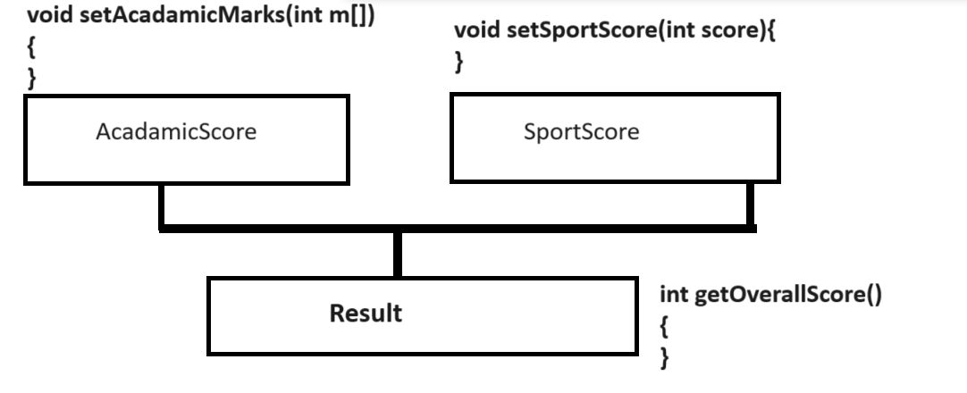

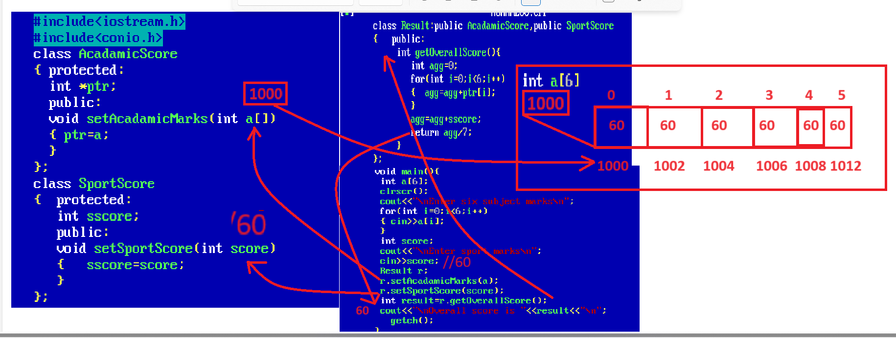

Example of Multi level inheritance
_______________________________________________________________
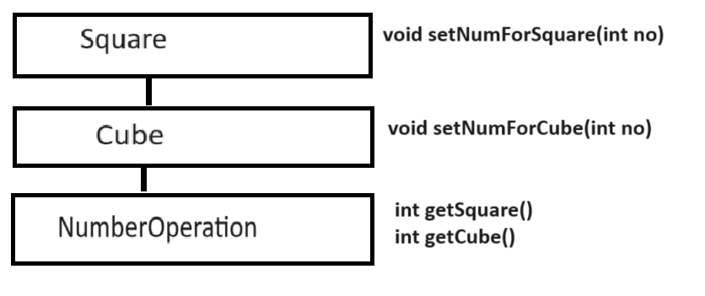
Example with source code
#include<iostream.h>
#include<conio.h>
class Square
{ protected:
int no;
public:
void setNumForSquare(int no)
{ this->no=no;
}
};
class Cube:public Square
{ protected:
int cno;
public:
void setNumForCube(int no)
{ cno=no;
}

};
class NumberOperation:public Cube
{ public:
int getSquare(){
return no*no;
}
int getCube(){
return cno*cno*cno;
}
};
void main(){
clrscr();
NumberOperation nop;
nop.setNumForSquare(10);
int sqResult=nop.getSquare();
cout<<"\nSquare is "<<sqResult<<"\n";
nop.setNumForCube(5);
int cResult=nop.getCube();
cout<<"\nCube is "<<cResult<<"\n";
getch();
}

Single level inheritance
_______________________________________________________________
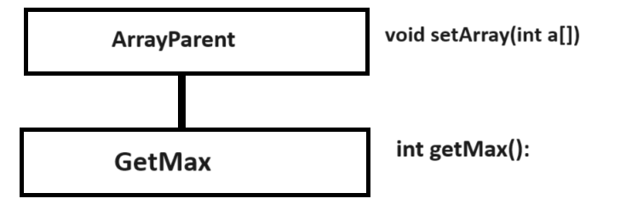

Example: find max value from array by using single level inheritance
#include<iostream.h>
#include<conio.h>
class ArrayParent
{ protected:
int *ptr;
public:
void setArray(int a[])
{ ptr=a;
}
};
class GetMax:public ArrayParent
{ int max;
public:
int getMax(){
max=ptr[0];
for(int i=0;i<5;i++)
{
if(ptr[i]>max)
{ max=ptr[i];
}
}
return max;
}
};
void main(){
clrscr();
int m[5];
cout<<"\nEnter five values in array\n";
for(int i=0;i<5;i++)
{ cin>>m[i];
}
GetMax g;
g.setArray(m);
int maxValue=g.getMax();
cout<<"\nMax value is "<<maxValue<<"\n";
getch();
}

Hybrid inheritance
__________________________________________________________
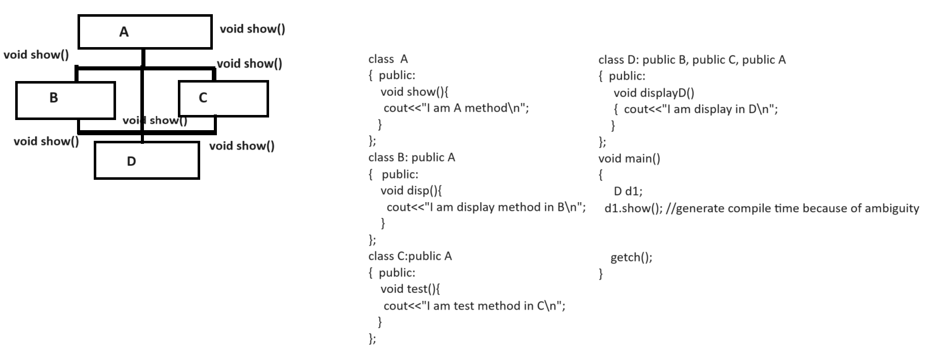
If we think about above diagram we get compile time error because we try to call show () method by using last child object and show () method contain three version in class D one from class A, one from class B and one from class C so compiler get confused about which version should call and if we want to solve this problem we have to use virtual class concept.
Note: we have to use virtual keyword where we want inherit main parent class.

#include<iostream.h>
#include<conio.h>
class A
{ public:
void show()
{ cout<<"I am A show method\n";
}
};
class B:virtual public A
{ public:
void disp()
{ cout<<"I am display method\n";
}
};
class C: virtual public A
{
public:
void display()
{ cout<<"I am display C method\n";
}
};
class D:public B,public C
{ public:
void test()
{ cout<<"I am test method of D\n";
}
};
void main(){
clrscr();
D d1;
d1.show();//
getch();
}
Constructor in inheritance
________________________________________________________
If we have constructor in parent class and constructor in child class and if parent class contain default constructor and if we create object of child class then parent constructor get executed automatically before child class constructor.

Example:
#include<iostream.h>
#include<conio.h>
class A
{ public:
A()
{ cout<<"I am parent class constructor\n";
}
};
class B: public A
{ public:
B()
{ cout<<"I am child class constructor\n";
}
};
void main(){
clrscr();
B b1;

getch();
}
If we think about above code we have constructor in parent class and constructor in child class and we create object of child class but parent constructor get executed before child class constructor.

Note: When we have parameter preset in parent class constructor and if we create object of child class then child constructor has responsibility to pass parameter to parent constructor and for that we can use base class constructor concept shown in following code.
How to use base class constructor concept
_____________________________________________________________
class childclassname: access specifier parent classname
{ public:
childclassname(parameter):parentclassname(parameter)
//base class constructor concept
{
}
};
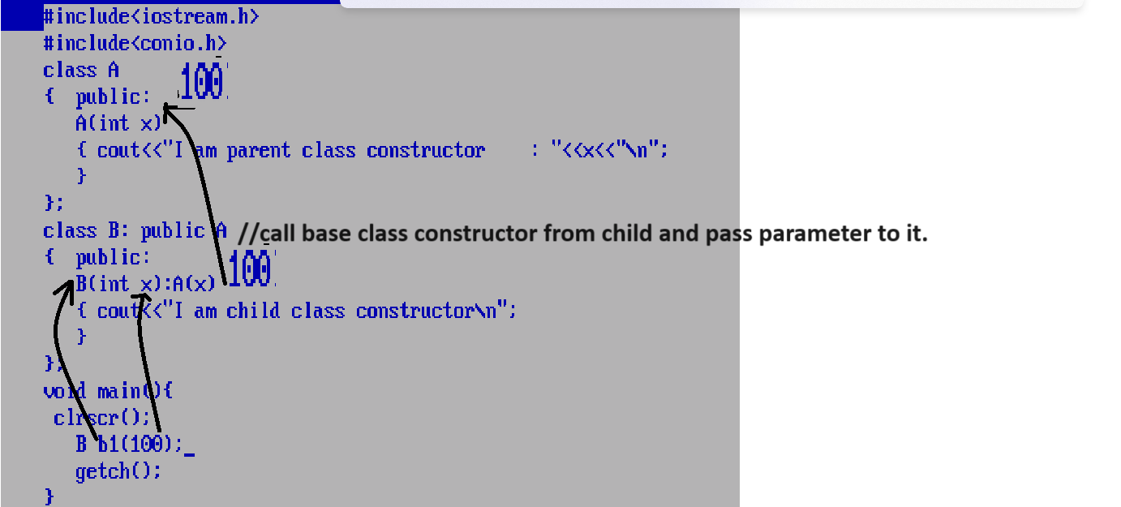

Example: Consider we have two classes name as CharP with parameterized constructor
CharP(char []): this constructor accept character array as input
We have one more child class name as CharC with parameterized constructor
CharC(char[]): this constructor accept character array as parameter
int getLength(): this constructor can calculate the length of string and return it.

#include<iostream.h>
#include<conio.h>
class CharP
{ protected:
char *ptr;
public:
CharP(char ch[])
{ ptr=ch;
}
};
class CharC:public CharP
{
public:
CharC(char ch[]):CharP(ch)
{ ptr=ch;
}
int getLength(){
int count=0;
while(*ptr!='\0')
{ ptr++;
++count;
}
return count;
}
};
void main(){
clrscr();
char ch[90];
cout<<"\nEnter chracter array from keyboard\n";
cin>>ch;
CharC c(ch);//
int l=c.getLength();
cout<<"\nLength of string is "<<l<<"\n";
getch();
}
Method overriding
________________________________________________________________
Method overriding means if we define the method within parent class and redefine same method again in child class called as method overriding.
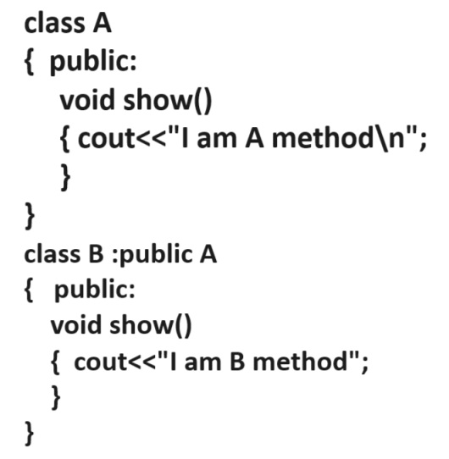
Note: if we think about method overriding if we create object of child class and try to call overridden method then by default child logic get executed.
Example with source code
#include<iostream.h>
#include<conio.h>
class A
{ public:
void show()
{ cout<<"I am A show method\n";
}
};
class B: public A
{ public:
void show()
{ cout<<"I am B show method\n";
}
};
void main()
{ clrscr();
B b1;
b1.show();
getch();
}

Q. Why we need to use method overriding?
___________________________________________________________________
There are two reasons to use method overriding
1. Customize the parent logic as logic as per the requirement of child class.
2. To Achieve dynamic polymorphism.

Customize the parent logic as logic as per the requirement of child class
______________________________________________________________
Some time we need to modify the parent logics in child class as per the requirement of child class then we can use method overriding concept.
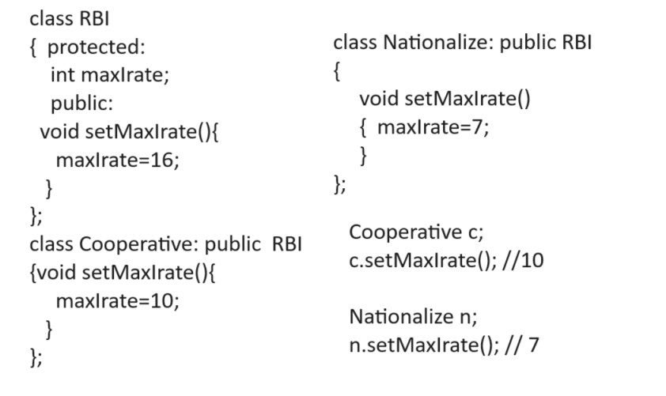

Example with source code.
#include<iostream.h>
#include<conio.h>
class RBI
{ protected:
int maxIrate;
public:
void setMaxIrate()
{ maxIrate=16;
}
};
class Cooperative:public RBI
{ public:
void setMaxIrate()
{ maxIrate=10;
}
void showCooperative(){
cout<<"\nMax interest rate is "<<maxIrate<<"\n";
}
};
class Nationalize:public RBI
{ public:
void setMaxIrate()
{ maxIrate=7;
}
void showNationalize(){
cout<<"\nMax interest rate is "<<maxIrate<<"\n";
}
};
void main()
{ clrscr();
Cooperative c;
c.setMaxIrate();
c.showCooperative();
Nationalize n;
n.setMaxIrate();
n.showNationalize();
getch();
}

Example: Suppose consider we want to develop the marksheet generation application for HighSchool and we want to generate marksheet for Eight, Nine and Tenth class and every class has six subject for exam so we need generate percentage according exam marks obtain by students but if we think about Tenth class then there is best of five scheme means student should attend exam of six subjects but calculate his percentage using five subject with best score
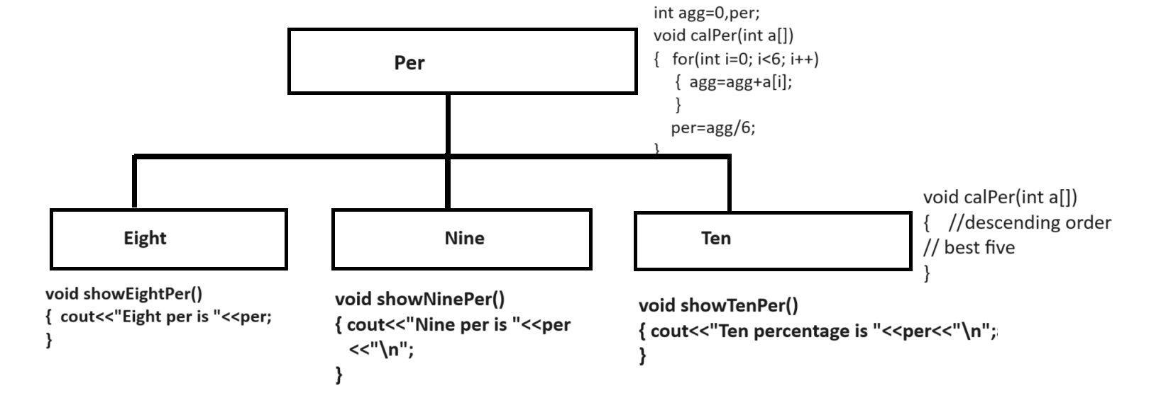

Note: if we think about method overriding we required using parent logics in method overriding case then we can call parent from child class using following syntax
Syntax: Parentclassname::method name (arguments);

#include<iostream.h>
#include<conio.h>
class Per
{ protected:
int per;
public:
void calPer(int a[])
{ int agg=0;
for(int i=0;i<6;i++)
{ agg=agg+a[i];
}
per=agg/6;
}
};
class Eight:public Per
{
public:
void showEightPer()
{ cout<<"\nEight percentage is "<<per<<"\n";
}
};
class Nine:public Per
{
public:
void showNinePer()
{ cout<<"\nNine percentage is "<<per<<"\n";
}
};
class Ten:public Per
{ int year;
public:
void askPassYear(int year)
{ this->year=year;
}
void calPer(int a[])
{
if(year>2010){
for(int i=0;i<6;i++)
{
for(int j=(i+1);j<6;j++)
{
if(a[i]<a[j])
{ int temp=a[i];
a[i]=a[j];
a[j]=temp;
}
}
}
int agg=0;
for(i=0;i<5;i++)
{ agg=agg+a[i];
}
per=agg/5;
}
else{
Per::calPer(a);
}
}
void showTenPer()
{ cout<<"\nTen percentage is "<<per<<"\n";
}
};
void main()
{ clrscr();

int a[]={60,70,80,90,60,50};

Eight e;
e.calPer(a);
e.showEightPer();

Nine n;
n.calPer(a);
n.showNinePer();

Ten t;
t.askPassYear(2009);
t.calPer(a);
t.showTenPer();

getch();
}

Abstract class and Abstract method using C++
_______________________________________________________________________
Abstract class means class cannot create its object and abstract method means method cannot have logics.
How to declare abstract method by using C++
___________________________________________________________________
If we want to declare abstract method by using C++ we have pure virtual function concept.

Syntax: virtual returntype functionname(arguments)=0;

Note: if we declare pure virtual function in any class then class mark as abstract class and we cannot create object of abstract class.

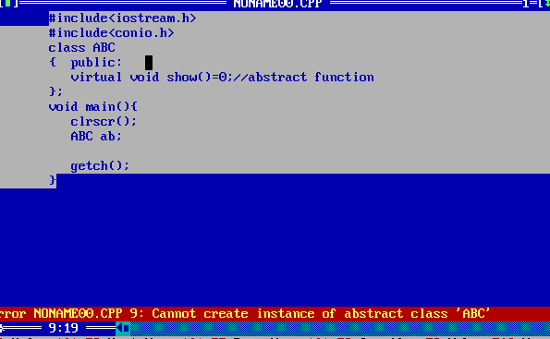
Q. Why use abstract class and abstract function?
________________________________________________________________
1. Achieve abstraction:
2. Achieve dynamic polymorphism.

Q. what is abstraction?
_____________________________________________________________________
Abstraction means to hide the implementation detail from end user at design level called as abstraction.
Means in the case of abstraction we not provide the any logical statement in method just we provide its template or prototype.
Means in the case of abstract we not write any logic in any parent we write logic in child class as per the requirement of child just we need to override abstract method from parent to child class

Example: Suppose consider we are going to design application for Vehicle manufacturing company and company manufacture two wheelers and four wheelers so we can say two wheeler is Vehicle and Four wheeler is also vehicle so two wheeler has engine and four wheeler also has engine means Vehicle has engine but every vehicle has different design of engine so we can say engine () is abstraction because every vehicle must have but engine design vary vehicle to vehicle shown in following code.

Example:
class Vehicle
{public:
virtual void engine()=0;
};
class Bike:public Vehicle
{
public:
void engine()
{ cout<<"200 CC"<<"\n";
}
};
class Car :public Vehicle
{
public:
void engine()
{ cout<<"1000 CC"<<"\n";
}
};
If we think about above code we have two classes name as Bike and Car and we override
engine() method in Bike class and in Car class means we write different logic of engine() method in Bike class and different logic in engine() method in Car class using method overriding technique so this major abstract must be override.

Example with source code
#include<iostream.h>
#include<conio.h>
class Vehicle
{
public:
virtual void engine()=0;
};
class Bike:public Vehicle
{
public:
void engine()
{ cout<<"200 CC"<<"\n";
}
};
class Car:public Vehicle
{ public:
void engine()
{ cout<<"1000 CC"<<"\n";
}
};
void main(){
clrscr();
Bike b;
b.engine();
Car c;
c.engine();

getch();
}

Example with source code
#include<iostream.h>
#include<conio.h>
class Value
{ protected:
int a,b;
public:
void setValue(int x,int y)
{ a=x;
b=y;
}
virtual int getResult()=0;
};
class Add:public Value
{
public:
int getResult()
{ return a+b;
}
};
class Mul:public Value
{
public:
int getResult()
{ return a*b;
}
};
void main(){
clrscr();
Add ad;
ad.setValue(10,20);
int result=ad.getResult();
cout<<"\nAddition is "<<result<<"\n";
Mul m;
m.setValue(10,20);
result=m.getResult();
cout<<"\nMultiplication is "<<result<<"\n";
getch();
}

If we want to work with abstract or abstract method and abstract class we have some important points.

1. Abstract class cannot create its object
2. Abstract method cannot have logics
3. If abstract class contains more than one abstract method then all method must be override where abstract class get inherit and if we not required any method then we must be override it as blank.

#include<iostream.h>
#include<conio.h>
class A
{ public:
virtual void show()=0;
virtual void display()=0;
};
class B:public A
{ public:
void show()
{ cout<<"I am show method in B class\n";
}
};
class C:public A
{ public:
void display()
{ cout<<"I am display method in C class\n";
}
};
void main(){
clrscr();
B b1;
b1.show ();
C c1;
c1.display ();
getch();
}
Note: Above code generate the compile time error to us because we have abstract class name as A which contain two abstract method name as show() and display() and we inherit this class in B and in C and we override show() method in class B and display() method in class C but the rule is override all abstract method from parent class but we not override all methods so we get compile time error.

If we want to solve this problem we have two solutions
_____________________________________________________________________
1. Override unused methods as blank.
#include<iostream.h>
#include<conio.h>
class A
{ public:
virtual void show()=0;
virtual void display()=0;
};
class B:public A
{ public:
void show()
{ cout<<"I am show method in B class\n";
}
void display(){
}
};
class C:public A
{ public:
void display()
{ cout<<"I am display method in C class\n";
}
void show()
{
}
};
void main(){
clrscr();
B b1;
b1.show();
C c1;
c1.display();

getch();
}
Note: the limitation of this approach is if we have abstract class with 10 abstract methods and if we have 5 child classes and every child required 1 abstract method then we need to override 9 blank method in every child class means we required to override 50 methods from parent class and 45 blank method so it is waste of time and unnecessary code or boilerplate code.
So we can use the one more concept known as adapter class.
2. Use Adapter class concept
__________________________________________________________________________

Q. what is adapter class?

