Servlet
_______________________________________________________________________
Q. what is Servlet?
_______________________________________________________________________________
Servlet is a java based server side technology which is used for develop the dynamic web pages

Q. What is a server side technology?
____________________________________________________________________________
Those technology need server for execute its application called as server side technology.

Q. what is server?
______________________________________________________________________
Server is application or software which is used for manages the user application at central location and accept request from client application and provide response to client application.
Some of server application 1. Apache tomcat 2. glassfish 3. web logic etc

Q. What is client?
____________________________________________________________________
Client is application which is used for send the request to server and accept response server
In the case of web technology browser work as client application or software

Q. What is client side technology?
Client side technology means those technologies need a client for execute its application called as client side technology.
HTML, CSS, JS is best of example of client side technology or languages

Q. How client send request to server?
_________________________________________________________________________
Client application send request to server application with the help of protocol.

Q. what is protocol?
__________________________________________________________________________
Protocol means some standard rules and regulation for communication between two different parties called as protocol

Types of protocol
http: hyper text transfer protocol and this protocol normally used in web technology and send request in the form of html or text format.
https: hyper text transfer protocol security layer
TCP/IP : Transfer control protocol / internet protocol it is used for send the data between client and server in the form of packets.
FTP : File transfer protocol it is used for upload the file on server or download the data from server
POP3 : Post office protocol it is used for read the mail and store as post office local machine of users.
Example: outlook
SMTP : SMTP simple mail transfer protocol it is used for send the mail
etc

Q. What are dynamic web pages?
___________________________________________________________________________
Dynamic web pages means those web pages connected with database and render data from database and update on web page called as dynamic web pages.

Q. what is static web pages?
_________________________________________________________________________
Those pages not connected with database and cannot modify its content at run time called as static web pages.

How to develop the servlet application or How to create Servlet application
_______________________________________________________________________________
Steps to develop application by using servlet

1. Installed Apache tomcat as web server
_________________________________________________________________
Apache tomcat work as web server so we required to install apache tomcat
You can download the apache tomcat using following URL
https://tomcat.apache.org/download-90.cgi

When we installed the server then at the time of installation we required to provide two port numbers 1. Server shut down port 2. Server connector port

Q. What is port number and why we need to provide port number to server?
____________________________________________________________________________________
Port number is unique identity of server in network and it is used for identify for server in machine because there is possibility single machine can have more than on server and if we want to access particular server then we provide unique number to that for identification purpose called as port number and when we installed the apache tomcat then we have 8080 is default connector port and default ip address is machine is 127.0.0.1 or localhost

There are two types of port number
____________________________________________________________________________
Connector port: connector port means it used for start the server
Shutdown port: it is used for stop the server execution

If we want to check your server is running or not then you can check from services of computer

If we found apache tomcat running in services consider your server installed properly and in running stage.

http://localhost:9090/
If we get following screen we can consider server running properly
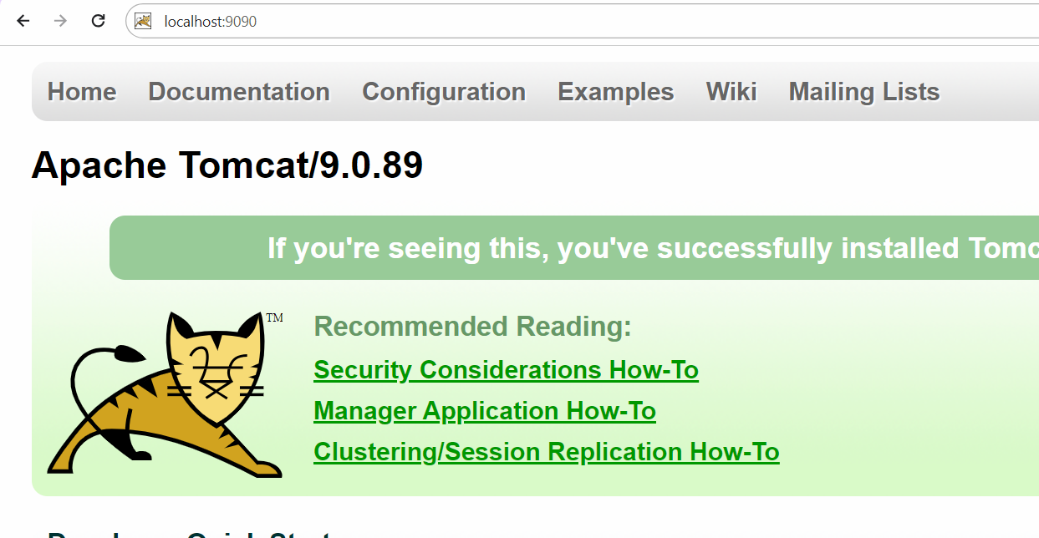
2. SET CATALINA_HOME path
_____________________________________________________________________________
CATALINA means tomcat and CATALINA_HOME tomcat root folder directory where we installed it.

How to set the CATALINA_HOME path
_______________________________________________________________________
Search menu --- advanced system setting ---- click on environmental variable ---- select system variable ----- click on new button --- variable name =(CATALINA_HOME) and variable value=path of tomcat where we installed it (e.g : C:\Program Files\Apache Software Foundation\Tomcat 9.0)

3. SET servlet-api.jar class path
____________________________________________________________________
Q. what is servlet-api.jar?
_________________________________________________________________
servlet is external technology of java and use for develop the web application so servlet packages not available in JDK setup so servlet packages present in servlet-api.jar and this file present in tomcat\lib folder and if we develop any application using text editor and if we want to use any we required to set classpath of .jar in environmental variable
How to setup the class path of servlet-api.jar file
_______________________________________________________________________________
If we want to set the class path of servlet-api.jar or any .jar we have to use following steps.

Start menu ----- search ------view advanced system setting ----- click on environmental variable ----- select system variable option ----click on new button ---- variable name =CLASSPATH and variable value = servlet-api.jar where it is present e.g. c:\program files\tomcat\lib\servlet-api.jar

Q. what is difference between class path and path?
Classpath help us to access .jar file globally in system and path help us to access .exe file in system globally.

4. Create Sample application: if we want to work with servlet we need to write minimum following code.

5. Create Standard folder provided by apache tomcat to us
import javax.servlet.*;
import javax.servlet.http.*;
import java.io.*;
public class TestServ extends HttpServlet
{ public void doGet(HttpServletRequest request,HttpServletResponse response)throws ServletException,IOException
{ response.setContentType("text/html");
PrintWriter out=response.getWriter();
out.println("good morning");
}
}
Code description
import javax.servlet.*;
import javax.servlet.http.*;
_________________________________________________________________
In this package contain all classes and interfaces required for servlet
import java.io.*: In Servlet we use PrintWriter class for display the output on web page or send response at client side and PrintWriter is member of java.io package.

public class TestServ extends HttpServlet : Here HttpServlet is a member of javax.servlet.http.* package and it is abstract class and it is used for generate or create dynamic web page and we inherit HttpServlet in TestServ class means TestServ is also web page in terms of servlet.

Internally : HttpServlet child of GenericServlet class and GenericServlet is a implementer class of Servlet interface.

public void doGet(HttpServletRequest request,HttpServletResponse response): this method is used for accept request send by client and send response to client using HttpServletRequest and HttpServletResponse interfaces.

response.setContentType("text/html"): response is a member of javax.servlet.http.HttpServletResponse and setContentType() is method of HttpServletResponse and this method decide in which format response send to client and by default it is text/html.

PrintWriter out=response.getWriter(): here response is a member of HttpServletResponse and getWriter() method of HttpServletResponse and this method return reference of PrintWriter and PrintWriter is a class from java.io package which is used for display the output on web page using println() method means we can say println() method generate response on web page in the form html

6. Create Standard folder structure provided by apache to us.
____________________________________________________________________________________
Apache tomcat provide the some standard folder for manage the web application
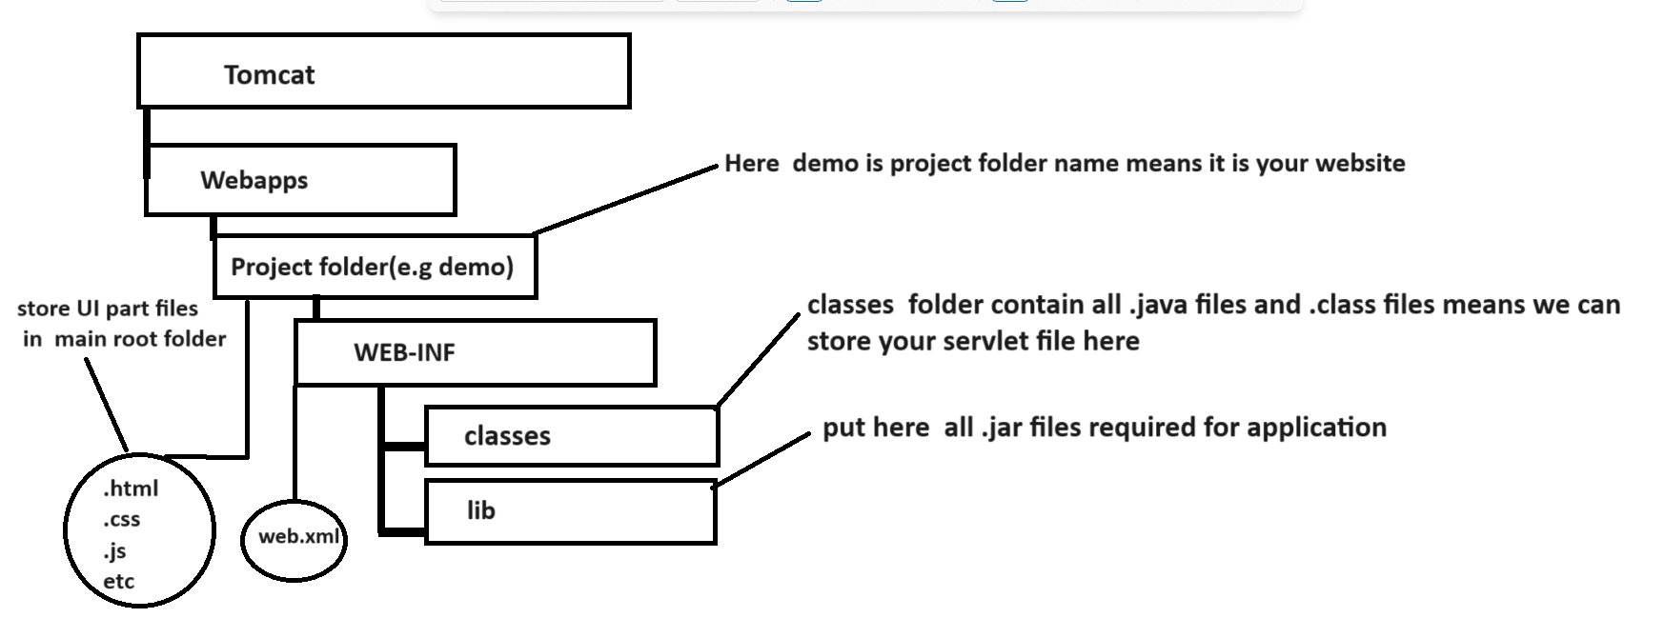

So we create folder structure you can save your servlet file in classes folder under WEB-INF
As per our example create class name as TestServ.java

7. Compile your servlet program
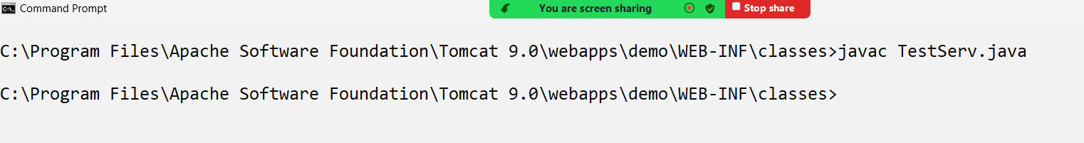

8. Create Web.xml file and configure servlet
___________________________________________________________________________
web.xml file is known as deployment descriptor file means this file is used for configure your servlet , context paramerter , config parameter etc
If we think about servlet you can configure servlet in file like as

web.xml file
<servlet>
<servlet-name>name of servlet</servlet-name>
<servlet-class>class name of servlet</servlet-class>
</servlet>
<servlet-mapping>
<servlet-name>name of servlet</servlet-name>
<url-pattern>/urlname</url-pattern>
</servlet-mapping>

<servlet-name>name of servlet</servlet-name>: servlet-name indicate reference of servlet class
<servlet-class>class name of servlet</servlet-class>: it is class name whose object created by servlet container i.e tomcat
<url-pattern>/urlname</url-pattern>: url pattern indicate it is link for call servlet to end user or url for send request to servlet

Example of web.xml file
<?xml version="1.0" encoding="UTF-8"?>
<web-app xmlns="http://xmlns.jcp.org/xml/ns/javaee"
xmlns:xsi="http://www.w3.org/2001/XMLSchema-instance"
xsi:schemaLocation="http://xmlns.jcp.org/xml/ns/javaee
http://xmlns.jcp.org/xml/ns/javaee/web-app_4_0.xsd"
version="4.0"
metadata-complete="true">

<servlet>
<servlet-name>t</servlet-name>
<servlet-class>TestServ</servlet-class>
</servlet>

<servlet-mapping>
<servlet-name>t</servlet-name>
<url-pattern>/test</url-pattern>
</servlet-mapping>
</web-app>
9. Deploy servlet application on server
___________________________________________________________
if we want to deploy your servlet program on server we have following steps
a) open browser
b) type the following type of url
http://localhost:portnumber/projectname/urlname
Example: http://localhost:9090/demo/test

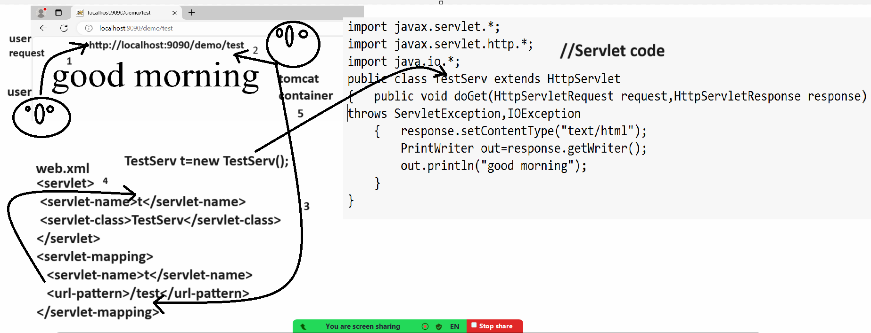

How to Create Servlet Application by using Eclipse
_____________________________________________________________________________
Steps to create servlet program by using eclipse
1. Open eclipse
2. Create Dynamic web project
file --- new --- other --- web --- dynamic web project --- click on next button --- give project name --- click on next and select checkbox for web.xml and click on finish button

Note: once we create project using eclipse then we get following folder structure
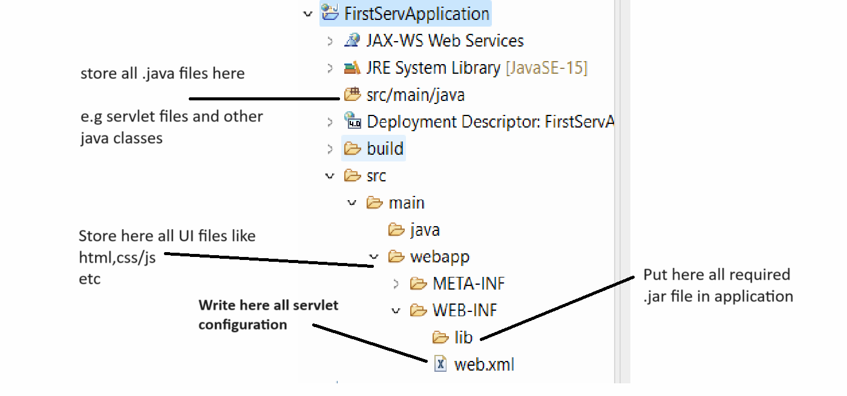

3. Create package under src
4. Create Servlet under created package
right click on servlet --- select new option --- select other --- web --- select servlet option --- give servlet class name --- click on next button ---- select url pattern ----

Example with source code
package org.techhub;

import java.io.IOException;
import javax.servlet.ServletException;
import javax.servlet.annotation.WebServlet;
import javax.servlet.http.HttpServlet;
import javax.servlet.http.HttpServletRequest;
import javax.servlet.http.HttpServletResponse;
import java.io.*;
/**
* Servlet implementation class FirstTest
*/
/*
* <serlvet>
* <servlet-name>f</servlet-name>
* <servlet-class>org.techhub.FirstTest</servlet-classs>
* </servlet>
* <servlet-mapping>
* <servlet-name>f</servlet-name>
* <url-pattern>/first</url-pattern>
* </servlet-mapping>
*/
@WebServlet("/first")
public class FirstTest extends HttpServlet {

protected void doGet(HttpServletRequest request, HttpServletResponse response) throws ServletException, IOException {
response.setContentType("text/html");
PrintWriter out=response.getWriter();
out.println("<h1>Good Morning</h1>");
}

/**
* @see HttpServlet#doPost(HttpServletRequest request, HttpServletResponse response)
*/
protected void doPost(HttpServletRequest request, HttpServletResponse response) throws ServletException, IOException {
// TODO Auto-generated method stub
doGet(request, response);
}

}
5. Run application or deploy application on server

How to create servlet by using maven?
_______________________________________________________________
Q. what is maven?
Q. why use maven and what are the benefits of maven?

